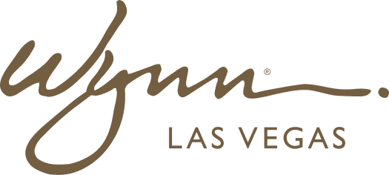 | WYNN RESORTS  Office of the General Counsel | Commercial Contracts  PRIVILEGED & CONFIDENTIAL

INTERNAL AUDIT REPORT
Contract Negotiation Playbook: Technology Vendor Agreements

Version | 2.3
Owner | VP Commercial Legal
Effective | September 2024

Technology Vendor Negotiation Positions

Issue | Vendor Standard Position | Wynn Preferred Position | Minimum Acceptable | Escalation Trigger | Notes
Limitation of Liability | Cap at 6 months fees; mutual | Cap at 12 months fees; mutual; uncapped for data breach | Cap at 6 months; data breach uncapped | Vendor refuses data breach carve-out | This is a hard line for any vendor processing personal data
Data Processing Agreement | Often omitted or minimal | Full CCPA/GDPR DPA with DPO sign-off; 48-hr breach notification | 48-hr breach notification; data deletion on termination | Vendor refuses DPA entirely | Engage CPO for any DPA that deviates from standard template
Source Code Escrow | Usually excluded | Escrow for all custom code with 30-day release trigger on vendor insolvency | Escrow for critical system code | Vendor agrees to escrow but not release triggers | Critical for systems where Wynn has no migration path
SaaS Uptime SLA | Usually 99.5% or lower | 99.9% with 10% monthly credit per qualifying incident | 99.5% with credit scheme | No credits offered | SaaS tools rated Business Critical require 99.9% minimum
Data Portability | Often excluded | Machine-readable export of all Wynn data within 30 days of termination | Export within 60 days | Vendor claims data portability not technically feasible | Reject this argument; all modern SaaS platforms support data export
Subprocessors | Right to add without notice | 30-day prior notice with right to object | 14-day notice | No notice requirement | Subprocessor changes can affect data residency and security posture
Price Escalation | Annual CPI or 5-7% | CPI capped at 3%; or fixed price for contract term | CPI or 5%, whichever lower | Annual increase above 8% | Escalation clauses are negotiable; vendors often concede to Wynn-preferred position
Professional Services Rates | T&M at published rate card | Blended rate or fixed-fee SOWs | Capped T&M at agreed rate card | Vendor insists on open-ended T&M | Require NTE (not-to-exceed) on all SOWs; fixed fee preferred for defined-scope work
IP Ownership (custom dev) | Vendor retains all IP; grants Wynn license | Wynn owns all custom work product | Assignment of work product; vendor license to base platform components | Vendor refuses assignment | Do not accept vendor IP ownership of Wynn-specific customizations
Audit Rights | Usually excluded | Annual audit right with 30-day notice | Annual audit right with 45-day notice | Vendor refuses audit rights | Nevada Gaming Regulation requires audit rights for gaming-adjacent systems
Termination for Convenience | Often excluded or with 180+ day notice | 90-day notice; no termination fee | 60-day notice; fee max 3 months remaining value | No termination for convenience right | Negotiate this on all contracts above $500K annual value
Background Checks | Usually excluded | All personnel accessing Wynn systems must pass Wynn background check | Vendor-equivalent background check program | No background check for system access personnel | Nevada Gaming Regulation requirement for gaming-adjacent systems

Deal Breakers -- Walk Away Conditions

- Vendor ownership of Wynn-specific custom work product with no assignment option
- No data processing agreement for a vendor processing personal data of Wynn guests or employees
- Governing law outside Nevada or Delaware for US contracts
- No termination for convenience right on contracts above $1M with no agreed exit mechanism
- Mandatory arbitration in a foreign jurisdiction
- Uncapped vendor liability for its own gross negligence or wilful misconduct
- No audit rights for vendors processing gaming financial data or personal data

