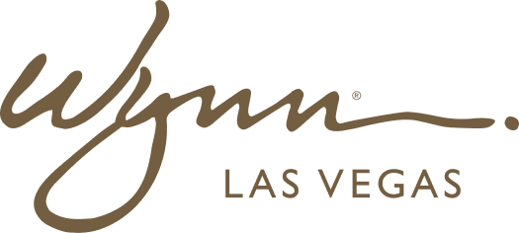 | WYNN RESORTS  Office of the General Counsel | Litigation  PRIVILEGED & CONFIDENTIAL

INTERNAL AUDIT REPORT
Contract Dispute and Litigation Summary -- FY2022 to FY2024

Period | FY2022-FY2024
Prepared By | Deputy General Counsel
Date | January 2025

Contract Dispute and Litigation Register -- FY2022-FY2024

Matter ID | Party | Contract Type | Nature of Dispute | Year Opened | Resolution | Settlement Amount | Legal Cost | Lessons Learned
CDL-2022-001 | Tech Vendor A (identity withheld) | SaaS / Professional Services MSA | Vendor delivered custom integration 8 months late; Wynn sought damages for lost revenue and re-procurement costs | 2022 | Settled | $420K paid to Wynn | $184K | Contract lacked specific milestone dates and liquidated damages for delay; add milestone schedule and LD clause to all professional services SOWs
CDL-2022-002 | F&B Supplier B | Supply Agreement | Supplier claimed force majeure for delivery failures during supply chain disruption; Wynn contested scope | 2022 | Mediation settlement | No payment; supplier provided credits | $62K | Force majeure clause was too broad; narrowed in all new supply agreements since 2022
CDL-2023-001 | Construction Contractor C | Construction Contract | Contractor claimed extras of $1.4M beyond fixed contract price; Wynn disputed scope creep | 2023 | Arbitration (Wynn prevailed) | None (Wynn prevailed) | $318K | Ensure change order process is explicitly tied to written approval only; no verbal approvals for scope changes
CDL-2023-002 | Former Employee D | Employment / Confidentiality Agreement | Former executive alleged Wynn interfered with new employment (tortious interference); filed JAMS arbitration | 2023 | Settled | $185K paid by Wynn | $247K | Non-compete enforceability limitations in Nevada; revise employment agreements to focus on confidentiality rather than non-compete
CDL-2023-003 | Entertainment Promoter E | Event Agreement | Wynn canceled headliner agreement due to artist conduct clause trigger; promoter disputed basis for cancellation | 2023 | Settled | $310K paid by Wynn | $142K | Conduct clause definitions need to be more specific and objective; subjective reputational damage triggers create dispute risk
CDL-2024-001 | Insurance Carrier F (cyber) | Cyber Insurance Policy | Carrier disputed coverage for INC-2024-006 vendor breach notification costs, citing vendor-caused vs Wynn-caused distinction | 2024 | Pending | In negotiation | $98K to date | Review cyber policy trigger language; first-party vs third-party coverage boundaries must be clearly defined before renewal
CDL-2024-002 | Technology Vendor G | SaaS License Agreement | Vendor claimed Wynn exceeded licensed user count by 140 users; demanded retroactive license fees of $380K | 2024 | Settled | $95K paid by Wynn | $44K | License count monitoring must be embedded in IT asset management; over-deployment clauses must be reviewed at contract renewal
CDL-2024-003 | Labor Union H | Collective Bargaining Agreement | Union grievance regarding shift scheduling change in F&B department following restructure | 2024 | Resolved in grievance process | None (management right upheld) | $38K | Union consultation required before implementing scheduling model changes; engage VP HR and Labor Relations Counsel earlier in change planning process

