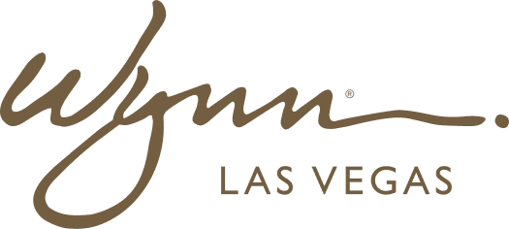 | WYNN RESORTS  Office of the General Counsel | Regulatory Affairs  INTERNAL USE ONLY

INTERNAL AUDIT REPORT
Jurisdiction Inventory and Regulatory Body Register

As Of | March 2025
Owner | VP Regulatory Affairs
Review Cycle | Quarterly

Jurisdiction and Regulatory Body Register

Jurisdiction | Regulatory Body | License Type | License Number | Expiry | Relationship Owner | Last Examination Date | Next Due
Nevada -- State | Nevada Gaming Control Board (NGCB) | Restricted Gaming License | Nevada-0041-2847 | Perpetual (3-yr review) | VP Regulatory Affairs | September 2022 | Q3 2025 (triennial review)
Nevada -- State | Nevada Gaming Commission | Gaming Operator Certificate | NGC-2022-0841 | Perpetual (3-yr review) | VP Regulatory Affairs | September 2022 | Q3 2025
Nevada -- Clark County | Clark County Business License | Business Operations License | CC-BL-2024-18742 | December 2025 | Dir. Compliance | N/A | December 2025 (renewal)
Massachusetts -- State | Massachusetts Gaming Commission (MGC) | Category 1 Gaming License | MGC-2019-CAT1-003 | March 2029 (5-yr review) | VP Regulatory Affairs | November 2024 | November 2026 (interim review)
Massachusetts -- State | Massachusetts Alcoholic Beverages Control Commission | All Alcohol License | ABCC-MA-2024-0847 | Annual (May 2025) | Dir. Licensing | May 2024 | May 2025 (annual renewal)
Federal -- FinCEN | Financial Crimes Enforcement Network | Casino BSA / AML Compliance | N/A (registration-based) | Perpetual | Chief Compliance Officer | August 2023 | TBD (FinCEN discretion)
Federal -- SEC | Securities and Exchange Commission | Reporting Company (10-K/10-Q) | NYSE: WYNN | Perpetual | CFO / General Counsel | Continuous (quarterly filings) | Q1 10-Q: May 12 2025
Federal -- FTC | Federal Trade Commission | Consumer Protection Compliance | N/A | N/A | CLO | N/A | Monitor for CPRA enforcement actions
Massachusetts -- City | City of Everett Licensing Board | Host Community Agreement | Everett-HCA-2019-001 | March 2029 (tied to MGC license) | VP Regulatory Affairs | N/A | March 2026 (HCA review milestone)
Federal -- FCC | Federal Communications Commission | Broadcast License (internal radio) | FCC-WRL-2022-0047 | March 2027 | Dir. IT | March 2022 | March 2027 (renewal)
Nevada -- Clark County | Southern Nevada Health District | Food Handler Permit | SNHD-2024-FH-08847 | Annual (October 2025) | VP F&B | October 2024 | October 2025 (annual renewal)
Massachusetts -- State | Massachusetts Department of Revenue | State Tax Registration | MA-TAX-REG-2019-14782 | Perpetual | Director of Tax | N/A | Continuous (monthly/quarterly filings)

