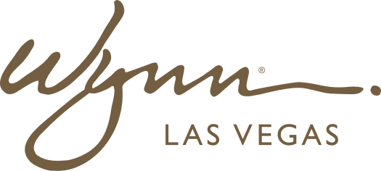 | WYNN RESORTS  Office of the General Counsel | Regulatory Affairs  INTERNAL USE ONLY

INTERNAL AUDIT REPORT
Regulatory and Compliance Obligations Calendar -- FY2025

Fiscal Year | 2025
Owner | VP Regulatory Affairs
Last Updated | January 2025

FY2025 Regulatory and Compliance Calendar

Obligation | Regulator | Frequency | Q1 Due Date | Q2 Due Date | Q3 Due Date | Q4 Due Date | Owner | Status
SEC Form 10-K Filing | SEC | Annual | Feb 28 | --- | --- | --- | CFO / CLO | Filed Feb 28 2025
SEC Form 10-Q Filing | SEC | Quarterly | --- | May 12 | Aug 11 | Nov 10 | CFO / CLO | Q1 pending
Nevada Gaming Tax Return | NGCB | Monthly | Jan 20 / Feb 20 / Mar 20 | Apr 20 / May 20 / Jun 20 | Jul 20 / Aug 20 / Sep 20 | Oct 20 / Nov 20 / Dec 20 | Dir. Tax | Current
Massachusetts Gaming Tax | MGC | Monthly | Jan 20 / Feb 20 / Mar 20 | Apr 20 / May 20 / Jun 20 | Jul 20 / Aug 20 / Sep 20 | Oct 20 / Nov 20 / Dec 20 | Dir. Tax | Current
FinCEN AML SAR Filing | FinCEN | Within 30 days of detection | Rolling | Rolling | Rolling | Rolling | Chief Compliance Officer | Current
FinCEN Currency Transaction Reports | FinCEN | Daily (transactions over $10K) | Rolling | Rolling | Rolling | Rolling | Casino Finance | Current
Nevada Triennial License Review | NGCB | Every 3 years | --- | --- | Sep 2025 | --- | VP Regulatory Affairs | Preparation underway
Massachusetts License Annual Report | MGC | Annual | --- | Apr 30 | --- | --- | VP Regulatory Affairs | In preparation
Federal Corporate Income Tax (Q1 Est.) | IRS | Quarterly | --- | Apr 15 | --- | --- | VP Tax | Pending
Federal Corporate Income Tax (Q2 Est.) | IRS | Quarterly | --- | --- | Jun 16 | --- | VP Tax | Pending
Federal Corporate Income Tax (Q3 Est.) | IRS | Quarterly | --- | --- | Sep 15 | --- | VP Tax | Pending
Nevada Modified Business Tax | NV Dept. of Tax | Quarterly | --- | Apr 30 | --- | Jul 31 | Dir. Tax | Pending
Problem Gambling Mitigation Report | MGC | Annual | --- | --- | --- | Oct 31 | Chief Compliance Officer | Annual obligation
Annual Report to Shareholders | NASDAQ | Annual | --- | Apr 30 | --- | --- | CFO / CLO / IR | In preparation
Massachusetts ABCC License Renewal | ABCC | Annual | --- | May 2025 | --- | --- | Dir. Licensing | Renewal in progress
SNHD Food Handler Permit Renewal | Clark County Health | Annual | --- | --- | --- | Oct 2025 | VP F&B | Upcoming

