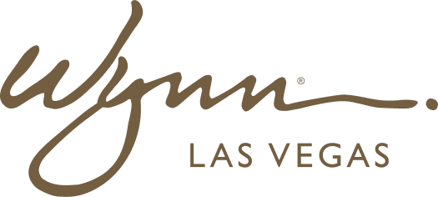 | WYNN RESORTS  Office of the General Counsel | Legal Operations  STRICTLY CONFIDENTIAL

INTERNAL AUDIT REPORT
Outside Counsel Rate Card and Legal Spend Report -- FY2024

Period | FY2024
Prepared By | Director of Legal Operations
Total Spend | $14.7M

Outside Counsel Rate Card and FY2024 Spend

Firm | Practice Area | Partner Rate/hr | Associate Rate/hr | FY2024 Budget | FY2024 Actuals | Variance | Panel Status
Greenberg Traurig | Gaming / Regulatory | $725 | $445 | $3.2M | $3.6M | ($400K) over | Preferred -- retain
Littler Mendelson | Labor & Employment | $680 | $420 | $2.1M | $2.4M | ($300K) over | Preferred -- retain
Holland & Hart | Litigation / Construction | $640 | $390 | $1.8M | $1.9M | ($100K) over | Preferred -- retain
Fenwick & West | IP / Technology | $780 | $480 | $1.4M | $1.2M | $200K under | Preferred -- retain
Pillsbury Winthrop | Insurance / Complex Litigation | $760 | $460 | $1.0M | $0.8M | $200K under | Preferred -- retain
Seyfarth Shaw | Wage & Hour / Class Action | $695 | $430 | $0.8M | $1.4M | ($600K) over | Preferred -- review class action billing
Ogletree Deakins | Labor & Employment (Boston) | $620 | $380 | $0.7M | $0.6M | $100K under | Preferred -- retain
Gordon Rees Scully Mansukhani | General Litigation (Defense) | $560 | $340 | $0.8M | $0.8M | On budget | Preferred -- retain

