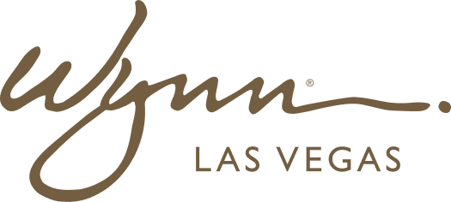 | WYNN RESORTS  Office of the General Counsel | Legal Operations  STRICTLY CONFIDENTIAL

INTERNAL AUDIT REPORT
Legal Department Intake Log -- FY2024 Annual Summary

Period | FY2024
Prepared By | Director of Legal Operations
Date | January 2025

Monthly Legal Intake Volume -- FY2024

Month | Total Requests | Primary Business Unit | Top Matter Type | Avg Days to Close | Escalated to Litigation? | Volume vs Prior Year
January | 47 | Casino Operations | Contract review (technology) | 8.4 | 0 | +12%
February | 52 | Hotel Operations | Employment advice | 7.1 | 1 | +8%
March | 61 | Marketing | Advertising / promotions review | 6.8 | 0 | +18%
April | 44 | Finance / CFO | Regulatory compliance | 9.2 | 0 | +4%
May | 58 | Casino Operations | Gaming regulation advice | 7.4 | 0 | +14%
June | 71 | Operations (all) | Contract review (vendor) | 8.1 | 2 | +22% (F&B restructure)
July | 48 | IT / CTO | Data privacy | 6.9 | 0 | +7%
August | 55 | Casino Operations | AML / compliance | 8.7 | 1 | +11%
September | 63 | HR | Labor and employment | 7.2 | 1 | +16%
October | 49 | Marketing | Sweepstakes / promotions | 6.4 | 0 | +3%
November | 57 | Real Estate / Facilities | Lease review | 9.8 | 0 | +9%
December | 38 | Finance / CFO | Year-end regulatory filings | 11.4 | 0 | (8%) -- seasonal dip
Total FY2024 | 643 | Casino Operations (28%) | Contract review (34%) | 8.2 | 5 escalated | avg +10.7% vs FY2023

Intake by Business Unit -- FY2024

Business Unit | FY2024 Requests | % of Total | FY2023 Requests | YoY Change | Avg Days to Close
Casino Operations | 180 | 28% | 163 | +10.4% | 8.1
Hotel Operations | 112 | 17% | 98 | +14.3% | 7.4
Marketing | 98 | 15% | 84 | +16.7% | 7.0
Finance / CFO | 74 | 12% | 71 | +4.2% | 9.6
HR / People | 68 | 11% | 58 | +17.2% | 8.8
IT / Technology | 54 | 8% | 42 | +28.6% | 7.2
F&B Operations | 32 | 5% | 29 | +10.3% | 6.9
Facilities / Real Estate | 25 | 4% | 23 | +8.7% | 11.2

