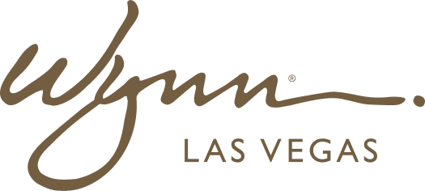 | WYNN RESORTS  Office of the General Counsel | Commercial Legal  INTERNAL USE ONLY

INTERNAL AUDIT REPORT
New Product and Service Launch -- Legal Review Checklist

Version | 1.6
Owner | VP Commercial Legal
Effective | March 2025

Legal Review Checklist -- New Product and Service Launch

Review Area | Question | Applicable Law/Regulation | Sign-Off Required | Status
Gaming Regulation | Does the new product involve any form of gaming, wagering, or prize element? | Nevada Gaming Regulations; Massachusetts MGC Regs | VP Regulatory Affairs + CLO | Required
Gaming Regulation | If yes, has the appropriate gaming regulator pre-approval or notification been completed? | NGCB Reg 5; MGC MICS | VP Regulatory Affairs | Required if gaming element present
Consumer Protection | Does the product involve any promotional offers, contests, or sweepstakes? | FTC Endorsement Guides; State prize laws | VP Commercial Legal | Required
Consumer Protection | Are all material terms and conditions disclosed clearly and conspicuously? | FTC Act Section 5; state UDAP laws | VP Commercial Legal | Required
Data Privacy | Does the product collect, use, or share personal data of guests? | CCPA/CPRA; Nevada Privacy Act; GDPR if EU guests affected | Chief Privacy Officer + CLO | Required
Data Privacy | Has a Privacy Impact Assessment (PIA) been completed? | Internal policy; GDPR Art. 35 | Chief Privacy Officer | Required for all new data collection
Data Privacy | Do consent and disclosure notices accurately reflect the new data practices? | CCPA; GDPR | Chief Privacy Officer | Required
Marketing Compliance | Have all marketing materials been reviewed for FTC compliance, including endorsements and testimonials? | FTC Endorsement Guides 2023 update | VP Commercial Legal | Required
Marketing Compliance | Does the marketing target any protected class in a manner that could constitute unlawful discrimination? | Fair Housing Act; Equal Credit Opportunity Act | VP Commercial Legal | Required for any targeted marketing
Employment | Does the new product require new roles or changes to existing job duties? | FLSA; state wage laws; CBA if applicable | VP HR + CLO | Required
Employment | If tipping is involved, has the tip pooling arrangement been reviewed for FLSA compliance? | FLSA Section 3(m) | VP HR + CLO | Required if tipping involved
Intellectual Property | Does the product use any third-party intellectual property (brand, music, software)? | Copyright Act; Lanham Act | VP Commercial Legal | Required
Intellectual Property | Have all necessary licenses been obtained? | As applicable | VP Commercial Legal | Required before launch
Contract Requirements | Have all vendor contracts necessary to support the product been executed? | Internal contracting policy | VP Commercial Legal | Required
Contract Requirements | Do existing vendor contracts need to be amended to cover the new product? | As applicable | VP Commercial Legal | Required
Tax | Are there any sales, use, or excise tax implications of the new product? | NRS 374; MGL ch. 64H; federal excise tax | Director of Tax | Required
Insurance | Does the new product create any insurance coverage gaps or require new coverage? | Wynn insurance program | VP Treasurer + CLO | Required
Licensing | Does the product require any new or amended licenses or permits? | As applicable by jurisdiction | VP Regulatory Affairs | Required
Accessibility | Does any digital component of the product comply with ADA and WCAG 2.1 AA? | ADA Title III; WCAG 2.1 | VP Commercial Legal + CTO | Required for all digital products
Sign-Off | Has the full legal checklist been reviewed and signed off by CLO? | Internal policy | CLO | Required before go-live

