C# Hai_Game User Manual

By Hai Tang, 9/18/2015

Step1:

Open Microsoft Visual Studio as red circled (rightmost) in the tool bar.

Macintosh HD:Users:williamsea:Desktop:Hai Tang Documents:IBT Data:C# Screenshot:Capture1.PNG

Step 2:

In the welcome screen, click Hai_EMG_Game under Recent as yellow circled.

Or click Open Prject… under Start.

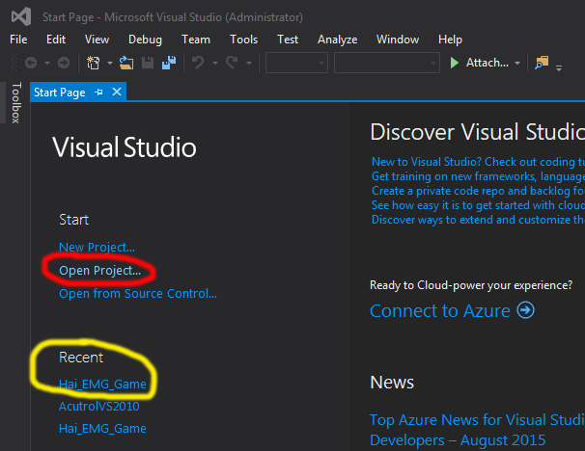

If you clicked Open Project… Then go to the folder as shown below and open the Hai_EMG_Game project.

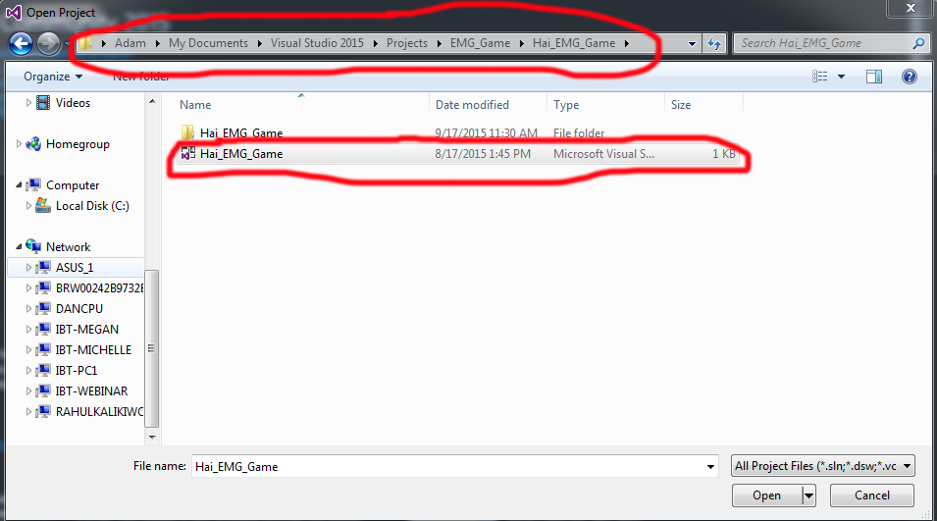

Step 3:

Click Start as red circled in Visual Studio.

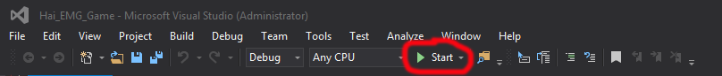

Step 4:

Now you’ve come to the Game Graphic User Interface.

Firstly, select the electrode you are using as blue circled. The default is IBT Version D.

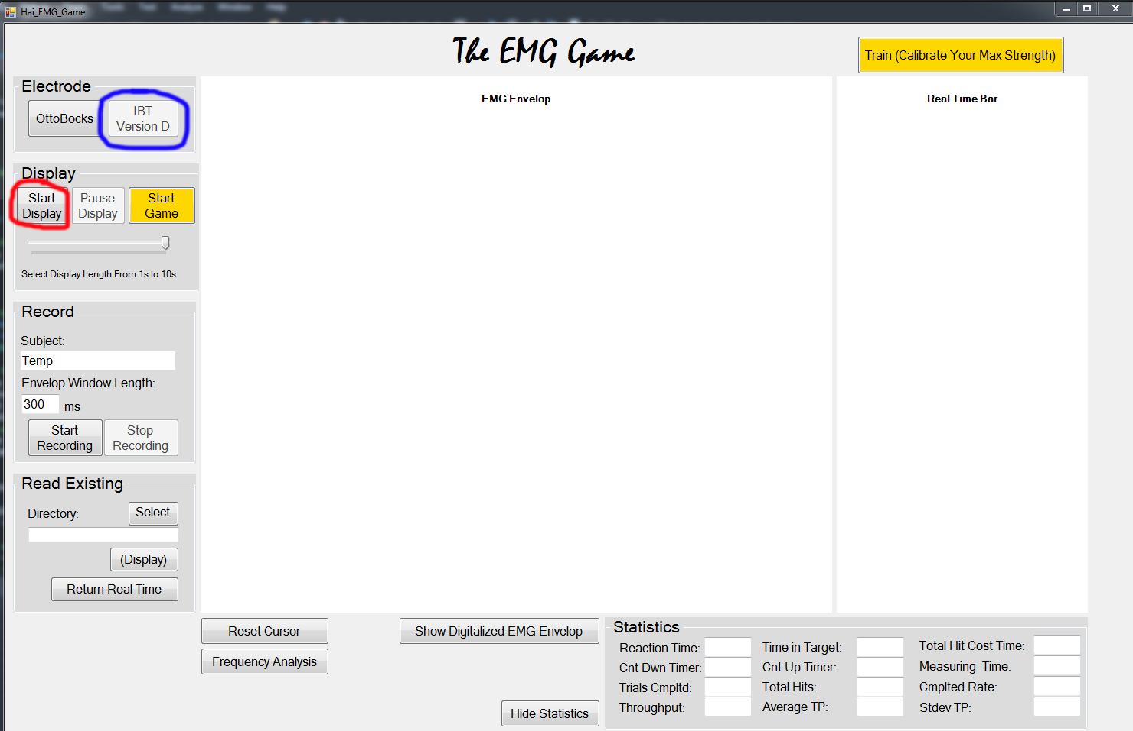

Click Start Display as red circled, and the real time EMG data begins to show in the EMG Envelop graph.

Step 5:

Check if the EMG signal is running in real time. If no signal comes in, check the power supply. If there are noticeable baseline noises, wait for a few seconds for the electrode to be fully settled. A sampling signal in middle of settling is shown below, whose magnitude keeps reducing. Wait for it goes to zero if it happens.

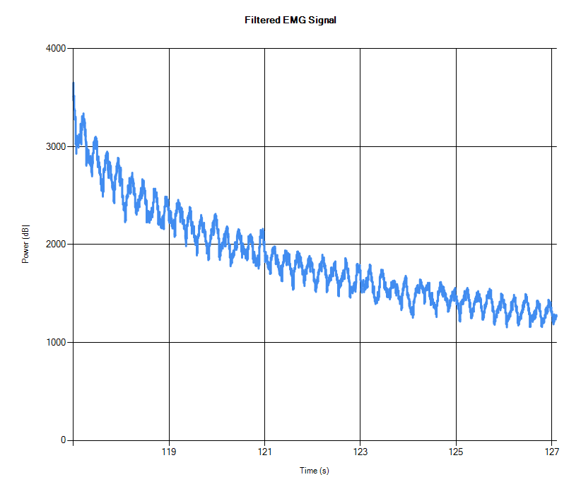

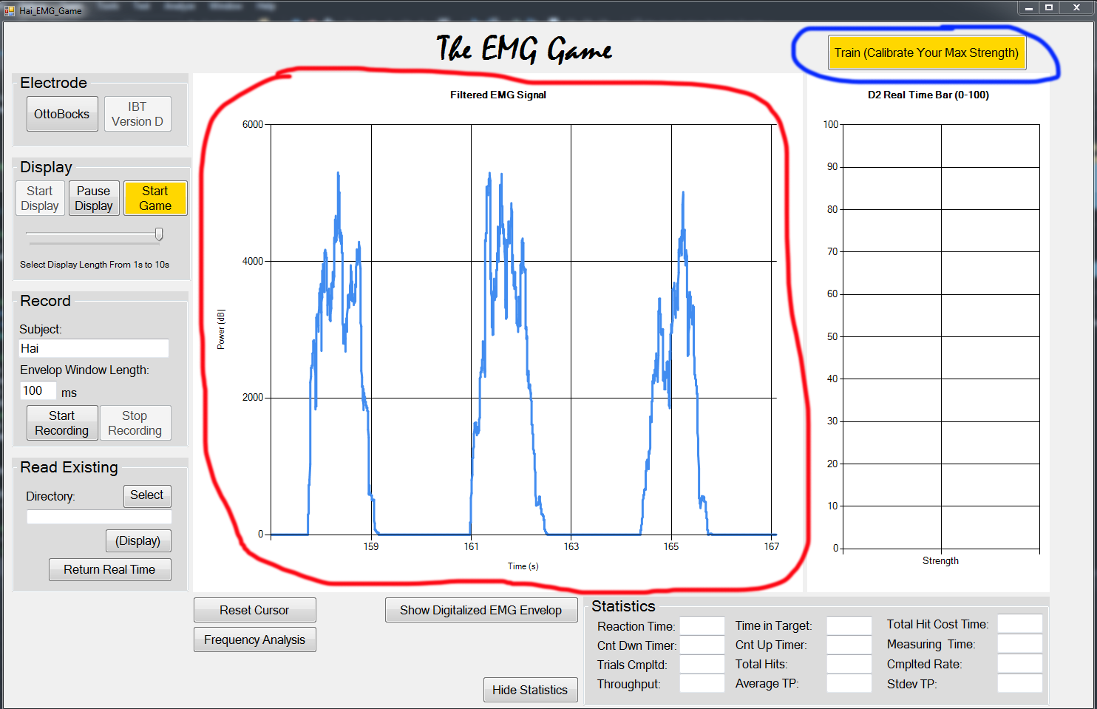

Step 6:

If you plan to play the game, check the red bar in the right side graph to see if you can reach both 10 and 90 without too much effort. If you have difficult reaching either of them, click Train as shown in blue circle above.

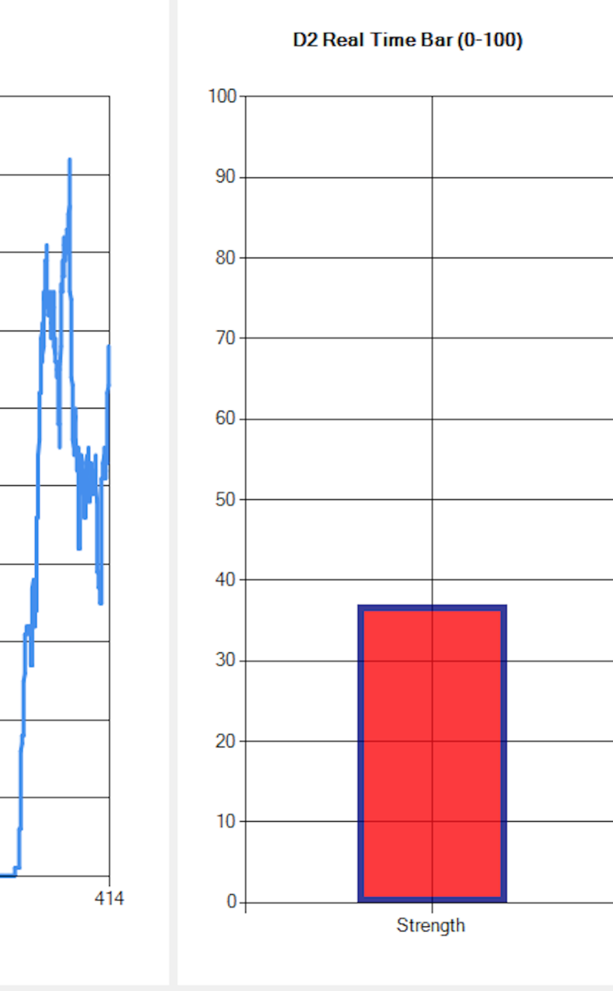

Then the button will turn blue to show it’s looking for the maximum value during a 5 second detecting time period.

Macintosh HD:Users:williamsea:Desktop:Hai Tang Documents:IBT Data:C# Screenshot:Capture7.PNG

After 5 second, your maximum strength is found. And the game will rescale your strength from 0-YourMaximun to 0-100 for the red bar controlling.

Macintosh HD:Users:williamsea:Desktop:Hai Tang Documents:IBT Data:C# Screenshot:Capture8.PNG

If you are not satisfied with the trained result, click the button again to retrain.

Step 7:

If you want to see the digitalized EMG data, click the Show Digitalized EMG Envelop button, which will rescale your strength from 0-YourTrainedMaximun to 0-100. Click the same button (text changed though) again to show the raw filtered data again.

Note that if your signal is larger than your trained maximum value, its exceeding part will be cut off in the digitalized EMG signal.

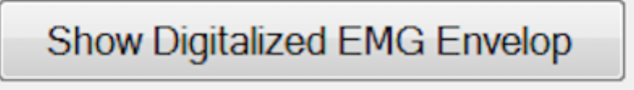

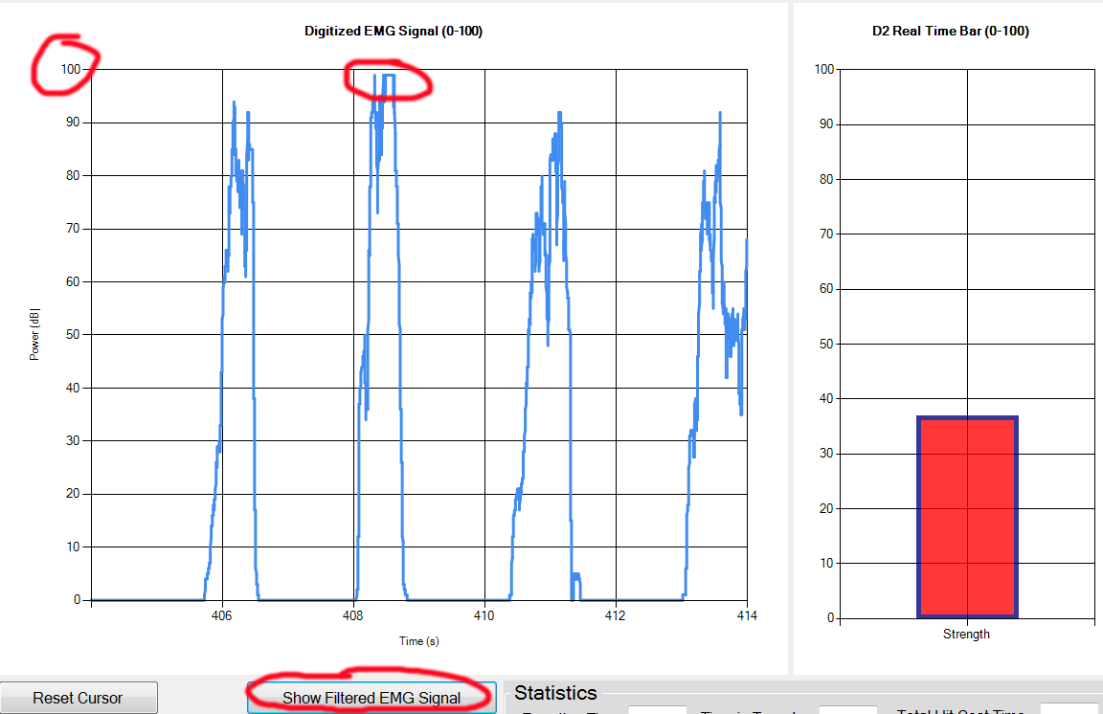

Step 8:

Click Start Game button. The button turns green to indicate that game has started, and you cannot click this button any more during the game.

The instructions will be shown to prepare the player for the next motion and indicate when to relax.

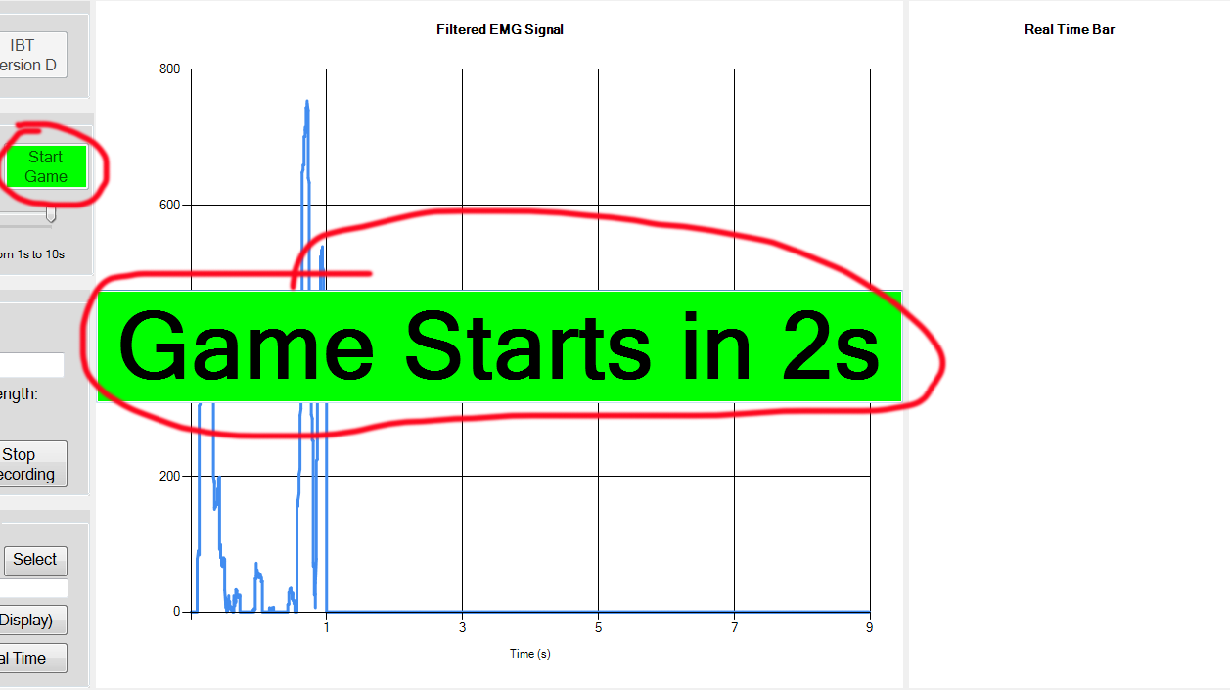

Step 9:

Try to put the tip of the red bar into the yellow target box, and try your best to stay in the target box until it turns green.

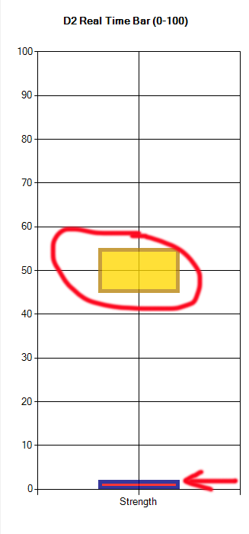

Once you have made the tip of red bar in the target yellow box for a certain length of time, the target box turns green, and you can relax your arm once it’s green.

Note that the height of the red bar is related to your latest EMG signal magnitude (strength).

Once you finished one trial, you can have a look at all your statistics in the Statistics section.

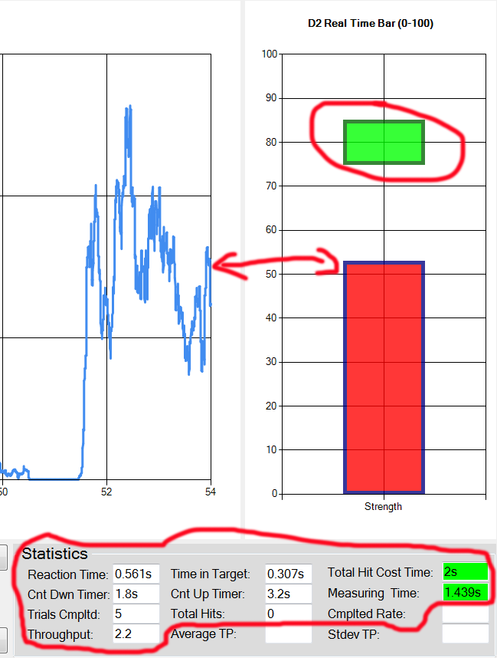

Also you can choose to hide the Statistics to avoid being affected by the numbers.

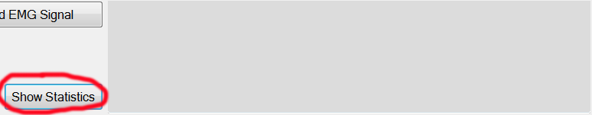

Step 10:

Once you finished all 10 trials of the game, a window will pop up indicating how many hits you got.

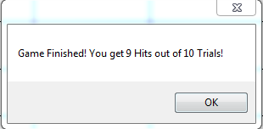

And the Statistics will show your average performance:

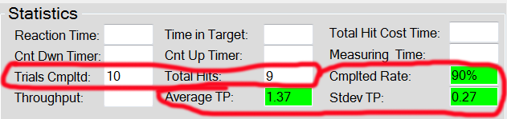

Note that the Average Throughput and Standard Deviation of Throughput do not include the missing hits.

Step 11:

Every time you run the game, the data during the game will be saved automatically. So make sure you’ve put subject’s name under Subject. And if you are using IBT electrode, make sure to put the window length as well. The saved folder name will be in format of “HaiIBT100” or “HaiOttobocks”.

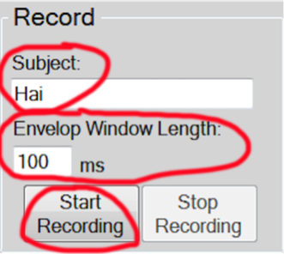

You can also manually control when to start and stop recording by clicking the Start Recording and Stop Recording button. Also make sure you put the correct Subject Name and Widow Length (for IBT electrode only).

Step 12:

You can open existing data file by clicking Select button.

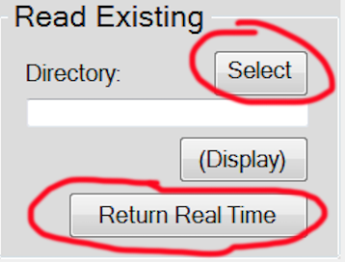

The default directory opened is Game_Data folder in Desktop. Select the subject.

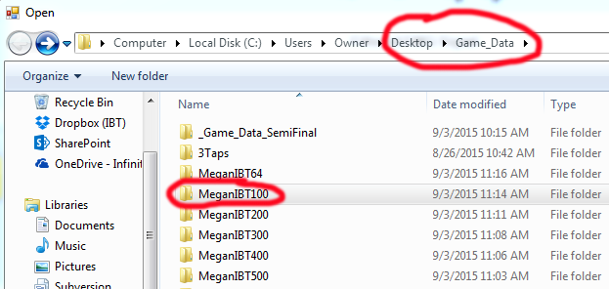

Then select the specific data file, in format of day-month-year_hour-minute-second.

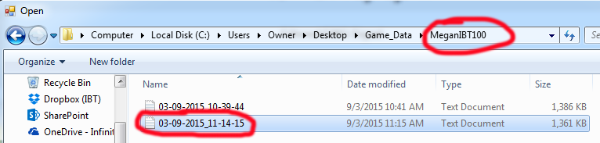

Then the saved data file will automatically be displayed. You don’t need to click the display button.

Another way to display the data file is to manually type the directory and click display, but it cost more time so is not recommended.

You can click Return Real Time to exist the read existing mode.

Step 13:

You can Zoom In to see the details of the graph (usually when you want to see the details of existing data) by just choosing the target area by mouse: click the upper-left point of a rectangular target area, drag your mouse to the button-right of the rectangular, and release the mouse.

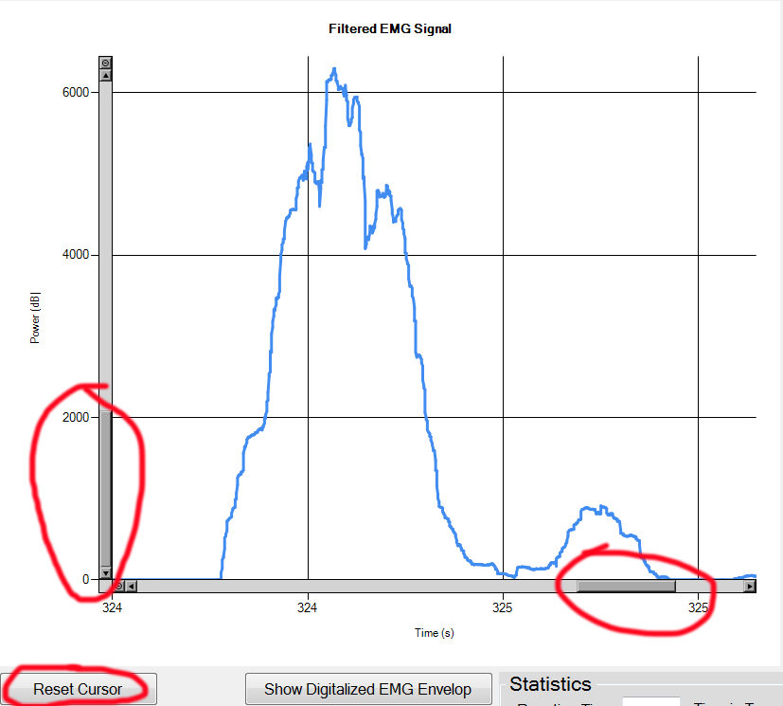

Click Reset Cursor button to exit the zoomed in mode.

Step 14:

Frequency Analysis can only be clicked when you are receiving raw EMG data instead of EMG envelop data, since FFT of envelop makes no sense and will cause problem to the program. The Frequency Analysis takes the latest 8s data and performs FFT and power spectrum calculation on that data, so make sure you need to run at least 8s before clicking the Frequency Analysis button. Since my FFT function may differ from the build-in FFT function in Matlab, the resulting power spectrum graph is slightly different from that in Matlab. So I would recommend doing frequency analysis in Matlab to keep it consistent.