|  |  |
| --- | --- |
| **Assignment Case** |  |
| <Subject Code1>[ | <Subject Code2>]  <Subject Name1>[ | <Subject Name2>] |
| **<Department/Program>** | **<Case Code>** |
| ***Valid on*** *[Odd/Even/Compact] Semester Year 9999/9999* | **Revision 00** |

1. Mahasiswa tidak diperkenankan untuk:

*Students are prohibited from:*

* + - Berdiskusi dan/atau bekerja sama dengan mahasiswa lainnya,

*Discussing and/or cooperating with other students,*

* + - Melihat sebagian atau seluruh jawaban mahasiswa lainnya,

*Seeing a part or the whole answer from other students,*

* + - Membuka dan/atau menyalin jawaban dari buku, catatan, video, dan jenis referensilainnya,

*Open and/or copy answer from books, notes, videos, and other references,*

* + - Membuka dan/atau menyalin jawaban dari internet,

*Open and/or copy answer from the internet,*

* + - Mengumpulkan jawaban yang tidak sesuai dengan tema soal,

*Submitting an answer with a different theme from the given case,*

* + - Melakukan tindakan yang menyebabkan jawaban dicontek oleh orang lain atau kelompok lain, baik disengaja maupun tidak disengaja,

*Doing action that could result the answer being copied by someone or other groups, intentionally or unintentionally,*

* + - Melakukan tindakan kecurangan lainnya.

*Committing other dishonest actions.*

1. Jika mahasiswa dan/atau terbukti melakukan tindakan seperti yang dicantumkan pada butir ke-1, maka nilai mahasiswa dan/atau kelompok yang melakukan kecurangan, baik menyontek atau dicontek, akan dinolkan sesuai dengan peraturan yang berlaku.

*If it has been proven that a student and/or group has committed dishonest actions outlined in point 1 above, the students and/or groups related to the incident, regardless of which one copies or has their answer copied, will be issued a score of zero according to the regulation.*

1. Jawaban yang dapat diterima dan dinilai adalah jawaban yang dikumpulkan sebelum batas waktu yang telah ditentukan.

*The answer must be submitted before the designated deadline to be accepted and graded,*

1. Jawaban akan dinilai berdasarkan teknik yang diajarkan dalam praktikum dengan menggunakan software yang telah ditentukan.

*The scoring will be based on the materials taught during the practicum classes using the designated software. Using different software than requested may result in your answer not being graded.*

1. Jika Anda tidak membaca peraturan ini, maka Anda dianggap sudah membaca dan menyetujuinya.

*By taking this exam, you agree to these regulations, regardless of whether you have read it or not.*

1. Persentase penilaian untuk matakuliah ini adalah sebagai berikut:

*The score will be distributed as follows:*

|  |  |  |
| --- | --- | --- |
| **Tugas Mandiri**  *Assignment* | **Proyek**  *Project* | **UAP**  *Final Exam* |
| 100% | - | - |

1. Perangkat lunak yang digunakan pada matakuliah ini adalah sebagai berikut:

*This course uses the following software:*

|  |
| --- |
| **Software**  *Software* |
| Software 1  Software 2  Software 3  etc |

1. Ekstensi file yang harus dikumpulkan untuk matakuliah ini adalah sebagai berikut:

*Your answers must be in the following file extensions:*

|  |  |  |
| --- | --- | --- |
| **Tugas Mandiri**  *Assignment* | **Proyek**  *Project* | **UAP**  *Final Exam* |
| Extension File 1, Extension File 2, Extension File 3, etc | - | - |

## Soal

*Case*

Answer the questions below within **100 minutes.** Use Google Colaboratory and submit your answer in an “**ipynb**” file.

1. **Solving Linear Equation**

Solve the following system of linear equations with the following requirements,

* You must determine whether the **equations** are **diagonally** **dominant** **programmatically, if the equation is not diagonal** then **print error message.**
* If the equations are **diagonally dominant**, use **Gauss-Seidel method** and the number **105** as the **max** **iterations**. **Otherwise**, show a message telling the equations are **not** **diagonally** **dominant**.
* Use a **pre-defined threshold $ϵ=0.0xx$**  where xx are the last two digits of your NIM.

*Example:*

NIM = 2702210499, then the $ϵ$ will have a value of $ϵ=0.099$

* Use the value 0 as the initial value of x1, x2,and x3

Then, show the result for each equation and check whether the **equations** below are **convergent** or **not** and **print** the **value** of x1, x2,and x3 ineach **iteration**.

Below are the systems of linear equations that you need to solve:

Snippet code for the equations:

x = [  
 [  
 [-72, 12, 19],  
 [54, -105, 6],  
 [35, 15, -94]  
 ],  
 [  
 [82, 101, 25],  
 [15, 107, 135],  
 [99, 11, -66]  
 ],  
 [  
 [72, 13, 13],  
 [37, 89, 9],  
 [44, 11, -99]  
 ],  
 [  
 [-87, 44, 4],  
 [28, -83, 12],  
 [46, 11, -95]  
 ],  
 [  
 [61, 12, 3],  
 [15, -94, 35],  
 [6, 24, -66]  
 ]  
]  
  
y = [  
 [-855, 859, 399],  
 [365, -174, -602],  
 [-113, 703, 75],  
 [232, 748, 671],  
 [-622, -355, -169]  
]

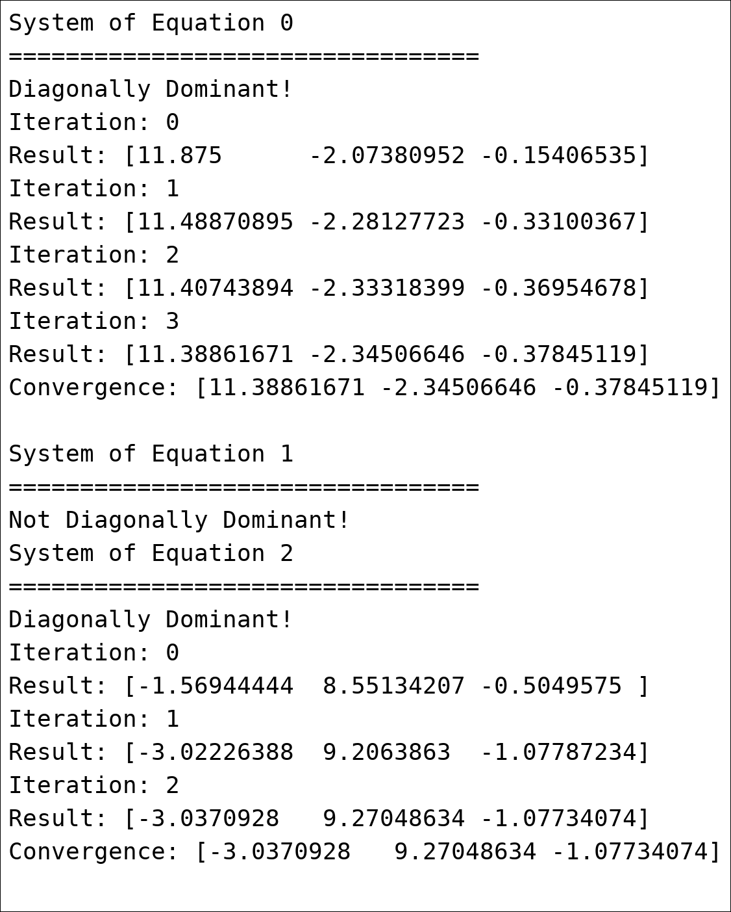

**Figure 1. Gauss Seidel Result with Epsilon 0.099**

1. **Regression and Plotting**

Create a **Least** **Square** **Regression** from the matrix (x, y) in “**2-matrix.txt**”, then **print** the value of ‘**m**’ and ‘**c**’ from the formula of **“y = mx + c”**. Lastly, Show the **original** **matrix** and the result of **Least Square Regression** in **one** **plot** using matplotlib (with legend).

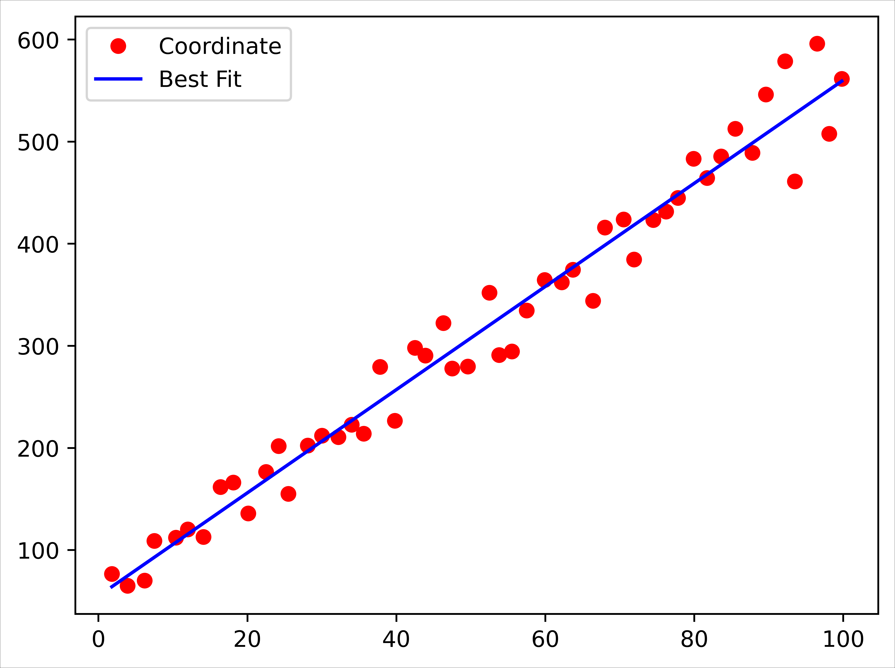

**Figure 2. Least Square Regression Plot Result**

1. **Newton Raphson**

Find the root of the equation from the equation f(x) below by using **Newton Raphson** method:

f(x) = -x⁵ + 2x⁴ - x³ + 43x² - 49x + 19

* How many **iterations** are required to find the root of the equation?
* With first guess of the value is **10.**
* With **tolerate error** is **0.0xx** with **xx** are the last digits of your NIM (e.g., 2702210499, then the last digits of the NIM are **99**)
* With the number of the **max iterations** is **73**
* **Print the result** of the **root** in **each** **iteration**. If the iteration is **over the max** iterations the **print error message.**

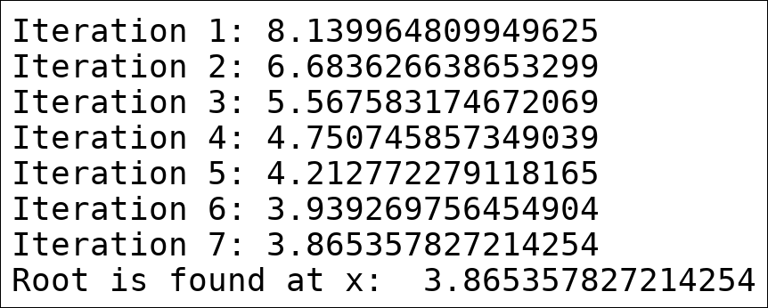

**Figure 3. Newton Raphson Result with Tolerate Error 0.099**

1. **Integral Riemann**

Use the Left Riemann and Mid Riemann Integral to find the approximate of With 273 evenly spaced grid points over the whole interval.