Capstone Preliminary Report:

PPG part

PPG (photoplethysmogram) Sensor:

Background & Theories:

As a crucial part of patient monitoring system, PPG sensor, known as pulse oximeter is used to measure the SpO2 level. “SpO2 stands for peripheral capillary oxygen saturation, an estimate of arterial oxygen saturation, or SaO2, which refers to the amount of oxygenated haemoglobin in the blood.” [1].

The blood oxygen saturation reading of a normal person should be between 95% and 100%. [1]. A respiratory or cardiovascular problem may be present if the oxygen saturation drops to 90% ~ 95%. The patient will highly likely experience hypoxic if the reading falls under 90%. [2]

Working principle of the infrared PPG sensor:

Photoplethysmogram Sensor (PPG sensor) takes advantage of the different absorption level of Oxyhemoglobin (HbO2) and deoxyhemoglobin (Hb) with light of different wavelength. By placing a pair of infrared and red LED on one side of the finger and a receiver on the other side, the variation of light intensity can be measured. The light transmitting through fingertip will be absorbed by pulsatile arterial blood, non pulsatile arterial blood, venous blood and tissue. [5] As we know the pulsatile arterial blood is varying according to the heart pulse, hence the light absorption is also varying according to the heart pulse. Such variation is used as the waveform of PPG signal.

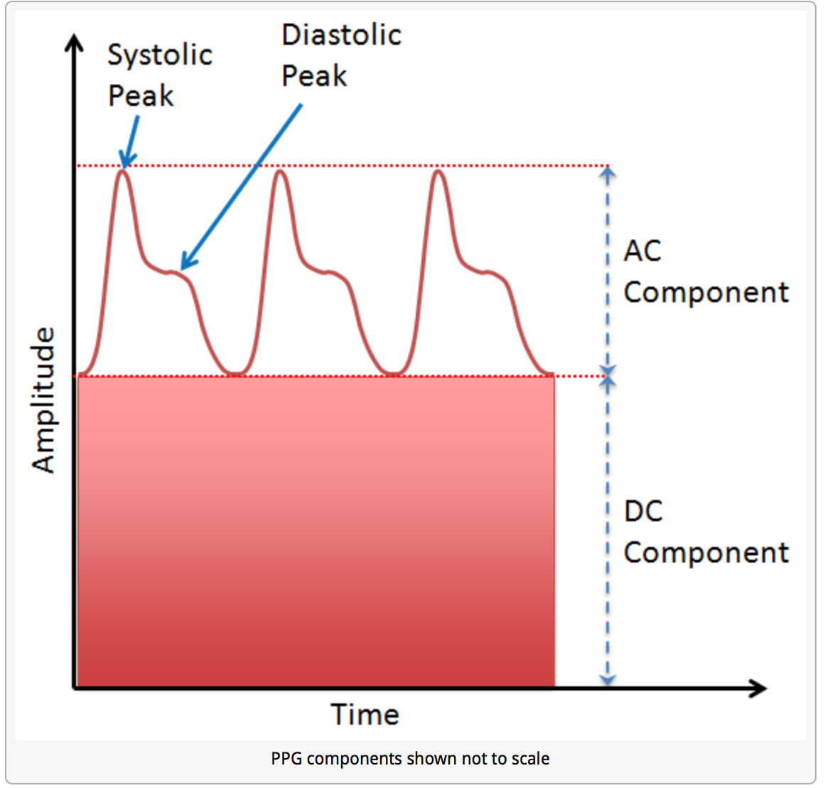

Figure XXX, [6]

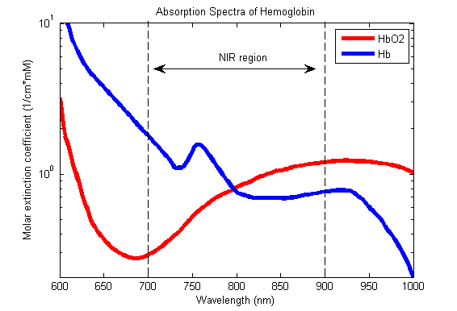

Figure XXX , [3]

The Oxygen saturation level can be calculated by the following equation:

The pulse oximeter uses **Beer–Lambert law** [4][5] to define relationship between the light attenuation (light absorption) and the material it travels through. [7]

A normalized ratio of the Red to IR is then calculated:

The accurate SpO2 is proportional to this ratio. Proper calibration can be done to get the accurate SpO2 reading.

When we tried to measure the heart rate by directly connecting a pair of infrared transmitter and receiver with the Arduino, we were not able to visualize any pulse signals. This could be due to two main reasons:

1. The photoplethysmogram signal is very small in amplitude compare with the DC offset component in the carrying signal.
2. The pair of sensors is not working properly.

To eliminate the second possibility, we did some testing with the sensors along. The intensity of the infrared beams received at the receiver is proportional to the separation between the transmitter and the receiver. By moving the transmitter towards and away from the receiver, we can observe instant change of the readings.

Hence, we come to the conclusion that the signal from our PPG sensor is very small compare with the DC offset and the high frequency noise. Therefore, low-pass filter, high-pass filter and op-amp are used to extract the useful information from the raw signal from PPG sensor. The signal firstly goes through a high-pass filter which filters the DC component.

For the Arduino we are using, it has 10-bit analog to digital convertor which maps the analog input between 0 to 5V into 1024 discrete levels between 0 and 1023. This gives the resolution around 5mV per unit.

Bandwidth selection:

The frequency of the normal resting heart rate is between 1Hz to 2Hz. [8] Hence, for our Pulse Oximeter, we allow the signal between 0.5Hz to 4Hz to pass through.

Circuit design:

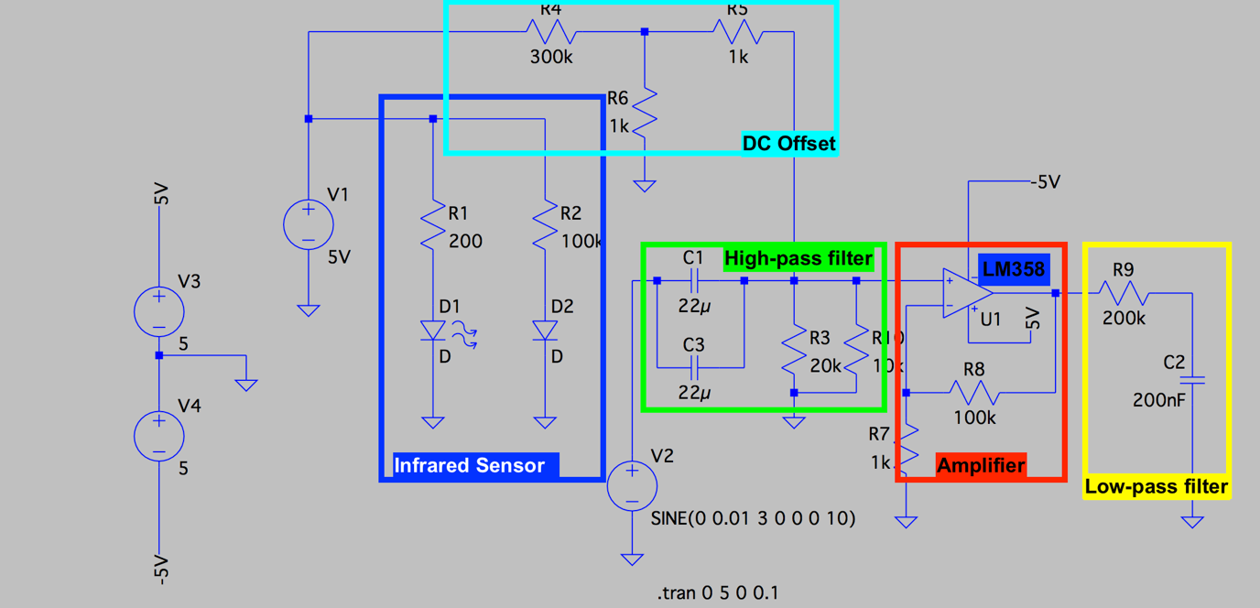

High pass filter:

A RC high pass filter is designed to meet the lower bound of the bandwidth requirement.

In our design, we choose R = 6666 ohms (20k and 10k in parallel) and C = 44 uF which gives us a cut-off frequency of 0.543 Hz.

Low pass filter:

A RC low pass filter is designed to meet the upper bound of the bandwidth requirement.

In our design, we choose R = 200k ohms and C = 200nF which gives us a cut-off frequency of 3.98 Hz which is close to 4 Hz.

Amplifier:

In order to amplify the signal to the magnitude of volts, we design an amplifier with gain of 100. This particular amplifier requires only positive voltage supply which is perfectly compatible with Arduino.

Offset voltage:

To avoid signal being saturated at 0, an offset voltage is supplied to the input signal before the amplifier. Since the output signal will have values between 0 ~ 5V, it is reasonable to have an offset voltage of 1.5V.

In order to achieve 1.5V offset at the output, the pre-amplified offset is set to be 1.5V/100 = 15mV, where 100 is the gain of the amplifier.

Voltage divider is used to get 15 mV from a 5V source.

LTSpice simulation:

A sinusoidal input with frequency 3 Hz with peak-to-peak voltage 20 mV is used for LTSpice simulation:

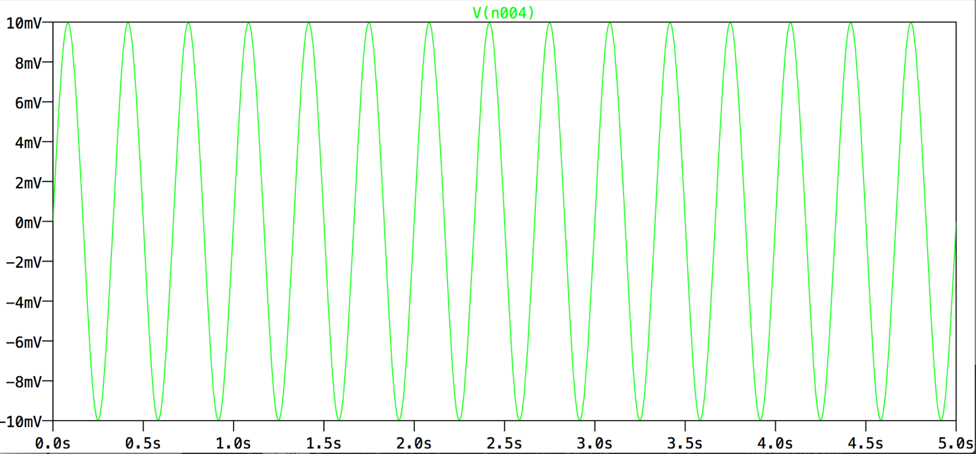

The output is:

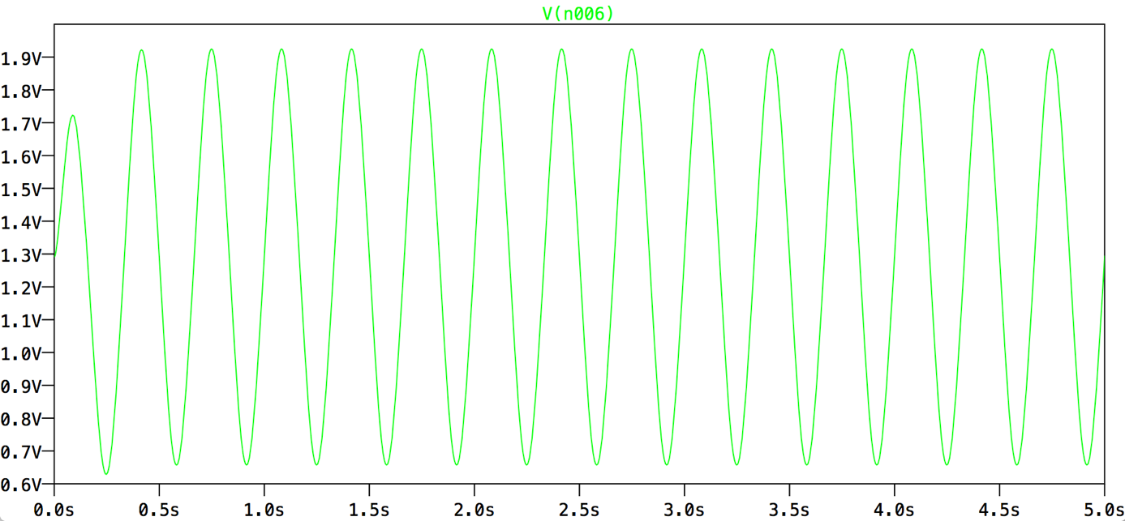

From the output plot, we are able to see the input sinusoidal signal has been amplified to roughly 1.4V peak-to-peak with 1.3V DC-offset.

PCB design:

Transmitter Schematics:

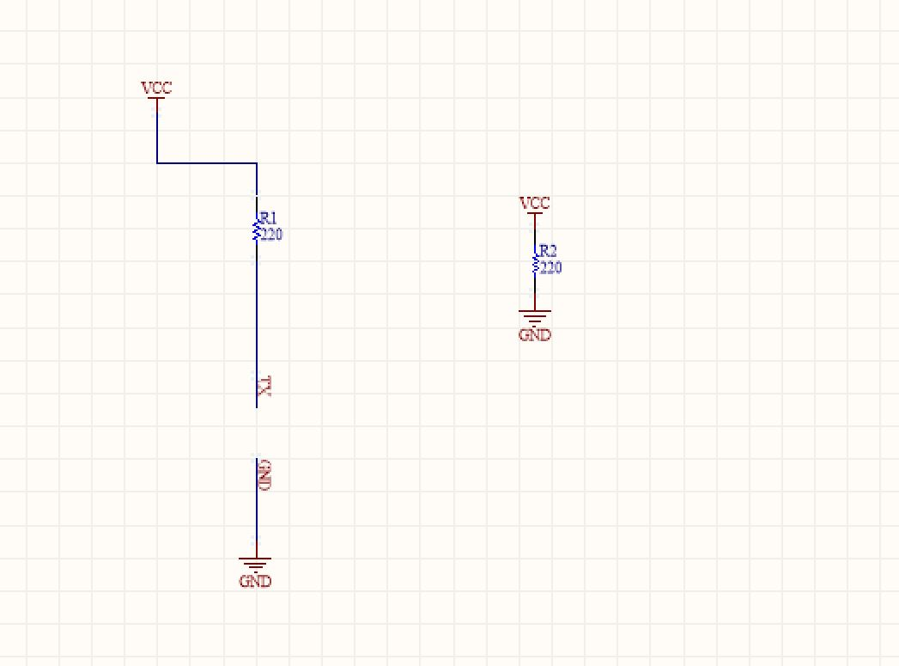

Transmitter PCB:

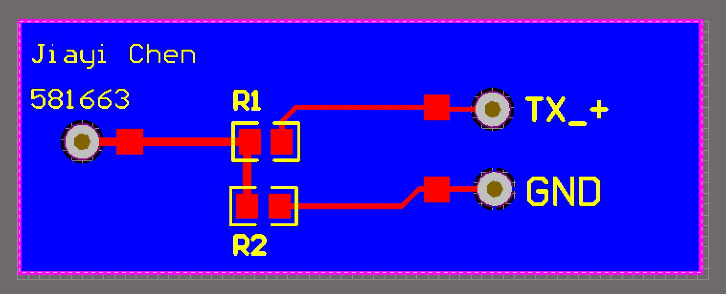

Receiver Schematics:

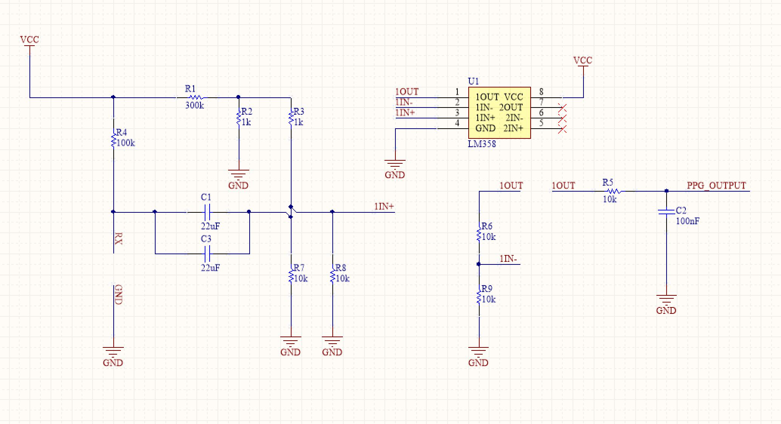

Receiver PCB:

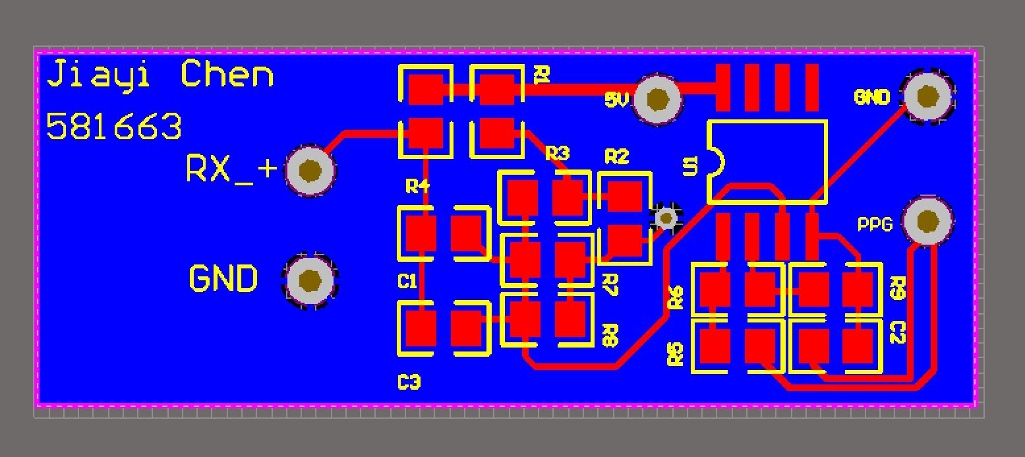

Results:

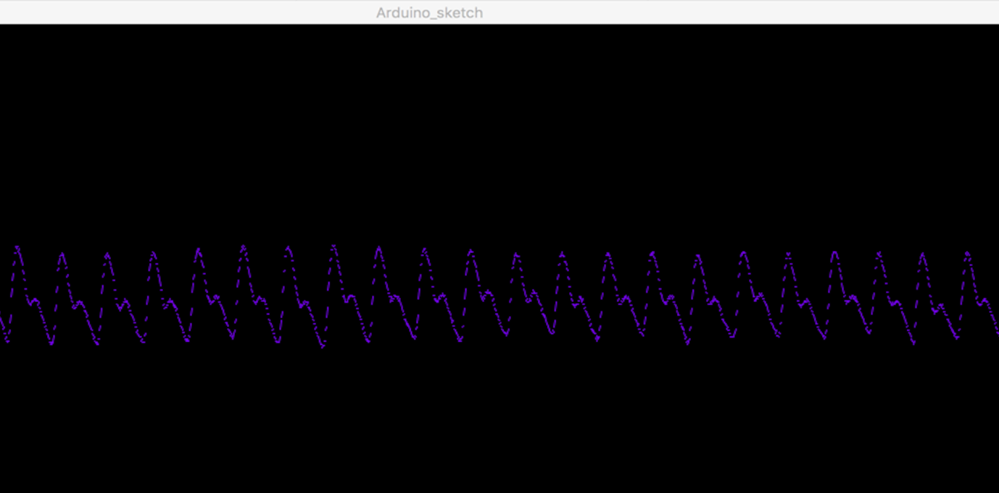

Software

Processing:

Heart rate measurement:

* Moving average

[1] <https://withings.zendesk.com/hc/en-us/articles/201494667-What-does-SpO2-mean-What-is-a-normal-SpO2-level->

[2] <http://www.ruralareavet.org/PDF/Anesthesia-Patient_Monitoring.pdf>

[3] <https://commons.wikimedia.org/wiki/File:Oxy_and_Deoxy_Hemoglobin_Near-Infrared_absorption_spectra.png> (picture)

[4]<https://www.researchgate.net/publication/220043789_A_Real_Time_Analysis_of_PPG_Signal_for_Measurement_of_SpO2_and_Pulse_Rate>

[5] <http://www.nxp.com/files/32bit/doc/app_note/AN4327.pdf?tid=AMdlDR>

[6] <http://embedded-lab.com/blog/easy-pulse-version-1-1-sensor-overview-part-1/> (picture)

[7] <https://en.wikipedia.org/wiki/Beer–Lambert_law>

[8] <http://www.mayoclinic.org/healthy-lifestyle/fitness/expert-answers/heart-rate/faq-20057979>

[9]