# Mustang Cobra R Registry

## Context:

There are 3 Ford Mustang models deemed as “Cobra R.” They were produced in 1993, 1995, and 2000. In 1993, there were 107 made. In 1995 there were 250 made. In 2000, there were 300 built. Each year had 1 color option: 1993: red, 1995: white, and 2000: red. These were all sold as specialty collector vehicles. Each year had many differences from their base model equivalents. This registry will use CRRUD principles to share vehicle information. Vehicle information will be pulled from several sources for test data.

## Design:

### Frontend:

Application will display in a web browser. Each page will use bootstrap and other things to create a visually appealing page. The users will be able to view their profile. The user will be able to create a new vehicle that is tied to their user account. The user will have the ability to add text, images, videos, and links to other sites pertaining the vehicle. The user will be able to create a profile that they can edit at any time. The user can also print the page using JavaScript. There will be multiple views for each CRRUD section.

### Backend:

The application will use a ASP.NET MVC. The information will be stored in a database. There will be a table for vehicle info, a table for users, and any additional tables required. The CRRUD application will talk to the database and make changes accordingly. The consume app will talk to the CRRUD app. The user will also be able to export and import vehicle entries as JSON. Vehicles and Users will be stored in a services folder. There will be three controllers, home, users, and vehicle.

### Comments:

Each file will have the appropriate comments pertaining to the code that is used and what each part does.

### Additional Updates:

The site will (hopefully) be configured for user accounts. The user will have the ability read a single vehicle based on ID or read all vehicles. There will be at least one administrator. Any changes that a user makes, i.e., creates a vehicle, updates information, or deletes a vehicle, will have to be approved by the administrator before it is posted to the site. Each vehicle will be tied to a user account that created the vehicle. A user can own multiple vehicles, but each vehicle can only have one owner.

## Database:

The initial table designs. If the user account system is implemented. The schema will be updated with additional user accounts.

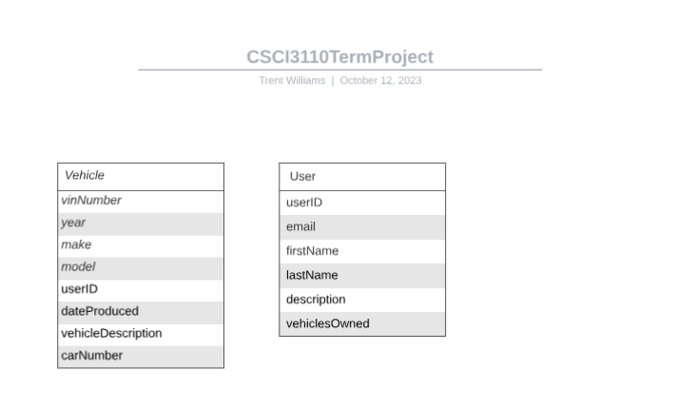

## Citiations:

* Vehicle Information:
  + <https://www.svtperformance.com/threads/cobra-r-registry-line-forms-in-here.7995/>
  + <https://www.1993cobra.com/>
  + <https://www.corral.net/threads/1994-1995-cobra-registry-thread.1073557/>
* Vehicle Pictures:
  + <https://www.steeda.com/classic-cobra-rs-find-new-owner>
  + https://www.steeda.com/everything-to-know-cobra-r