ORGANISATION SYSTEM

HAVOC SERVERS, DARK-RP MODULE – ID: HSORG

This is a systems analysis document detailing the requirements, functions, and aim of the *Organisation System* module for Dark-RP.

*‘Organisation System’* is abbreviated to *‘Org’* within this document to refer to an organisation in the system.

Authored by Strâaskesko Herzog,

Works by Havoc Servers and Syndex Digital Studios.

# SUMMATION

This module is intended to replace the contemporary organisation module known as *Organizations*. As it stands, the system is broken and is lacking many features. This work is based on it, aiming to improve and add to the concept of the original work in the form of a brand-new system.

The Org system will include the following features:

* **Organisation Info** – Name, Org type, Org colour, motto/slogan, ticker, hover-name, ranking, bulletin;
* **Membership** – Managing ranks, invitation system, privileges, member counts, payroll;
* **Banking** – Org bank accounts, money management;
* **Logging** – Transaction logging (banking, membership, management);
* **Alliances** – Ally with other organisations (menu, management, alliance capacities);

# UI DESIGN [1]

## BULLETIN

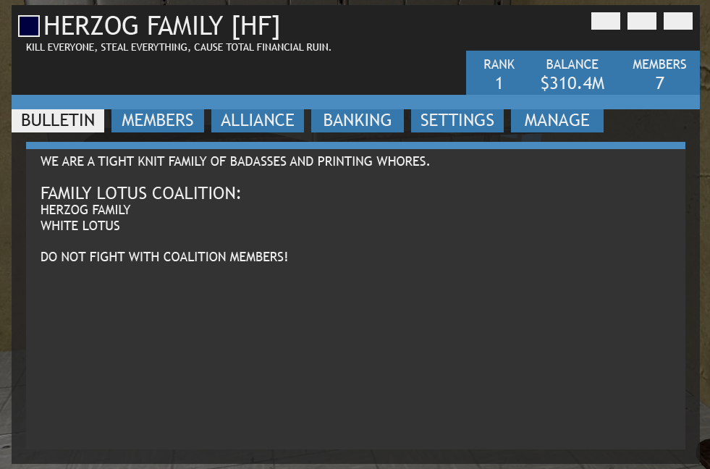

## MEMBER LIST

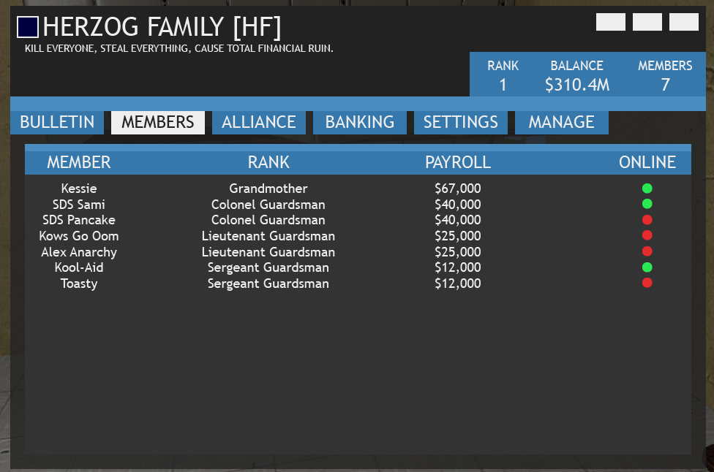

## ALLIANCE

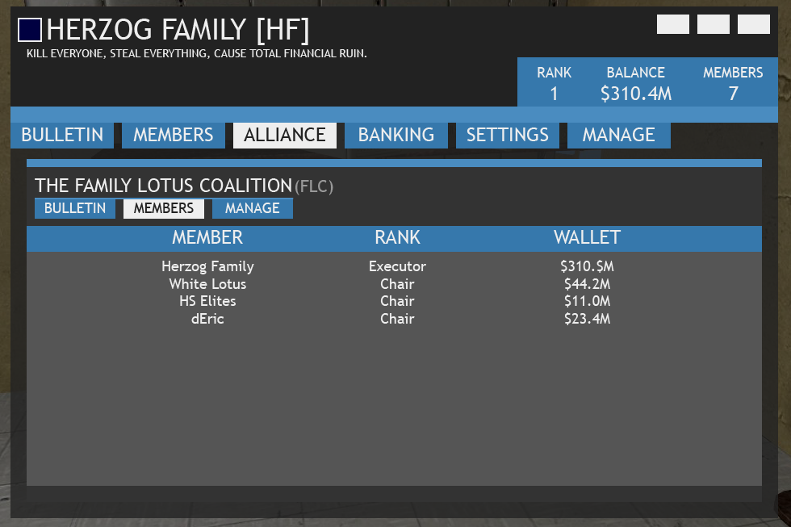

## BANKING

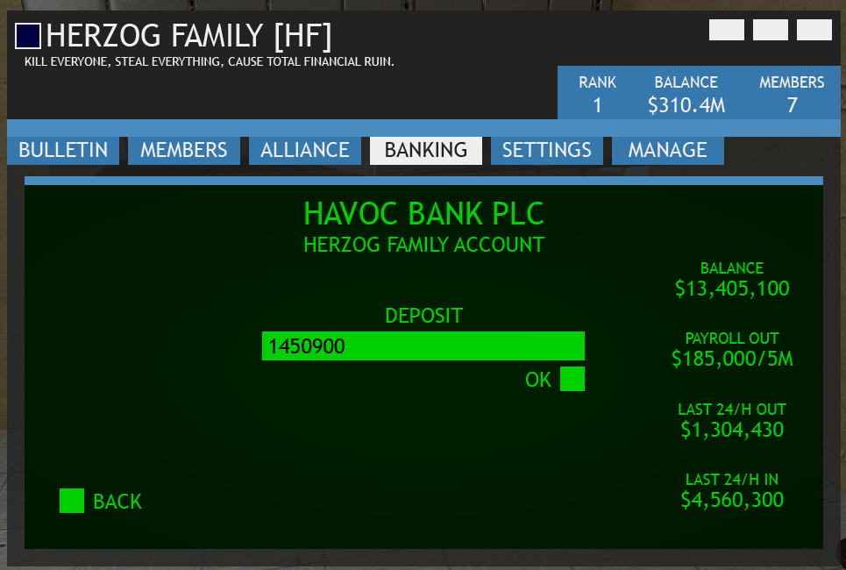

## SETTINGS

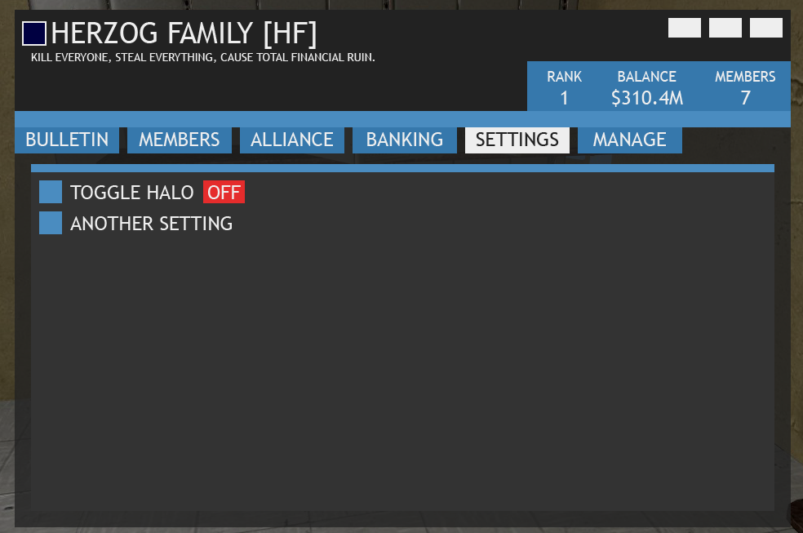

# REQUIREMENTS [2]

## ORGANISATION INFO [2.1]

**NAME [2.1.1]**

The name of the organisation, limited to 48 ASCII alphanumeric characters. It represents the Org by name.

**ORG TYPE [2.1.2]**

Official Org classification, that sets limits and the status of an Org. It will be present on leader boards and the Org Info menu itself.

This table shows four of the fields that compose the organisation types. The full file can be found in the archive (organisation_types.xlsx).

|  |  |  |  |
| --- | --- | --- | --- |
| TYPE | COST | REQ. MEMBERS | MEMBER CAP |
| Group | $0 | 0 | 10 |
| Organisation | $10,000 | 15 | 30 |
| Company | $50,000 | 30 | 50 |
| Intranational | $100,000 | 40 | 60 |
| Secret Society | $5,000,000 | 5 | 20 |
| Corporation | $6,000,000 | 50 | 100 |
| Megacorporation | $8,500,000 | 80 | 150 |
| Hypercorporation | $15,000,000 | 100 | 300 |

*See the “organisation_types.xlsx file for the full table.*

**ORG COLOUR [2.1.3]**

The Org may choose a colour, from an RGB picker, to represent them as an organisation. It may be changed at any time. This colour appears on the main Org menu (aside Org name), hover-name text, and player ticker.

**ORG MOTTO [2.1.4]**

A 64 character motto that briefly describes what the Org is about. It resides under the Org’s title on the Org menu.

**ORG TICKER AND HOVER-NAME [2.1.5]**

The Org ticker is the abbreviated version of the full Org name. It is a unique set of characters that accompanies player’s chat messages as a prefix.

Example: **[HF] Kessie Herzog** and **[SAS] Xeliom**.

The hover-name is the text that appears on a player when the cursor hovers over the player and is within range. It displays the org’s full name and colour.

**RANKING [2.1.6]**

Each Org will have a rank on the main leader board. This is sorted by the bank balance of that Org, in descending order of placement (richest at the leading place).

**BULLETIN [2.1.7]**

Like an MOTD, the bulletin is an editable (by those with sufficient privileges) page on the Org menu that contains whatever information the Org wants to post there. It is only visible to Org members.

## TRANSACTION LOGGING **[2.2]**

As defined below, certain transactions should be logged to database, and implemented for it, a section of the Org menu with which to display these logs. This section will be visible only to Org members holding a rank with privileges allowing them to see it (see privileges section).

The construct of the database table is as follows:

|  |  |  |  |  |  |  |
| --- | --- | --- | --- | --- | --- | --- |
| LogID | Org | ActionType | ActionBy | ActionValue | ActionAgainst | Timestamp |
| 1 | [org] | Membership | [player] | Join | The Organisation | [timestamp] |
| 2 | [org] | Membership | [player] | Leave | The Organisation | [timestamp] |
| 3 | [org] | Membership | [player] | Kick | [player] | [timestamp] |
| 4 | [org] | Rank | [player] | [rank name] | [player] | [timestamp] |

**Membership Transactions (Example Logs)**

Logging for joining, leaving, kicking, and ranking of members.

## MEMBER MODULE **[2.3]**

**RANK MANAGEMENT [2.2.1]**

Each Org has the ability to create ranks up to 32.