April 22nd, 2020

Federal Trade Commission

600 Pennsylvania Avenue NW

Washington, DC, 20580

(860) 992-2789

[william.j.violette@gmail.com](mailto:william.j.violette@gmail.com)

To Whom It May Concern,

Thank you for considering this paper. The analysis uses unique, proprietary data from a large, regulated piped water provider in Manila, Philippines. As a condition for using the data in research, I have signed a Non-Disclosure Agreement that avoids disclosing the name of the company. While I will not be able to make the microdata public, I am happy to provide a simulated or synthetic version of the dataset for replication. Please let me know if you have any questions.

Sincerely,

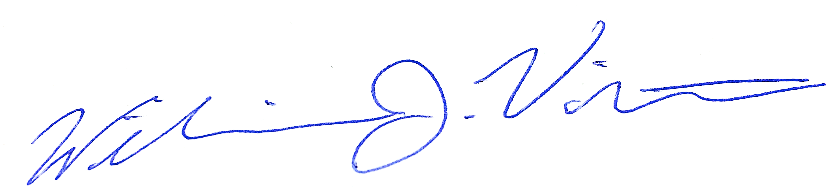

William J. Violette