April 21st, 2020

Federal Trade Commission

600 Pennsylvania Avenue NW

Washington, DC, 20580

(860) 992-2789

[william.j.violette@gmail.com](mailto:william.j.violette@gmail.com)

To Whom It May Concern,

Thank you for considering this paper. The analysis uses unique, proprietary data from a large piped water provider in Manila, Philippines. I have signed a Non-Disclosure Agreement in order to use this data for research; however, I am working to negotiate with the company about which subsets of the data I will be able to release publicly to replicate the analysis. Since the analysis does not rely on any identifiable information, I am optimistic that the data will be available for public release. Please let me know if you have any questions.

Sincerely,

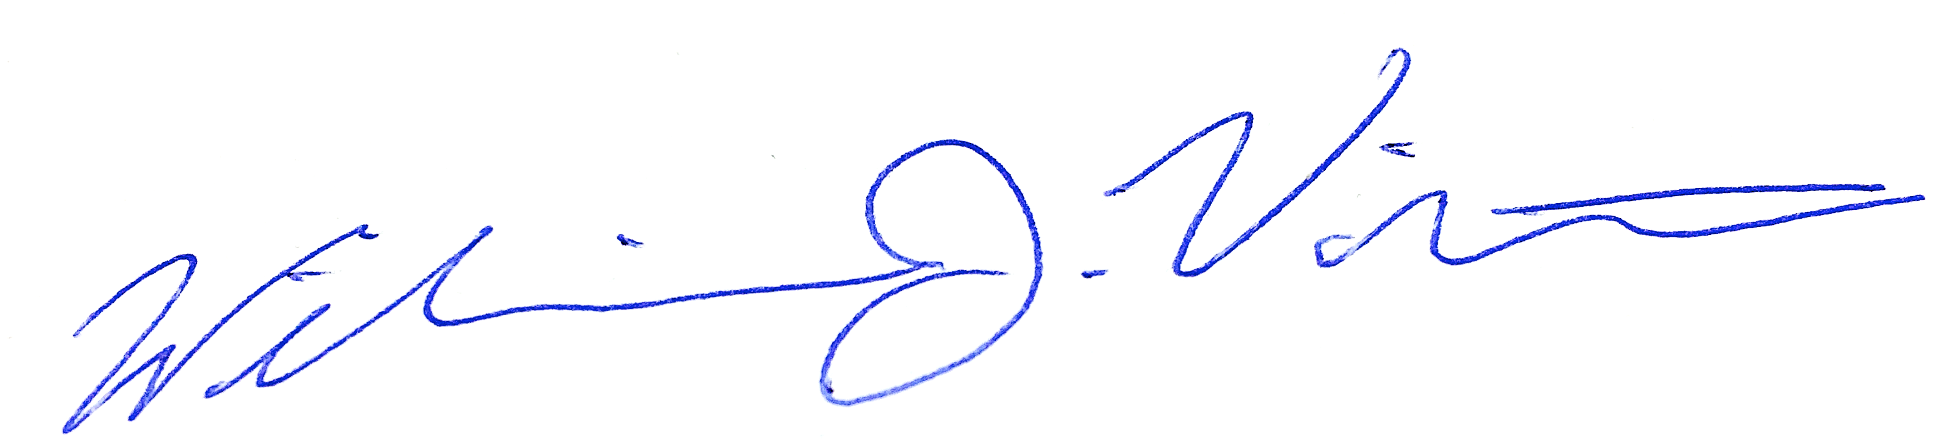

William J. Violette