**ECE 20100 – Spring 2016**

**Exam #2**

**March 10, 2016**

**Section (circle below)**

1. 8

2. 4

3. 5

4. 2

5. 1

6. 3

7. 5

8. 1

9. 7

10. 1

 ⧫ = L/R  = RC

**Question 1**

Find the Thevenin equivalent of the two-terminal network shown below (please note that voc is the Thevenin voltage).

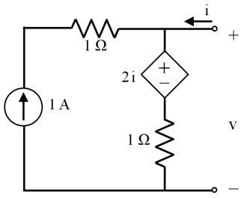

1. Rth = 1 Ω; Voc = 0.5 V
2. Rth = 1 Ω; Voc = 1 V
3. Rth = 1 Ω; Voc = 2 V
4. Rth = 2 Ω; Voc = 0.5 V
5. Rth = 2 Ω; Voc = 1 V
6. Rth = 2 Ω; Voc = 2 V
7. Rth = 3 Ω; Voc = 0.5 V
8. Rth = 3 Ω; Voc = 1 V
9. Rth = 3 Ω; Voc = 2 V

**Question 2**

For the circuit below, the current-voltage (i-v) relationship is known to be:

v = 0.5 + i

Find the resistances *R1* and *R2*.

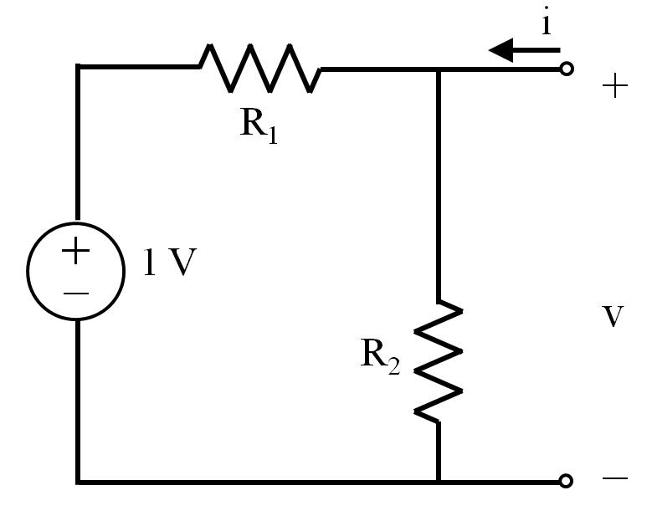

1. R1 = 1 Ω; R2 = 1 Ω
2. R1 = 1 Ω; R2 = 2 Ω
3. R1 = 2 Ω; R2 = 1 Ω
4. R1 = 2 Ω; R2 = 2 Ω
5. R1 = 2 Ω; R2 = 4 Ω
6. R1 = 4 Ω; R2 = 2 Ω
7. R1 = 3 Ω; R2 = 3 Ω

**Question 3**

In the circuit shown below, find the value of resistor (R) such that the power transferred to R is maximized. [Hint: Find the Thevenin equivalent circuit as seen by R first.]



(1) R = 5 Ω

(2) R = 10 Ω

(3) R = 15 Ω

(4) R = 20 Ω

(5) R = 25 Ω

(6) R = 30 Ω

(7) R = 35 Ω

(8) R = 40 Ω

**Question 4**

The current in the inductor shown below is found to be iL(t) = $\sqrt{10}$ sin(πt) A. Find the instantaneous energy stored in the inductor at time t = 0.5 s.

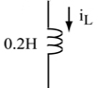

(1) $0.1\sqrt{10}$ J

(2) 1 J

(3) $0.5$ J

(4) 10 J

(5) $sin\left(t\right)$ J

(6) $\sin^{2}(t)$ J

(7) $0$ J

(8) none of above

**Question 5**

In the circuit below, the voltage across the capacitor at *t* = 0 s is *vC(0+)* = 0 V. Calculate the voltage across the capacitor (*VC*) at times *t* = 1 sec and *t* = 2 sec. Note: a current source of 1 A is used in the circuit.



(1) *VC* (1) = 10 V, *VC* (2) = 20 V

(2) *VC* (1) = 0 V, *VC* (2) = 10 V

(3) *VC* (1) = 0.82 V, *VC* (2) = 0.67 V

(4) *VC* (1) = 8.2 V, *VC* (2) = 6.7 V

(5) *VC* (1) = 10 V, *VC* (2) = 73.8 V

(6) *VC* (1) = 1 V, *VC* (2) = 7.38 V

(7) *VC* (1) = -10 V, *VC* (2) = 10 V

(8) None of the above

**Question 6**

For the circuit shown below, *C1*= 8mF, *C2*= 6mF, and *C3*= 12mF. Find the equivalent capacitance as seen by the current source.

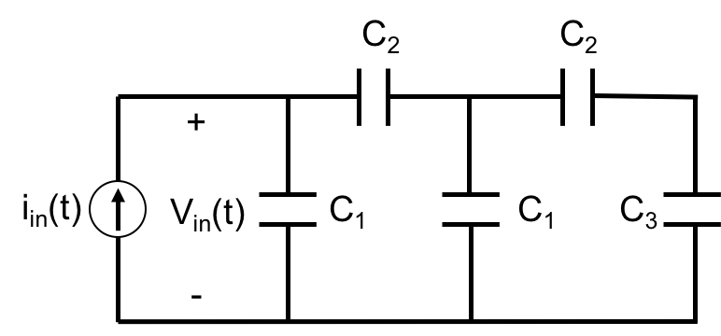

1. 8 mF
2. 6 mF
3. 12 mF
4. 24 mF
5. 4 mF
6. 3 mF
7. 28 mF
8. 32 mF
9. 20 mF

(10) None of the above

**Question 7**

In the circuit shown below, vc(0−) = 20V, and the switch opens at *t* = 4 s. Find vc(t)at *t* = 14 s.

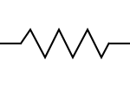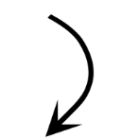

t=4sec

0.5mF

20k



5k



iR(t)

+

-

vc(t)

1. e−3
2. −e−3
3. 0.4
4. −0.4
5. 20e−3
6. −20e−3
7. 5e−3
8. −5e−3
9. 4e−2

(10) 4e−3

**Question 8**

The switch is opened at time *t* = 0 s after being closed (as shown) for a long time. Find the current *iC*at *t* > 0.

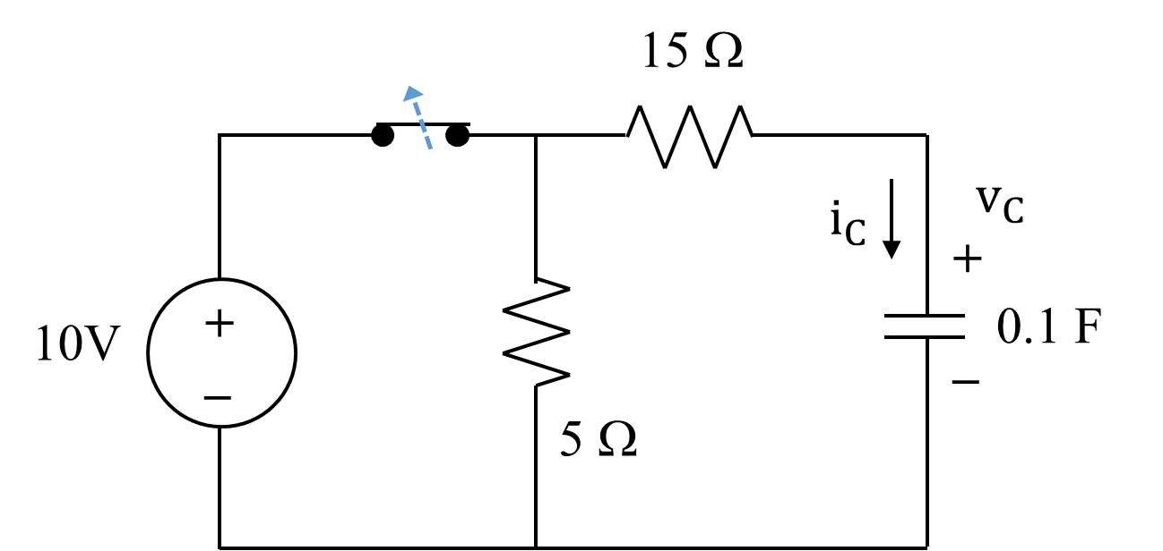

(1) $-0.5 e^{-t/2}$ A (2) $0.5 e^{-t/2}$ A (3) $-0.25 e^{-t/2}$ A (4) $10 e^{-t/2}$ A

(5) $-0.5 e^{-2t}$ A (6) $0.5 e^{-2t}$ A (7) $10 e^{-2t}$ A (8) none of above

**Question 9**

In the circuit below, *R1* = *R2* = 500Ω, and *C* = 2mF. The switch closes at time *t* = 1 s after being open for a long time. It is known that:

*vC*(1−) = 10 (1−e−1) V

Find *vC*(2), the voltage across the capacitor at time *t* = 2 s.

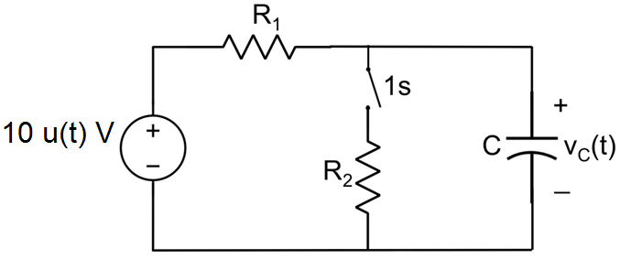

(1) 10 V (2) 5 V (3) 6.49 V (4) 6.18 V

(5) 6 V (6) 5.49 V (7) 5.18 V (8) none of the above

**Question 10**

The following graph presents an approximate saw-tooth voltage measured across a capacitor that has been generated by a 1st order RC circuit during successive charging and discharging cycles.

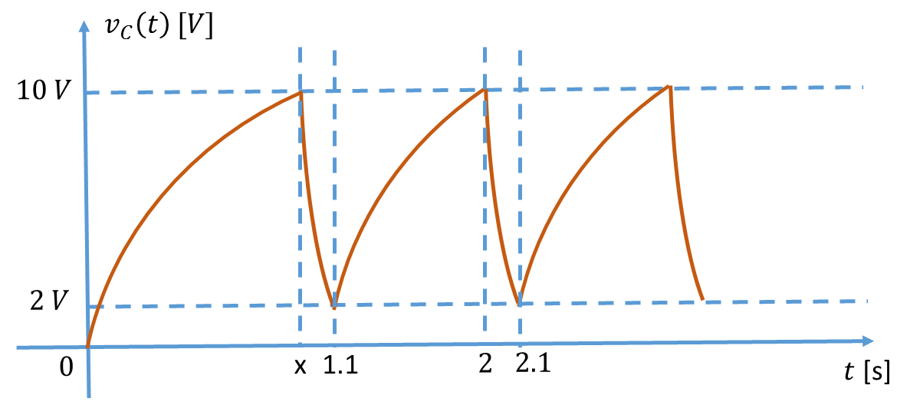

Which of the following statements must be incorrect?

(1) The time constants of the charging and discharging cycles are the same.

(2) Both the charging and discharging cycles consume energy.

(3) The current through the capacitor may not be continuous.

(4) The energy stored in the capacitor at the end of the charging cycle is higher than the  
 energy stored in the capacitor at the end of the discharging cycle.

(5) $v_{c}\left(0^{-}\right)=0$ V.

(6) The current through the capacitor can be found by $i_{C}\left(t\right)=C\frac{dv_{C}(t)}{dt}$ for $1.1<t<2$.