**ECE 20100 – Fall 2015**

**Exam #3**

**December 2, 2015**

**Section (circle below)**

Cui (3:30) – 0002 Chen (11:30) – 0004 Tan (1:30) – 0005

Zhu (2:30) – 0011 Peleato-Inarrea (10:30) – 0012

Name ____________________________ PUID____________

***Instructions***

1. DO NOT START UNTIL TOLD TO DO SO.
2. Write your name, section, professor, and student ID# on your **Scantron** sheet. We may check PUIDs.
3. This is a CLOSED BOOKS and CLOSED NOTES exam.
4. The use of a TI-30X IIS calculator is allowed, but not necessary.
5. If extra paper is needed, use the back of test pages.
6. Cheating will not be tolerated. Cheating in this exam will result in, at the minimum, an F grade for the course. In particular, **continuing to write after the exam time is up is regarded as cheating**.
7. If you cannot solve a question, be sure to look at the other ones, and come back to it if time permits.
8. ***All of the problems*** on Exam #3 provide evidence for satisfaction of this ECE 20100 Learning Objective:

iii) An ability to analyze 2nd order linear circuits with sources and/or passive elements.

The minimum score needed to satisfy this objective will be posted on Blackboard after the exam has been graded. Remediation options will be posted in Blackboard if you fail to satisfy any of the course outcomes.

**Question 1**

For t < 0, the switches S1 and S2 are connected to position A and C, respectively (as shown). At t = 0, both switches were connected to position B. Find the value of the current iL at t = 1.25π sec.

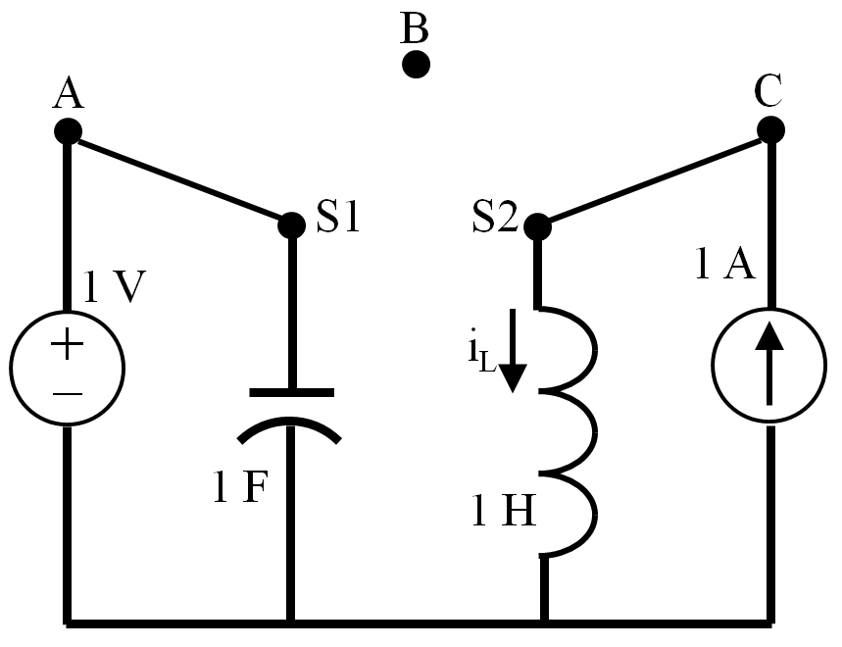

1. 0 A
2. A
3. − A
4. 1 A
5. −1 A
6. 2 A
7. −2 A

**Question 2**

For the circuit below, the response for the capacitor voltage, vc(t), is desired. If the general solution is of the form, , select the final value, , in V (hint: xn(t) is the solution for the “undriven” RLC circuit).

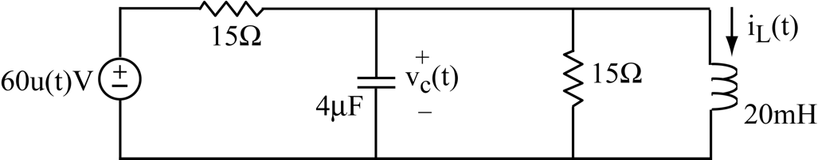

(1) 0 V

(2) 2 V

(3) 30 V

(4) 4 V

(5) 5 V

(6) 6 V

(7) 60 V

(8) 8 V

**Question 3**

For what values of R would the circuit below be underdamped?

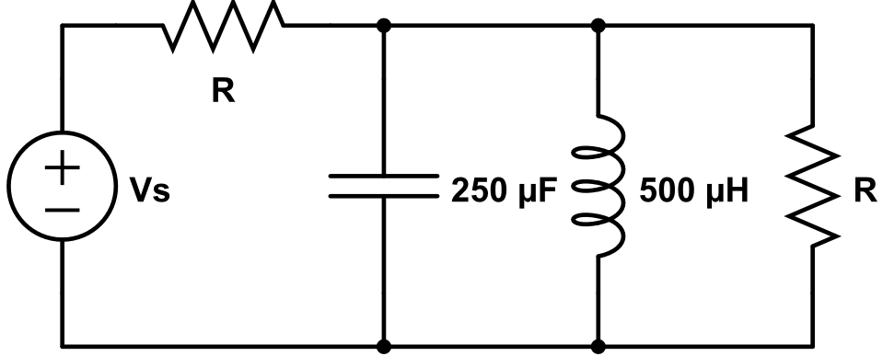

(1) Only for R = Ω

(2) Only for R = Ω

(3) Only for R = VS/2 Ω

(4) For any R < Ω

(5) For any R > Ω

(6) For any R < Ω

(7) For any R > Ω

(8) For any R < VS/2 Ω

(9) For any R > VS/2 Ω

(10) None of the above

**Question 4**

The switch in the RLC circuit has been closed for a long time. It opens at t = 0. The capacitor voltage for t > 0 is of the form:



(1) vC(t) = 16 + K1e2t +K2e3t V

(2) vC(t) = 6 + K1e2t +K2e3t V

(3) vC(t) = 16 + (K1 +K2t)e3t V

(4) vC(t) = 6 + (K1 +K2t)e3t V

(5) vC(t) = 16 + e3t [A cos (11.87t) +B sin (11.87t)]V

(6) vC(t) = 6 + e3t [A cos (11.87t) +B sin (11.87t)]V

(7) vC(t) = 16 + K1e4t +K2e5t V

(8) vC(t) = 6 + K1e4t +K2e5t V

(9) vC(t) = 16 + (K1 +K2t)e4t V

(10) vC(t) = 6 + (K1 +K2t)e3t V

**Question 5**

The switch in the circuit below has been *closed* for a long time. It *opens* at *t* = 0 s. Then  at t = 0+ is:

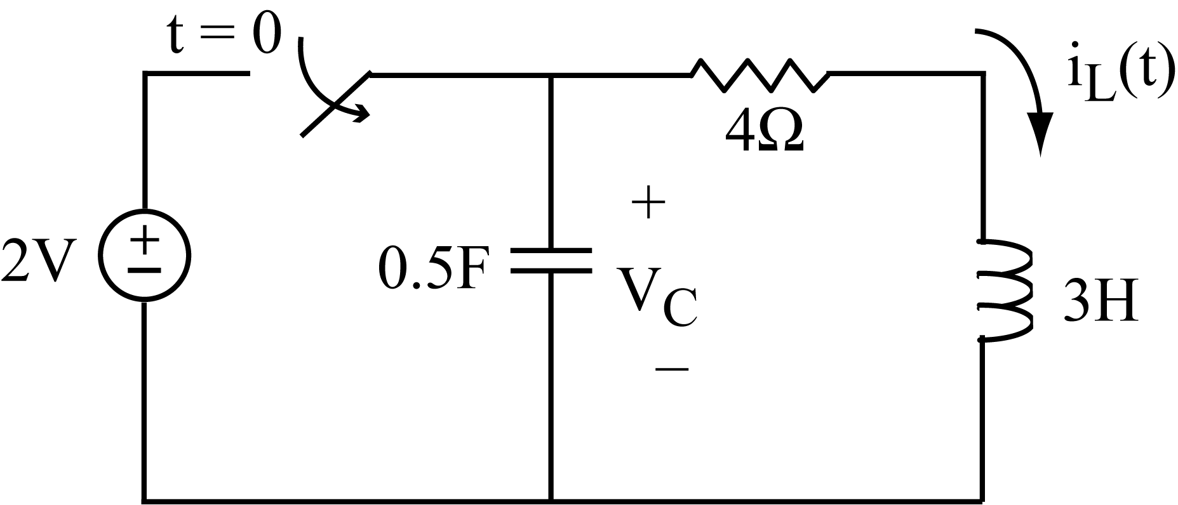

(1) −4 V/s

(2)  −3 V/s

(3) −2 V/s

(4)  −1 V/s

(5) 0 V/s

(6) 1 V/s

(7) 2 V/s

(8) 3 V/s

(9) 4 V/s

**Question 6**

Choose an appropriate value for the resistance R to make Vout = 0 V (assuming that the operational amplifier is ideal).

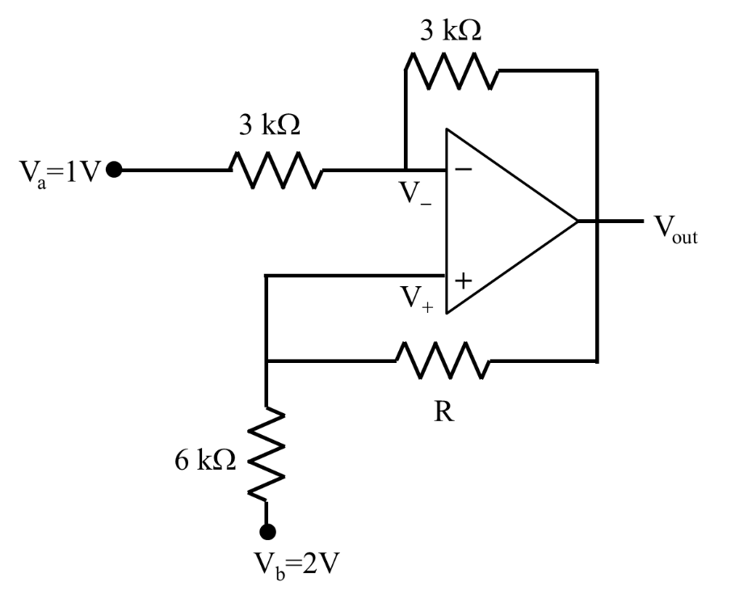

(1) R = 0 kΩ (short)

(2) R = 1 kΩ

(3) R = 2 kΩ

(4) R = 3 kΩ

(5) R = 4 kΩ

(6) R = 6 kΩ

(7) R = 12 kΩ

(8) R = ∞ (open)

(9) No possible R for this to happen

(10) None of the above statement is correct

**Question 7**

Which of the following describes the Thevenin equivalent of the network between ports A & B (assuming that the operational amplifier is ideal)?

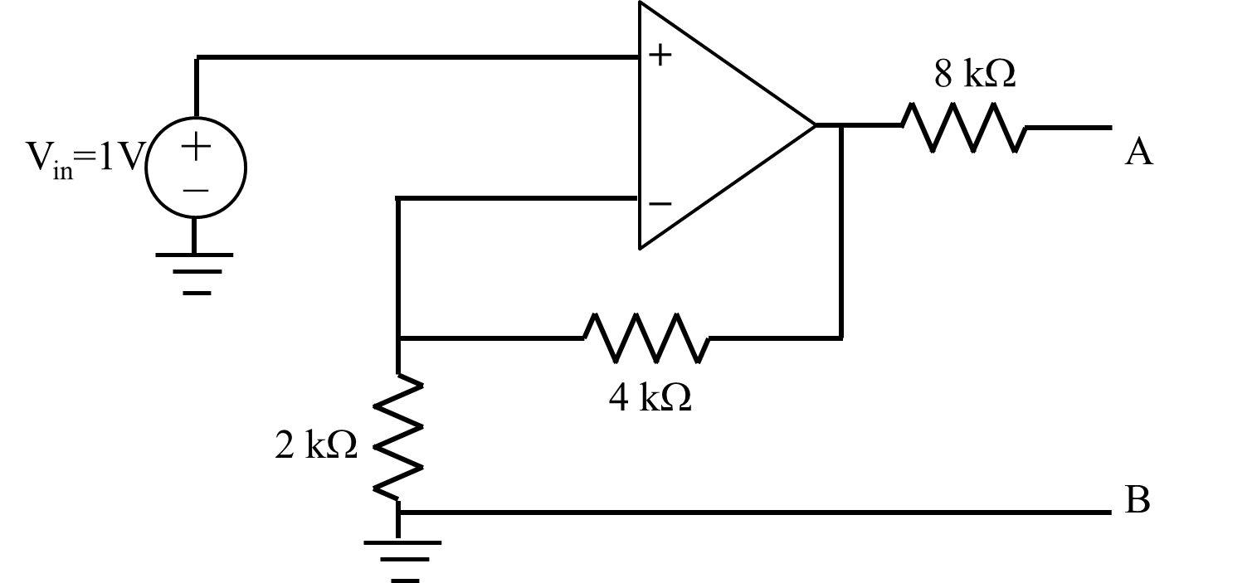

(1) VOC = 1 V, RTH = 8 kΩ

(2) VOC = 2 V, RTH = 8 kΩ

(3) VOC = 3 V, RTH = 8 kΩ

(4) VOC = 4 V, RTH = 8 kΩ

(5) VOC = 1 V, RTH = 14 kΩ

(6) VOC = 1 V, RTH = 12 kΩ

(7) VOC = 1 V, RTH = 10 kΩ

(8) VOC = 1 V, RTH = 4 kΩ

(9) VOC = 1 V, RTH = 1 kΩ

(10) VOC = 1 V, RTH = −4 kΩ

**Question 8**

In the circuit shown below, R1 = 1 kΩ, R2 = 2 kΩ, C = 1 mF, vC(0−) = 0 V, and K = 10 V. Determine the time constant τ in the output voltage:

vout(t) = 10 + 20 e−t/τ  V for t > 0.

**lecture 29 example 6.tif**

(1) 1 s

(2) 2 s

(3) 3 s

(4) 4 s

(5) 5 s

(6) 6 s

(7) 7 s

(8) 8 s

(9) 9 s

(10) 10 s

**Question 9**

The circuit below has an independent voltage source v1(t) = 20cos(ωt+30°). In steady state, the phasor voltage across the capacitor is **V**C = 10∠−60° at ω = 200 rad/sec. Find the value of the capacitance C.



(1) 102 mF

(2) 10 mF

(3) 1 mF

(4) 102 μF

(5) 10 μF

(6) 1 μF

(7) 0.1 μF

(8) 0.01 μF

(9) 0.001 μF

(10) none of the above

**Question 10**

Find the equivalent impedance of the following circuit when  = 4000 rad/s.

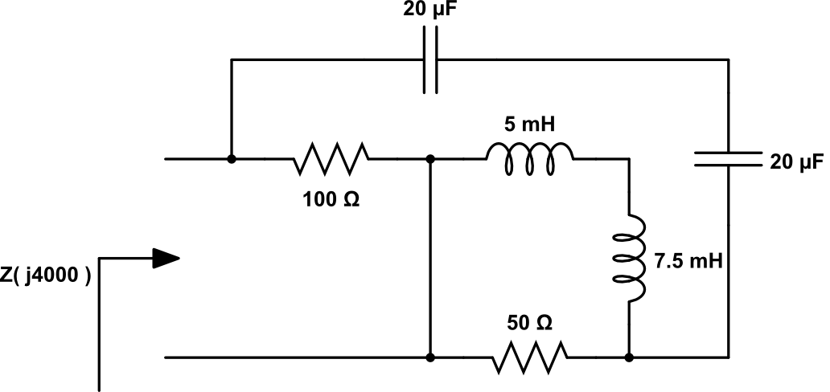

(1) Z(j4000) = 0 Ω

(2) Z(j4000) = 20 Ω

(3) Z(j4000) = 33.3 Ω

(4) Z(j4000) = 100 Ω

(5) Z(j4000) = j100 Ω

(6) Z(j4000) = − j 0.33 Ω

(7) Z(j4000) = 0.3 + j5.25 Ω

(8) Z(j4000) = 3 + j5 Ω

(9) Z(j4000) = 100 – j20 Ω

(10) Z(j4000) = 50 – j10 Ω

**Question 11**

The relationship between phasors **V** and **I** is:

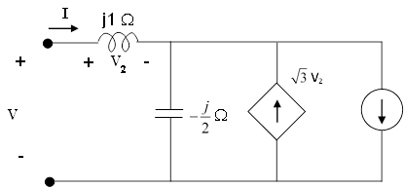

(1) 

(2) 

(3) 

(4) 

(5) 

(6)

(7) 

(8) 

(9) 

(10) 

**Question 12**

Which of the following is the closest match to the magnitude of the frequency response, , of the circuit below:

**Vin**

**Vout**



1 H



1 

0.1 mF



**Potentially Useful Formulas**

First order circuit: ,  = L/R or  = RC

Series RLC: 

Parallel RLC: 







, where 









**ECE 20100 – Fall 2015**

**Exam #3**

**December 2, 2015**

**Question 1** (3)

**Question 2**  (1)

**Question 3**  (7)

**Question 4**  (1)

**Question 5** (4)

**Question 6** (3)

**Question 7**  (3)

**Question 8**  (1)

**Question 9**  (6)

**Question 10** (2)

**Question 11** (2)

**Question 12** (8)