Title: Noninvasive audiovisual neurostimulation differentially alters glial responses at 20Hz and 40Hz

Authors – Not in pub order yet
Veronica, Megha, Emma, Alia, Alayna, Joseph, Zachery, Sara, Tina, Matthew, Annabelle, Levi, Ashley

Affiliations
Durham Department of Veterans Affairs Medical Center
Georgia Institute of Technology Department of Biomedical Engineering (BME)
Georgia Institute of Technology, Institute of Bioengineering and Biosciences (IBB) (MSS)

Abstract
Astrocyte and microglia act as key regulators of neuroimmune signaling in Alzheimer’s disease, coordinating inflammatory signaling, synaptic remodeling, and circuit stability. In disease states, these glial responses can diverge, contributing to either resilience or progression. In wild-type mice, we previously found that noninvasive audiovisual neurostimulation (flicker) has different neuroimmune effects depending on the frequency of light and sound stimulation, with acute 20Hz and 40Hz flicker causing distinct effects on microglia and cytokines, the primary immune cells and signals of the brain. Such flexible control of neuroimmune responses could be useful in a variety of disease contexts, including Alzheimer’s disease. However, few studies have examined the different effects of chronic 20Hz and 40Hz flicker on astrocytes and the effects of 20Hz flicker in the context of Alzheimer’s disease. Accordingly, we tested the hypothesis that 20Hz and 40Hz flicker induce distinct effects on microglia, astrocytes, and cytokines that regulate immune cells in WT mice and a mouse model of amyloidosis. In 6-month-old female and male mice, we assessed microglia and astrocyte morphology via 3D cell reconstruction and cytokines via multiplexed immune assay in the hippocampus following exposure to chronic (1 hour/day for 7 days) audiovisual flicker across frequencies (No Flicker, 20Hz, 40Hz), sexes, and the presence or absence of amyloid pathology (wild-type, 5xFAD). In wild-type mice, we found pronounced differences between stimulation frequencies in astrocytes with 40Hz eliciting smaller cells with increased tiling and density compared to 20Hz and No Flicker. Among analytes within the assay's linear range, cytokine expression in wild-type mice differed little between stimulation frequencies, with only IFN-γ higher after flicker than after No Flicker. In 5xFAD mice, we found sex- and frequency-specific differences in glia morphology, with 40Hz in females and 20Hz in males eliciting larger cells with more ramified phenotypes. Cytokine expression in 5xFAD mice was likewise not significantly different between frequencies, but instead tracked glial morphology, with microglial density and tiling correlating strongly with MIG, IL-10 and RANTES, suggesting that pathology and glial state rather than flicker frequency dominate the hippocampal cytokine profile. These results show that flicker frequency is a key variable to control neuroimmune responses in both healthy and pathological contexts. These findings inform the future optimization of flicker interventions for neurodegenerative disease.

Annabelle’s Highlights (not necessarily in order of importance)
- 40Hz flicker results in smaller and more densely packed astrocytes in 5XFAD and WT mice
- In WT mice, cytokine expression was largely unchanged by flicker frequency once analytes outside the assay's linear range were excluded; IFN-γ was the exception
- 40Hz flicker altered microglia surveillance in 5XFAD mice, with sex-specific effects
- IFN-γ was higher in WT mice after both 20Hz and 40Hz flicker than after No Flicker
- 20Hz flicker increased microglia surveillance of the microenvironment in 5XFAD mice

Other points that are not highlight-type points (which are short and factual) but may go in summary
- Microglia morphology changed little across flicker conditions in WT mice, and so did cytokine expression; the cytokines that do vary track glial density and tiling rather than stimulation frequency
- In 5XFAD mice, cytokine expression explained most by Abeta pathology, rather than flicker condition
Overall:
- Do we think 20Hz is enhancing motility and surveillance and 40Hz shifting immune cells into action?
  - I know we don’t always see a clear 20hz shift but some of that could be a lack of sensitivity
- Otherwise, overall we also highlight that while these different frequences induce different immune functions, the effects are also context-dependent including pathological context and sex

Highlights/ Teaser
- Chronic 40Hz audiovisual neurostimulation modulates wild-type astrocytes and microglia across sexes
- Frequency-specific modulation of astrocytes increased density and tiling especially at 40Hz, regardless of amyloid pathology
- Cytokine expression correlated with astrocyte and microglia morphology, most strongly in 5xFAD animals, and did so irrespective of flicker frequency
  - Frequency specific modulation of astrocytes and microglia revealed sexually dimorphic responses, regardless in context of amyloid pathology
    - 20Hz – surveillance in males, 40Hz in females

Introduction
Neuroimmune signaling plays a central role in Alzheimer’s disease progression through coordinated interactions between astrocytes, microglia and cytokine networks that shape synaptic stability, circuit function, and behavior in a sex- and context-dependent manner. Noninvasive audiovisual neurostimulation, or ‘flicker,’ involves exposure to lights and/or sounds that turn on and off with millisecond precision, and has been shown to modulate neuroimmune and neural activity [1–4]. Previous studies have demonstrated that visual 40Hz flicker in amyloidosis model (5xFAD) male mice reduced amyloid-β (aβ) levels and altered microglia phenotype [2] towards engulfment phenotypes and increased density associated with improved amyloid-β (aβ) levels [5]. More recent studies suggest that flicker at 40Hz can also engage astrocytes, including increases in aquaporin-4 polarization which coincides with improvement of amyloid pathology in 5XFAD mice [6]. While many studies have reported the effects of 40Hz flicker, most studies have focused on a single stimulation frequency, limiting our understanding of how different frequencies of flicker can be used to tune neuroimmune responses in AD and other neurodegenerative disease. We previously assessed flicker’s effects across multiple frequencies [3, 7, 8] We found that acute 20Hz and 40Hz flicker elicit distinct microglia morphologies and cytokine profiles in wild-type male mice within visual cortex. Specifically, 40Hz flicker shifted microglia into an engulfing phenotype, 20Hz flicker induced ramified phenotypes with each frequency inducing different immune signaling patterns [8]. These frequency-specific shifts may be particularly important in contexts where highly sensitive yet selective responses to debris are required to improve brain health, and where generalized uncoordinated microglial reactivity could risk exacerbating pathology by enhancing inflammation. However, it remains unclear whether these frequency-specific effects extend to astrocytes, persist under chronic (> 1 day) stimulation, or generalize beyond visual cortex and into disease relevant contexts such as amyloidosis. Because astrocytes and microglia exhibit different changes across disease progression and individuals, a single stimulation approach may not be universally effective; instead, a flexible suite of stimulation frequencies is needed to differentially modulate neuroimmune activity according to context. Accordingly, we determined how different frequencies of flicker (No Flicker, 20Hz, or 40Hz) altered astrocytes and microglia, and determined whether such modulation coincides with changes in cytokines or improvements in pathology.

Here, we analyzed astrocytes and microglia morphological and cytokine changes in hippocampus of 5xFAD and wildtype (WT) 6-month old male and female mice after exposure to different frequencies of flicker (No Flicker, 20Hz, 40Hz for 1hr/day for 7 days). The 5xFAD mouse model, which exhibits highly aggressive amyloidosis, was used alongside littermate controls to assess flicker in a disease context. After flicker, we analyzed microglia, astrocytes, amyloid plaques, and cytokines. We found both astrocytes and microglia responded differently to 20Hz and 40Hz flicker, and some of these effects differed across genotype and sex. In wild-type mice, 40Hz flicker induced a greater number of smaller, amoeboid shaped, densely tiled astrocytes and microglia, while 20Hz flicker resulted in more sparsely distributed cells consistent with surveillance phenotypes. To elucidate potential immune-signaling mechanisms underlying morphology shifts and density in WT mice, 20Hz flicker induced distinct chemokine expression compared to 40Hz, which elicited cytokines including growth factors. In 5xFAD mice, the effect on astrocytes morphology was evident, but separating the data by sex revealed potential sex-specific effects in the context of amyloidosis. Further, cytokine changes were most explained by amyloidβ pathology, rather than flicker condition. This study incorporates 20Hz, an understudied flicker frequency, and often-overlooked genotype and sex-specific differences in the application of flicker, advancing our understanding of the context-dependent application of flicker to modulate AD-related immune responses.

Materials and Methods
Animals
6-month-old 5xFAD and WT mice (N = 8/group per genotype per flicker frequency) were housed individually on a 12-hour light/12-hour dark cycle. Both male and female mice were used for the current study. Both male and female 5xFAD mice are known to overexpress human amyloid precursor protein (APP) and amyloid-β, with females having been shown to have higher levels of both than males (Sil et al., 2022). The mouse strain used for this research project was obtained from the Mutant Mouse Resource and Research Center (MMRRC) at The Jackson Laboratory. The mouse strain used for this research project, B6SJL-Tg(APPSwFlLon,PSEN1*M146L*L286V) 6799Vas/Mmjax, RRID:MMRRC_034840-JAX, was obtained from the Mutant Mouse Resource and Research Center (MMRRC) at The Jackson Laboratory, an NIH-funded strain repository, and was donated to the MMRRC by Robert Vassar, Ph.D., Northwestern University. Mice were bred in-house via pairs by crossing hemizygous female 5xFAD mice (Jackson Laboratory, 006554) with male C57BL/6J mice (Jackson Laboratory, 000664) to create 5xFAD+ or wild-type littermates. 5xFAD and wild-type littermates were randomized to each flicker group with litters split across conditions as much as possible. Mice were housed individually for 7 days prior to the first day of flicker exposure. Experimenters were blind to animal genotypes during flicker exposure and to flicker condition during analyses.

Flicker exposure
Visual stimulation was achieved using white light-emitting diodes (LEDs) emitting a range of visible wavelengths (390–700 nm) and having a correlated color temperature (CCT) of 4,000 K with intensities between 100 and 400 lux. The LEDs were programmed to be on for 50% of each duty cycle, creating a flashing light. Auditory stimulation was achieved using speakers (Pyramid TW28 3.75" 600W) that were placed out-of-reach from the mice, at 60 dB sound level. Mice were exposed to one of three experimental conditions for one hour: (1) 40Hz flicker, which was concurrent visual and auditory stimuli at 40Hz with 50% duty-cycle, (2) 20Hz flicker, which was concurrent visual and auditory stimuli at 20Hz with 50% duty-cycle, or (3) No Flicker, constant light and no sound, as a control group. For repeated exposure across one week, the time of day was kept consistent, and exposure was controlled through a MATLAB script and NIDAQ (). Animals were singly housed during all types of exposure as in prior studies [3, 4].

Perfusion, Tissue Processing, and Immunohistochemistry
Mice were transcardially perfused with phosphate buffered saline (PBS) under anesthesia (5% isoflurane), and brains were bisected into left and right hemispheres. The left hemisphere was post-fixed in 4% paraformaldehyde in PBS overnight. The right hemisphere was dissected into primary visual cortex, prefrontal cortex, and hippocampus. The left hemisphere was incubated for two days in 30% sucrose, then frozen at -80°C prior to cryosectioning (Leica) into 40 μm coronal slices. Sections were permeabilized and blocked in PBS with 0.3% Triton X-100 and 7.5% donkey serum at room temperature for 2 hours. Sections were then incubated overnight at 4°C in primary antibody solutions containing PBS with 0.1% Triton X-100 and 1% donkey serum in serial staining (one antibody per night). Primary antibodies were: anti-β-amyloid, anti-Iba1, anti-GFAP and DAPI (S. Table 1 for suppliers and concentrations). The following day, brain sections were incubated with fluorescently conjugated secondary antibodies (Iba1 1:1000, Alexa Fluor 488 1:5,000; Aβ 1:2,000, Alexa Fluor 555 1:5,000; GFAP 1:1,000, Alexa Fluor 647 1:5,000) for 2 hours at room temperature, and nuclei were stained with DAPI (1:500) for 2 min at room temperature (S. Table 1). Images were acquired on a Nikon A1R MP+ as 2x1 tiled z-stacks of 40 μm with a 0.5 μm step size. Three images were acquired from HPC CA1 dorsal to the pyramidal layer for each mouse.

Cytokine Panel
Cytokines were profiled utilizing the Milliplex® MAP Mouse Cytokine/Chemokine 32-Plex kit (Eotaxin, G-CSF, GM-CSF, IFN-γ, IL-1α, IL-1β, IL-2, IL-3, IL-4, IL-5, IL-6, IL-7, IL-9, IL-10, IL-12p40, IL-12p70, IL-13, IL-15, IL-17, IP-10, KC, LIF, LIX, MCP-1, M-CSF, MIG, MIP-1α, MIP-1β, MIP-2, RANTES, TNF-α, and VEGF) (Millipore Sigma #MCYTMAG-70K-PX32). Hippocampal mouse tissue from the right hemisphere was lysed using the Bio-Plex cell lysis kit (Bio-Rad Laboratories, #171304011), which was supplemented with protease and phosphatase inhibitors (cOmplete™, Roche; PhosSTOP, Roche). Prior to analysis, cell lysates were centrifuged at 4°C, 13,500 RPM for 10 minutes, and supernatants were collected for protein determination. Protein concentrations were obtained using a Pierce BCA Protein Assay (Thermo Fisher #23225). Following determination of protein concentration, a linear range was performed, and linearity was present at a concentration of 0.5 ug protein, diluted at the manufacturer’s specification, for the Cytokine analysis. Cell lysates were diluted in Milliplex® MAP Assay Buffer (EMD, Millipore, Billerica, MA). The kit was carried out under the specification of the manufacturer and plates were read on a Luminex® MAGPIX® system. Cytokine results were analyzed using R (version 4.1.3.) and heatmaps were generated using heatmap3, a package of R. Heatmap3 utilizes an hclust function to make the dendrogram, with clustering, based on Euclidean distance using the arithmetic mean (unweighted pair group method). Cytokine data was subtracted from background values, and any negative values were set to 0. Cytokine values are therefore reported as background-subtracted median fluorescence intensity; unlike the amyloid panel, the cytokine multiplex was not interpolated to a standard curve. Partial Least Squares Discriminate Analysis (PLSDA) was performed to separate patterns from the data, reducing its dimensionality (C. Nunes, MathWorks File Exchange).

Amyloid-beta 2-plex
A 2-plex MILLIPLEX® Human Amyloid Beta Magnetic Bead Panel (HNABTMAG-68K, MilliporeSigma) was used to quantify Aβ1-40 and Aβ1-42 isoforms in 5xFAD right hemisphere hippocampus tissue lysates. Hippocampal tissue was dissected and homogenized using the Bioplex cell lysis kit (Bio-Rad Laboratories, #171304011), which was supplemented with protease and phosphatase inhibitors (cOmplete™, Roche; PhosSTOP, Roche). Lysates were sonicated briefly, centrifuged at 13,500 RPM for 10 min at 4°C, and supernatants were collected for protein quantification via a Pierce BCA Protein assay (Thermo Fisher #23225). Following determination of protein concentration, a linear range was performed, and linearity was present at a concentration of 2 ug protein, which was then diluted in Milliplex® MAP Assay Buffer (EMD, Millipore, Billerica, MA) at the manufacturer’s specification. The samples were read on a Luminex® MAGPIX® system, and analyte concentrations were interpolated from a standard curve. This assay was validated by Wood et al. [32] to corroborate immunohistochemistry (IHC) and Western blotting screening of amyloid.

Image Analysis
Microglia Rendering
Microglial cells were reconstructed using the IMARIS 10.1.0 AI module (Oxford Instruments, Concord, MA). Separate AI models were trained for soma and filament reconstruction respectively using images across all experimental groups, with somas reconstructed as surfaces. In images showing clustered microglia whose filaments were not differentiable from one another, these filaments were excluded from filament reconstruction and measures. Whole cell microglia, including the soma and its processes, were reconstructed as surfaces using an IMARIS 10.1.0 AI module, and microglia signal under 40 µm² area were filtered out of the data analysis to account for small and extraneous processes that did not belong to whole cell microglia within the field of view. For the soma model, the surfaces detail parameter was set to 0.921 µm. For the filament model: average soma size was estimated as 8 µm; estimated process width was set to 0.2 µm; the diameter of the sphere regions was set to twice the estimated soma size (16 µm); the maximum gap length was set to 13 µm; and the seed point intensity threshold was set to 700 (Supplemental Figure 1).

Microglia spots were used to localize somas and quantify soma clustering via nearest neighbor. A Convex Hull volume analysis was done by creating a 3D outline of the cell processes, measuring the enclosed volume of the distal points on each microglia (Convex Hull XTension). Only cells with processes entirely within the image were included in the dataset for morphological analysis.

Amyloid-β Rendering
Amyloid beta plaques were reconstructed as surfaces using IMARIS 10.0.1 and only plaques with a minimum area of 10 µm² were included. Amyloid-beta plaque surfaces were used to quantify amyloidβ plaque volume and plaque count using the Volume and Number of Disconnected Components output files, respectively.

Astrocytes Image Analysis
Astrocytes were reconstructed using the IMARIS 10.1.0 AI module with surfaces generated based on GFAP’s immunofluorescence. Parameters were manually optimized and adjusted to account for variability in background noise and staining intensity by applying a gaussian filter, surface detail set to 2.5 µm, an average soma size of 8 µm, and thinnest process width to 0.2 µm. The reconstructed surfaces included both soma and major processes. No area or volume filters were applied, and all segmented surfaces were retained. Spots were created to localize astrocyte somas with DAPI to determine astrocyte count and distribution. Astrocyte interactions with amyloid-beta plaques were quantified through colocalization analysis of astrocyte soma surfaces and amyloid-beta plaques using the same formula as above from microglia. The astrocyte measurements included surface volume, cell count, distance to nearest neighbor, colocalization with amyloid β plaques, and number of cells associated with amyloid β plaques. Only cells with processes entirely within the image were included in the dataset for morphological analysis.

Microglia and Astrocyte Colocalization with Amyloid
Microglia, whole cell and soma, and amyloid surfaces that were previously constructed in IMARIS were utilized for colocalization. Background subtraction (threshold of 6.0µm) was applied, with thresholds set to minimize the selection of background signal and false glia processes. The resulting overlapped surfaces between amyloid-β volume and cell volume were exported, and colocalization was expressed as a ratio:

$$Colocalization ratio per cell=\frac{Overlap Volume \left(Amyloid Volume+Cell Volume\right)}{Cell Volume}$$

Statistical Analysis
All data was analyzed separately within genotype across the three flicker groups (No Flicker, 20Hz, 40Hz). Statistical analyses were performed using a custom script in Matlab 2025a (morphology) and in R (cytokine, amyloid, and correlation analyses). Data for each parameter was tested for normality using Anderson-Darling test to determine appropriate parametric or nonparametric tests. Normally distributed data was compared using a one-way, two-tailed, unpaired analyses of variance (ANOVAs) comparing the effects of flicker frequency within genotype separately in both males and females. These tests were followed by Tukey’s post hoc multiple comparisons tests between the three flicker frequency groups (No Flicker, 20Hz, 40Hz). On data that was not distributed normally, a Kruskal Wallis test was performed followed by a Dunn’s post hoc test, correcting for multiple comparisons. For morphology analyses, each subject had three technical replicates of neighboring sections from CA1. All morphology data were analyzed by cell and presented as violin plots except for number of cells, ratio of cells contacting plaques, and colocalization ratio, which were quantified per image. For the cytokine multiplex, analytes were restricted to those within the assay's linear range. Beginning from the 17 analytes previously determined to be linear on the loading-dilution series, we further excluded any analyte whose signal in these samples was indistinguishable from the assay floor, defined as taking 10 or fewer distinct values across the 43 animals, spanning 5 or fewer MFI units above background, or reading zero in at least 20% of animals. This removed MIP-1b, leaving 16 analytes for analysis. Among the excluded analytes were four myeloid-related cytokines (G-CSF, GM-CSF, M-CSF, LIF), each of which took only 5 to 9 distinct values across all 43 animals; because group tests and correlations on such variables are dominated by ties, these are reported separately as an exploratory supplement (Supplementary Figure 9) rather than in the primary analysis. An additive sex shift was removed within genotype for the pooled-sex heatmaps and PLS-DA, while the inferential tests were run on unadjusted values with sex modeled explicitly. PLS-DA (two latent variables, orthogonally rotated in the LV1-LV2 plane) was used for visualization and analyte weighting only; no statistical test was applied to the latent-variable scores, since these are linear combinations of the measured analytes. Loadings are reported as the mean and standard deviation across 1000 leave-one-out cross-validation iterations. Model validity was assessed by permutation as described previously [7, 8]: animals were randomly reassigned to flicker groups and the PLS-DA refit 1000 times, with p(permutation) defined as the proportion of permuted models whose leave-one-out classification accuracy matched or exceeded that of the true group assignment. Key cytokines were defined within each genotype as the three analytes with the largest absolute cross-validated loading on LV1 and the three with the largest on LV2, taken from that genotype's own model. Group comparisons were made on individual analytes within genotype using the Anderson-Darling gated ANOVA+Tukey or Kruskal-Wallis+Dunn's tests above, with a linear mixed model (Flicker + Sex + (1|litter)) as a sex-controlled alternative. Tukey's or Dunn's correction is the multiple-comparison adjustment for these tests; no further correction was applied across analytes. Cytokine correlations with amyloid and morphology used Spearman's rho (Pearson line for display), with the p-value rather than a rho cutoff driving inclusion. False discovery rate (Benjamini-Hochberg) was applied across the 16 retained analytes separately for each target, that is, for each amyloid species and each morphology measure, rather than across all 32 analytes of the kit or across the correlation matrix as a whole. FDR-adjusted values are reported as q.

Results
Astrocytes robust respond to chronic flicker in hippocampus of healthy wildtype mice
To determine how frequency-specific flicker modulates glial responses in the hippocampus, we first examined astrocyte morphology in wild-type mice following chronic flicker. Although astrocytes are increasingly recognized as key regulators of brain homeostasis and disease, their responses to flicker have been comparatively understudied relative to microglia [6, 33, 34]. To establish a baseline signature of chronic flicker in healthy mice, we first screened wild-type littermates following 7 days of flicker at 20Hz and 40Hz (1hr/day), frequencies known to induce bidirectional effects at acute timepoints. We found that hippocampal astrocytes robustly responded to 40 Hz flicker after seven days of consecutive stimulation (Figure 1). 40Hz exposure produced a marked reduction in astrocyte morphological complexity as indicated by the reduction in volume (H (2)= 256.6939, p = 1.8182e-56) , tighter spacing (H (2)= 102.8652, p = 4.6037e-23) , and increased density ((H (2)= 20.189, p = 4.1307e-05)) suggesting a shift toward a more reactive state (Figure 1c). These changes were not mirrored in microglia except for tiling (spacing between cells) (Figure 1f-h, (H (2)= 6.374, p = 0.041296), which showed minimal morphological modulation at either 20 Hz or 40 Hz within CA1. While both glial types responded to flicker by shifting tiling architecture at 40Hz, astrocytes not only shifted their clustering as reported by the tiling pattern but also an increase in astrocyte density (GFAP+ cells per mm²) at 40Hz (H (2)= 20.189, p = 4.1307e-05) (Figure 1c-d), a finding that was not observed in the microglia at any frequency. This likely reflect changes in astrocyte process labeling or territorial organization rather than cell migration. Given that sensitivity to stimuli and subsequent glial responses have been shown to differ in sexes, we next wanted to determine if this response to flicker differed in the sexes. Sex-specific stratification of the data revealed that the 40 Hz astrocyte response was consistent in both males and females (Supplemental Figure 2, a-c). Microglia, however, showed a sex-specific response to flicker with males showing significant separation in cell volume in response to 20Hz or 40Hz, whereas females demonstrated a modest but significant shift in microglia tiling in response to 40Hz stimulation (Supplemental Figure 2, (H (2) = 9.0778, p = 0.010685)). Overall, responses in astrocytes were robust across sexes at 40Hz stimulation compared to 20Hz and No Flicker conditions. These findings establish that in a healthy hippocampus, 40 Hz flicker reduces astrocyte volume and intercellular spacing while increasing astrocyte density relative to both 20 Hz and No Flicker conditions, with comparatively modest and sex-dependent effects observed in microglia.

Chronic flicker produces limited cytokine changes in the hippocampus of healthy wildtype mice
Given that cytokines are both released by and act upon astrocytes and microglia to regulate their functional state, we next asked whether flicker-induced morphological changes were associated with corresponding shifts in hippocampal immune signaling, we quantified hippocampal cytokine profiles of wildtype mice following 20Hz and 40Hz chronic flicker exposure. Restricting analysis to the 16 analytes within the assay's linear range, cytokine expression in wild-type mice was largely unaffected by stimulation frequency. Of these analytes, only IFN-γ differed between groups, being higher after both 20Hz and 40Hz flicker than after No Flicker (both p = 0.044, Kruskal-Wallis with Dunn's; Supplementary Figure 6), and a 20Hz versus 40Hz difference in LIX was present in females alone (p = 0.048, Supplementary Figure 6). None of the six cytokines most heavily weighted by the PLS-DA model differed between flicker groups (Supplementary Figure 5), and a linear mixed model controlling for sex gave the same result. The PLS-DA model itself did not classify flicker condition better than chance (leave-one-out accuracy 0.25 versus a chance level of 0.33; p(permutation) = 0.59, Figure 2c), so the latent variables are presented as a descriptive weighting of the cytokine profile rather than as evidence of group separation. Four myeloid-related cytokines previously reported to increase at 20Hz (GM-CSF, G-CSF, M-CSF, LIF) fell outside the assay's linear range in these samples and are reported separately (Supplementary Figure 9); in that exploratory analysis only M-CSF differed between groups (20Hz versus No Flicker, p = 0.014). Taken together, chronic flicker produced only modest morphological change in wild-type microglia (Figure 1) and correspondingly little change in hippocampal cytokine expression, in contrast to the robust astrocyte response at 40Hz.

Astrocytes respond to chronic flicker, with amyloid pathology altering the magnitude of response in a sex-specific manner.
Astrocytes are key regulators of the amyloid microenvironment and glial-immune interactions in Alzheimer’s disease, raising the question of whether their response to flicker is preserved or altered under pathological conditions [7, 33, 34]. Therefore, we asked whether these flicker-induced changes in astrocyte morphology also occurred in an AD-relevant pathological context. To address this question, we used 6 months old male and female 5xFAD mice, which exhibit substantial amyloid burden and pathology-associated glial states. After exposure to chronic audiovisual stimulation (1 hr/day for 7 days), astrocyte and microglia morphology was assessed. Consistent with observations made in the healthy wild-type littermates, we found that astrocytes morphology differed across flicker frequency (Figure 3). Specifically, 5xFAD brains showed significantly reduced astrocyte volume (H (2)= 133.4553, p = 1.0485e-29), closer tiling (H (2)= 62.4261, p = 2.7819e-14), and increased density (H (2)= 9.6827, p = 0.0078965) at 40Hz stimulation, mirroring the patterns observed in wild-type littermate mice (Figure 1). In contrast, microglia cell volume differed between 20Hz and 40Hz frequencies compared to No Flicker controls. Interestingly, we found that the robust morphological shifts observed in astrocytes aligned with changes in astrocyte-amyloid interactions (Figure 3e). Specifically, 20 Hz stimulation reduced astrocyte-plaque colocalization, whereas 40 Hz did not (H (2)= 16.0874, p = 0.00032111). This effect appeared to be directionally opposite in microglia, although it did not reach statistical significance (Figure 3i). This suggests that varying frequencies of flicker produce distinct functional roles for each cell type. To determine if this observation held true across the sexes, we stratified the data by sex to characterize sex-based glial morphology, tiling, and density changes in 5xFAD mice (Supplemental Figure 3). We found that flicker effects on astrocyte volume differed between males and females. In females, 20 Hz stimulation was associated with increased astrocyte volume. In contrast, males showed greater sensitivity to 40 Hz stimulation, with a decrease in astrocyte volume.

In 5xFAD mice cytokine expression is unrelated to flicker frequency
Given that cytokines both reflect and regulate neuroimmune responses associated with amyloid pathology, we next examined whether flicker-induced cytokine changes were linked to amyloid burden in 5xFAD mice. To do this, we measured cytokine and amyloid levels within the hippocampus. Consistent with prior reports, we found that 40Hz stimulation reduced Aβ1-40 levels compared to No Flicker (p = 0.060; n.s. after Kruskal-Wallis + Dunn's), indicating that chronic 40Hz stimulation may be more effective than 20Hz at reducing hippocampal amyloid burden in both male and female 5XFAD mice (Figure 4). To determine whether the amyloid reduction was associated with flicker-driven changes in cytokine signaling, we assessed cytokine profiles at 20Hz and 40Hz (Supplemental Figure 4) and correlated cytokine responses across frequencies to amyloid burden of Aβ1-40 and Aβ1-42 (Figure 4). Among the 16 analytes within the assay's linear range, the strongest associations with Aβ1-42 burden were the myeloid-related chemokines LIX (ρ = 0.57, p = 0.0044) and MIG (ρ = 0.53, p = 0.0087), and MIG was also the strongest correlate of Aβ1-40 (ρ = 0.51, p = 0.014) (Figure 4c). None of these associations survived false discovery rate correction across the retained analytes (q = 0.069 for both LIX and MIG on Aβ1-42), so they are reported as trends rather than as established relationships. In line with our findings in wild-type mice, no cytokine within the assay's linear range differed significantly between flicker groups in 5xFAD mice, by either the Anderson-Darling gated tests or the sex-controlled mixed model (Supplementary Figures 4-5). As in wild-type mice, the 5xFAD PLS-DA model did not classify flicker condition better than chance (leave-one-out accuracy 0.30 versus 0.33; p(permutation) = 0.38). Cytokine expression in the amyloid context therefore appears to be governed by pathology and glial state rather than by stimulation frequency.

Cytokine signatures correlate with microglial tiling and density in 5XFAD mice
To identify whether astrocytes or microglia were the source of immune signaling following flicker in the context of amyloidosis, we correlated population-based outcomes of tiling and density with the cytokine expression in 5XFAD mice (Figure 5). We found that astrocyte tiling was positively correlated with Aβ1–40 levels (ρ = 0.57, p = 0.0044), but had no significant correlation with microglia (Figure 5 a - b). In contrast, astrocyte density (the average number of astrocytes per image) was inversely correlated with IL-10 (ρ = -0.61, q = 0.032) and RANTES (ρ = -0.56, q = 0.042) (Figure 5c). We observed the opposite relationship in microglia, where microglia density positively correlated with MIG (ρ = 0.71, q = 0.0022), IL-10 (ρ = 0.69, q = 0.0023), RANTES (ρ = 0.52, q = 0.043) and IP-10 (ρ = 0.52, q = 0.043) (Figure 5d), and microglial tiling correlated inversely with the same analytes (MIG ρ = -0.70, q = 0.0032; IL-10 ρ = -0.67, q = 0.0043; RANTES ρ = -0.60, q = 0.014). These are the only cytokine associations in the dataset that survive correction for multiple comparisons, and they support the interpretation that myeloid-lineage cells such as microglia are major cytokine producers in the context of AD. In wild-type mice the same relationships were weaker and none survived correction: microglial tiling correlated with IL-10 (ρ = 0.51, p = 0.022, q = 0.35) and MIG (ρ = -0.46, p = 0.044, q = 0.35), astrocyte density with IL-10 (ρ = -0.51, p = 0.022, q = 0.14), and microglial density showed no associations (Supplementary Figure 7). These findings suggest that glial clustering, particularly microglial clustering, under pathological conditions is a critical determinant of population-level cytokine responses to flicker in the context of AD.

40 Hz flicker enhances microglia surveillance in the context of amyloid pathology.
Finally, to assess changes in microglial surveillance behavior, we quantified convex hull metrics and process extension as measures of microenvironment coverage. 5xFAD mice exposed to 40 Hz flicker for 7 days showed significant extension of convex hull, a metric that captures the spatial extent of microglial processes and their coverage of the local microenvironment, compared to No Flicker (Figure 6b). Because the data appeared bi-modal, we determined if flicker-induced convex hull responses differed between the sexes, by stratifying the data and found that microglia in females elicited robust, frequency-specific shifts in microglia extension compared to No Flicker and 20 Hz exposed female mice ((H (2) = 30.535, p = 2.341e-07)). In contrast, convex hull changes in microglia from male 5XFAD mice (H (2) = 6.5049, p = 0.038679) were most pronounced after 20 Hz flicker (p = 0.03519), with little change observed at 40 Hz. Surprisingly, these robust changes in convex hull extension observed in 5XFAD mice were absent in wild-type littermates following chronic flicker exposure, suggesting that shifts in microglia surveillance in response to flicker are sensitized in diseased contexts and are more heightened than microglia response in healthy contexts. These data collectively show that flicker engages glial surveillance in a sex- and frequency-dependent manner, with 40 Hz modulation in females emerging as particularly potent.

Discussion
Although astrocytes play central roles in shaping neuroinflammatory signaling and circuit homeostasis in Alzheimer’s disease, most flicker-based studies have focused on microglia, leaving astrocyte-specific responses to chronic stimulation largely unexplored [2, 4, 35]. In this study, we extend this framework by evaluating how chronic audiovisual stimulation at 20 Hz and 40 Hz shapes glial organization and inflammatory signaling in the hippocampus across sex and disease state. Here we show that chronic flicker produced frequency-dependent and genotype-specific effects on astrocyte morphology and spatial organization. Microglial changes were pathology dependent. After flicker stimulation in wild-type mice, astrocyte structural remodeling was evident including volumetric and density changes that differed based on stimulation frequency. Whereas in 5xFAD mice, changes to astrocyte morphology were flicker-frequency dependent, whereas microglia morphology and cytokine expression were pathology and sex-dependent. Together, these findings suggest astrocyte architecture represents a previously underexplored parameter through which chronic flicker may influence cell dynamics within the hippocampus.

Across genotypes, chronic flicker produced its most consistent morphological effects in astrocytes, an understudied immune cell in studies of noninvasive neurostimulation. In both wild-type and 5xFAD mice, 40 Hz stimulation was associated with reduced volume together with changes in tiling and density in CA1, indicating a reproducible reorganization of astrocyte structure in response to sustained flicker. However, direct evidence linking chronic flicker to astrocyte spatial remodeling remains limited [1]. For example, Murdock et al. showed that 40Hz altered astrocyte-mediated AQP4 release and arterial pulsatility, suggesting that flicker may be a promising intervention for cardiovascular contributions to neurodegenerative pathology [6]. Astrocytes are not only promising biomarkers for preclinical AD, but show sex specific differences with higher GFAP levels in women with preclinical AD [21, 36]. Here, we show that chronic flicker can be linked with reproducible astrocyte spatial remodeling in vivo, a dimension of glial response that has not been well characterized. The present findings, therefore, suggest that astrocytes may be particularly sensitive to prolonged noninvasive flicker stimulation, even in the absence of overt neurodegenerative pathology.

Microglial morphological shifts to chronic flicker were strongly shaped by both disease context and sex. In wild-type mice, changes in microglial spatial organization were observed, and sex-based stratification of the data revealed differences that were obscured in pooled data, suggesting subtle reorganization rather than large-scale morphological transformation in healthy CA1. In female 5xFAD mice, flicker-elicited microglial phenotypes were opposite to those published in prior studies of chronic flicker, with 40 Hz associated with increased convex hull volume, consistent with expanded surveillance territory. Conversely in male mice 40Hz produced a smaller, more amoeboid cell, indicating that amyloid pathology and sex interact to modulate microglial responsiveness to chronic flicker. Our findings in healthy mice align with prior work demonstrating that gamma-frequency stimulation can bias microglial behavior and cytokine expression in healthy subjects [8], while also highlighting that microglial engagement under chronic flicker is not uniform across healthy and pathological states, especially regarding sex [37]. This sex-specific effect was not observed at the amyloid contact assessment level, and may just be due to sex-specific resolution strategies that converge downstream at the functional level. We suggest that future studies of flicker in the context of disease pathology pursue sex-specific and frequency-specific effects for better optimization in clinical applications.

We find that cytokine responses to flicker are closely associated with pathology as well as astrocytes and microglia morphology. In WT animals, IL-10 signaling appears to shape glial architecture. In WT animals IL-10 expression correlated positively with astrocyte tiling (ρ = 0.49, p = 0.027), though this did not survive correction across the analyte panel (q = 0.42), suggesting at most a trend toward anti-inflammatory signaling accompanying changes in glial tiling [38]. In contrast, neither astrocytes nor microglia tiling showed the same frequency-dependent coupling with cytokine expression in 5XFAD mice, and the overall cytokine expression was largely independent of flicker frequency. This pattern is consistent with a loss of flexible immune-glia coordination in the presence of amyloid pathology [39, 40]. Notably, glial density in 5XFAD mice diverged, with astrocyte density negatively associated with IL10, while microglia density showed a positive correlation. This diverging effect suggests that IL-10 may bias astrocytes and microglia differently in the context of pathology. Because these correlations hold irrespective of flicker condition, they point to microglial density and tiling, rather than stimulation frequency, as the population-level variable most closely associated with hippocampal cytokine expression under pathological conditions [40].

Limitations
While the present study addresses the frequency specific effects of flicker on two immune cell types in the context of health and disease and in males and females, there are several limitations. As our results are limited to the 5xFAD mouse model, frequency specific effects between sexes may not be generalized to other in-vivo models of late-stage amyloid accumulation, tau aggregation or neurodegeneration. The five FAD mutations expressed in the 5xFAD mouse model cause rapid accumulation of amyloid beta, but this aggressive amyloid brain deposition may have heightened the inflammatory response and obscured flicker frequency-specific effects. While there was increased recruitment of microglia to sites of amyloid burden and increased colocalization between microglia and amyloid beta in 5xFAD mice, similar studies using both sexes are necessary to conclude transferability to the APP/PS1, CK-p25, or other tau pathology mouse models [5, 41]. Few studies of neurostimulation have examined the effects of different flicker frequencies on sex or have included females. In CK-p25 mouse models of neurodegeneration without amyloid or tau accumulation, 40 Hz flicker also caused increased microglial process volume, associated with a surveillance phenotype, and decreased cortical pathology in Ck-p25 female mice [5]. Further, mice were exposed to chronic flicker for one hour per day over seven days, however prior studies have shown that duration of flicker can influence efficacy and amyloid load clearance [3, 6]. Prior studies by our lab have shown that 20Hz versus 40Hz flicker can induce distinct microglia and immune profiles following only one hour of stimulation, however 20Hz has been underexamined as a modulatory frequency [2, 7–9]. Thus, the time course of glial shifts in the context of different frequencies of flicker and across sex are largely unknown. Lastly, this study was confined to the hippocampal CA1 region, but prior studies have confirmed variability in flicker efficacy depending on the brain region such as the visual cortex and prefrontal cortex [3, 42]. To address this, a more thorough examination can be performed in different cortical or subcortical regions to clarify glial and cytokine responses in a broader context.

Summary
Here, we show for the first time how frequency-specific flicker intervention modulates astrocytes and characterize astrocyte response to flicker in the context of health and disease. We found that 40 Hz modulation of astrocytes was more pronounced than the effects observed here and previously reported in microglia, despite prior studies showing that 40 Hz flicker modulates hippocampal microglia morphology toward amoeboid states in both healthy and amyloid pathology. Thus, astrocytes are promising targets for future studies of noninvasive neurostimulation to reduce neurodegenerative disease pathology. In another frequency of interest...We observed distinct phenotypes for astrocytes following 20Hz and 40Hz flicker, possibly linked to phenotype-specific immune cell functions. In contrast, hippocampal cytokine expression in healthy animals was largely unchanged by stimulation frequency once analytes outside the assay's linear range were excluded, with only IFN-γ differing between flicker and No Flicker. While this frequency-distinct immune profile was not observed in 5xFAD animals, we were likely able to replicate prior studies’ immune effects observed following acute visual stimulation in male visual cortex because those studies were also in healthy animals [7, 8]. Conversely, in 5xFAD mice cytokine expression was unrelated to flicker frequency and instead tracked glial morphology, with microglial density and tiling correlating strongly with MIG, IL-10 and RANTES, suggesting that frequency-specific immune shifts may be obscured by pathological threat. Despite increased neurodegenerative disease diagnoses and sex-dependent glial pathology for women and mice alike, this is one of a few studies to examine frequency-specific flicker across sex, revealing potential important differences in how flicker can be optimized across sex in disease interventions. Here we highlight that while 20Hz and 40Hz induce different immune cell morphologies and immune profiles, we suggest that future flicker studies and interventions that aim to modulate astrocyte functions may do so by optimizing stimulation frequency based on disease context as well as sex.

Acknowledgements

Funding
A.P. - Veterans Affairs RR&D Career Development Award (CDA2), E4544- W

Author Contributions
V.S, M.S, E.S., A.K., A.H., J.M. all assisted in sample collection, image analysis and writing.
Z. U. amyloid beta analysis and writing
S.B. cytokine analysis and writing
M.C.G sample collection, writing
T.F, A.P experimental design, analysis, writing
A.S. experimental design, writing, conceptualization, funding acquisition, supervision
L.W. experimental design, writing, conceptualization, funding acquisition, supervision

Competing interests
A.C.S. owns shares of Cognito Therapeutics and serves on the Scientific Advisory Board. Her conflicts are managed by Georgia Institute of Technology. A.C.S. and L.B.W. are inventors of Systems and methods for driving neural activity to control brain signaling and gene expression, US Patent US11964109. All other authors declare they have no conflict of interest.

Data and materials availability

Figures
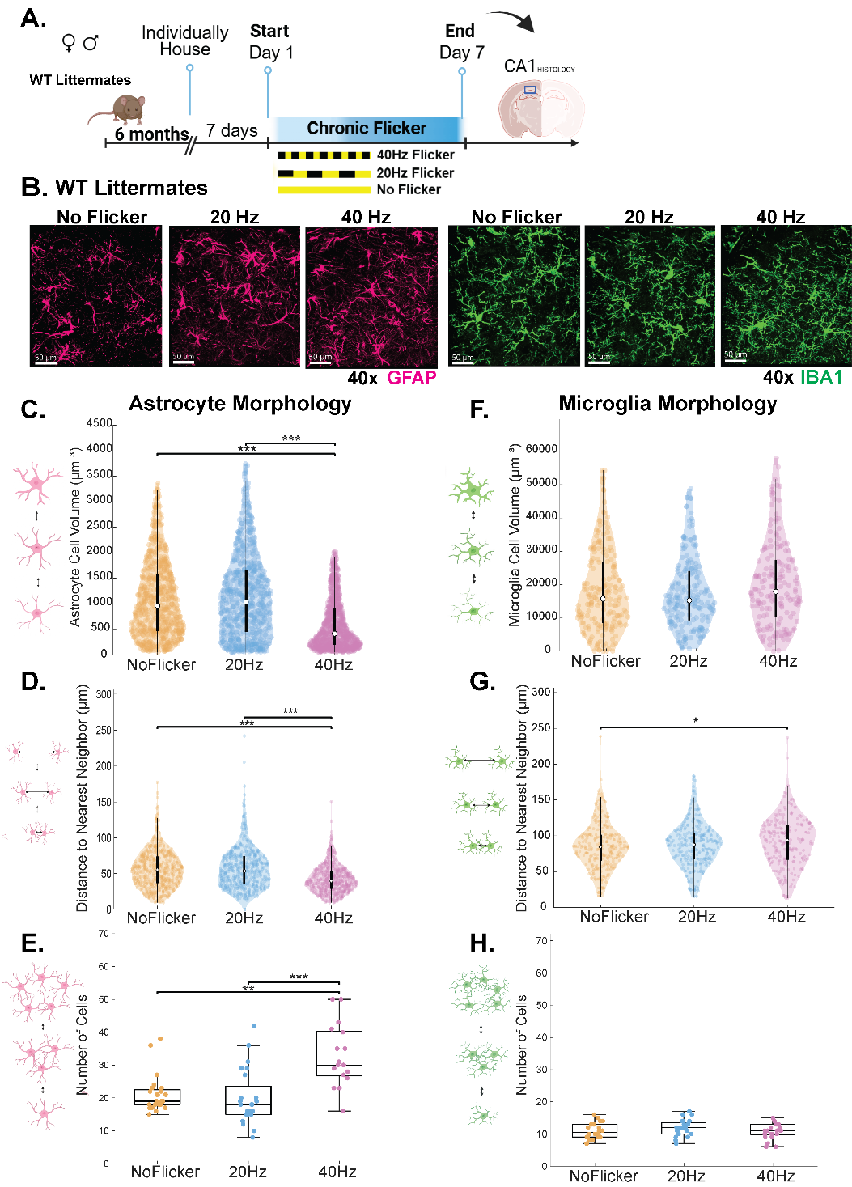
Figure 1. 40Hz and 20Hz AV flicker differentially affects astrocyte morphology in WT mice
A) Experimental paradigm of chronic flicker exposure for 1hour/ day x 7 days to either No Flicker (yellow), 20Hz (blue), and 40Hz (pink) followed by left hemisphere CA1 immunohistochemistry B) Representative images across flicker conditions of 40x z-stacks with astrocytes (pink) and microglia (green). C) Astrocyte cell volume was significantly different (H (2)= 256.6939, p = 1.8182e-56), reduced from No Flicker vs 40Hz (p < .001) and larger for 20Hz vs 40Hz (p < .001). D) Astrocyte tiling (distance to nearest neighbour) was significantly different (H (2)= 102.8652, p = 4.6037e-23), with closer proximity between No Flicker vs 40Hz (p < .001) and more dispersed for 20Hz compared to 40Hz (p < .001). E) Astrocyte cell density was significantly different (H (2)= 20.189, p = 4.1307e-05), with increased number between No Flicker and 40Hz (p = 0.001) and increased number for 40Hz vs 20Hz (p=.00004). F) Microglia cell volume was not significantly different across flicker frequencies G) Microglia tiling was significantly different (H (2)= 6.374, p = 0.041296) between No Flicker and 40Hz (p = 0.035). H) Microglia cell density was not significantly different across flicker frequencies. N= 8 mice/ group, 3 technical replicates per mouse. For C, F, D, G, 1 dot = 1 cell, for E & H, 1 dot = 1 image. *p<0.05, **p<0.01, ***p<0.001

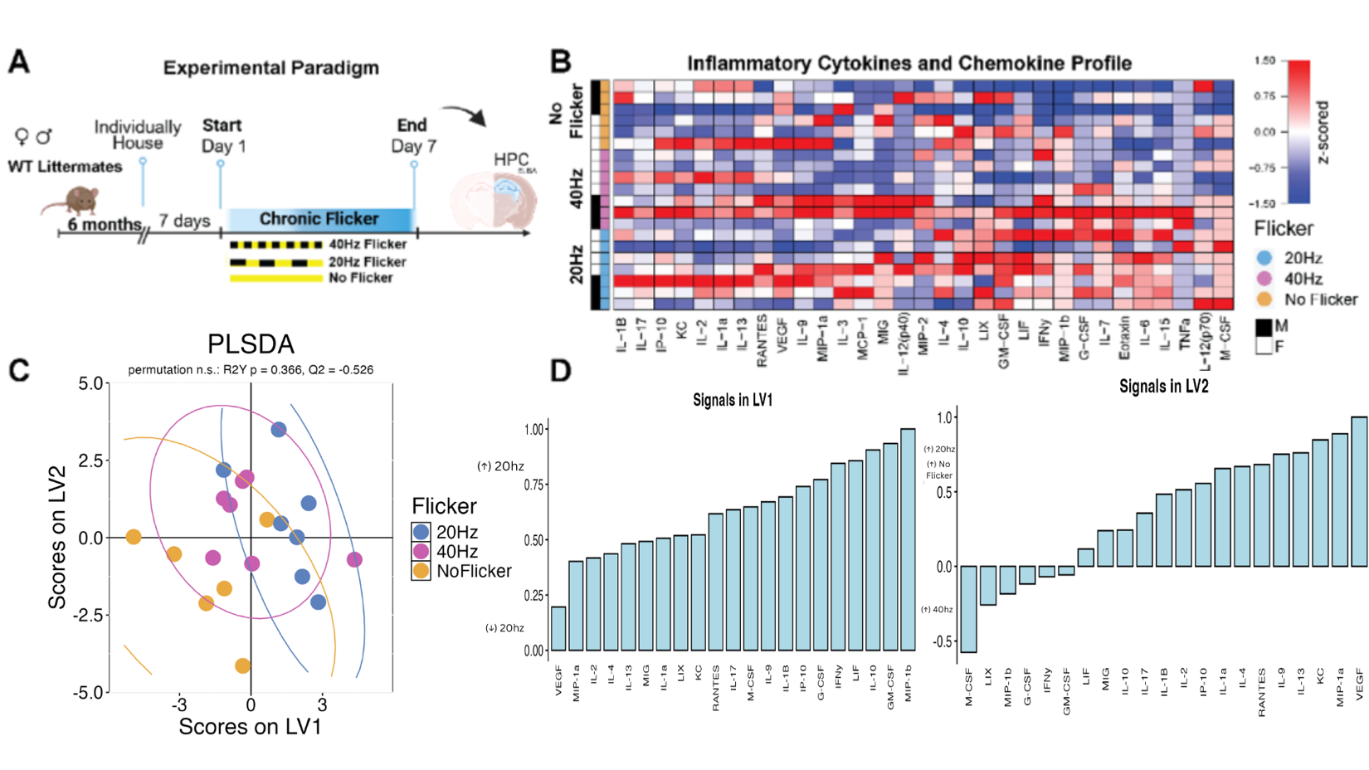

Figure 2. WT cytokine profiles are largely unchanged across flicker frequencies
A) Experimental paradigm of chronic flicker exposure (1hour / day x 7 days) followed by right hemisphere hippocampus cytokine multiplex. B) Cytokine and chemokine multiplex, z-scored within analyte, for male (black) and female (white) mice; the 16 analytes within the assay's linear range are shown, batch-adjusted for sex within genotype.Hippocampal (columns) One row represents one subject’s z-scored analyte expression that increased (red) or decreased (blue) across the three flicker groups. C) PLS-DA scores on LV1 and LV2 for No Flicker (yellow), 20Hz (blue), and 40Hz (pink) exposed animals. Groups overlap, and the model did not classify flicker condition better than chance (leave-one-out accuracy 0.25 against a chance level of 0.33; p(permutation) = 0.59 across 1000 label permutations; R2Y p = 0.43, Q2 = -0.52). Scores are shown for visualization only and no statistical test was applied to them. D) Weighted profile of cytokines contributing to LV1 and LV2, plotted as the mean and standard deviation across 1000 leave-one-out cross-validation iterations. The three analytes with the largest absolute loading on each latent variable are drawn in darker fill; these are the key cytokines carried forward to the group comparisons in Supplementary Figure 5. N = 6–7 mice/group (No Flicker n = 6, 20Hz n = 7, 40Hz n = 7). One dot represents one animal.
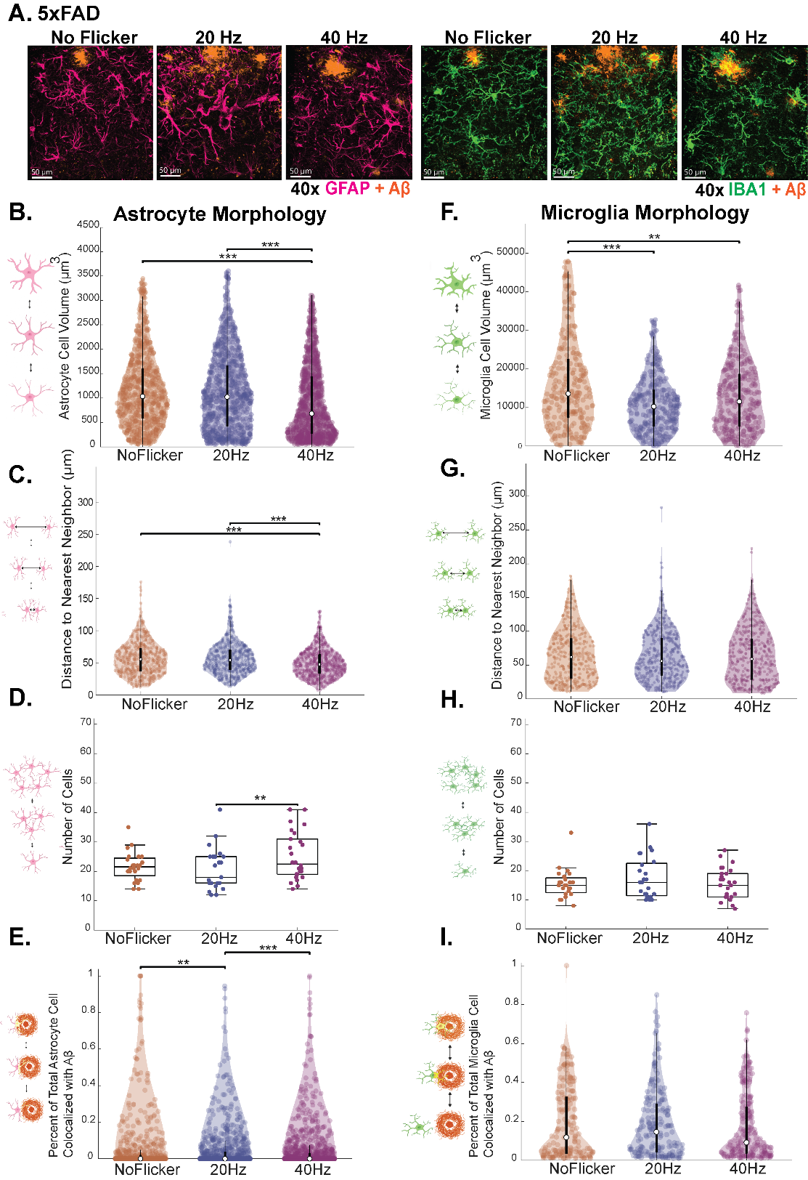
Figure 3. Astrocytes differentially respond to 40Hz vs 20Hz in the context of Aβ pathology
A) Representative images across flicker conditions for No Flicker (orange), 20Hz (dark blue), and 40Hz (purple) of 40x z-stacks from HPC – CA1 with astrocytes (pink), microglia (green) and amyloid β (orange). B) Astrocyte cell volume was significantly different (H (2)= 133.4553, p = 1.0485e-29), with larger cells for No Flicker vs 40Hz (p = 3.3307e-16), and larger cells for 20Hz vs 40Hz (p < .001). C) Astrocyte tiling was significantly different (H (2)= 62.4261, p = 2.7819e-14), with closer proximity between cells for 40Hz vs No Flicker (p = 6.49e-08) and closer proximity for 40Hz vs 20Hz (p = 9.4458e-13). D) Astrocyte density was significantly different (H (2)= 9.6827, p = 0.0078965) between 20Hz and 40Hz (p = 0.0058). E) Astrocytes showed a higher colocalization (H (2)= 16.0874, p = 0.00032111) between No Flicker vs 20Hz ( p = 0.0026), and 40Hz was more colocalized than 20Hz (p = 0.005). F) Microglia whole cell volume. G) Microglia tiling was not significantly different between groups. H) Microglia density was not significantly different between groups. I) Microglia did not show significant differences in colocalization between groups. N= 8 mice/ group, 3 technical replicates per mouse. For B-D & F-H one dot represents one cell, for E & I, one dot represents one image. *p<0.05, **p<0.01, ***p<0.001

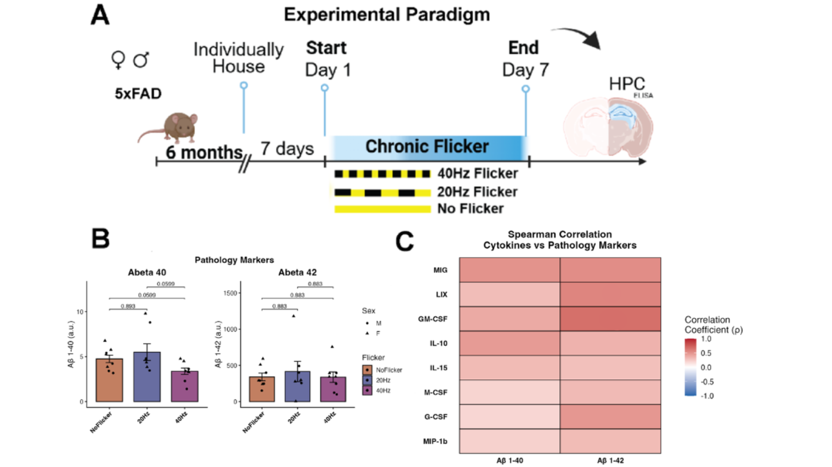

Figure 4. Cytokine expression tracks Aβ pathology rather than flicker frequency
A) Experimental paradigm of chronic flicker exposure (No Flicker (orange), 20Hz (dark blue), and 40Hz (purple)) and right hemisphere hippocampus used for amyloid β ELISA and a 32-plex cytokine/chemokine multiplex, of which the 16 analytes within the assay's linear range were analyzed. B) For Aβ-40 there was no significant difference after correction, though 40Hz showed lower Aβ-40 than No Flicker (p = 0.060, KW + Dunn's), but no significant difference between flicker groups for Aβ-42. C) Spearman correlations between cytokines and amyloid burden, showing the 5xFAD key cytokines together with any analyte reaching p < 0.05 on either marker; the value in each cell is ρ. The strongest associations were LIX (ρ = 0.57, p = 0.0044) and MIG (ρ = 0.53, p = 0.0087) with Aβ-42, and MIG with Aβ-40 (ρ = 0.51, p = 0.014). None survived false discovery rate correction across the 16 retained analytes for each marker (q = 0.069 for LIX and MIG on Aβ-42; q = 0.20 for MIG on Aβ-40), so no cell is marked with an asterisk. No individual cytokine or chemokine within the assay's linear range differed significantly between flicker groups in 5xFAD mice.N = 7–8 mice/group (No Flicker n = 8, 20Hz n = 7, 40Hz n = 8). One dot represents one animal. Significances: *p<=0.05

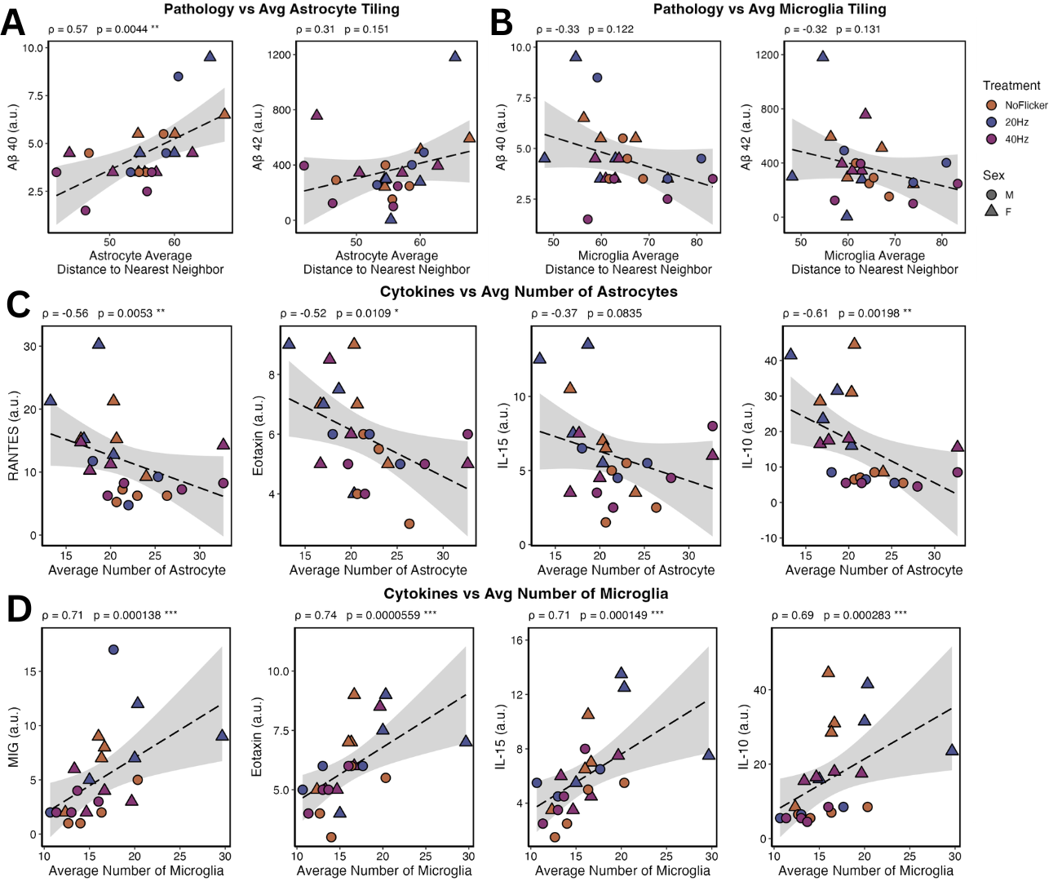

Figure 5. In 5xFAD mice astrocyte tiling positively correlates with amyloid pathology whereas density of GFAP+ astrocyte and microglia divergently correlate with cytokine expression across flicker frequencies
There were significant or trending spearman correlations between morphology and cytokine expression within subject, irrespective of flicker frequency No Flicker (orange), 20Hz (dark blue), and 40Hz (purple) A.) Aβ-40 was positively correlated with astrocyte tiling (distance to nearest neighbor) (ρ = 0.57, p = 0.0044) but was not correlated with Aβ-42 (ρ = 0.31, p = 0.151). B) Amyloid was not significantly correlated with microglia tiling (Aβ-40 ρ = -0.33, p = 0.122; Aβ-42 ρ = -0.32, p = 0.131). C) Astrocyte density was negatively correlated with IL-10 (ρ = -0.61, p = 0.0020, q = 0.032) and RANTES (ρ = -0.56, p = 0.0053, q = 0.042). D) Microglia density was positively correlated with MIG (ρ = 0.71, p = 0.00014, q = 0.0022), IL-10 (ρ = 0.69, p = 0.00028, q = 0.0023), RANTES (ρ = 0.52, p = 0.011, q = 0.043) and IP-10 (ρ = 0.52, p = 0.011, q = 0.043); microglial tiling correlated inversely with the same analytes (MIG ρ = -0.70, q = 0.0032; IL-10 ρ = -0.67, q = 0.0043; RANTES ρ = -0.60, q = 0.014). Panels C and D show the 5xFAD key cytokines identified from the PLS-DA loadings. Correlations were observed irrespective of flicker frequency, though more variation was present in the 20Hz animals. ρ and uncorrected Spearman p are shown with q, the Benjamini-Hochberg adjusted value across the 16 retained analytes for that morphology measure. *q<0.05, **q<0.01, ***q<0.001N = 7–8 mice/group (No Flicker n = 8, 20Hz n = 7, 40Hz n = 8). One dot represents one animal. Significances: *p<0.05

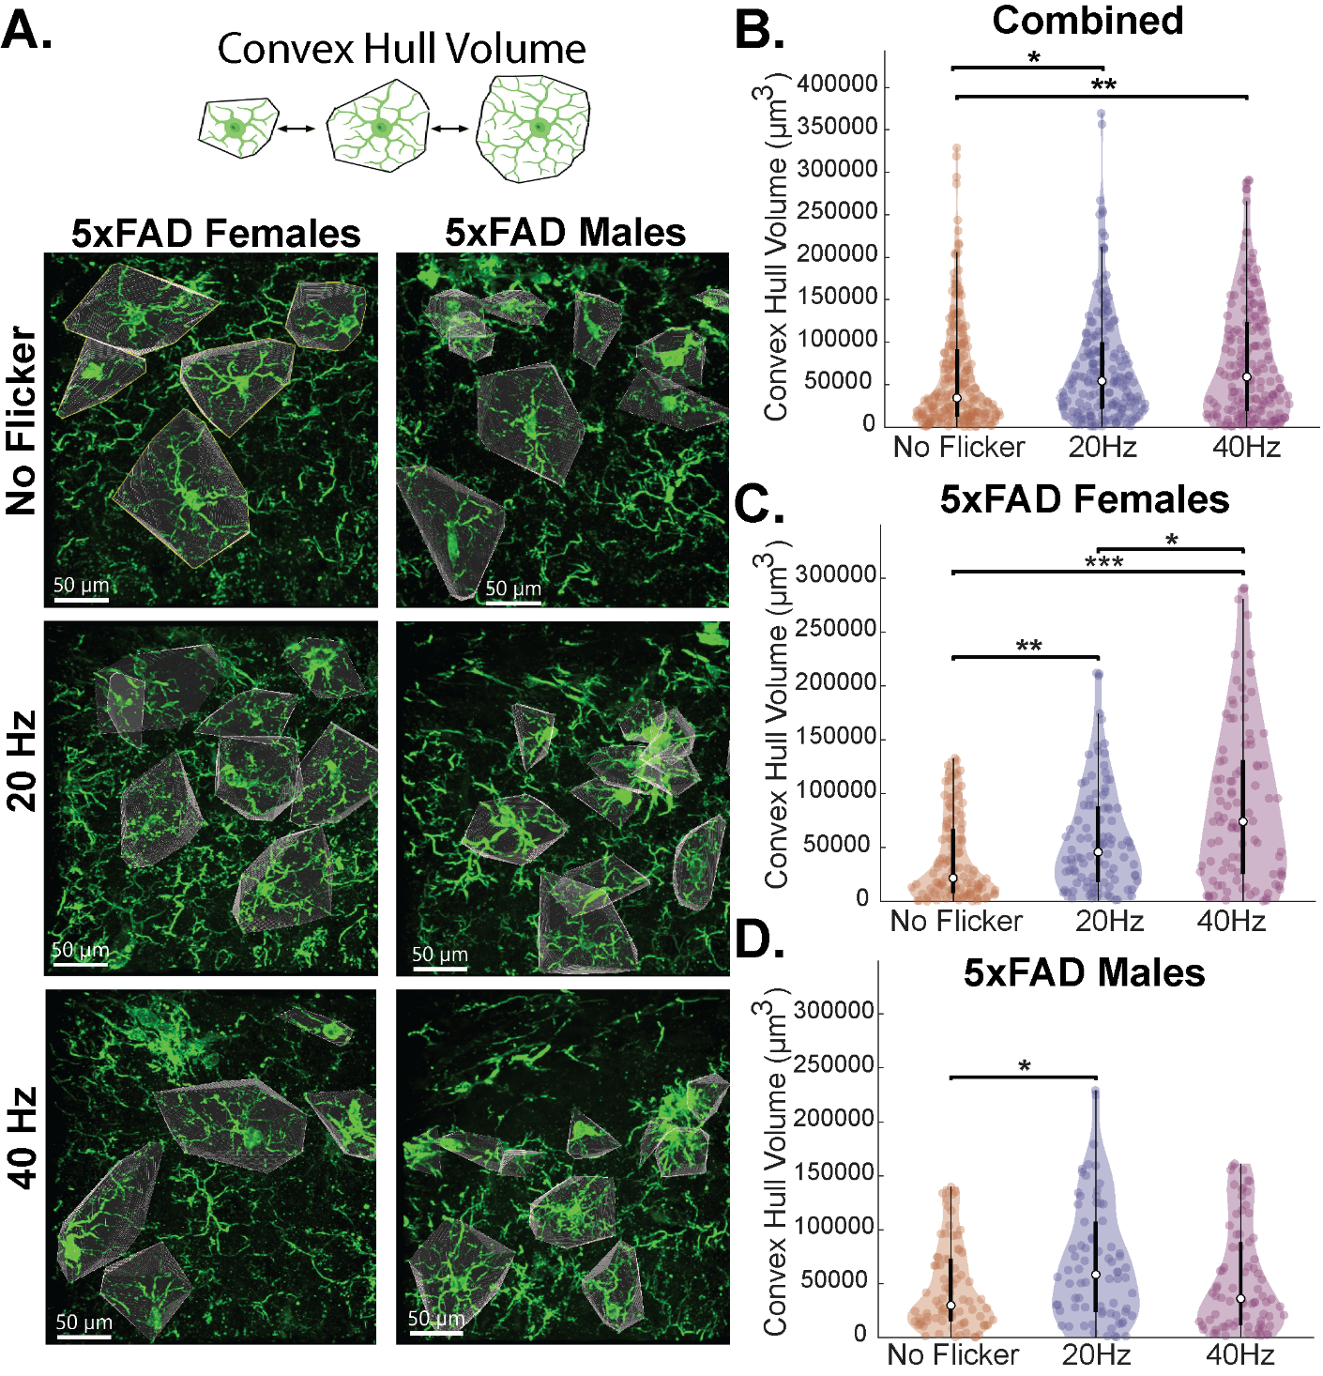
Figure 6. Frequency and sex specific effects on microglia complexity in context of Aβ pathology
A) Representative images of microglia convex hull volume for 5xFAD male and female mice across flicker groups. B) when male and female data are combined, there is a significant difference (H (2)= 10.913, p = 0.0042685) with increased volume for 40Hz vs No Flicker (p = 0.0062116) and for 20Hz vs No Flicker (p = 0.042351). When data were separated by sex, C) significant effects were observed for females (H (2) = 30.535, p = 2.341e-07) with increased convex hull volume for 20Hz vs No Flicker (p = 0.008563) and 40Hz vs No Flicker (p = 1.1365e-07), and larger hull volume for 40Hz vs 20Hz (p = 0.03975). While significant effects were observed for D) males (H (2) = 6.5049, p = 0.038679), 20Hz showed increased volume compared to No Flicker (p = 0.03519) which also trended toward larger than 40Hz, though was not significant (p=0.2). N= 8 mice/ group (4 males: 4 females), 3 technical replicates per mouse. One dot represents one cell. Significances: *p<0.05, **p<0.01, ***p<0.001

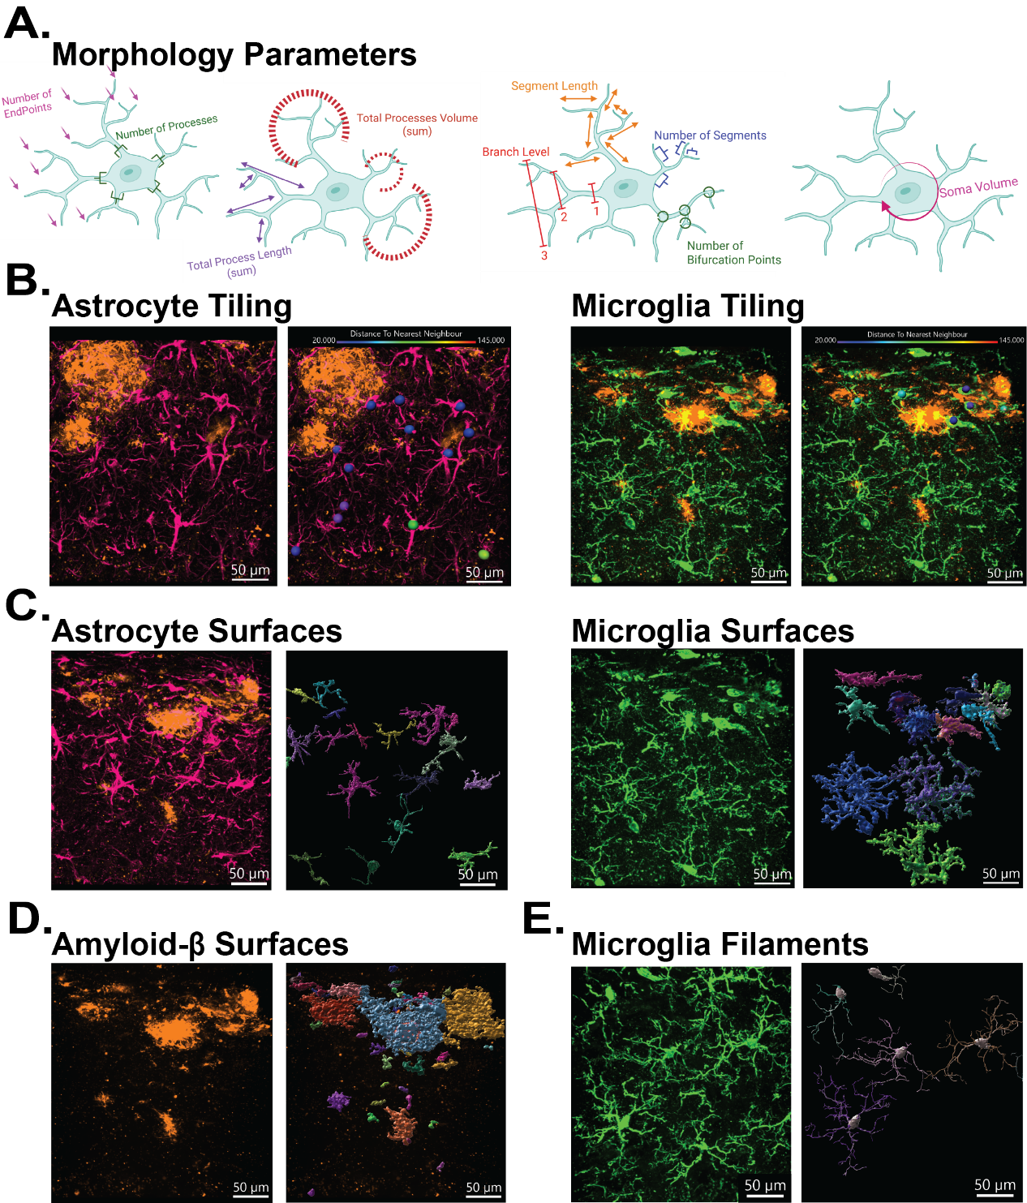
Supplementary Figure 1. Representative Imaris Protocols and Parameters.
Representative protocols for IMARIS 10.1.0 A) Representation of parameters obtained from Imaris microglia filaments data files including; number of endpoints, number of processes, total process length, total process volume, segment length, branch level, number of segments, number of bifurcation points, convex hull volume, number of intersections per radi (sholl), and soma volume. B-E) Left) raw 40x images of WT and 5xFAD mouse hippocampus CA1 region above the pyramidal layer Right) Imaris surface, spot, or filament reconstructions of the same raw images. B) Left) Astrocyte surfaces (pink) and amyloid-β surface (orange) colocalization showing the overlap (yellow) between amyloid and astrocytes and Imaris color spectrum of astrocyte soma spots (defined by overlap with DAPI nuclei stain) to soma distance to nearest neighbor (tiling) ranging from closest (blue) to furthest apart (red). Right) the same in Iba1+ microglia (green). C) Left) Whole cell staining for astrocytes (pink) and Iba1 microglia (green) and Imaris 3D reconstructed surfaces Right) the same for microglia (green). (D) Left) Amyloid- β labeling (orange) and Imaris 3D surface reconstruction. Total signal was filtered for plaques ≥10µm. Surface measures included volume and count. E) Left) Whole cell microglia (green) Right) Filaments of reconstructed microglia soma and its processes. The filaments were reconstructed through an Imaris AI model that was trained and optimized with several samples resulting from a sequence of pre-processing, segmentation, and component labelling, as well as manual editing and filtering. Cells were reconstructed only if 80% of processes were within the field of view. Images that had clustered cells whose processes were inseparable were excluded from reconstruction and analysis. The filaments output parameters were used to calculate convex hull volume.

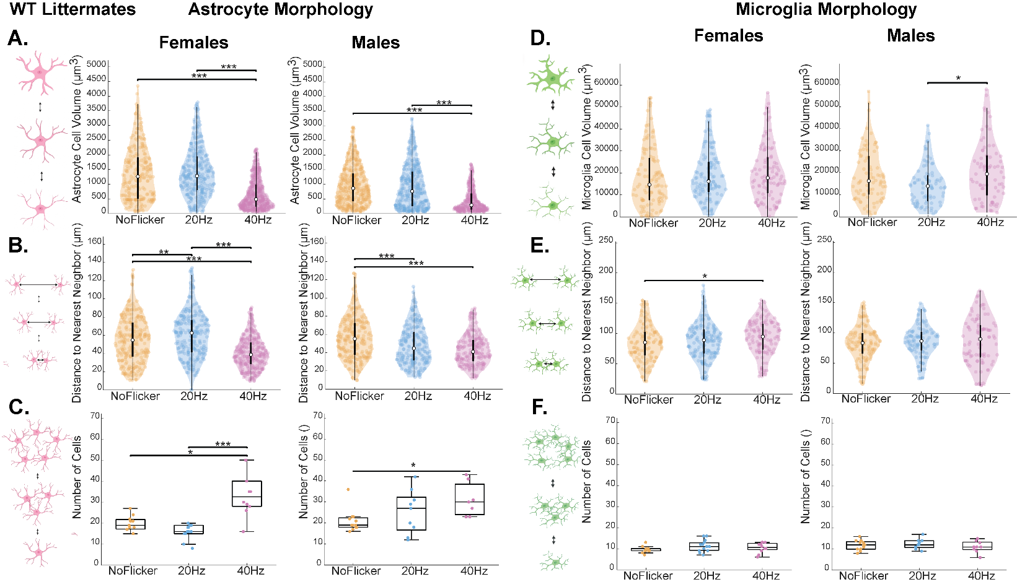
Supplementary Figure 2. Similar trends across sex for frequency-specific effects of flicker in healthy HPC astrocytes
Representative morphology measures separated by females and males for astrocytes and microglia across No Flicker (yellow), 20Hz (blue), and 40Hz (pink) exposed animals. A) Females showed significant differences between groups for astrocyte cell volume (H (2) = 143.7402, p = 6.1266e-32) with larger cells in No Flicker compared to 40Hz ( p = < .001) and 20Hz compared to 40Hz (p = < .001), with Males showing a similar trend (H (2) = 44.8025, p = 1.8675e-10), No Flicker vs 40Hz (p = 2.1782e-10) and (p = 2.5657e-05). B) Astrocyte tiling was significantly different between groups for Females (H (2) = 96.3982, p = 1.1679e-21) with closer proximity for 40Hz vs No Flicker (p = 3.4984e-10), for 40Hz vs 20Hz (p < .001), and more dispersed for 20Hz vs No Flicker (p = 0.0089595). Similar trends were seen in Males for astrocyte tiling (H (2) = 34.7359, p = 2.8655e-08), for No Flicker vs 40Hz (p = 1.6866e-08) and for No Flicker vs 20Hz (p = 0.0013047). C) Astrocyte density was significantly different in Females (H (2) = 18.3474, p = 0.00010373) with increased number for 40Hz vs No Flicker (p = 0.045004) and 40Hz vs 20Hz (p = 5.5367e-05), and a similar trend for Males (F = 5.4115, p = 0.011485), with more cells in 40Hz vs No Flicker (p = 0.0089275). D)
E) Microglia tiling was significantly different for Females (H (2) = 9.0778, p = 0.010685), with closer proximity for No Flicker compared to 40Hz (p = 0.0098253). Significant differences between frequencies were not observed for Males (H (2) = 0.28245, p = 0.86829). F) Microglia density was not significantly different in either sex or between flicker frequencies. N= 8 mice/ group (4 male: 4 female), 3 technical replicates per mouse. For A,B,D,E one dot represents one cell, for E & H one dot represents one image. Significances: *p<0.05, **p<0.01, ***p<0.001
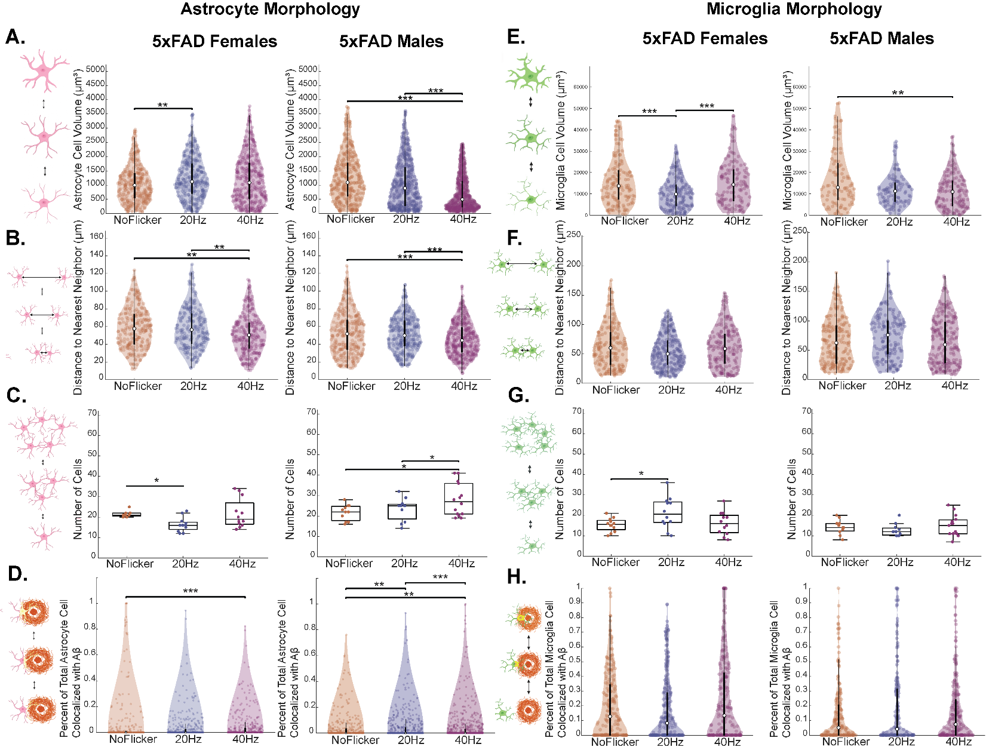
Supplementary Figure 3. Sex and frequency specific effects of flicker in the context of Aβ Pathology
Representative morphology measures separated by females and males for astrocytes and microglia across No Flicker (orange), 20Hz (dark blue), and 40Hz (purple) exposed animals. A) Females showed significant differences between groups for astrocyte cell volume (H (2) = 6.9142, p = 0.031521) with larger cells in the 20Hz group compared to No Flicker (p = 0.026258). Males showed significant differences between groups (H (2) = 114.62, p = 1.29e-25) with smaller cells in the 40Hz group compared to No Flicker (p < .001) and 40Hz compared to 20Hz (p = 2.6645e-15). B) In Females astrocyte tiling was significantly different between groups (H (2) = 14.1682, p = 0.00083) with closer proximity in 40Hz compared to No Flicker (p = 0.0053057) and 40Hz were closer in proximity than 20Hz (p = 0.0026765). Males showed significant differences in tiling between groups (H (2) = 38.629, p = 4.0909e-09) with 40Hz cells in closer proximity relative to No Flicker (p = 0.00065309) and 40Hz more proximate to the 20Hz group (p = 1.0028e-08). C) In Females astrocyte density was significantly different between groups (H (2) = 8.3607, p = 0.015293), with fewer cells in the 20Hz group relative to No Flicker (p = 0.020231). In Males there was a significant difference between groups for cell density males: (F (375.5682, 2) = 5.2394, p = 0.010565), with greater number in 40Hz relative to No Flicker (p = 0.02) and 40Hz relative to 20Hz ( p = 0.03) D) In Females, for astrocytes that did contact plaques, colocalization was significantly different between groups (H (2) = 13.9784, p = 0.00092179) with 40Hz showing greater colocalization in No Flicker astrocytes than 40Hz (p = 0.00056062). In Males, there were significant differences for colocalization between groups (H (2) = 47.017, p = 6.1714e-11) with greater colocalization in 40Hz compared to No Flicker (p = 0.0053545) and to 20Hz (p = 5.1502e-11), as well as greater colocalization in 20Hz compared to No Flicker (p = 0.0036335). E)
F) Females show increased microglia tiling in 20Hz compared to No Flicker and 40Hz, however there were not significant differences (H (2) = 4.9546, p = 0.083968). Whereas in Males, there appeared to be greater distance between microglia in 20Hz compared to 40Hz and No Flicker, but these trends were not significant (H (2) = 3.5952, p = 0.1657). G) In Females there was a significant difference in microglia density (F (2, 33) = 3.7094, p = 0.035225), with a greater number in 20Hz compared to No Flicker (p = 0.044973), whereas in Males there was no significant differences in microglia density. H)
One dot represents one cell. Significances: *p<0.05, **p<0.01, ***p<0.001

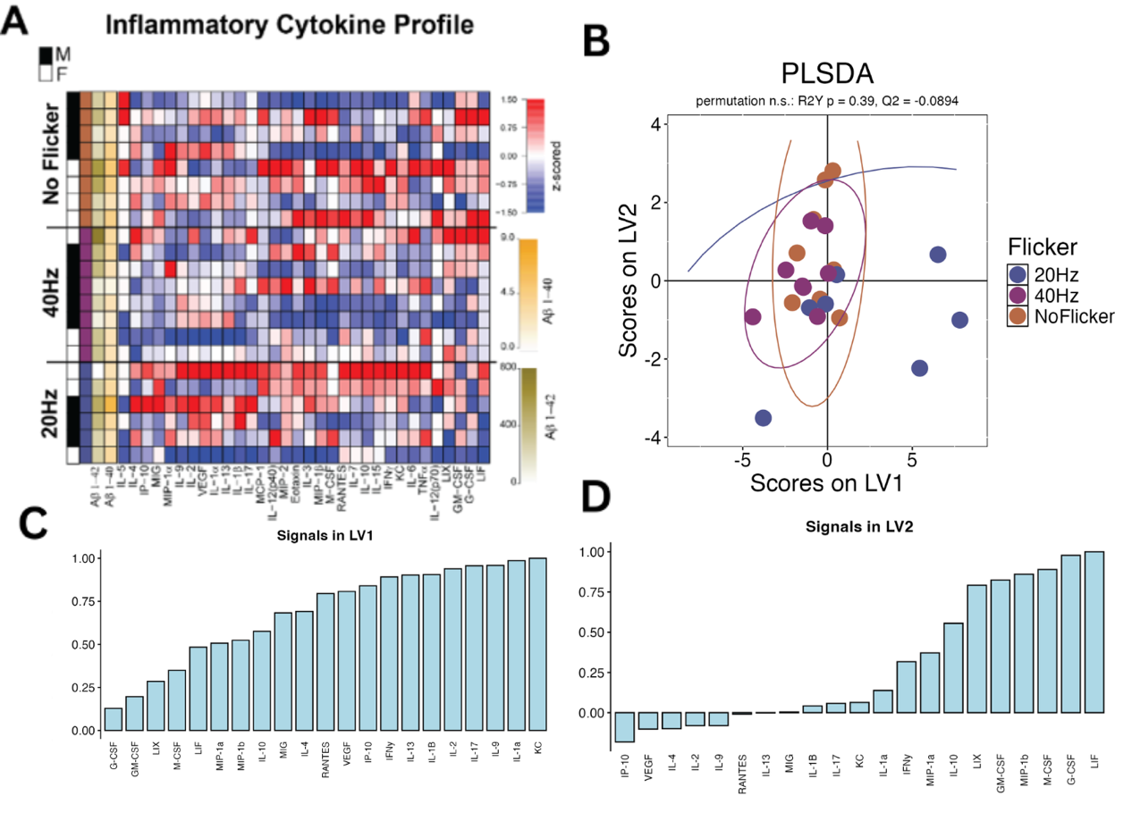

Supplementary Figure 4. 5xFAD hippocampal cytokine profile and PLS-DA
A) Hippocampal cytokine and chemokine multiplex z-scored within analyte male (black) and female (white) mice across Aβ I-40 (yellow) and Aβ I-42 (green) levels. One row represents one subject’s z-scored analyte expression that increased (red) or decreased (blue) across the three flicker groups. B) PLS-DA scores for No Flicker (orange), 20Hz (dark blue), and 40Hz (purple) exposed animals. Groups overlap and the model did not classify flicker condition better than chance (leave-one-out accuracy 0.30 against a chance level of 0.33; p(permutation) = 0.38 across 1000 label permutations; R2Y p = 0.44, Q2 = -0.20). C) Signals in LV1 and D) signals in LV2: the weighted profile of cytokines contributing to each latent variable, plotted as the mean and standard deviation across 1000 leave-one-out cross-validation iterations, with the three largest absolute loadings on each latent variable in darker fill. One dot represents one animal.

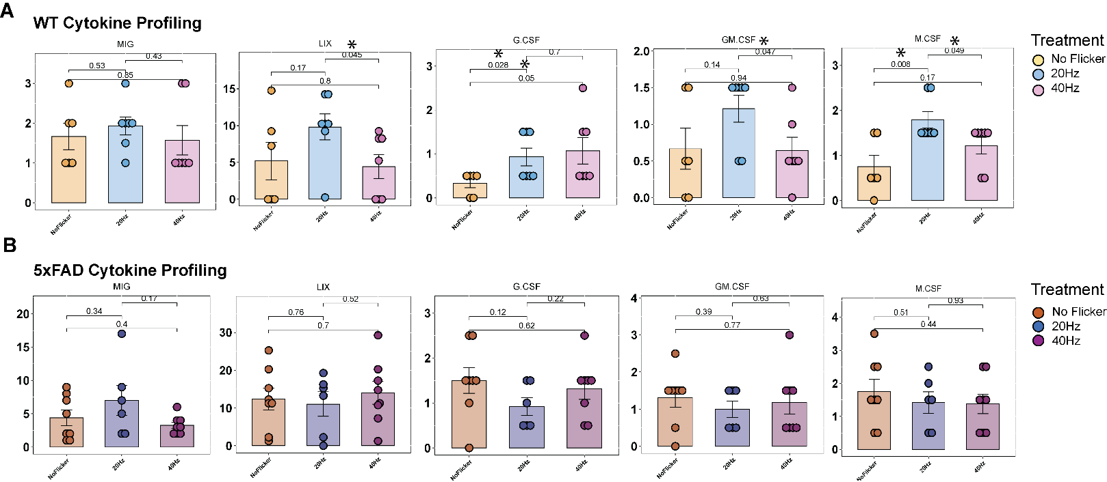
Supplementary Figure 5. Cytokines most heavily weighted by PLS-DA do not differ between flicker groups
The key cytokines identified from the PLS-DA loadings, defined within each genotype as the three analytes with the largest absolute cross-validated loading on LV1 and the three largest on LV2. A) In WT animals (IL-1B, IL-10, IP-10, KC, MIP-1a, VEGF) no cytokine differed between No Flicker (yellow), 20Hz (blue), and 40Hz (pink) exposed animals; all pairwise p ≥ 0.54 after Tukey's or Dunn's correction. B) In 5xFAD animals (IL-1a, IL-10, IL-17, IP-10, KC, MIP-1a) there were likewise no significant differences between flicker groups; all pairwise p ≥ 0.09. A linear mixed model controlling for sex (Flicker + Sex + (1|litter)) gave the same result in both genotypes. Note that neither PLS-DA model passed permutation testing (Figure 2c, Supplementary Figure 4b), so these analytes represent the profile the model weighted most heavily rather than analytes shown to separate the groups. One dot represents one animal; circles are males and triangles females.

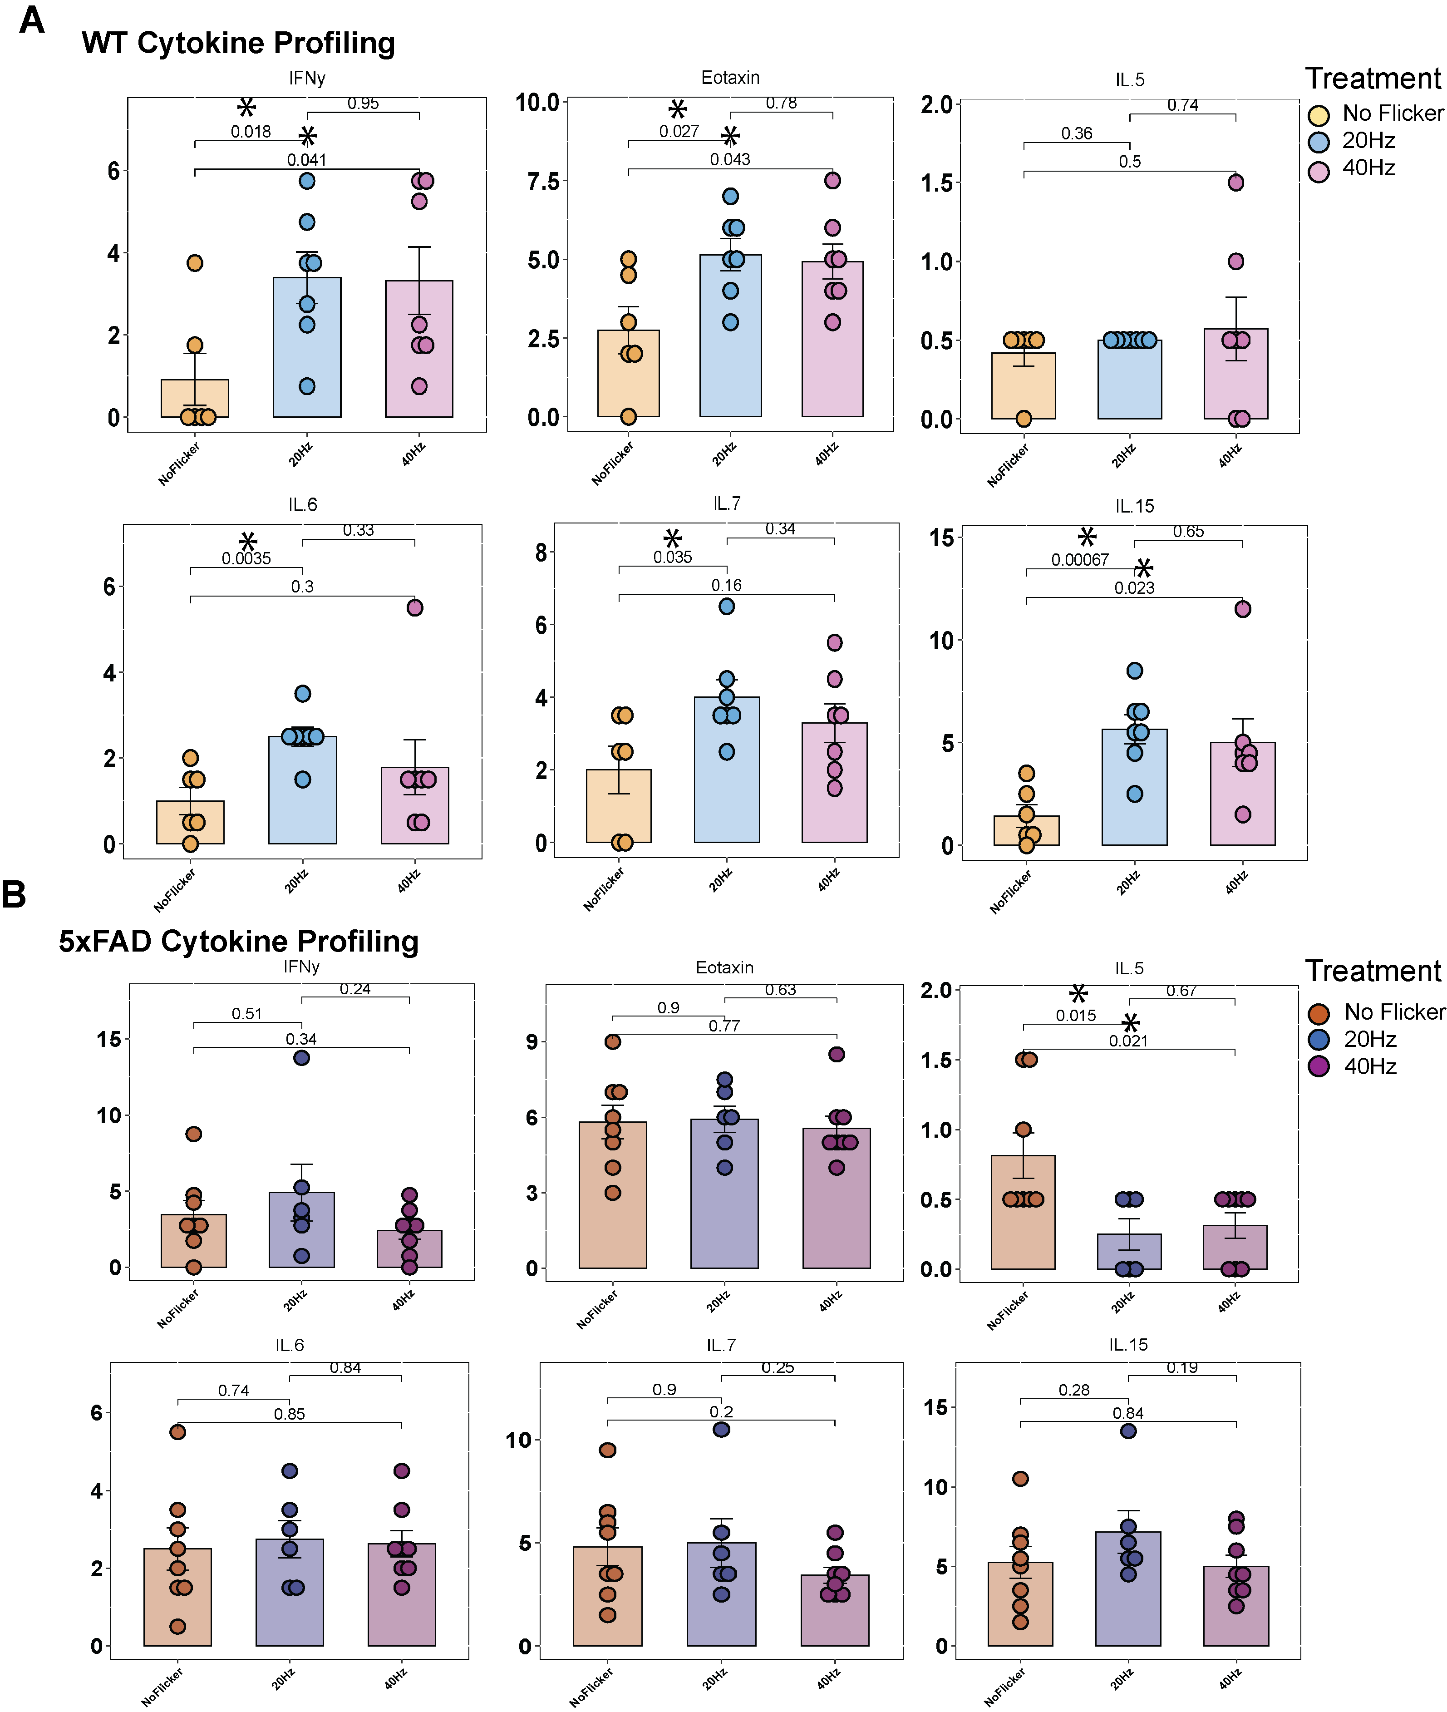
Supplementary Figure 6. IFN-γ is the only cytokine within the assay's linear range that responds to flicker
The only analytes within the assay's linear range for which any flicker contrast reached p < 0.05. A) In WT animals, IFN-γ was greater after 20Hz than No Flicker (p = 0.044) and greater after 40Hz than No Flicker (p = 0.044; Kruskal-Wallis with Dunn's correction, sexes pooled). B) LIX differed between 20Hz and 40Hz in females only (p = 0.048, ANOVA with Tukey's correction); LIX did not differ between flicker groups with sexes pooled. No analyte reached significance in 5xFAD mice. Analytes reported in the previous version of this panel (Eotaxin, IL-5, IL-6, IL-7 and IL-15) fall outside the assay's linear range in these samples and are no longer analyzed. One dot represents one animal; circles are males and triangles females. *p<0.05

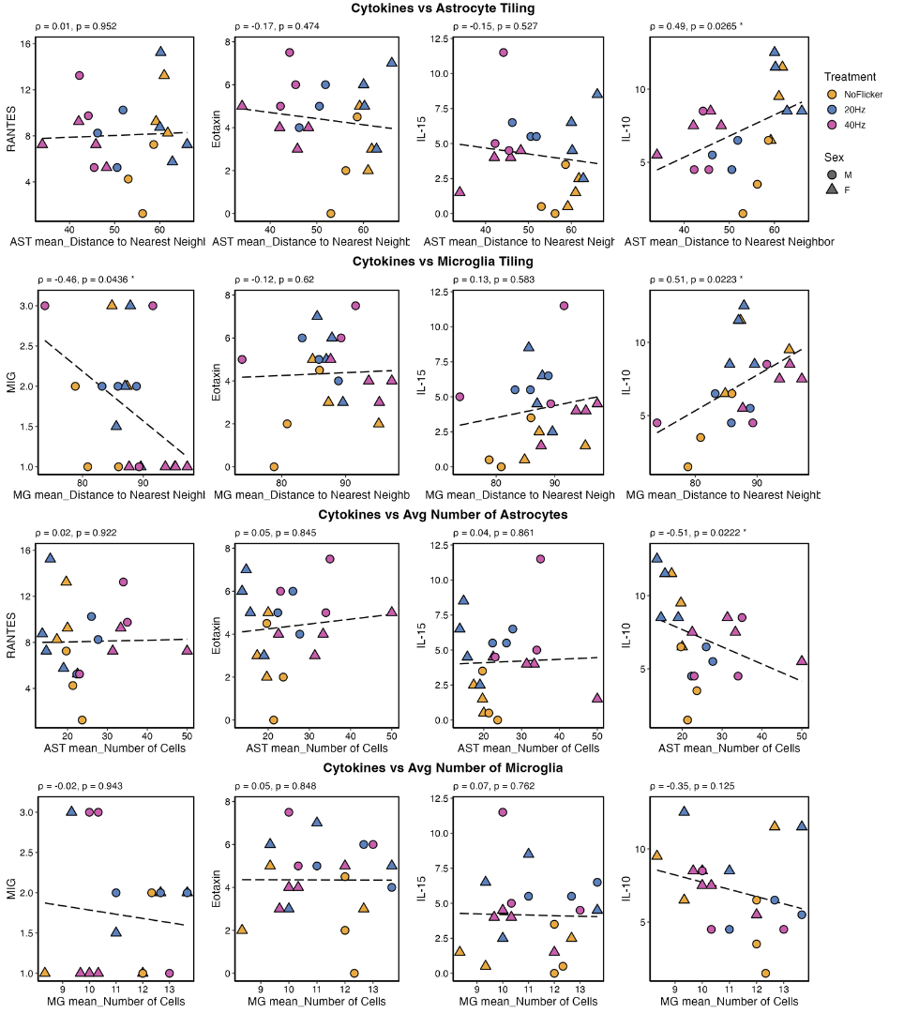
Supplementary Figure 7. In WT mice cytokine-morphology correlations are weaker and do not survive correction.
To examine cytokines as a potential mechanism for changes observed in glia tiling and density, Spearman correlations were performed (Pearson line shown for display) between cytokines and astrocyte and microglia morphology, respectively. Panels show the WT key cytokines identified from the PLS-DA loadings (IL-1B, IL-10, IP-10, KC, MIP-1a, VEGF). A) Astrocyte tiling correlated with IL-10 (ρ = 0.49, p = 0.027, q = 0.42). B) Microglia tiling correlated with IL-10 (ρ = 0.51, p = 0.022, q = 0.35); MIG, which is outside the key set, also correlated with microglia tiling (ρ = -0.46, p = 0.044, q = 0.35). C) Astrocyte density correlated with IL-10 (ρ = -0.51, p = 0.022, q = 0.14). D) No correlations were observed with microglia density. Uncorrected Spearman p and the Benjamini-Hochberg adjusted q across the 16 retained analytes are both shown; none of these correlations survive correction, in contrast to the 5xFAD correlations in Figure 5. One dot represents one animal; circles are males and triangles females.
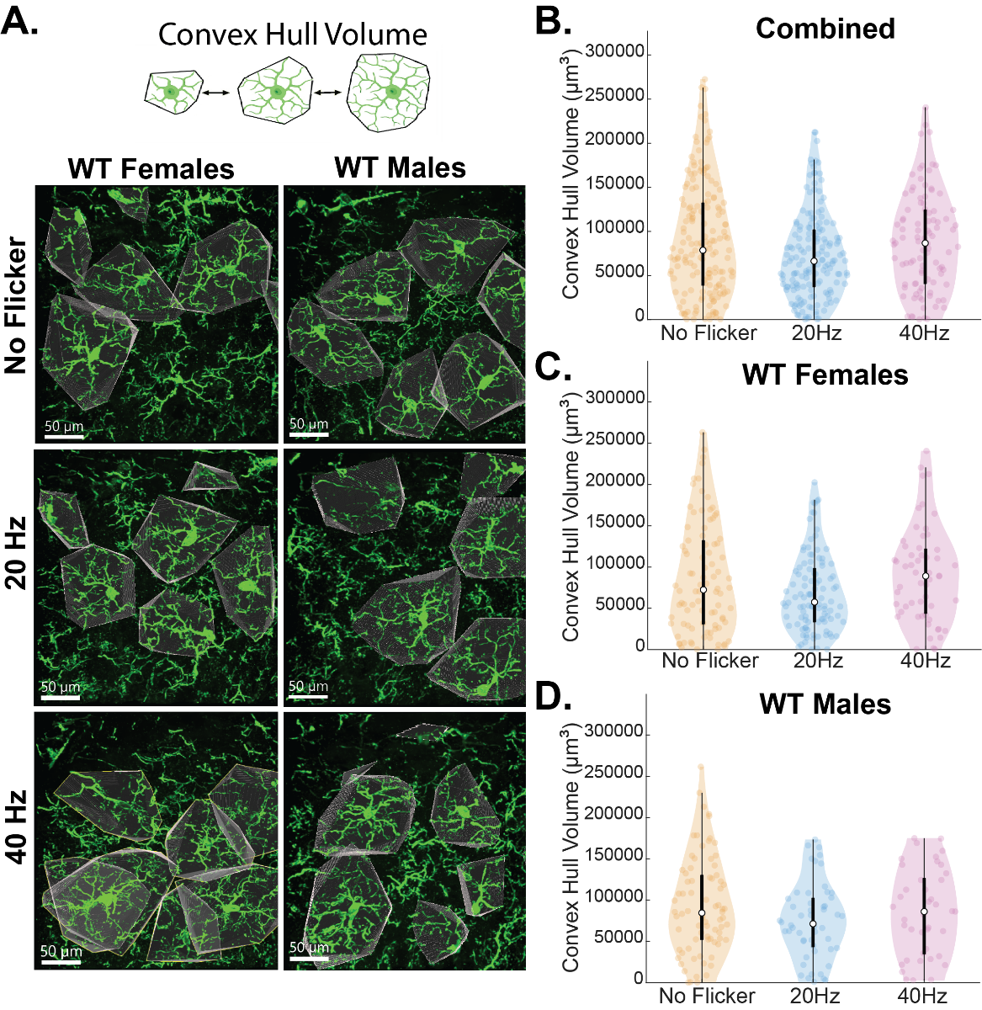
Supplementary Figure 8. Frequency and sex specific effects on 5xfAD microglia surveillance was not present in WT
A) Representative images of microglia convex hull volume for 5xFAD male and female mice across flicker groups. B) when male and female data are combined, convex hull volume was not significantly different across the rank totals of Flicker groups (H (2)= 3.6829, p = 0.15859). C) In females, convex Hull Volume was NOT significantly significant across Flicker (H (2) = 5.1665, p = 0.075527). D) In males, convex Hull Volume was not significantly significant across Flicker (H (2) = 2.5501, p = 0.27942). One dot represents one cell.

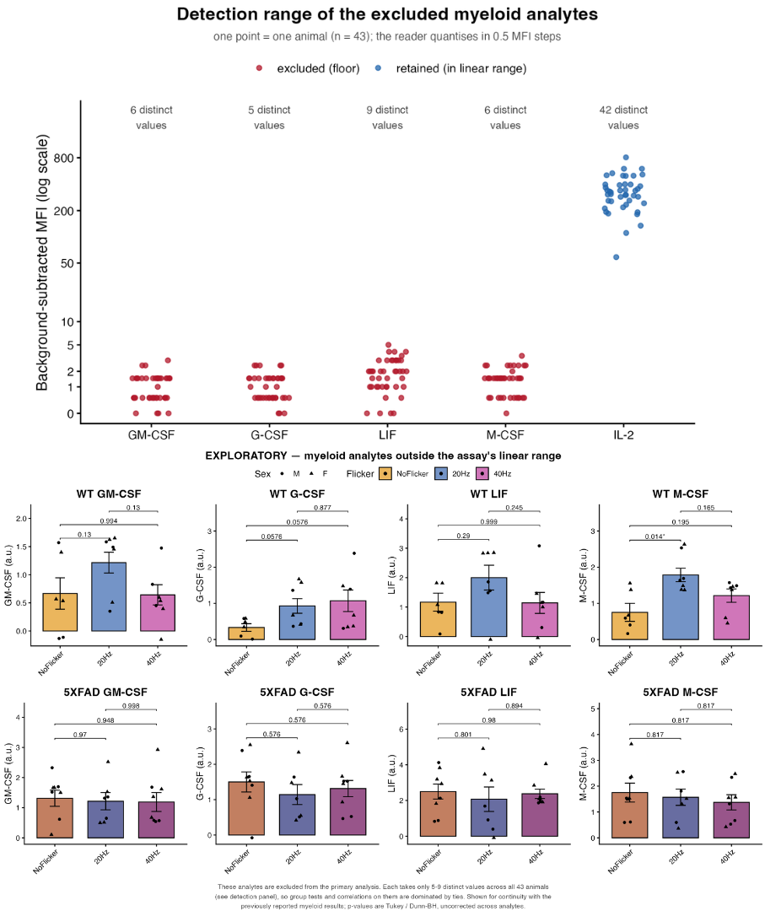

Supplementary Figure 9. Exploratory: myeloid-related cytokines outside the assay's linear range
A) The four myeloid-related cytokines reported in earlier versions of this manuscript (GM-CSF, G-CSF, LIF, M-CSF), shown across No Flicker, 20Hz and 40Hz for WT (top row) and 5xFAD (bottom row) mice. Tests are the same Anderson-Darling gated ANOVA with Tukey's or Kruskal-Wallis with Dunn's correction used elsewhere; of the twenty-four contrasts only WT M-CSF, 20Hz versus No Flicker, reaches p < 0.05 (p = 0.014). B) Distribution of background-subtracted signal for each of these analytes across all 43 animals, with the in-range analyte IL-2 shown for scale. Each excluded analyte takes only 5 to 9 distinct values spanning 2.5 to 5 MFI units above background, against 42 distinct values spanning 750 units for IL-2; because the reader quantises in 0.5 MFI steps, group tests and correlations on these analytes are dominated by ties. These analytes are therefore excluded from the primary analysis and this panel is exploratory. One dot represents one animal.N= 8 mice/ group (4 males: 4 females), 3 technical replicates per mouse.

Supplementary Materials
Primary |  | Secondary
Anti- β-amyloid  (Cell Signaling Technology D54D2) | 1:2,000 | Alexa Fluor 555 Anti-Rabbit  (ThermoFisher PIA32732) | 1:5,000
Anti-Iba1  (Synaptic Signaling 234308) | 1:1,000 | Alexa Fluor 488 Anti-Guinea Pig (Thermofisher scientific A32732) | 1:5,000
Anti-GFAP  (Abcam ab4674) | 1:1,000 | Alexa Fluor 647 Anti-Chicken (ThermoFisher A78952) | 1:5,000
DAPI (Biotium 89139-118) | 1:500
Supplementary Table 1. IHC antibody and secondary concentrations
Primary and secondary antibodies used to visualize IBA1, GFAP, and Amyloid in mouse hippocampal CA1.

 | Cell Type/ Marker | Test Statistic | Pairwise Comparisons
Figure 1
C | Astrocyte: Volume | (H (2)= 256.6939, p = 1.8182e-56) | NoFlicker vs 40Hz p = 0
C | Astrocyte: Volume | (H (2)= 256.6939, p = 1.8182e-56) | NoFlicker vs 20Hz p = 0.99786
C | Astrocyte: Volume | (H (2)= 256.6939, p = 1.8182e-56) | 40Hz vs 20Hz p = 0
D | Astrocyte: Tiling | (H (2)= 102.8652, p = 4.6037e-23) | NoFlicker vs 40Hz p = 0
D | Astrocyte: Tiling | (H (2)= 102.8652, p = 4.6037e-23) | NoFlicker vs 20Hz p = 0.99781
D | Astrocyte: Tiling | (H (2)= 102.8652, p = 4.6037e-23) | 40Hz vs 20Hz p = 0
E | Astrocyte: Number | (H (2)= 20.189, p = 4.1307e-05) | NoFlicker vs 40Hz p = 0.0015546
E | Astrocyte: Number | (H (2)= 20.189, p = 4.1307e-05) | NoFlicker vs 20Hz p = 0.70872
E | Astrocyte: Number | (H (2)= 20.189, p = 4.1307e-05) | 40Hz vs 20Hz p = 4.1757e-05
F | Microglia: Volume
G | Microglia: Tiling | (H (2)= 6.374, p = 0.041296) | NoFlicker vs 40Hz p = 0.034633
G | Microglia: Tiling | (H (2)= 6.374, p = 0.041296) | NoFlicker vs 20Hz p = 0.6149
G | Microglia: Tiling | (H (2)= 6.374, p = 0.041296) | 40Hz vs 20Hz p = 0.33924
H | Microglia: Number | (F (2) = 6.1016, p = 0.94731) | N.S
Figure 2
D | PLSDA loadings (WT) | LV1-LV2 | Permutation, 1000 label shuffles: leave-one-out accuracy 0.25 vs chance 0.33, p(permutation) = 0.59 (n.s.); R2Y p = 0.43, Q2 = -0.52. No statistics on LV scores.
D | PLSDA loadings (WT) | LV1 top 3 | IP-10 (0.451), IL-10 (0.434), IL-1B (0.419); mean loading over 1000 LOOCV iterations
D | PLSDA loadings (WT) | LV2 top 3 | VEGF (0.425), MIP-1a (0.373), KC (0.369); mean loading over 1000 LOOCV iterations
Figure 3
B | Astrocytes: Volume | (H (2)= 133.4553, p = 1.0485e-29) | NoFlicker vs 20Hz p = 0.084877
B | Astrocytes: Volume | (H (2)= 133.4553, p = 1.0485e-29) | NoFlicker vs 40Hz p = 3.3307e-16
B | Astrocytes: Volume | (H (2)= 133.4553, p = 1.0485e-29) | 20Hz vs 40Hz p = 0
C | Astrocytes: Tiling | (H (2)= 62.4261, p = 2.7819e-14) | NoFlicker vs 20Hz p = 0.15994
C | Astrocytes: Tiling | (H (2)= 62.4261, p = 2.7819e-14) | NoFlicker vs 40Hz p = 6.49e-08
C | Astrocytes: Tiling | (H (2)= 62.4261, p = 2.7819e-14) | 20Hz vs 40Hz p = 9.4458e-13
D | Astrocytes: Number | (H (2)= 9.6827, p = 0.0078965) | NoFlicker vs 20Hz p = 0.39878
D | Astrocytes: Number | (H (2)= 9.6827, p = 0.0078965) | NoFlicker vs 40Hz p = 0.26646
D | Astrocytes: Number | (H (2)= 9.6827, p = 0.0078965) | 20Hz vs 40Hz p = 0.0058861
E | Astrocytes: Colocalization | (H (2)= 16.0874, p = 0.00032111) | NoFlicker vs 40Hz pval = 1
E | Astrocytes: Colocalization | (H (2)= 16.0874, p = 0.00032111) | NoFlicker vs 20Hz pval = 0.0026048
E | Astrocytes: Colocalization | (H (2)= 16.0874, p = 0.00032111) | 40Hz vs 20Hz pval = 0.00054956
F | Microglia: Volume
G | Microglia: Tiling | (H (2)= 1.3765, p = 0.50245) | N.S
H | Microglia: Number | (H (2)= 1.4884, p = 0.47512) | N.S
I | Microglia: Colocalization
Figure 4
B | Aβ40 |  | Aβ40: NoFlicker vs 20Hz p = 0.89; NoFlicker vs 40Hz p = 0.060 (n.s.); 20Hz vs 40Hz p = 0.060
B | Aβ42 |  | Aβ42: NoFlicker vs 20Hz p = 0.88; NoFlicker vs 40Hz p = 0.88
C | Aβ40 | Strongest: MIG rho = 0.51, p = 0.014, q = 0.20 (n.s.); IL-10 rho = 0.47, p = 0.025, q = 0.20; IP-10 rho = 0.42, p = 0.045, q = 0.24. None survive FDR.
C | Aβ42 | Strongest: LIX rho = 0.57, p = 0.0044, q = 0.069; MIG rho = 0.53, p = 0.0087, q = 0.069. None survive FDR across the 16 retained analytes.
Figure 5
A | Astrocyte Tiling | Ab40: rho=0.57, p=0.0044
A | Astrocyte Tiling | Ab42: rho=0.31, p=0.151
B | Microglia Tiling | Ab40: rho=-0.33, p=0.122
B | Microglia Tiling | Ab42: rho=-0.32, p=0.131
C | Astrocyte Density | IL-1a: rho=-0.05, p=0.836, q=0.902
C | Astrocyte Density | IL-10: rho=-0.61, p=0.00198, q=0.032
C | Astrocyte Density | IL-17: rho=0.11, p=0.622, q=0.902
C | Astrocyte Density | IP-10: rho=-0.35, p=0.107, q=0.426
D | Microglia Density | KC: rho=-0.21, p=0.343, q=0.885
D | Microglia Density | MIP-1a: rho=0.17, p=0.429, q=0.885
D | Microglia Density | IL-1a: rho=0.04, p=0.862, q=0.874
D | Microglia Density | IL-10: rho=0.69, p=0.000283, q=0.0023
D | Microglia Density | IL-17: rho=0.22, p=0.314, q=0.471
D | Microglia Density | IP-10: rho=0.52, p=0.0109, q=0.043
D | Microglia Density | KC: rho=0.26, p=0.229, q=0.445
D | Microglia Density | MIP-1a: rho=-0.22, p=0.324, q=0.471
Figure 6
B | combined | (H (2)= 10.913, p = 0.0042685) | NoFlicker vs 20Hz p = 0.042351
B | combined | (H (2)= 10.913, p = 0.0042685) | NoFlicker vs 40Hz p = 0.0062116
B | combined | (H (2)= 10.913, p = 0.0042685) | 20Hz vs 40Hz p = 0.93796
C | females | (H (2) = 30.535, p = 2.341e-07) | AD-NoFlicker vs AD-20Hz p = 0.008563
C | females | (H (2) = 30.535, p = 2.341e-07) | AD-NoFlicker vs AD-40Hz p = 1.1365e-07
C | females | (H (2) = 30.535, p = 2.341e-07) | AD-20Hz vs AD-40Hz p = 0.039758
D | males | (H (2) = 6.5049, p = 0.038679) | AD-NoFlicker vs AD-40Hz p = 0.78677
D | males | (H (2) = 6.5049, p = 0.038679) | AD-NoFlicker vs AD-20Hz p = 0.03519
D | males | (H (2) = 6.5049, p = 0.038679) | AD-40Hz vs AD-20Hz p = 0.20611
Sup. Figure 2
A | WT Astrocytes: Volume | females: (H (2) = 143.7402, p = 6.1266e-32) | WT-NoFlicker vs WT-40Hz p = 0
A | WT Astrocytes: Volume | females: (H (2) = 143.7402, p = 6.1266e-32) | WT-NoFlicker vs WT-20Hz p = 0.46916
A | WT Astrocytes: Volume | females: (H (2) = 143.7402, p = 6.1266e-32) | WT-40Hz vs WT-20Hz p = 0
A | WT Astrocytes: Volume | males: (H (2) = 44.8025, p = 1.8675e-10) | WT-NoFlicker vs WT-40Hz p = 2.1782e-10
A | WT Astrocytes: Volume | males: (H (2) = 44.8025, p = 1.8675e-10) | WT-NoFlicker vs WT-20Hz p = 0.15562
A | WT Astrocytes: Volume | males: (H (2) = 44.8025, p = 1.8675e-10) | WT-40Hz vs WT-20Hz p = 2.5657e-05
B | WT Astrocytes: Tiling | females: (H (2) = 96.3982, p = 1.1679e-21) | WT-NoFlicker vs WT-40Hz p = 3.4984e-10
B | WT Astrocytes: Tiling | females: (H (2) = 96.3982, p = 1.1679e-21) | WT-NoFlicker vs WT-20Hz p = 0.0089595
B | WT Astrocytes: Tiling | females: (H (2) = 96.3982, p = 1.1679e-21) | WT-40Hz vs WT-20Hz p = 0
B | WT Astrocytes: Tiling | males: (H (2) = 34.7359, p = 2.8655e-08) | WT-NoFlicker vs WT-40Hz p = 1.6866e-08
B | WT Astrocytes: Tiling | males: (H (2) = 34.7359, p = 2.8655e-08) | WT-NoFlicker vs WT-20Hz p = 0.0013047
B | WT Astrocytes: Tiling | males: (H (2) = 34.7359, p = 2.8655e-08) | WT-40Hz vs WT-20Hz p = 0.06329
C | WT Astrocytes: Number | females: (H (2) = 18.3474, p = 0.00010373) | WT-NoFlicker vs WT-40Hz p = 0.045004
C | WT Astrocytes: Number | females: (H (2) = 18.3474, p = 0.00010373) | WT-NoFlicker vs WT-20Hz p = 0.21324
C | WT Astrocytes: Number | females: (H (2) = 18.3474, p = 0.00010373) | WT-40Hz vs WT-20Hz p = 5.5367e-05
C | WT Astrocytes: Number | males: (F (585.1563, 2) = 5.4115, p = 0.011485) | WT-NoFlicker vs WT-40Hz p = 0.0089275
C | WT Astrocytes: Number | males: (F (585.1563, 2) = 5.4115, p = 0.011485) | WT-NoFlicker vs WT-20Hz p = 0.20739
C | WT Astrocytes: Number | males: (F (585.1563, 2) = 5.4115, p = 0.011485) | WT-40Hz vs WT-20Hz p = 0.2786
D | WT Microglia: Volume | females
D | WT Microglia: Volume | males
E | WT Microglia: Tiling | females: (H (2) = 9.0778, p = 0.010685) | N.S.
E | WT Microglia: Tiling | males: (H (2) = 0.28245, p = 0.86829) | N.S.
F | WT Microglia: Number | females: (F (2, 34) = 2.0482, p = 0.14459) | N.S.
F | WT Microglia: Number | males: (F (2, 27) = 0.65725, p = 0.52637) | N.S.
Sup. Figure 3
a | Astrocytes: Volume | females: (H (2) = 6.9142, p = 0.031521) | AD-NoFlicker vs AD-20Hz p = 0.026258
a | Astrocytes: Volume | females: (H (2) = 6.9142, p = 0.031521) | AD-NoFlicker vs AD-40Hz p = 0.61413
a | Astrocytes: Volume | females: (H (2) = 6.9142, p = 0.031521) | AD-20Hz vs AD-40Hz p = 0.30495
a | Astrocytes: Volume | males: (H (2) = 114.62, p = 1.29e-25) | AD-NoFlicker vs AD-40Hz p = 0
a | Astrocytes: Volume | males: (H (2) = 114.62, p = 1.29e-25) | AD-NoFlicker vs AD-20Hz p = 0.99909
a | Astrocytes: Volume | males: (H (2) = 114.62, p = 1.29e-25) | AD-40Hz vs AD-20Hz p = 2.6645e-15
b | Astrocytes: Tiling | females: (H (2) = 14.1682, p = 0.00083835) | AD-NoFlicker vs AD-20Hz p = 0.9897
b | Astrocytes: Tiling | females: (H (2) = 14.1682, p = 0.00083835) | AD-NoFlicker vs AD-40Hz p = 0.0053057
b | Astrocytes: Tiling | females: (H (2) = 14.1682, p = 0.00083835) | AD-20Hz vs AD-40Hz p = 0.0026765
b | Astrocytes: Tiling | males: (H (2) = 38.629, p = 4.0909e-09) | AD-NoFlicker vs AD-40Hz p = 0.00065309
b | Astrocytes: Tiling | males: (H (2) = 38.629, p = 4.0909e-09) | AD-NoFlicker vs AD-20Hz p = 0.05386
b | Astrocytes: Tiling | males: (H (2) = 38.629, p = 4.0909e-09) | AD-40Hz vs AD-20Hz p = 1.0028e-08
c | Astrocytes: Number | females: (H (2) = 8.3607, p = 0.015293) | AD-NoFlicker vs AD-20Hz p = 0.020231
c | Astrocytes: Number | females: (H (2) = 8.3607, p = 0.015293) | AD-NoFlicker vs AD-40Hz p = 0.80215
c | Astrocytes: Number | females: (H (2) = 8.3607, p = 0.015293) | AD-20Hz vs AD-40Hz p = 0.098672
c | Astrocytes: Number | males: (F (375.5682, 2) = 5.2394, p = 0.010565) | AD-NoFlicker vs AD-40Hz p = 0.023478
c | Astrocytes: Number | males: (F (375.5682, 2) = 5.2394, p = 0.010565) | AD-NoFlicker vs AD-20Hz p = 0.99981
c | Astrocytes: Number | males: (F (375.5682, 2) = 5.2394, p = 0.010565) | AD-40Hz vs AD-20Hz p = 0.036395
d | Astrocytes: Colocalization | females: (H (2) = 13.9784, p = 0.00092179) | AD-40Hz vs AD-20Hz p = 0.24183
d | Astrocytes: Colocalization | females: (H (2) = 13.9784, p = 0.00092179) | AD-40Hz vs AD-NoFlicker p = 0.00056062
d | Astrocytes: Colocalization | females: (H (2) = 13.9784, p = 0.00092179) | AD-20Hz vs AD-NoFlicker p = 0.11434
d | Astrocytes: Colocalization | males: (H (2) = 47.017, p = 6.1714e-11) | AD-NoFlicker vs AD-40Hz p = 0.0053545
d | Astrocytes: Colocalization | males: (H (2) = 47.017, p = 6.1714e-11) | AD-NoFlicker vs AD-20Hz p = 0.0036335
d | Astrocytes: Colocalization | males: (H (2) = 47.017, p = 6.1714e-11) | AD-40Hz vs AD-20Hz p = 5.1502e-11
e | Microglia: Volume | females
e | Microglia: Volume | males
f | Microglia: Tiling | females: (H (2) = 4.9546, p = 0.083968) | N.S.
f | Microglia: Tiling | males: (H (2) = 3.5952, p = 0.1657) | N.S.
g | Microglia: Number | females: (F (2, 33) = 3.7094, p = 0.035225) | AD-NoFlicker vs AD-40Hz p = 0.94618
g | Microglia: Number | females: (F (2, 33) = 3.7094, p = 0.035225) | AD-NoFlicker vs AD-20Hz p = 0.044973
g | Microglia: Number | females: (F (2, 33) = 3.7094, p = 0.035225) | AD-20Hz vs AD-40Hz p = 0.08884
g | Microglia: Number | males: (F (2, 34) = 0.61374, p = 0.54721) | N.S
h | Microglia: Colocalization | females
h | Microglia: Colocalization | males
Sup. Figure 4
a
b
Sup. Figure 5
b | 5xFAD | IP-10: | NoFlicker vs 20Hz p = 0.803; NoFlicker vs 40Hz p = 0.803; 20Hz vs 40Hz p = 0.803
b | 5xFAD | IP-10: | NoFlicker vs 20Hz p = 0.543; NoFlicker vs 40Hz p = 0.996; 20Hz vs 40Hz p = 0.573
b | 5xFAD | IP-10: | NoFlicker vs 20Hz p = 0.638; NoFlicker vs 40Hz p = 0.568; 20Hz vs 40Hz p = 0.992
b | 5xFAD | VEGF: | NoFlicker vs 20Hz p = 1.00; NoFlicker vs 40Hz p = 1.00; 20Hz vs 40Hz p = 1.00
b | 5xFAD | VEGF: | NoFlicker vs 20Hz p = 0.769; NoFlicker vs 40Hz p = 0.769; 20Hz vs 40Hz p = 0.769
b | 5xFAD | VEGF: | NoFlicker vs 20Hz p = 0.736; NoFlicker vs 40Hz p = 0.678; 20Hz vs 40Hz p = 0.994
b | 5xFAD | IL-17: | NoFlicker vs 20Hz p = 0.461; NoFlicker vs 40Hz p = 0.789; 20Hz vs 40Hz p = 0.180
b | 5xFAD | IL-17: | NoFlicker vs 20Hz p = 0.771; NoFlicker vs 40Hz p = 0.638; 20Hz vs 40Hz p = 0.638
b | 5xFAD | IL-17: | NoFlicker vs 20Hz p = 0.789; NoFlicker vs 40Hz p = 0.407; 20Hz vs 40Hz p = 0.407
b | 5xFAD | MIP-1a: | NoFlicker vs 20Hz p = 0.429; NoFlicker vs 40Hz p = 0.782; 20Hz vs 40Hz p = 0.429
b | 5xFAD | MIP-1a: | NoFlicker vs 20Hz p = 0.278; NoFlicker vs 40Hz p = 0.784; 20Hz vs 40Hz p = 0.0913
b | 5xFAD | MIP-1a: | NoFlicker vs 20Hz p = 0.804; NoFlicker vs 40Hz p = 0.428; 20Hz vs 40Hz p = 0.825
Sup. Figure 6
- | WT and 5xFAD | IFNy: | Kruskal-Wallis H(2) = 6.69, p = 0.035; Dunn-BH: NoFlicker vs 20Hz p = 0.044; NoFlicker vs 40Hz p = 0.044; 20Hz vs 40Hz p = 0.913
- | WT and 5xFAD | LIX: | ANOVA + Tukey: 20Hz vs 40Hz p = 0.048; NoFlicker vs 20Hz p = 0.317; NoFlicker vs 40Hz p = 0.469. LIX is not significant with sexes pooled.
- | WT and 5xFAD | all retained analytes | No analyte within the assay's linear range differed between flicker groups (all p > 0.05).
- | WT and 5xFAD | Eotaxin, IL-5, IL-6, IL-7, IL-15 | Outside the assay's linear range in these samples; no longer analyzed (see Methods).
Sup. Figure 7
a | Astrocyte: Tiling | IL-1B: rho=-0.17, p=0.469, q=0.857
a | Astrocyte: Tiling | IL-10: rho=0.49, p=0.0265, q=0.424
a | Astrocyte: Tiling | IP-10: rho=-0.09, p=0.719, q=0.857
a | Astrocyte: Tiling | KC: rho=-0.10, p=0.691, q=0.857
b | Microglia: Tiling | MIP-1a: rho=0.08, p=0.750, q=0.857
b | Microglia: Tiling | VEGF: rho=-0.23, p=0.321, q=0.733
b | Microglia: Tiling | IL-1B: rho=-0.05, p=0.849, q=0.997
b | Microglia: Tiling | IL-10: rho=0.51, p=0.0223, q=0.348
b | Microglia: Tiling | IP-10: rho=0.24, p=0.300, q=0.966
b | Microglia: Tiling | KC: rho=-0.05, p=0.843, q=0.997
b | Microglia: Tiling | MIP-1a: rho=-0.28, p=0.228, q=0.966
b | Microglia: Tiling | VEGF: rho=-0.22, p=0.362, q=0.966
c | Astrocyte: Number | IL-1B: rho=0.20, p=0.410, q=0.580
c | Astrocyte: Number | IL-10: rho=-0.51, p=0.0222, q=0.144
c | Astrocyte: Number | IP-10: rho=0.18, p=0.435, q=0.580
c | Astrocyte: Number | KC: rho=0.21, p=0.364, q=0.580
c | Astrocyte: Number | MIP-1a: rho=-0.01, p=0.962, q=0.962
c | Astrocyte: Number | VEGF: rho=0.32, p=0.169, q=0.539
d | Microglia: Number | IL-1B: rho=0.02, p=0.922, q=0.971
d | Microglia: Number | IL-10: rho=-0.35, p=0.125, q=0.971
d | Microglia: Number | IP-10: rho=-0.18, p=0.456, q=0.971
d | Microglia: Number | KC: rho=-0.11, p=0.646, q=0.971
d | Microglia: Number | MIP-1a: rho=-0.03, p=0.907, q=0.971
d | Microglia: Number | VEGF: rho=0.12, p=0.601, q=0.971
b | Microglia: Tiling | MIG (not a key cytokine): rho=-0.46, p=0.044, q=0.348
Sup. Figure 8
b | Combined | (H (2)= 3.6829, p = 0.15859) | N.S
c | Females | (H (2) = 5.1665, p = 0.075527) | N.S
d | Males | (H (2) = 2.5501, p = 0.27942) | N.S
Sup. Figure 9
a | WT | M-CSF: | NoFlicker vs 20Hz p = 0.014; NoFlicker vs 40Hz p = 0.195; 20Hz vs 40Hz p = 0.166 (Dunn-BH)
a | WT | G-CSF: | NoFlicker vs 20Hz p = 0.058; NoFlicker vs 40Hz p = 0.058; 20Hz vs 40Hz p = 0.877 (Dunn-BH)
a | WT | GM-CSF: | NoFlicker vs 20Hz p = 0.130; NoFlicker vs 40Hz p = 0.994; 20Hz vs 40Hz p = 0.130 (Dunn-BH)
a | WT | LIF: | No significant differences between flicker groups
a | 5xFAD | GM-CSF, G-CSF, LIF, M-CSF: | No significant differences between flicker groups
b | all | Detection range | GM-CSF 6, G-CSF 5, LIF 9, M-CSF 6 distinct values across 43 animals (range 2.5-5 MFI above background); IL-2, retained, has 42 distinct values over 750 MFI
- | all | Status | EXPLORATORY. These analytes are outside the assay linear range and are excluded from the primary analysis; p values are uncorrected across analytes.

Supplementary Table 2. Statistics
Mice were divided by genotype (5xFAD vs WT littermates) and flicker frequency (No Flicker, 20Hz, 40Hz). For image analyses each mouse contributed 3 technical replicates from left hemisphere CA1; for amyloid and cytokine analyses each mouse contributed a single right hippocampal lysate (WT n = 6/7/7 and 5xFAD n = 8/7/8 for No Flicker/20Hz/40Hz). Cytokine entries reflect the corrected analysis described in Methods: 16 analytes within the assay linear range, Tukey or Dunn correction for the three-group comparisons, and Benjamini-Hochberg q across the retained analytes for each correlation target. In all statistics, groups were compared using ANOVA for data that fit parametric assumptions and nonparametric tests such as Kruskal Wallis, followed by or Dunn within genotype across the three flicker conditionsfor data that did not meet parametric assumptions, were usedTukey’s HDS ’s correction for multiple comparisons, respectively. Morphological data that showed clear frequency-specific differences between sexes were separated by genotype and sex for statistical comparisons and corrected for multiple comparisons as above.

References

1. C. Adaikkan and L.-H. Tsai, Gamma Entrainment: Impact on Neurocircuits, Glia, and Therapeutic Opportunities, Trends Neurosci. (2020).doi:10.1016/j.tins.2019.11.001
2. H. F. Iaccarino, A. C. Singer, A. J. Martorell, A. Rudenko, F. Gao, T. Z. Gillingham, H. Mathys, J. Seo, O. Kritskiy, F. Abdurrob, C. Adaikkan, R. G. Canter, R. Rueda, E. N. Brown, E. S. Boyden, and L. H. Tsai, Gamma frequency entrainment attenuates amyloid load and modifies microglia, Nature 540, 230 (2016).
3. A. J. Martorell, A. L. Paulson, H. J. Suk, F. Abdurrob, G. T. Drummond, W. Guan, J. Z. Young, D. N. Kim, O. Kritskiy, S. J. Barker, V. Mangena, S. M. Prince, E. N. Brown, K. Chung, E. S. Boyden, A. C. Singer, and L. H. Tsai, Multi-sensory Gamma Stimulation Ameliorates Alzheimer’s-Associated Pathology and Improves Cognition, Cell 177, 256 (2019).
4. A. C. Singer, A. J. Martorell, J. M. Douglas, F. Abdurrob, M. K. Attokaren, J. Tipton, H. Mathys, C. Adaikkan, and L. H. Tsai, Noninvasive 40-Hz light flicker to recruit microglia and reduce amyloid beta load, Nat Protoc 13, 1850 (2018).
5. C. Adaikkan, S. J. Middleton, A. Marco, P. C. Pao, H. Mathys, D. N. Kim, F. Gao, J. Z. Young, H. J. Suk, E. S. Boyden, T. J. McHugh, and L. H. Tsai, Gamma Entrainment Binds Higher-Order Brain Regions and Offers Neuroprotection, Neuron 102, 929 (2019).
6. M. H. Murdock, C.-Y. Yang, N. Sun, P.-C. Pao, C. Blanco-Duque, M. C. Kahn, T. Kim, N. S. Lavoie, M. B. Victor, and M. R. Islam, Multisensory gamma stimulation promotes glymphatic clearance of amyloid, Nature 627, 149 (2024).
7. K. M. Garza, L. Zhang, B. Borron, L. B. Wood, and A. C. Singer, Gamma Visual Stimulation Induces a Neuroimmune Signaling Profile Distinct from Acute Neuroinflammation, J Neurosci 40, 1211 (2020).
8. A. Prichard, K. M. Garza, A. Shridhar, C. He, S. Bitarafan, A. Pybus, Y. Wang, E. Snyder, M. C. Goodson, T. C. Franklin, D. Jaeger, L. B. Wood, and A. C. Singer, Brain rhythms control microglial response and cytokine expression via NF-kappaB signaling, Sci Adv 9, eadf5672 (2023).
9. S. Bitarafan, A. F. Pybus, F. G. Rivera Moctezuma, M. Adibi, T. C. Franklin, A. C. Singer, and L. B. Wood, Frequency and duration of sensory flicker control transcriptional profiles in 5xFAD mice, APL Bioeng. 9, 036102 (2025).
10. Y. Yao, Y. Ying, Q. Deng, W. Zhang, H. Zhu, Z. Lin, S. Zhang, J. Ma, and Y. Zhao, Non-invasive 40-Hz Light Flicker Ameliorates Alzheimer’s-Associated Rhythm Disorder via Regulating Central Circadian Clock in Mice, Front. Physiol. 11, 294 (2020).
11. H. J. Suk, N. Buie, G. Xu, A. Banerjee, E. S. Boyden, and L. H. Tsai, Vibrotactile stimulation at gamma frequency mitigates pathology related to neurodegeneration and improves motor function, Front Aging Neurosci 15, 1129510 (2023).
12. T. Kim, B. T. James, M. C. Kahn, C. Blanco-Duque, F. Abdurrob, M. R. Islam, N. S. Lavoie, M. Kellis, and L.-H. Tsai, Gamma entrainment using audiovisual stimuli alleviates chemobrain pathology and cognitive impairment induced by chemotherapy in mice, Sci. Transl. Med. 16, eadf4601 (2024).
13. J. Tinston, M. R. Hudson, A. Harutyunyan, Z. Chen, and N. C. Jones, Forty-hertz sensory entrainment impedes kindling epileptogenesis and reduces amyloid pathology in an Alzheimer disease mouse model, Epilepsia 66, 886 (2025).
14. A. D. Bachstetter, L. J. Van Eldik, F. A. Schmitt, J. H. Neltner, E. T. Ighodaro, S. J. Webster, E. Patel, E. L. Abner, R. J. Kryscio, and P. T. Nelson, Disease-related microglia heterogeneity in the hippocampus of Alzheimer’s disease, dementia with Lewy bodies, and hippocampal sclerosis of aging, Acta Neuropathol. Commun. 3, 32 (2015).
15. C. Baker, M. Kim, and B. A. Benayoun, A researcher’s guide to studying sex differences in immune aging, Trends Mol. Med. 31, 702 (2025).
16. A. K. Bonkhoff, G. Coughlan, V. Perosa, K. Alhadid, M. D. Schirmer, R. W. Regenhardt, S. van Veluw, R. Buckley, M. D. Fox, and N. S. Rost, Sex differences in age-associated neurological diseases-A roadmap for reliable and high-yield research, Sci. Adv. 11, eadt9243 (2025).
17. L. Castro-Aldrete, M. V. Moser, G. Putignano, M. T. Ferretti, A. Schumacher Dimech, and A. Santuccione Chadha, Sex and gender considerations in Alzheimer’s disease: The Women’s Brain Project contribution, Front. Aging Neurosci. 15, 1105620 (2023).
18. N. Cook, C. Yang, Y. Zeng, S. K. Sivasankaran, S. Song, L. Talozzi, D. Western, C. Yang, Y. Liu, Y. Le Guen, I. Stewart, C. Young, FinnGen, E. C. Mormino, A. Altmann, Z. He, V. Napolioni, A. P. Wingo, T. S. Wingo, C. Cruchaga, Y. J. Sung, M. D. Greicius, and M. E. Belloy, Integrative Genetic, Proteogenomic, and Multi-omics Analyses Reveal Sex-Biased Causal Genes and Drug Targets in Alzheimer’s Disease, MedRxiv Prepr. Serv. Health Sci. 2025.10.31.25339089 (2025).doi:10.1101/2025.10.31.25339089
19. I. Fyfe, Immune responses influence sex differences in Alzheimer disease, Nat. Rev. Neurol. 20, 691 (2024).
20. E. G. Reed and P. R. Keller-Norrell, Minding the Gap: Exploring Neuroinflammatory and Microglial Sex Differences in Alzheimer’s Disease, Int. J. Mol. Sci. 24, 17377 (2023).
21. C. Vila-Castelar, M. Akinci, E. Palpatzis, P. Aguilar-Dominguez, G. Operto, G. Kollmorgen, C. Quijano-Rubio, K. Blennow, H. Zetterberg, C. Falcon, K. Fauria, J. D. Gispert, O. Grau-Rivera, M. Suárez-Calvet, E. M. Arenaza-Urquijo, and ALFA study, Sex/gender effects of glial reactivity on preclinical Alzheimer’s disease pathology, Mol. Psychiatry 30, 1430 (2025).
22. Y. Wu, K. J. Travaglini, M. Gabitto, C. D. Keene, A. R. Dunn, C. C. Kaczorowski, P. L. De Jager, V. Menon, J. A. Schneider, D. A. Bennett, L. Dumitrescu, and T. J. Hohman, Single-cell landscape of sex-specific drivers of Alzheimer’s disease, Alzheimers Dement. J. Alzheimers Assoc. 21, e71041 (2025).
23. B. T. Casali, L. Lin, O. Benedict, H. Zuppe, E. Marsico, and E. G. Reed, Sex chromosomes and gonads modify microglial-mediated pathology in a mouse model of Alzheimer’s disease, J. Neuroinflammation 22, 81 (2025).
24. M.-V. Guillot-Sestier, A. R. Araiz, V. Mela, A. S. Gaban, E. O’Neill, L. Joshi, E. T. Chouchani, E. L. Mills, and M. A. Lynch, Microglial metabolism is a pivotal factor in sexual dimorphism in Alzheimer’s disease, Commun. Biol. 4, 1 (2021).
25. A. Papazoglou, C. Henseler, S. Weickhardt, J. Teipelke, P. Papazoglou, J. Daubner, T. Schiffer, D. Krings, K. Broich, J. Hescheler, A. Sachinidis, D. Ehninger, C. Scholl, B. Haenisch, and M. Weiergräber, Sex- and region-specific cortical and hippocampal whole genome transcriptome profiles from control and APP/PS1 Alzheimer’s disease mice, PloS One 19, e0296959 (2024).
26. T. L. Stephen, M. Cacciottolo, D. Balu, T. E. Morgan, M. J. LaDu, C. E. Finch, and C. J. Pike, APOE genotype and sex affect microglial interactions with plaques in Alzheimer’s disease mice, Acta Neuropathol. Commun. 7, 82 (2019).
27. J. L. Bundy, C. Vied, C. Badger, and R. S. Nowakowski, Sex-biased hippocampal pathology in the 5XFAD mouse model of Alzheimer’s disease: A multi-omic analysis, J Comp Neurol 527, 462 (2019).
28. S. S. Jiao, X. L. Bu, Y. H. Liu, C. Zhu, Q. H. Wang, L. L. Shen, C. H. Liu, Y. R. Wang, X. Q. Yao, and Y. J. Wang, Sex Dimorphism Profile of Alzheimer’s Disease-Type Pathologies in an APP/PS1 Mouse Model, Neurotox Res 29, 256 (2016).
29. Z. Manji, A. Rojas, W. Wang, R. Dingledine, N. H. Varvel, and T. Ganesh, 5xFAD Mice Display Sex-Dependent Inflammatory Gene Induction During the Prodromal Stage of Alzheimer’s Disease, J Alzheimers Dis 70, 1259 (2019).
30. A. Sil, A. Erfani, N. Lamb, R. Copland, G. Riedel, and B. Platt, Sex Differences in Behavior and Molecular Pathology in the 5XFAD Model, J Alzheimers Dis 85, 755 (2022).
31. J. T. Yang, Z. J. Wang, H. Y. Cai, L. Yuan, M. M. Hu, M. N. Wu, and J. S. Qi, Sex Differences in Neuropathology and Cognitive Behavior in APP/PS1/tau Triple-Transgenic Mouse Model of Alzheimer’s Disease, Neurosci Bull 34, 736 (2018).
32. R. O. Brothers, S. Bitarafan, A. F. Pybus, L. B. Wood, and E. M. Buckley, Systems analysis of the neuroinflammatory and hemodynamic response to traumatic brain injury, J. Vis. Exp. JoVE 10.3791/61504 (2022).doi:10.3791/61504
33. S. Bitarafan, A. F. Pybus, F. G. Rivera Moctezuma, M. Adibi, T. C. Franklin, A. C. Singer, and L. B. Wood, Frequency and duration of sensory flicker control transcriptional profiles in 5xFAD mice, APL Bioeng. 9, 036102 (2025).
34. E. Galea, L. D. Weinstock, R. Larramona-Arcas, A. F. Pybus, L. Gimenez-Llort, C. Escartin, and L. B. Wood, Multi-transcriptomic analysis points to early organelle dysfunction in human astrocytes in Alzheimer’s disease, Neurobiol Dis 166, 105655 (2022).
35. K. Borst, A. A. Dumas, and M. Prinz, Microglia: Immune and non-immune functions, Immunity 54, 2194 (2021).
36. M. Fernández-Matarrubia, A. Valera-Barrero, M. Renuncio-García, M. Aguilella, C. Lage, S. López-García, J. G. Ocejo-Vinyals, F. Martínez-Dubarbie, G. D. Molfetta, A. Pozueta-Cantudo, M. García-Martínez, A. Corrales-Pardo, M. Bravo, M. López-Hoyos, J. Irure-Ventura, K. Blennow, N. J. Ashton, H. Zetterberg, P. Sánchez-Juan, and E. Rodríguez-Rodríguez, Early microglial and astrocyte reactivity in preclinical Alzheimer’s disease, Alzheimers Dement. J. Alzheimers Assoc. 21, e70502 (2025).
37. K. B. Casaletto, E. Nichols, V. Aslanyan, S. M. Simone, J. S. Rabin, R. La Joie, A. M. Brickman, K. Dams-O’Connor, P. Palta, R. G. Kumar, K. M. George, C. L. Satizabal, J. Schneider, and J. Pa, Sex-specific effects of microglial activation on Alzheimer’s disease proteinopathy in older adults, Brain 145, 3536 (2022).
38. L. Flores-Aguilar, M. F. Iulita, C. Orciani, N. Tanna, J. Yang, D. A. Bennett, and A. C. Cuello, Cognitive and brain cytokine profile of non-demented individuals with cerebral amyloid-beta deposition, J. Neuroinflammation 18, 147 (2021).
39. T. J. LaRocca, A. N. Cavalier, C. M. Roberts, M. R. Lemieux, P. Ramesh, M. A. Garcia, and C. D. Link, Amyloid beta acts synergistically as a pro-inflammatory cytokine, Neurobiol. Dis. 159, 105493 (2021).
40. K. Li, H. Shi, B. Zhang, X. Ou, Q. Ma, Y. Chen, P. Shu, D. Li, and Y. Wang, Myeloid-derived suppressor cells as immunosuppressive regulators and therapeutic targets in cancer, Signal Transduct. Target. Ther. 6, 362 (2021).
41. Y. Yao, Y. Ying, Q. Deng, W. Zhang, H. Zhu, Z. Lin, S. Zhang, J. Ma, and Y. Zhao, Non-invasive 40-Hz Light Flicker Ameliorates Alzheimer’s-Associated Rhythm Disorder via Regulating Central Circadian Clock in Mice, Front Physiol 11, 294 (2020).
42. L. Zheng, M. Yu, R. Lin, Y. Wang, Z. Zhuo, N. Cheng, M. Wang, Y. Tang, L. Wang, and S.-T. Hou, Rhythmic light flicker rescues hippocampal low gamma and protects ischemic neurons by enhancing presynaptic plasticity, Nat. Commun. 11, 3012 (2020).

Revised Figures (corrected analysis) — data panels for swap-in
These are the corrected data panels from the second re-analysis round (cytokine_analysis/results/revised_figures_png/; see the margin comments above for each stat change). Analytes are the 16 within the assay's linear range; the four myeloid analytes previously featured are now an exploratory supplement. The published figures are composites that also contain microscopy and schematic panels, which cannot be regenerated from the data — so rather than overwrite those, these panels are provided here to be dropped into the corresponding figure composites. Colors match the manuscript (No Flicker / 20Hz / 40Hz); males = circles, females = triangles.
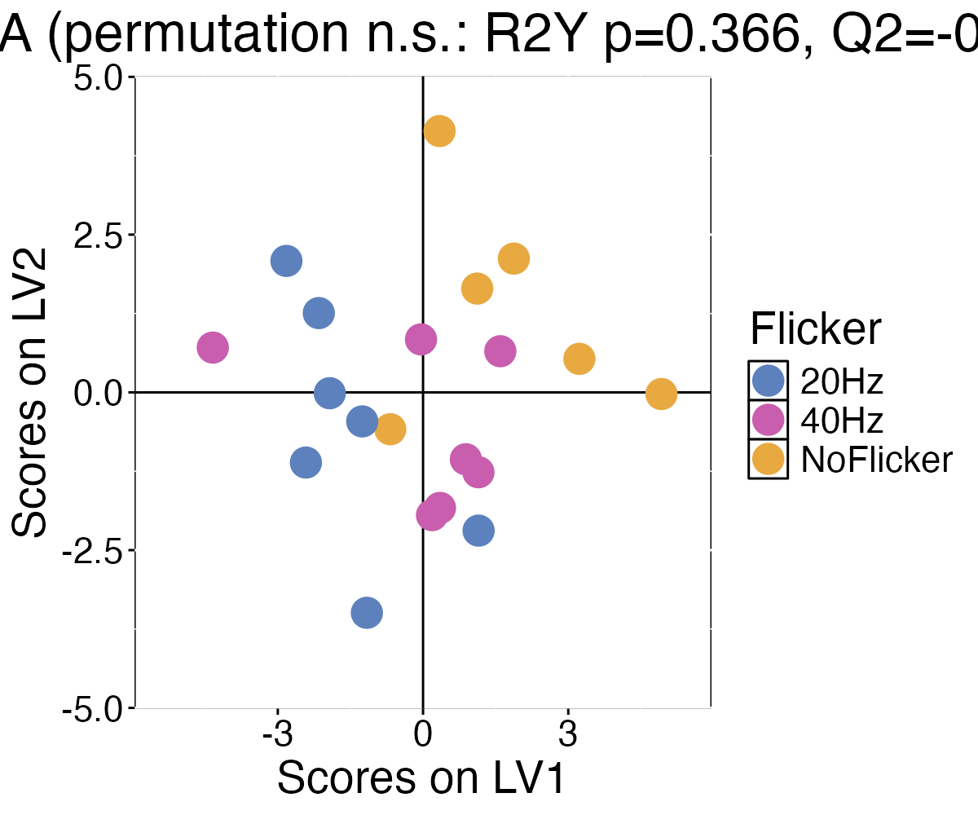
Revised Fig 2C (WT PLS-DA) — file Fig2C_plsda_scores_WT.png. Scores shown for visualization only. The model does not pass permutation testing (leave-one-out accuracy 0.25 vs chance 0.33, p(permutation) = 0.59; R²Y p = 0.43, Q² = −0.52); the old LV-score t-test p-values are removed.

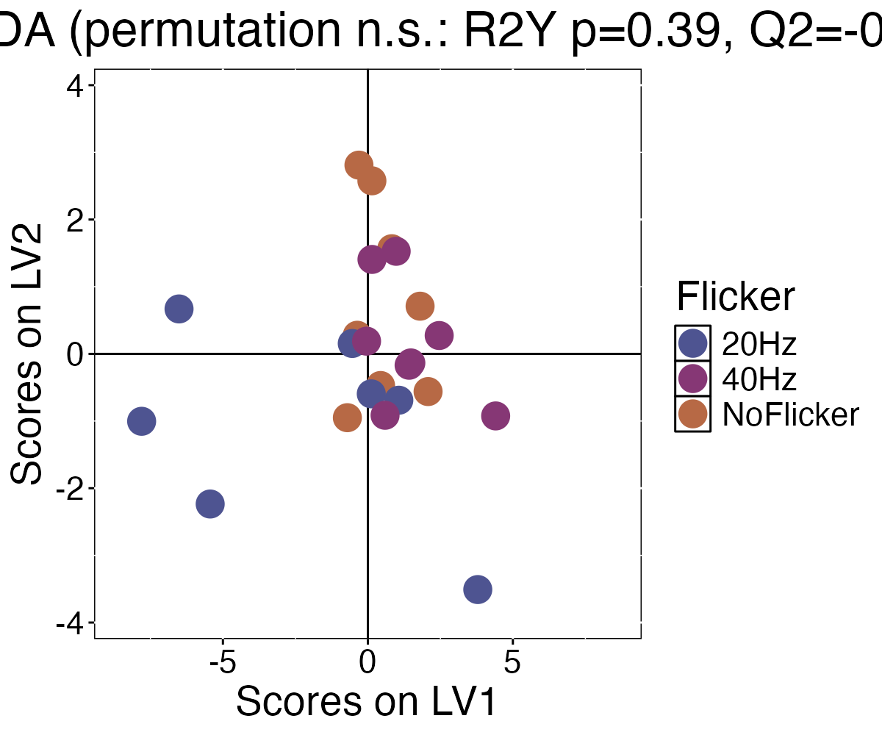
Revised PLS-DA (5xFAD) — file Supp4B_plsda_scores_5XFAD.png. Also non-significant by permutation (accuracy 0.30 vs chance 0.33, p(permutation) = 0.38; R²Y p = 0.44). Loadings with LOOCV error bars: Fig2D_loadings_WT_LV1/LV2.png and Supp4B_loadings_5XFAD_LV1/LV2.png.

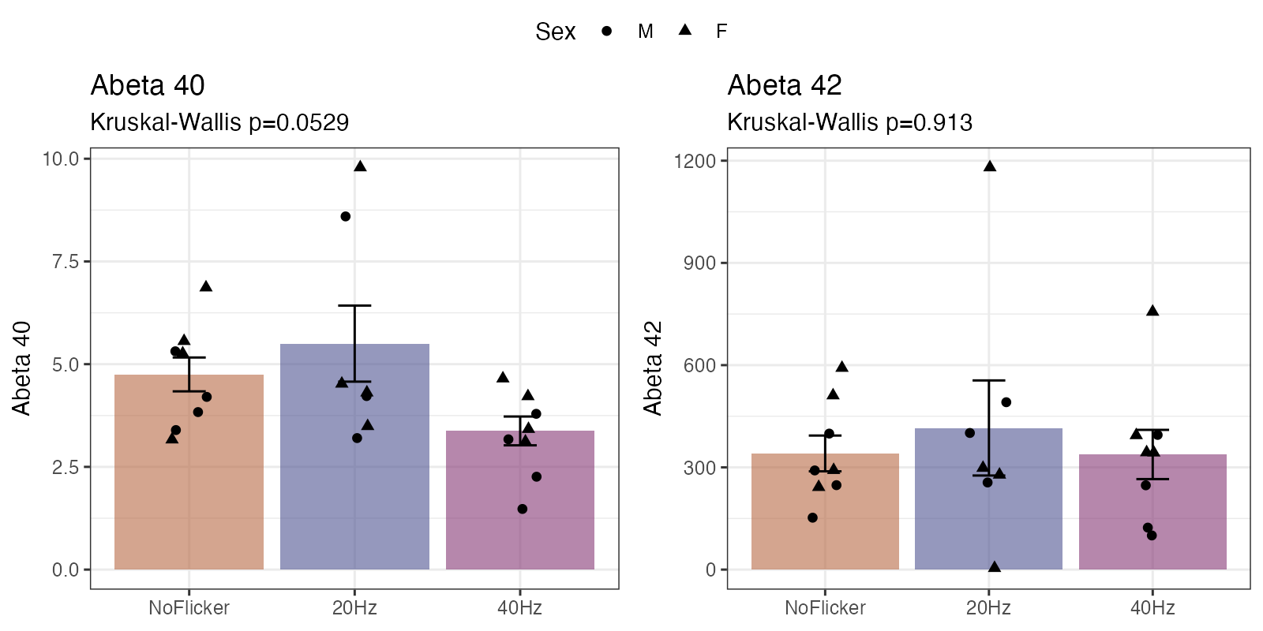
Revised Fig 4B — file Fig4B_amyloid_bars.png. Aβ40 / Aβ42 across flicker in 5xFAD, Kruskal-Wallis + Dunn's. Aβ40 40Hz vs No Flicker is p = 0.060 (was 0.024) — no longer significant. Unchanged from round 1; amyloid does not depend on the cytokine panel.

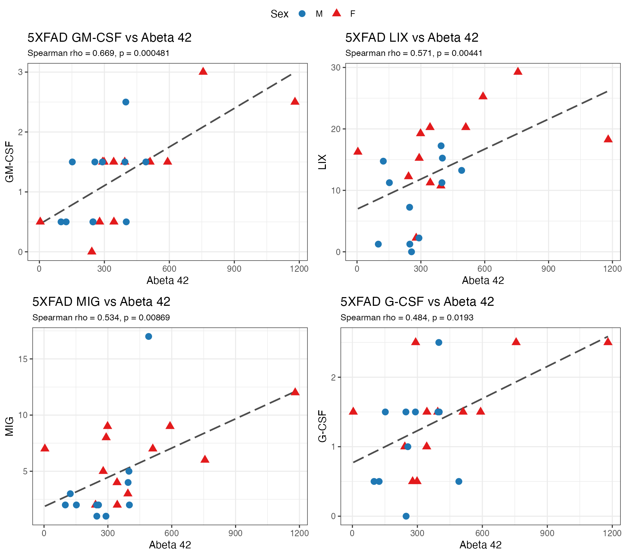
Revised Fig 4C — file Fig4C_cytokine_amyloid_heatmap.png. Cytokines vs Aβ40/Aβ42, ρ printed in each cell; rows are the 5xFAD key cytokines plus any analyte reaching p < 0.05. Statistic is Spearman; FDR is across the 16 retained analytes per marker. Nothing survives correction (LIX and MIG ~ Aβ42 both q = 0.069), so no cell carries an asterisk.

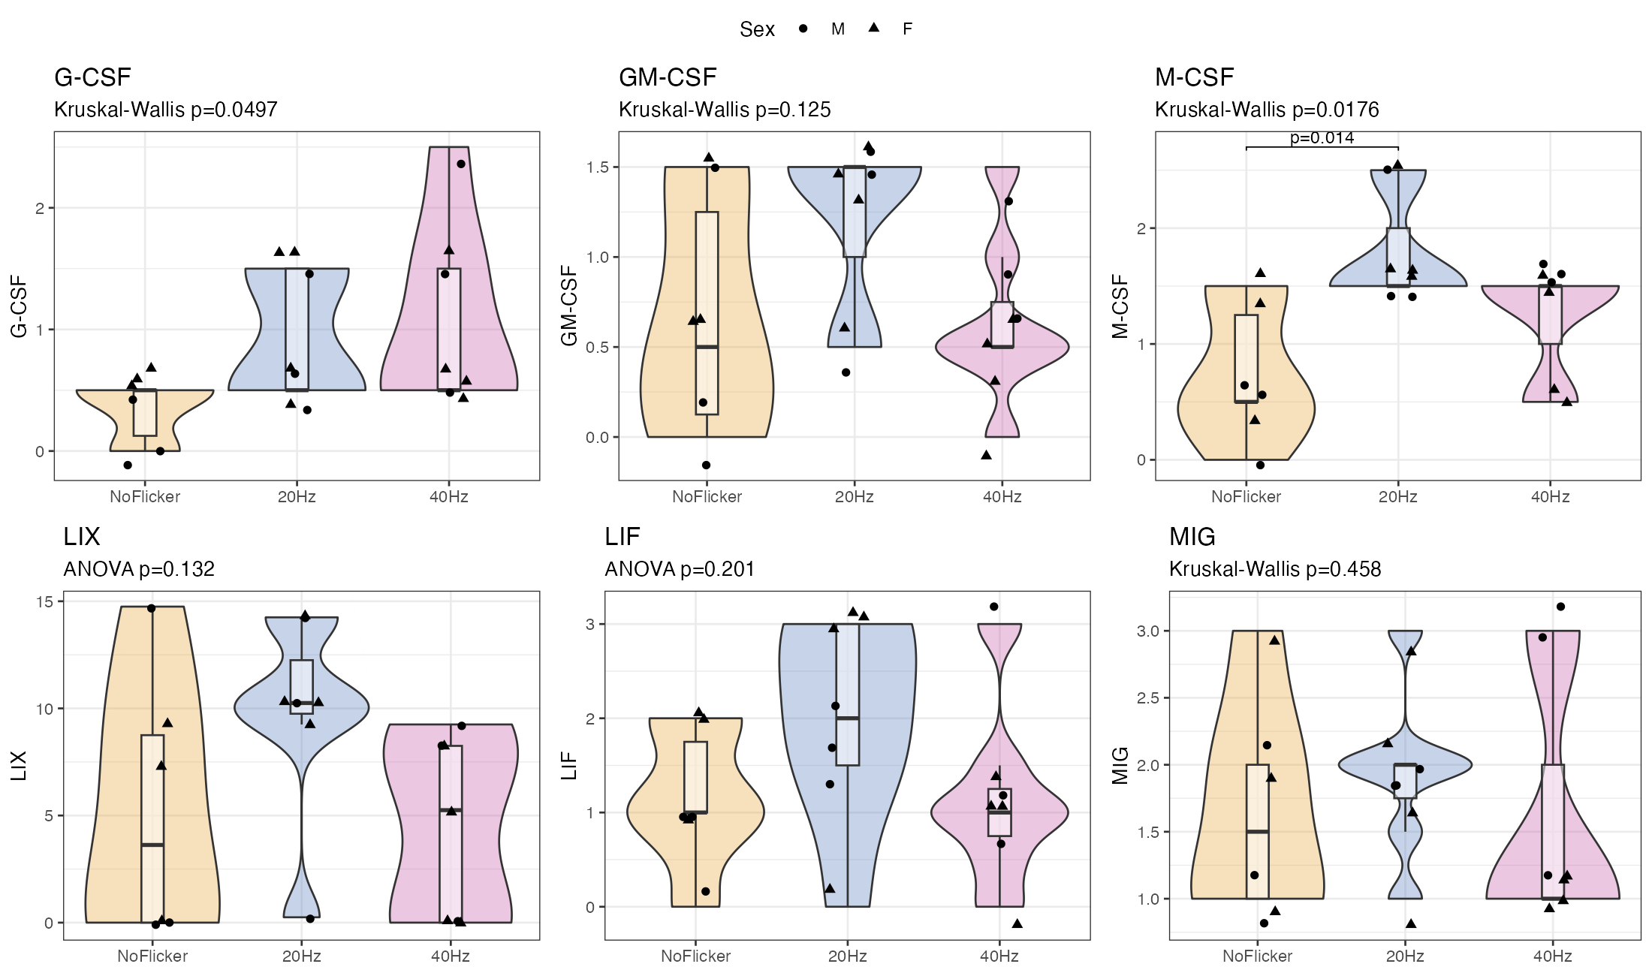
Revised Supp Fig 5 (WT key cytokines) — file Fig_key_cytokines_WT.png. The top 3 analytes on LV1 and LV2 (IL-1B, IL-10, IP-10, KC, MIP-1a, VEGF), Anderson-Darling gated ANOVA+Tukey / KW+Dunn's. No analyte differs between flicker groups.

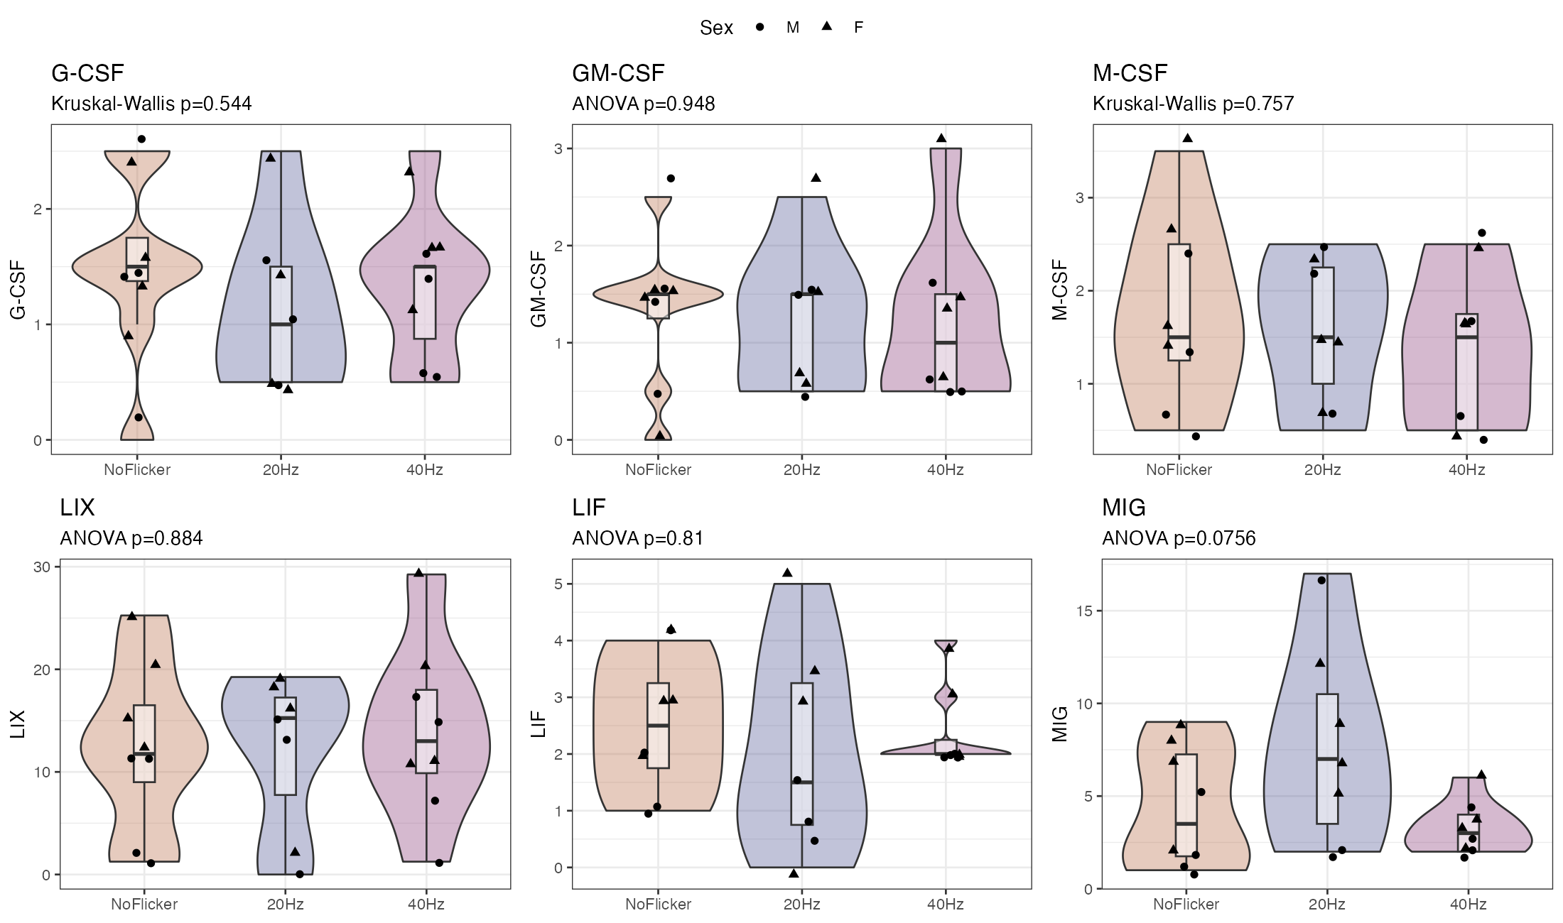
Revised Supp Fig 5b (5xFAD key cytokines) — file Fig_key_cytokines_5XFAD.png. IL-1a, IL-10, IL-17, IP-10, KC, MIP-1a; same corrected tests, no significant differences.

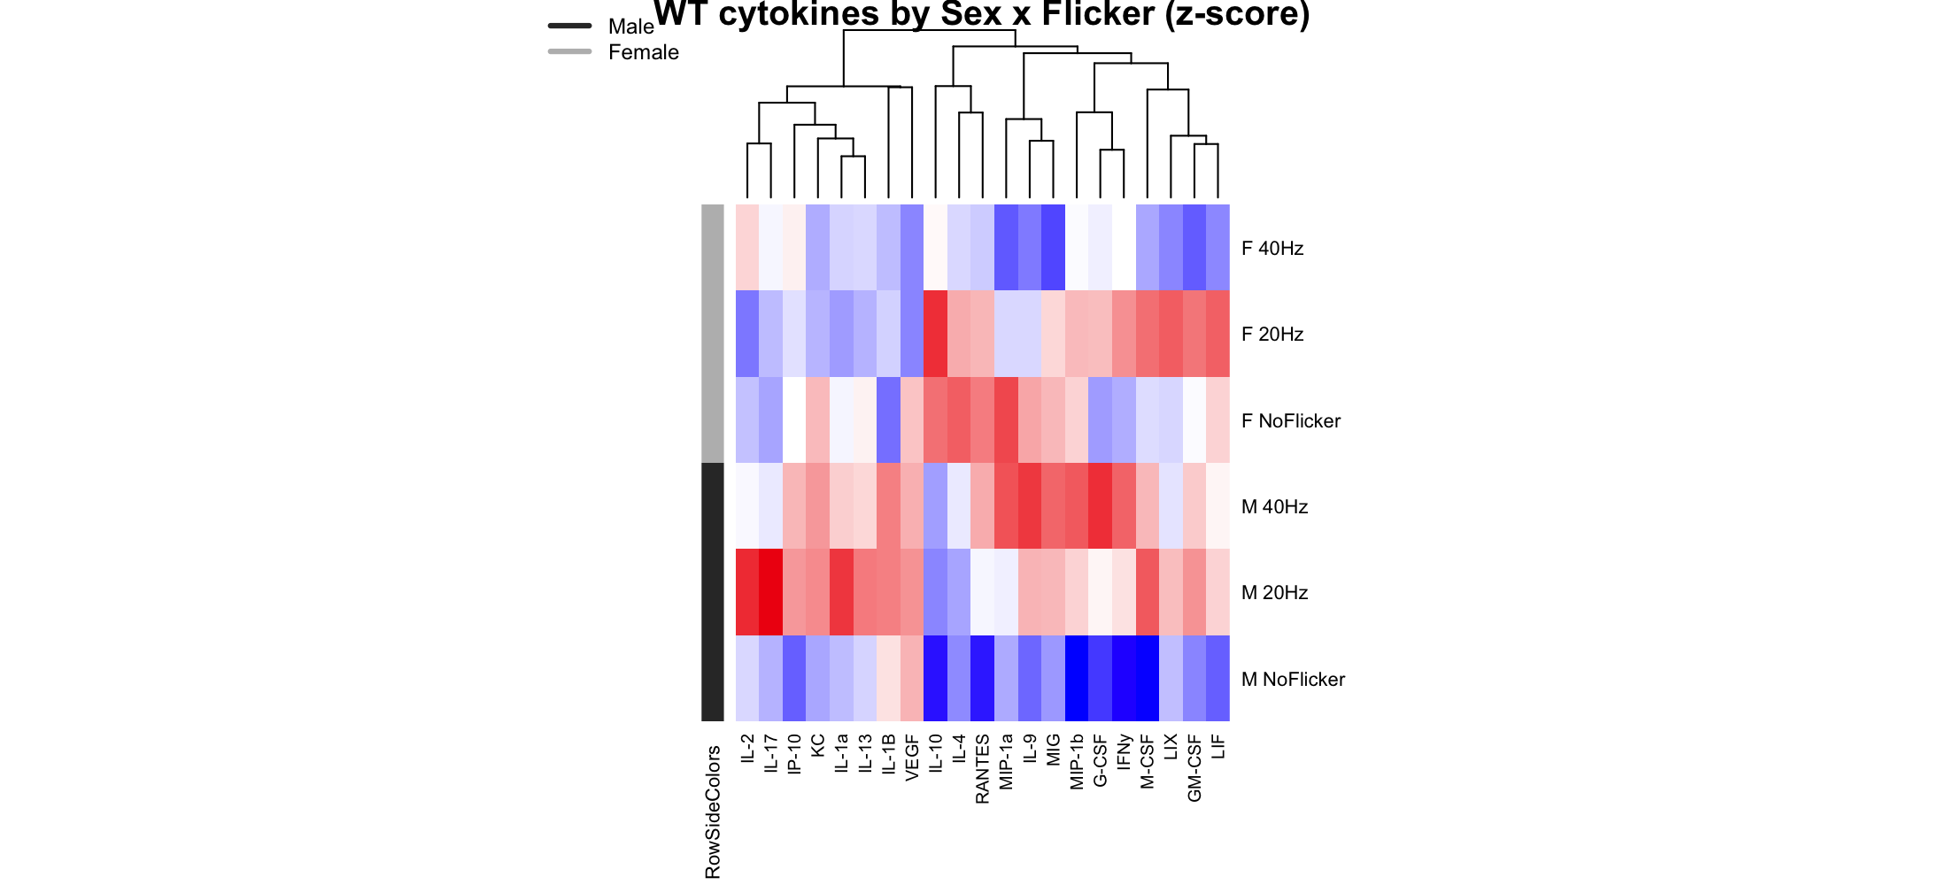
New — WT sex-batched heatmap: cytokine z-scores averaged within each Sex × Flicker group, so male vs female patterns are directly visible (addresses 'are there sex-specific differences / show a batched heatmap').

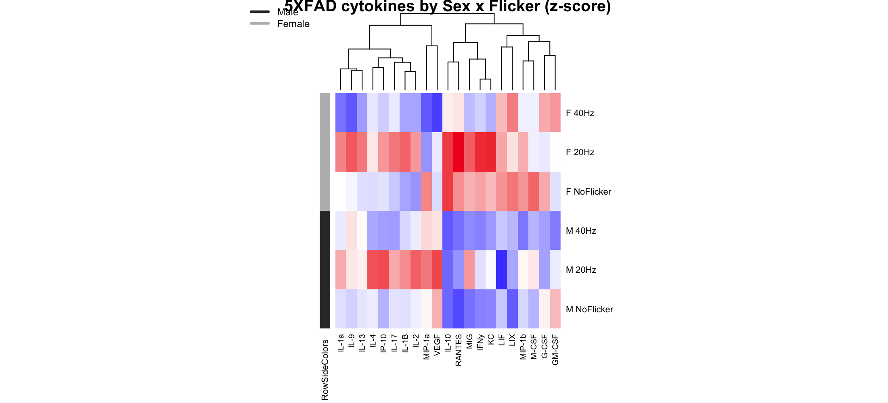
New — 5xFAD sex-batched heatmap (Fig_sexbatched_heatmap_5XFAD.png). New — Supp Fig 6 (Supp6_flicker_responsive_WT.png): WT IFN-γ and female LIX, the only analytes in the retained panel with any flicker contrast under 0.05. New — Supp Fig 9 (Supp9_myeloid_exploratory_bars.png and Supp9_myeloid_exploratory_detection.png): the four excluded myeloid analytes plus the detection-range panel that justifies excluding them. Also updated — Fig5C/D (Fig5C_cytokine_vs_astro_number.png, Fig5D_cytokine_vs_mg_number.png) and Supp 7 (Supp7A-D), which now show the key cytokines instead of the out-of-range Eotaxin and IL-15.

