Homework 4

CS 361: Programming Languages Principles and Implementations

Weili Zhong
November 5, 2018

Grammars

Due on 10/31

The work has to be done in a group of 2 students.

A hard copy is required. Professional presentation is important.

100 points

Exercise 1:
We consider the BNF grammar below:
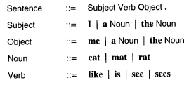
- Show that I like the cat. is recognized by this BNF grammar using a rightmost derivation and, then, a parse tree.
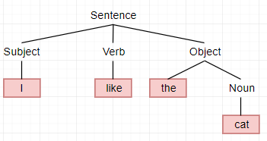
Sentence → Subject Verb Object
→Subject Verb the Noun
→Subject Verb the cat
→Subject like the cat
→I like the cat
- Provide an expression that is NOT recognized by the grammar.
I hate the cat.
Exercise 2:

We consider the following grammar:

EXPRESSION ::= NUMERAL | ( EXPRESSION OPERATOR EXPRESSION )
NUMERAL ::= 0 | 1 | 2 | 3 | 4 | 5 | 6 | 7 | 8 | 9
OPERATORS ::= + | -

Show that (4 - (3 + 2)) is a legal EXPRESSION using a leftmost derivation, and,then, a parse tree.

Expression → (Expression Operator Expression)
→(Numeral Operator Expression)
→(4 Operator Expression)
→(4 - (Expression))
→(4 - (Numeral Operator Expression))
→(4 - (3 Operator Expression))
→(4 - (3 + Expression))
→(4 - (3 + Numeral))
→(4 - (3 + 2))

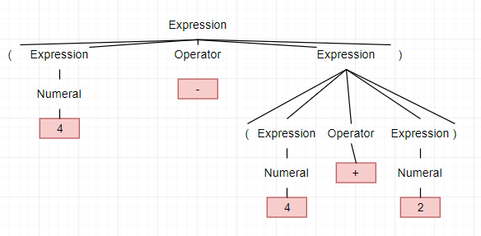

Exercise 3:

Show that the following grammar is ambiguous:

X -> a | bX | bXcX
where a,b,c are terminals.

Ambiguous when there’s multiple ways to get to a certain result. Since bX is a case for bXcX this would make easy to create strings that have multiple ways to arrive to. Such as bacba can be done the in the following:

X → bX
→bXcX
→bacX
→bacba

X→bXcX
→bXcX
→bXcX
→bacX
→bacba

Exercise 4:

- Design a BNF grammar that recognizes expressions of the form Ai where A is in {a,b,c} and i is a digit.
EXPRESSION ::= LETTER | DIGIT
LETTER ::= a | b | c | …. | z
DIGIT ::= 1 | 2 | 3 | 4 | 5 | 6 | 7| 8 | 9 | 0

- Design a BNF grammar that recognizes lists of the form A1, A2, A3, …, An. Use question a).
EXPRESSION ::= SET | EXPRESSION , SET
SET ::= LETTER DIGIT
LETTER ::= |a| b| c
DIGIT ::= 1 | 2 | 3 | 4 | 5 | 6| 7 | 8 | 9 | 0

- Write a BNF grammar and a regular expression that describes the structure of US telephone numbers, which can either be (xxx)xxx-xxxx or xxx-xxxx, where x is a digit from 0 to 9.
<telephonenumber>::=(<digit><digit><digit>)<digit><digit><digit><digit><digit>
<digit><digit> | <digit><digit><digit>-<digit><digit><digit><digit>
<digit> ::= 0|1|2|3|4|5|6|7|8|9

Exercise 5:

Do the online exercises here: https://regex.sketchengine.co.uk/ and report your answers.

- .*p.t.*
- .*ap.?t*
- (r|b)|(f|a)+fg+.*(f|k|h).*
- .*s\. .*|.*g\. .*|.*\? .*|.*\." .*|.*! .*|.*!' .*|.*\) .*

Exercise 6:

- Write a JAY program that computes the sum of the n first numbers with a loop.
void main (){
int n = 7; // n numbers
int sum;
int counter = 1;

while (counter <= n){
sum = sum + counter;
counter = counter - 1;
}
- Write a JAY program that assigns the minimum of two numbers in a variable called min.
void main (){
int num1 = 7
int num2 = 3
int min;

if(num1 <= num2){
min = num1;
}
else {
min = num2;
}
}
- Provide 2 examples of lexical errors in JAY.
- ^
- ~

- Provide 2 examples of JAY programs with 2 different syntax errors.
- 1 ++ 2
- true = 2

- Provide 2 examples of JAY programs with errors that are neither detected during the lexical analysis nor during the syntactic analysis.
- void main() { // Divide by 0 Error
int i = 5;
int n = 0;
int quotient;

quotient = i / n;
}

- void main() {
boolean i = 1; // Assigning boolean to digit Error
}

