作业8

求以下多段图的最短路径，写出求解过程

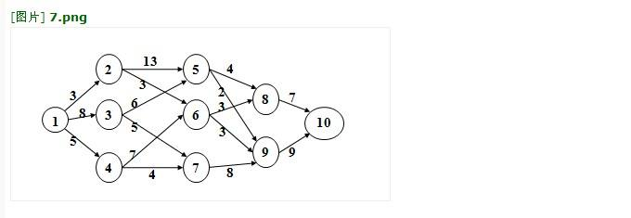

(1) 动态规划函数为：

*d*(*j*) = min(*d*(*s*)+*cs*,*j*)

其中，s是与j存在有向边<s,j>的点集

(2) 初始值为：

d(2)=3, d(3)=8, d(4)=5

(3) 填表：

|  |  |  |  |  |  |  |  |  |  |  |
| --- | --- | --- | --- | --- | --- | --- | --- | --- | --- | --- |
|  | 1 | 2 | 3 | 4 | 5 | 6 | 7 | 8 | 9 | 10 |
| d(j) | 0 | 3 | 8 | 5 | 14 | 6 | 9 | 9 | 9 | 16 |
| path | -1 | 1 | 1 | 1 | 3 | 2 | 4 | 6 | 6 | 8 |

结论：最短路径为：1🡪2🡪6🡪6🡪10，路径长度为16