Want a meeting with Dr Williamson?
Book one on my calendar here:
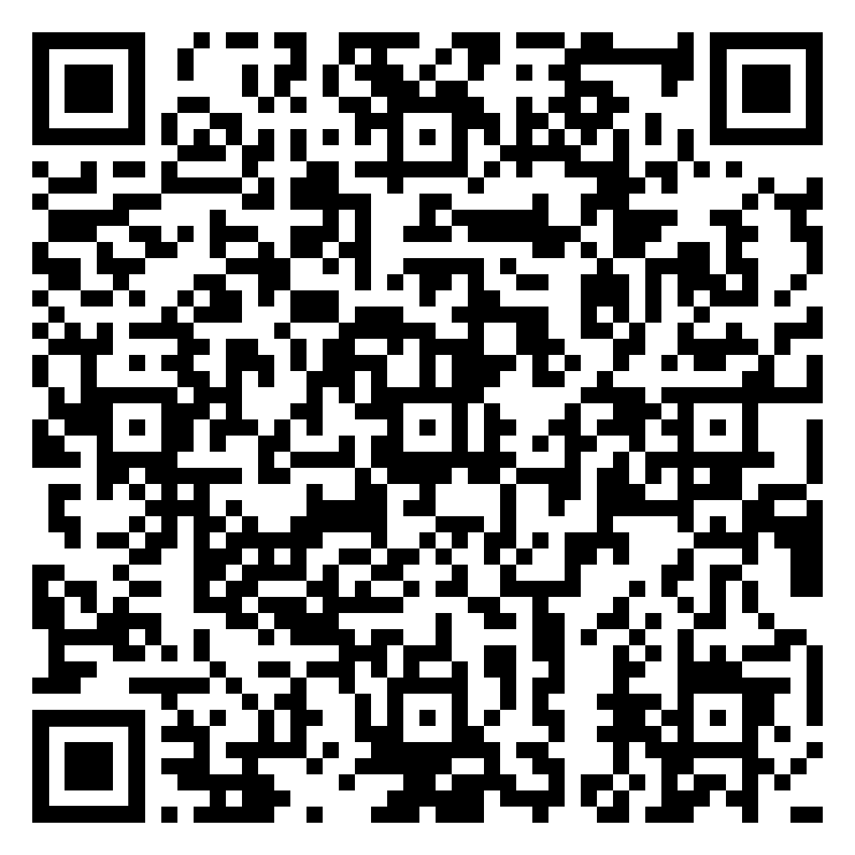
Or use this link: www.tinyurl.com/RJW-bookings
(QR codes are spooky)

