**PROJECT Home Computer Specifications**

**Objective** To investigate the specifications associated with purchasing a home computer.

***PROJECT DESCRIPTION***

What are the specifications behind purchasing a typical home computer system?

That is what will be researched in this lab project.

***Information About this Project***

This project reviews the typical specifications of a home computing system.

***Steps To Complete This Project***

**STEP 1 Open a New MS Excel Worksheet**

Open MS Excel and a new worksheet. Use the worksheet to answer each of the following questions according to the given instructions.

**STEP 2 How Much Processing Speed?**

The first number generally associated with a home computer is the CPU

( central processing unit ) clock or processing speed, typically measured in gigahertz. One gigahertz ( GHz ) , written in standard notation, represents 1,000,000,000 or one billion cycles per second. 3.5 GHz , in standard notation, represents 3,500,000,000 cycles per second.

In your Excel worksheet, type the word **gigahertz** in cell A1 . Then in cell B1 , write, in standard notation, using zeros and commas and without a decimal point, the clock speed specification of 4.2 gigahertz. Adjust your Column B width, if necessary.

**STEP 3 Memory Considerations**

The second most popular numerical specification of a typical home computer is random - access memory or RAM , usually measured in megabytes or gigabytes   
 ( where 2 20 bytes represents an exact megabyte and 2 30 represents an exact gigabyte ) .

If a computer currently has 512 megabytes of RAM memory and has a capacity of 1.024 gigabytes of RAM , how much more RAM memory, in exact megabytes can be added to the computer without exceeding the capacity?

In your Excel worksheet, type the word **RAM** in cell A2 . Then in cell B2 , enter a numerical expression that computes the answer to the above question.

**STEP 4 Communication**

Home computers may often be equipped with a dial - up modem, usually rated at 56.6 kbps ( kilobits per second ) where eight bits ( binary digits ) equals one byte of memory. How long will it take to transfer a 3.5 megabyte MP3 music file through a 56.6 kbps modem? To answer this question, proceed as follows.

In your Excel worksheet, type the word **modem** in cell A3 . Then in cell B3 , enter a numerical expression that computes the answer to the above question.

**STEP 5 Computer Files**

USB portable hard drives are handy peripheral devices for storing and retrieving documents. If a USB portable hard drive has a 2 gigabyte capacity, about how many word processing documents ( average files size is 250 kilobytes ) can be stored on the portable drive if ten percent of the drive is to be free?

In your Excel worksheet, type the word **USB** in cell A4 . Then in cell B4 , enter a numerical expression that computes the answer to the above question.

**PROJECT Home Computer Specifications**

**STEP 6 Surge Protection**

A good device to complete a home computing system is a power surge protector, usually rated in joules. If you originally have a 960 joule surge protector and upgrade to one rated as 1,200 joules, what percent increase is this?

In your Excel worksheet, type the word **Joules** in cell A5 . Then in cell B5 , enter a numerical expression that computes the answer to the above question.

**STEP 7 Aspect Ratio**

An important consideration when purchasing a monitor is the monitor’s aspect ratio. The aspect ratio is the ratio between the width of the picture and the height of the picture. A normal TV's aspect ratio is 4 : 3 ( 1.33 : 1 ) , in other words, the film image is 1.33 times as wide as it is tall, which is often denoted

by 4 × 3 , meaning 4 units of width for every 3 of height. Newer TVs may even have a 16 : 9 aspect ratio.

If a computer monitor has an aspect ratio of 4 : 3 and it is 12 inches wide, what is the height of the picture?

In your Excel worksheet, type the word **aspect** in cell A6 . Then in cell B6 , enter a numerical expression that computes the answer to the above question.

**STEP 8 Digital Subscriber Line ( DSL )**

A particular DSL service provides 6 mbps of downloading capacity and 512 kbps

for uploading capacity.

What is the difference, in kbps, between the upload and download capacities?

In your Excel worksheet, type the word **DSL** in cell A7 . Then in cell B7 , enter a numerical expression that computes the answer to the above question.

**STEP 9 Power Supplies**

The average power supply for a home computer system is 400 watts. If power, measured in watts, is the multiplicative product of voltage and current, measured in volts and amperes, respectively, how many amperes of current will be drawn by a power supply of 400 watts through a household voltage of 120 volts?

In your Excel worksheet, type the word **watts** in cell A8 . Then in cell B8 , enter a numerical expression that computes the answer to the above question.

**STEP 10 DVD - ROM**

The data transfer rate of a DVD drive is given in multiples of 1,350 kB / s , which means that a drive with 16 x speed designation allows a data transfer rate of

16 × 1,350 = 21,600 kB / s ( 21.09 MB / s when using 1 KB = 1,024 bytes ).

Assume a uniform linear data transfer rate, what would be the transfer rate for a 32 x speed designation?

In your Excel worksheet, type the word **DVD** in cell A9 . Then in cell B9 , enter a numerical expression that computes the answer to the above question.

**STEP 11 Hard Disk Capacity**

If a typical internal hard drive has 120 gigabytes of memory, what would double this capacity be in terms of megabytes?

In your Excel worksheet, type the word **hard disk** in cell A10 . In cell B10 , enter a numerical expression to compute the answer to the above question.

**STEP 12 Submit Your Worksheet**

Enter your name within the worksheet and submit a copy of it for credit.

**PROJECT Home Computer Specifications**

**Step 13 Questions and Answers Concerning this Computer Laboratory Project**

Open MS Word and, within a new document, place your responses to these questions. Submit your completed MS Word document for credit.

**(1) ( Surge Protection, Physics and Computers: Units of Power )**

Review the Web links below on information about surge protection for computer equipment.

<https://www.homedepot.com/c/surge_protector_buying_guide_HT_BG_EL>

<https://www.britannica.com/science/joule>

Surge protectors are often rated in units of Joules.

Use the link below to convert 960 Joules to an English measurement in foot - pound units.

<https://www.thecalculatorsite.com/conversions/energy.php>

**(2) ( Aspect Ratio )**

A Blu - Ray DVD shows these video format specifications:

1080 p 16 x 9 2.4 : 1

What is the interpretation of these video format specifications?

You can review the link below for some information on this subject.

<https://answers.yahoo.com/question/index?qid=20090408142225AAtAslE&guccounter=1>

**(3) ( Speed Test )**

Visit the link below and perform a speed test on your computer’s online connection.

<http://speedtest.xfinity.com/>

Take a snapshot of your results, which should look similar to this image.

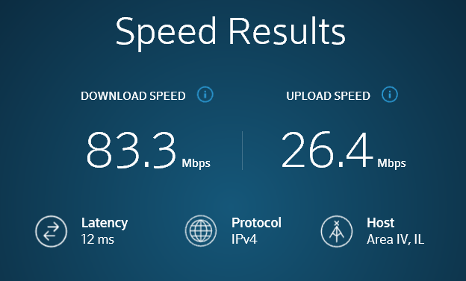

**PROJECT Home Computer Specifications**

**(4) ( Power Supplies )**

In electronics, power *P* is measured as *P* = *V* × *I* where *V* is the voltage, measured in volts, and *I* is the current, measured in amperes.

Determine the electric power produced by a supply at 110 volts and a current of ( 3 / 2 ) amperes.

**(5) ( Hard Disk Capacity )**

A certain hard drive has a capacity of 125 gigabytes. What would be its equivalent capacity in terabytes?