Robert Williams

Lab 4 – Numbers, Codes and Ciphers

1. MOD 11

What is meant by a MOD 11 operation?

This operation means that a number will be divided by 11, and the mod will be the remainder after the division is complete.

1. MOD Operations

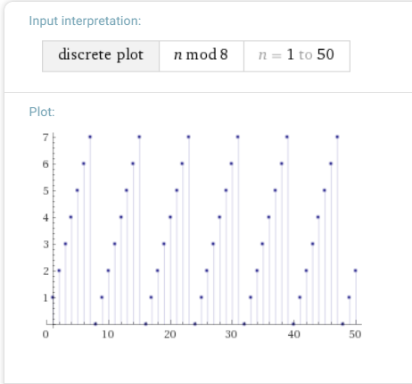

1. The MS Excel MOD Function

=MOD(8,0) will return an error

1. The MS Excel MOD Function

MOD(20, 7) = 6

20 – 7 \* INT(n/d) = 6

1. Computer Programming and the MOD Operation

**System.*out*.println(" first " + (29 % 5)); = first 4**

**System.*out*.println(" second " + (7 % 9)); = second 7**

**System.*out*.println(" third " + (-73 % 37)); = third - 36**

**System.*out*.println(" fourth " + (13 + 31 % 4)); = fourth 16**

**System.*out*.println(" fifth " + (19 % 61 % 3)); = fifth 1**