**PROJECT Windows Command Prompt Network Monitoring Tools**

**Objective** To familiarize you with various network commands using the Windows OS .

***PROJECT DESCRIPTION***

Explore the world of the Windows Command Prompt and network monitoring.

***Information About this Project***

Through the Windows Command Prompt computer operators can use the various features available with Windows to monitor network activity and examine PC settings. These features and functions yield important information pertaining to computer architecture and organization.

***Steps to Complete this Project***

**STEP 1 Launch the Command Prompt Window**

Open the Command Prompt Window by pressing the [ Windows Logo ] button, selecting [ R ] , and within the text field of the **Run** window, entering the text **cmd** and clicking OK .

Note: some of the following commands may not be available on a particular PC .

**STEP 2 Explore the help Command**

When the **Command Prompt** window opens, type the following command at the prompt and press Enter .

**help | more**

Browse through the various commands available on your system.

**STEP 3 Clear the Screen**

At the Command prompt, type the following command and press Enter .

**cls**

Observe that your screen is now clear and ready for more commands.

**STEP 4 Explore the ipconfig Command**

At the Command prompt, type the following command and press Enter .

**ipconfig**

Note your computer’s IP address.

At the Command prompt, type the following command and press Enter .

**ipconfig /renew**

Did your computer’s IP address change?

At the Command prompt, type the following command and press Enter .

**ipconfig /all**

Observe the information returned by this command.

**STEP 5 Explore the ping Command**

At the Command prompt, type the following command and press Enter .

**ping www.yahoo.com**

Note the information returned by this command.

Copy the information by clicking the prompt icon on the upper left corner of the window. Within the menu, point to Edit and select Mark . Use your mouse to select the complete ping statistics. With the ping statistics highlighted, click again the prompt icon on the upper left corner of the window. Within the menu, point to Edit and select Copy .

Paste the ping results into an MS Word document and label the pasted section accordingly.

**STEP 6 Explore the tracert Command**

At the Command prompt, type the following command and press Enter .

**tracert www.cnn.com**

**PROJECT Windows Command Prompt Network Monitoring Tools**

Observe the results of the command and paste the results in your MS Word document. Label the pasted section accordingly.

**STEP 7 Explore the netstat Command**

At the Command prompt, type the following command and press Enter .

**netstat**

Observe the results of the command and paste the results in your MS Word document.

At the Command prompt, type the following command and press Enter .

**netstat -n**

Observe the results of the command and paste the results in your MS Word document.

**STEP 8 Explore the regedit Command**

At the Command prompt, type the following command and press Enter .

**regedit**

If the command is available, explore the resulting **Registry Editor** window.

Expand the HKEY_USER node and take a screen snapshot of the contents of this section of the editor. Place the screen snapshot into your MS Word document.

**STEP 9 Explore the finger Command**

Determine the IP address of another computer on your network.

At the Command prompt, type the following command and press Enter .

**finger 10.0.1.101**

Note: the above command uses a sample IP address, your address could differ.

Observe the results of the command and paste the results in your MS Word document.

After the command returns information to you, use Ctrl + C to return to the command prompt.

**STEP 10 Explore the defrag Command**

At the Command prompt, type the following command and press Enter .

**defrag c:**

Observe the results of the command and paste the results in your MS Word document.

**STEP 11 Explore the mmc Command**

At the Command prompt, type the following command and press Enter .

**mmc**

Take a screen snapshot of the console and paste it into your Word document.

**STEP 12 Explore the systeminfo Command**

At the Command prompt, type the following command and press Enter .

**systeminfo**

Observe the results of the command and paste the results in your document.

**STEP 13 Explore the tasklist Command**

At the Command prompt, type the following command and press Enter .

**tasklist /svc**

Observe the results of the command and paste them in your Word document.

**STEP 14 Submit Your MS Word Document**

Ensure that your Word document, containing your screen snapshots and other items, is properly label. Submit a copy of the document for credit.

**PROJECT Windows Command Prompt Network Monitoring Tools**

**STEP 15 Questions and Answers Concerning this Computer Laboratory Project**

Open MS Word and, within a new document, place your responses to these questions. Submit your completed MS Word document for credit.

**(1) ( Command Prompt Properties )**

Open the Windows Command Prompt on your computer.

Right - click on the Command Prompt icon to open the **Command Prompt Properties** dialog box, which should appear similar to that shown below.

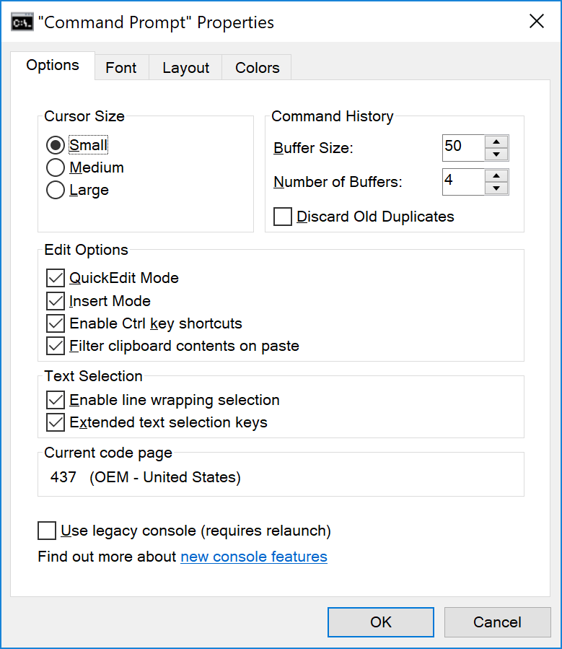

Under the [ Options ] tab, click the " new console features ", which usually opens a Web link such as:

<https://docs.microsoft.com/en-us/previous-versions/orphan-topics/ws.11/mt427362(v=ws.11)>

Examine a new console features item at that Web link and write a brief but complete summary about it.

**(2) ( The start Command )**

Using the Windows Prompt " start " command try to open the Windows Media Player, which is identified by this executable: wmplayer

Take a screen snapshot of the Windows Media Player after it opens.

**PROJECT Windows Command Prompt Network Monitoring Tools**

**(3) ( Redirecting to a File )**

The Windows Command Prompt has two redirection operators:

*redirection operator description*

> file is created if it does not exist and file is overwritten if it does exist

>> file is created if it does not exist and file is appended if it does exist

**[ Example ( Create or Overwrite a File ) ]**

**C:\Users\papad>date /t > c:\temp\dates.txt**

**[ Example ( Create or Append a File ) ]**

**C:\Users\papad>date /t >> c:\temp\dates.txt**

Using the above information, create a new file on your computer that uses the Windows Command Prompt command " systeminfo " to write your computer’s System Information to a file named: myPCinfo.txt

Submit a screen snapshot segment of your file contents.

**(4) ( Who am I )**

Often, when logged on a publicly used computer terminal, a user will wish to know some information about who they are on the network.

Try using the " whoami " command to identify yourself on your computer system.

**(5) ( Various Windows Prompt Commands )**

Try using these various prompt commands and observe the results. Take screen snapshots of a segment of your results to submit for credit.

(a) **doskey /history**

(b) **assoc | more**

(c) **tasklist**

(d) **tree**

(e) **nslookup yahoo.com**