**PROJECT Mathematics and Network Communications 100 Points __ *your score***

**Objective** To investigate the mathematics associated with computing systems.

***PROJECT DESCRIPTION***

What is the mathematics behind networking and communications? That is what will be researched in this lab project.

***Information about This Project***

Computer mathematics includes the study of topics such as bits and bytes and binary and hexadecimal numbers as well as a look into transmissions speed of data files.

***Steps To Complete This Project***

**STEP 1 Launch MS Excel**

Open a new MS Excel worksheet. Onto the new worksheet, copy the spreadsheet segment given below.

|  |  |  |  |  |  |
| --- | --- | --- | --- | --- | --- |
|  | A | B | C | D |  |
| 1 | ***Binary*** | ***Decimal*** | ***Hexadecimal*** |  |  |
| 2 |  |  | **BD** |  |  |
| 3 | **11010011** |  |  |  |  |
| 4 |  | **72** |  |  |  |
| 5 |  |  | **C** |  |  |
| 6 | **01011011** |  |  |  |  |
| 7 |  | **276** |  |  |  |
| 8 |  |  | **AFA** |  |  |
| 9 | **10001001** |  |  |  |  |
| 10 | **10100010** |  |  |  |  |
| 11 |  | **327** |  |  |  |
| 12 |  | **2021** |  |  |  |
| 13 |  |  | **DAD** |  |  |
| 14 |  |  | **EFF** |  |  |
| 15 |  |  |  |  |  |

**STEP 2 Formulate Your Worksheet**

Various numbers have been placed in the cells according to the number type. Using the Windows Calculator, in the Programmer View , convert the given number into the other number equivalents. For example, if the number given in the column labeled binary is 10010001 , you will find that the number is 145 in decimal format and 91 in hexadecimal format.

A screen snapshot of the Windows Calculator is given below.

**PROJECT Mathematics and Network Communications**

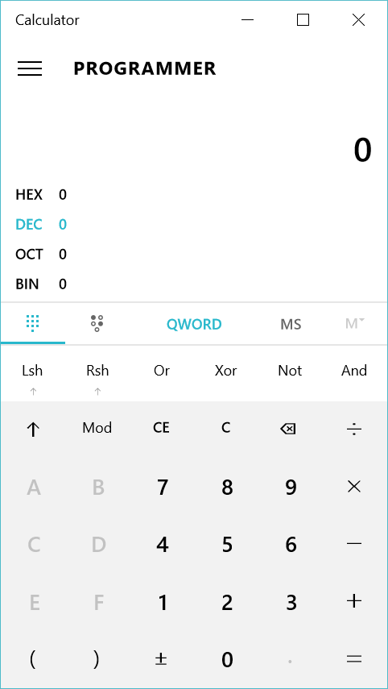

You can also use the WolframAlpha computational engine to perform number system conversions. For example, if the number given in binary is 10010001 , you can convert it to decimal or hexadecimal as follows:

**binary to decimal 10010001**

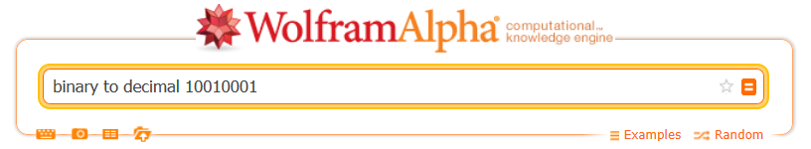

**binary to hexadecimal 10010001**



**PROJECT Mathematics and Network Communications**

**STEP 3 Negative Binary Numbers ( Two's Complement )**

Binary numbers can be negative ( unsigned ) , but do not display a negative sign when the subtrahend exceeds the minuend. Try using the Windows Calculator

( set to Bin and Byte ) and subtract 100 by 101 . Observe the result.

Show how the decimal number − 3,173 would be expressed as a 16 - bit binary integer using **two's complement** notation. Remember for binary addition use these rules: 0 + 0 = 0 , 1 + 0 = 1 , 0 + 1 = 1 and 1 + 1 = 10 ( the 1 is the " carried " number ) .

Hint: first create the complement of the binary number, substitute a 0 for a 1 and a 1 for a 0 , and then add a 1 to this complement binary number.

**(1)** write the original decimal number in a binary number format

|  |  |  |  |  |  |  |  |  |  |  |  |  |  |  |  |
| --- | --- | --- | --- | --- | --- | --- | --- | --- | --- | --- | --- | --- | --- | --- | --- |
|  |  |  |  |  |  |  |  |  |  |  |  |  |  |  |  |

**(2)** change the numbers: a 1 becomes a 0 , a 0 becomes a 1

|  |  |  |  |  |  |  |  |  |  |  |  |  |  |  |  |
| --- | --- | --- | --- | --- | --- | --- | --- | --- | --- | --- | --- | --- | --- | --- | --- |
|  |  |  |  |  |  |  |  |  |  |  |  |  |  |  |  |

**(3)** add 1 to the result in **Step 2** above

|  |  |  |  |  |  |  |  |  |  |  |  |  |  |  |  |
| --- | --- | --- | --- | --- | --- | --- | --- | --- | --- | --- | --- | --- | --- | --- | --- |
|  |  |  |  |  |  |  |  |  |  |  |  |  |  |  |  |

Enter the result within your worksheet.

**STEP 4 Network Communications**

Logarithm functions can be used to illustrate intensity.

A broadcasting output signal for a Chicago based radio station is 10,000 watts. However, a radio station located in another state and 170 miles away from the Chicago station, is broadcasting at 5,000 watts. People in Chicago can hear " static " and or music from the other station, especially at night.

Using the " power ratio expression, " which gives an indication as to the strength of a signal ( in decibels ) , dB = 10 × ( log **10** [ Signal 1 / Signal 2 ] ) calculate the dB for this situation. This will give an indication on the amount of the signal   
 ( the radio station we want to hear ) to " noise " ( the radio station we do not want to hear ) . Let Signal 1 be the value for the Chicago station.

Use your current worksheet to show your calculations.

**STEP 5 Network Communications**

Everyone likes to download ( legally, of course ) ! But some users download at a faster speed than others. Download speeds can be as slow as dial - up: 56,600 bits per second ( bps ) ; or the download speeds can be as fast as 1.54 megabits per second ( Mbps ) if one has a DSL line or a cable - modem.

In a manner similar to the template below, use your current worksheet to determine approximately how long, in minutes, it will take to send a 120 megabyte file through a 56.6 kbps modem.

Use your current worksheet to show your calculations.

**PROJECT Mathematics and Network Communications**

|  |  |
| --- | --- |
|  |  |
| 120,000,000 | bytes |
|  |  |
| × |  |
|  |  |
|  | number of bits in one byte |
|  |  |
| = |  |
|  |  |
|  | bits |
|  |  |
| ÷ |  |
|  |  |
| 56,600 | bits per second |
|  |  |
| = |  |
|  |  |
|  | seconds |
|  |  |
| ÷ |  |
|  |  |
|  | seconds in one minute |
|  |  |
| = |  |
|  |  |
|  | minutes |

Give the template below, use your worksheet to approximate how many minutes it will take to send a 120 megabyte file through a 760 Kbps DSL modem.

|  |  |
| --- | --- |
|  |  |
| 120,000,000 | bytes |
|  |  |
| × |  |
|  |  |
|  | number of bits in one byte |
|  |  |
| = |  |
|  |  |
|  | bits |
|  |  |
| ÷ |  |
|  |  |
| 760,000 | bits per second |
|  |  |
| = |  |
|  |  |
|  | seconds |
|  |  |
| ÷ |  |
|  |  |
|  | seconds in one minute |
|  |  |
| = |  |
|  |  |
|  | minutes |

**STEP 5 Some Number Theory**

Submit a copy of your Excel worksheet for credit.