* **Method description**

Load image’s paths and labels and sort them to same order. Do one-hot encoding to binarize labels for training. In training phase, dynamically load data by path to avoid memory limit issue. Do the prediction after training and load into a csv file.

* **Experimental results – accuracy**

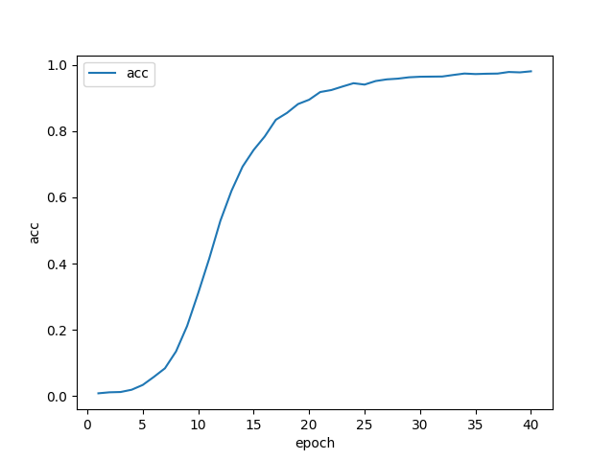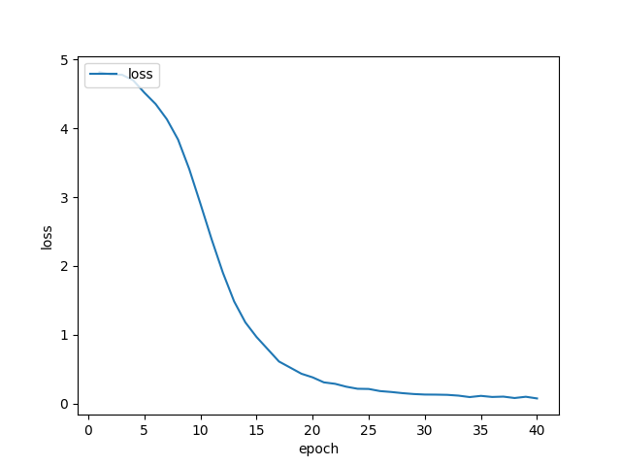

* **Discussion of difficulty or problem encountered**

I load all data together at the beginning, but it always killed by linux OOM. To avoid the problem, I try to load data dynamically, only when model need the data then we load it. It is a python generator-like method.