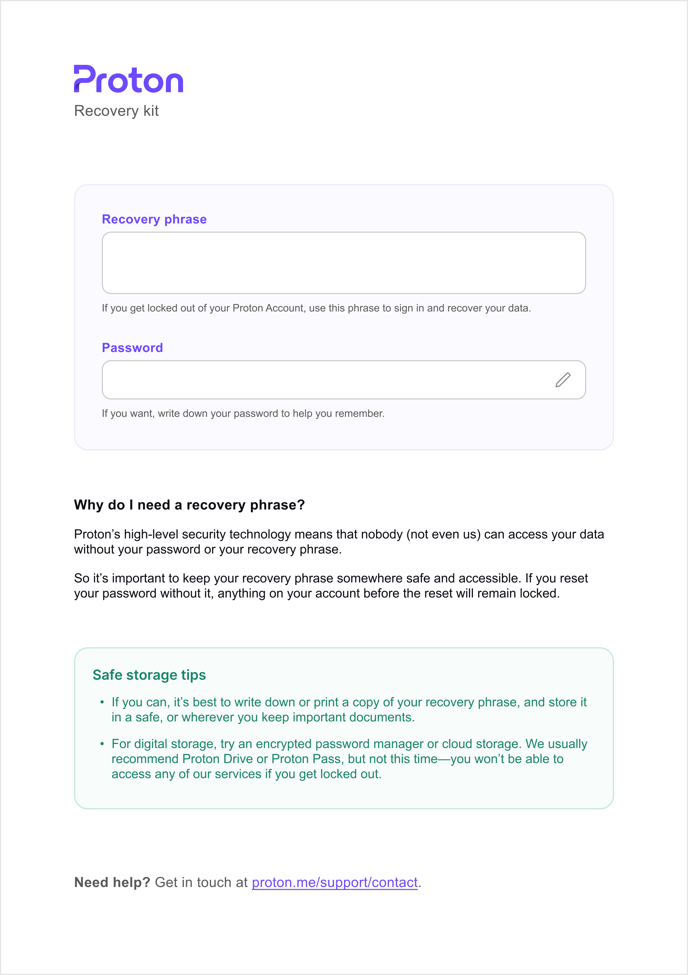
williecreator0626@proton.me
Recovery kit Created on 2026924
Recovery phrase
female caught scorpion hybrid cruel fury
nature broccoli group horse brick found
If you get locked out of your Proton Account, use this phrase to sign in and recover your data.
Password
If you want, write down your password to help you remember.
Why do I need a recovery phrase?
Proton’s high-level security technology means that nobody (not even us) can access your data without your password or your recovery phrase.
So it’s important to keep your recovery phrase somewhere safe and accessible. If you reset your password without it, anything on your account before the reset will remain locked.
Safe storage tips
«If you can, it’s best to write down or print a copy of your recovery phrase, and store it in a safe, or wherever you keep important documents
«For digital storage, try an encrypted password manager or cloud storage. We usually recommend Proton Drive or Proton Pass, but not this time—you won’t be able to access any of our services if you get locked out.
Need help? Get in touch at | proton.me/support/contact | .

