Arduino TPS

ATtiny84 Layout Documentation

Schematic
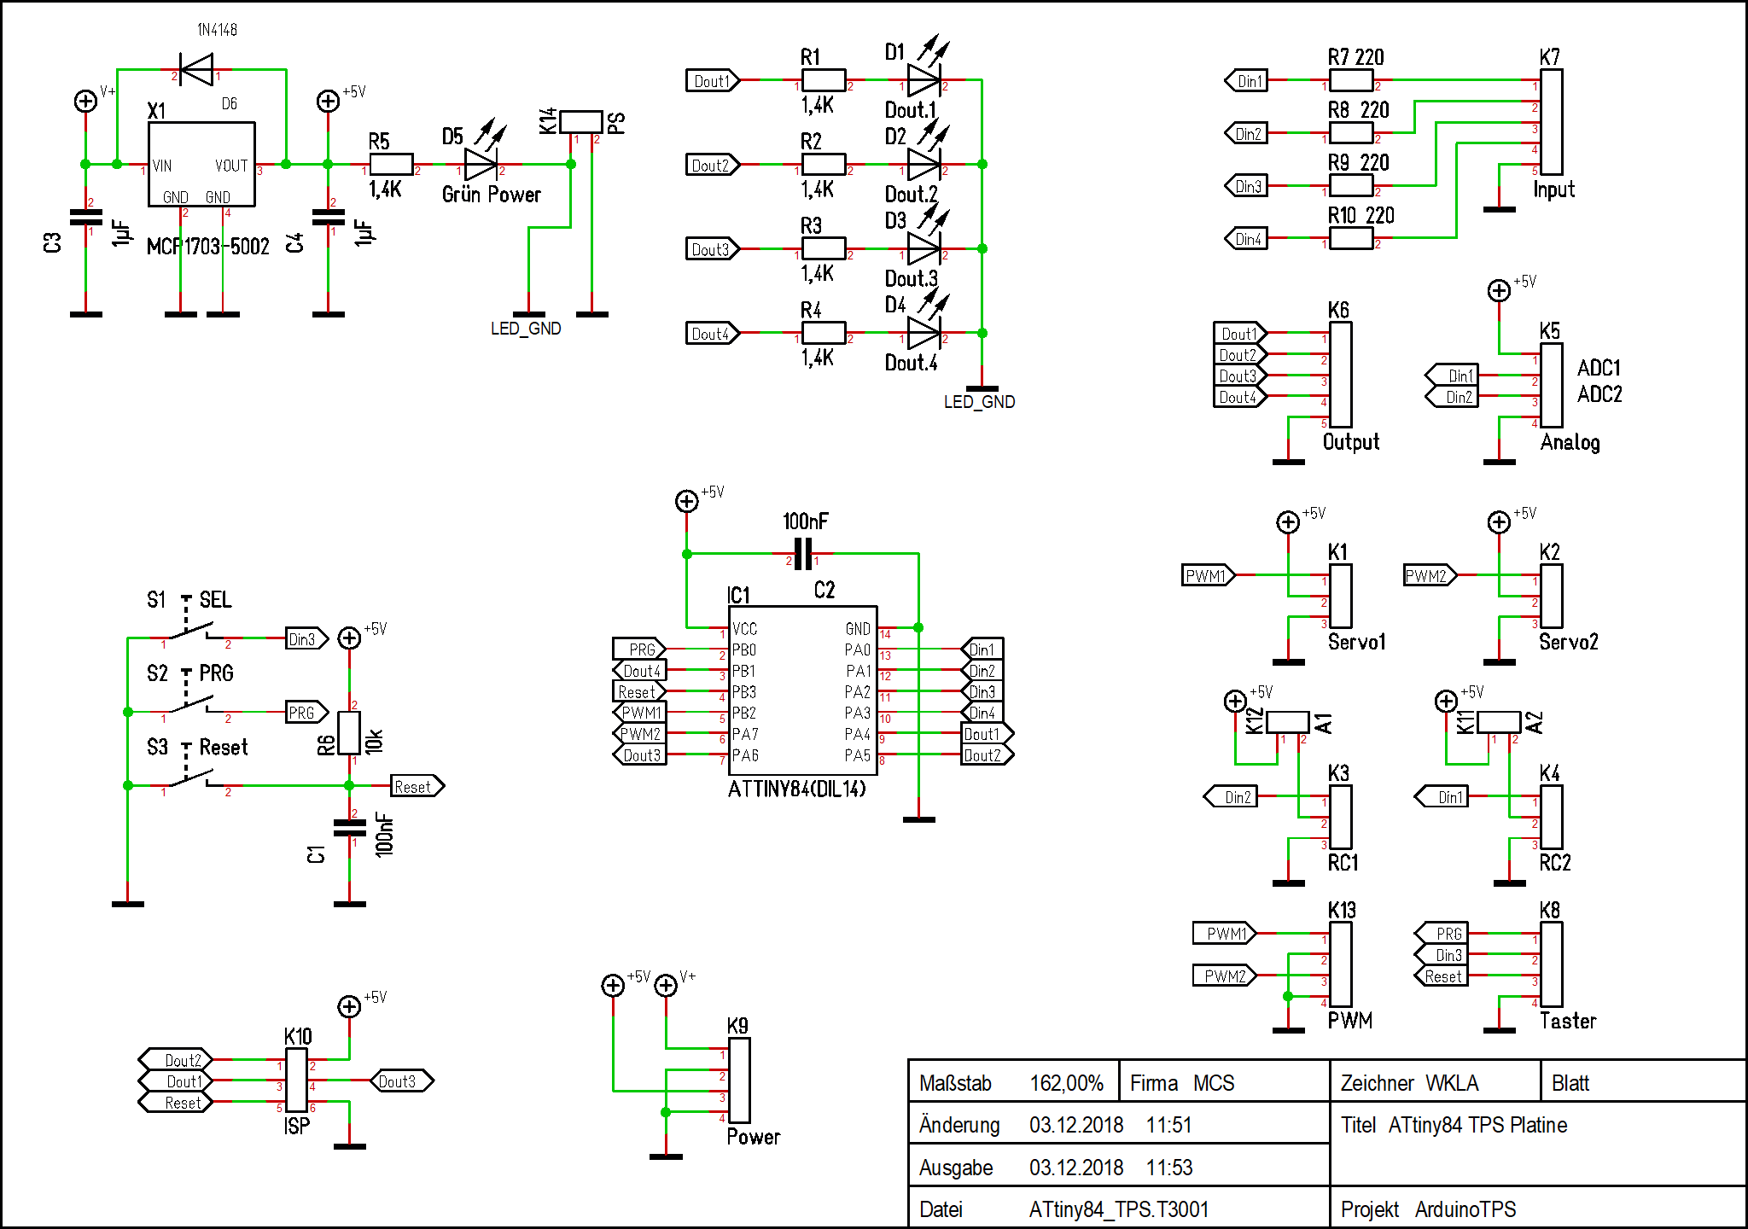

Layout
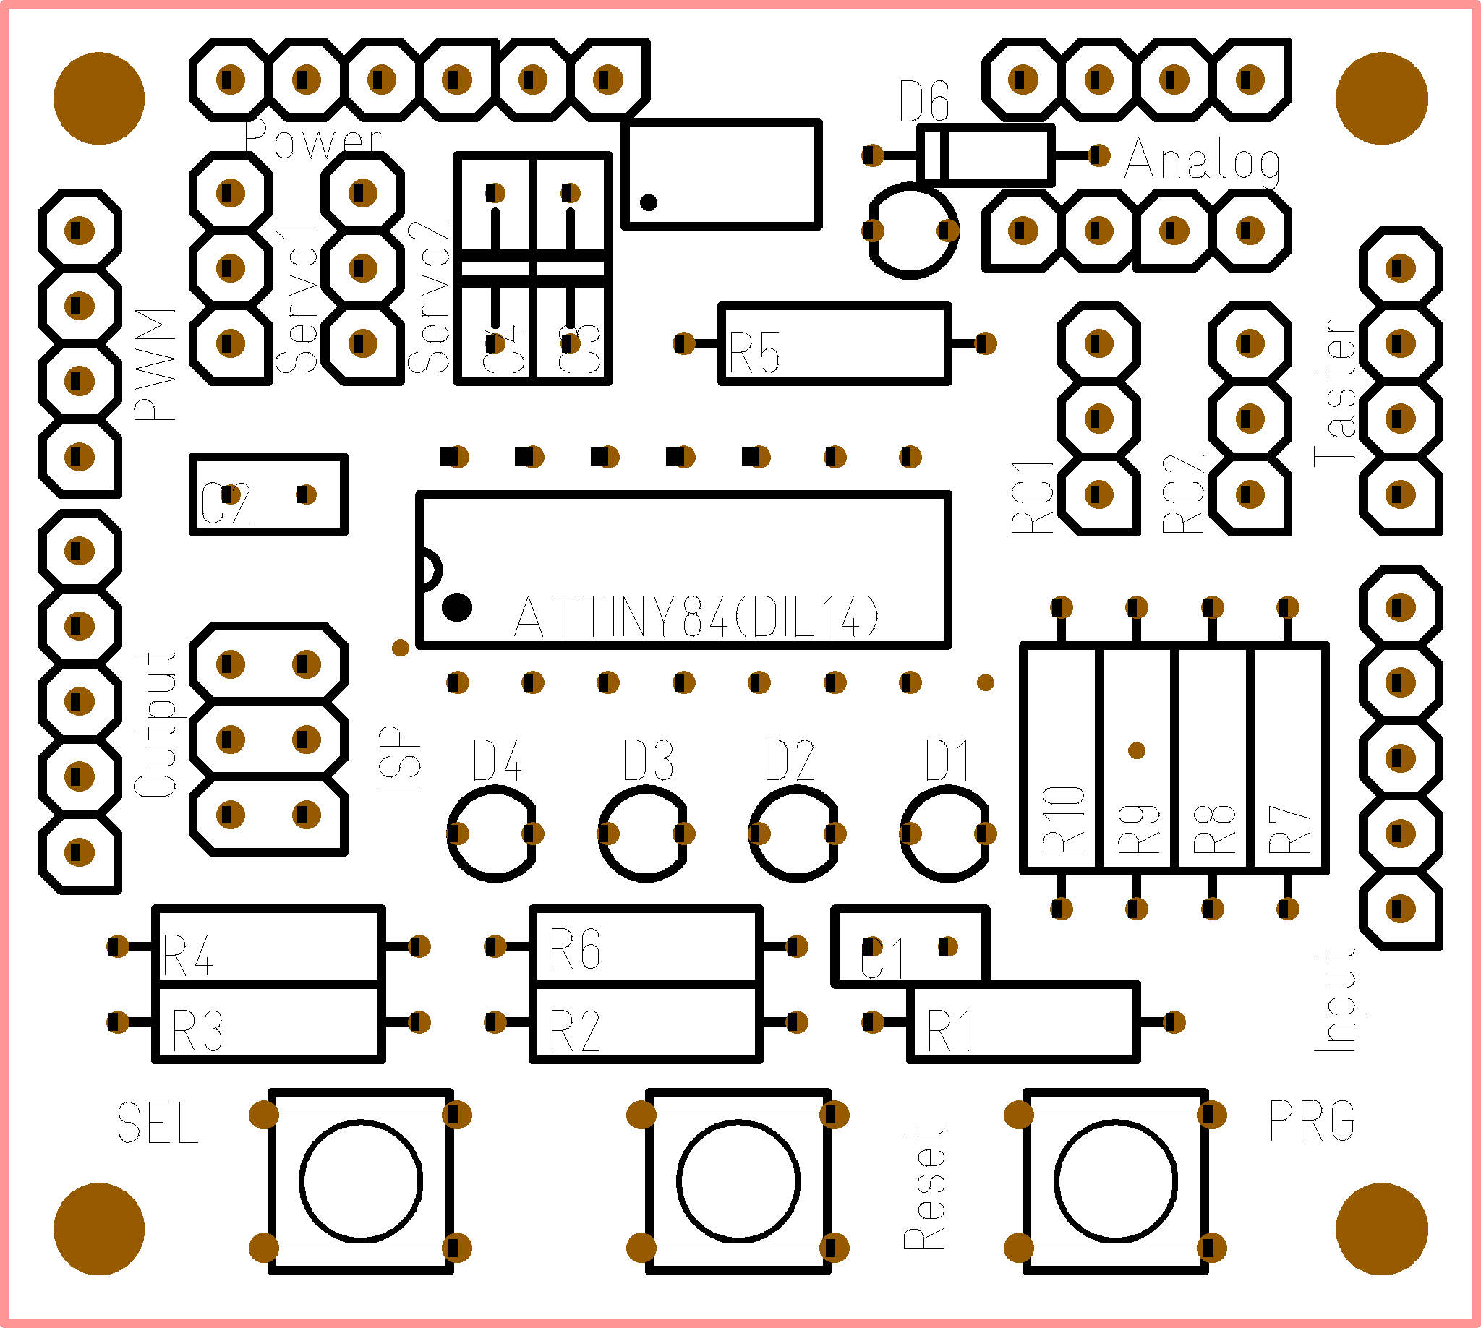

Connections
All connections to the board are described here.

Analog
The analog input provide access to A/D Convert 1 and 2. The pinout is

1 +5V
2 ADC1
3 ADC2
4 GND

Input
Standard TPS input section with 4 inputs protected by 220 Ohm resistors.

1 Din.1
2 Din.2
3 Din.3
4 Din.4
5 GND

Output
Standard TPS output section with 4 outputs parallel to the on board low current LEDs.

1 Dout.1
2 Dout.2
3 Dout.3
4 Dout.4
5 GND

PWM
PWM Outputs. Frequency 500Hz.
1 PWM1
2 GND
3 PWM2
4 GND

Power
Power connector to power up the TPS and to get some regulated power from the internal 5V source. (max. 100mA)
1 PS, Power savings jumper, if not closed, all LEDs will be off
2 PS
3 V+in
4 GND
5 +5V
6 GND

Servo
There are 2 RC_Servo connections on this board.
1 PWM
2 +5V
3 GND

RC
There are two RC PWM Inputs for standard model receivers. The Pulse should be between 1ms and 2ms. The +5V pin can be powered via the internal source when the jumper A is closed. If the internal source is not wanted remove this jumper.
1 PWM
2 +5V (
3 GND

Switches
The switches (or additional ones in parallel) can be placed outside as well.
1 PRG
2 SEL
3 Reset
4 GND

