Arduino SPS

ArduninoSPS Layout Documentation

Schematic
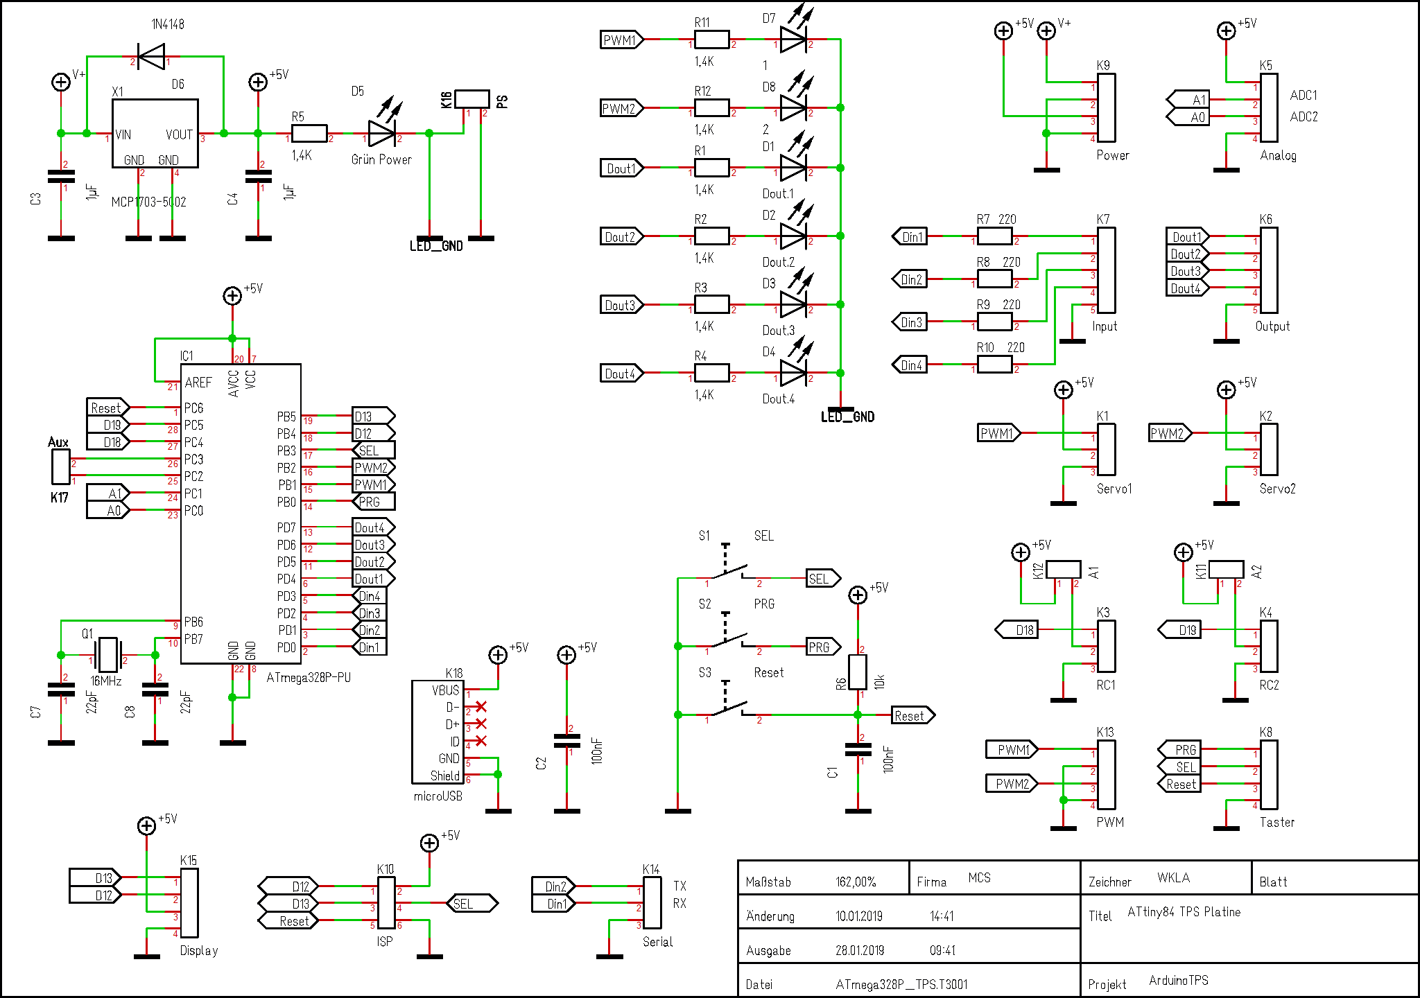
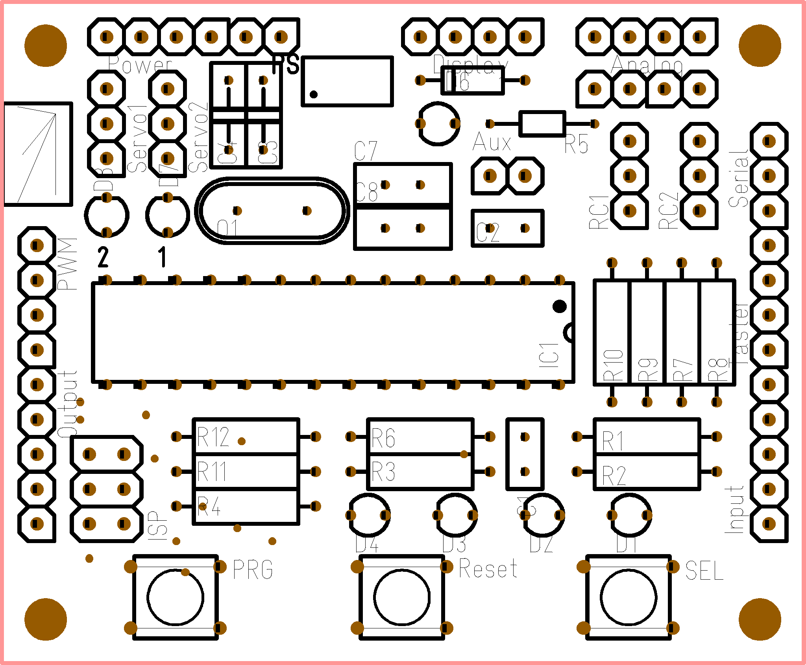

Connections
All connections to the board are described here.

Analog
The analog input provide access to A/D Convert 1 and 2. The pinout is

1 +5V
2 ADC1
3 ADC2
4 GND

Input
Standard TPS input section with 4 inputs protected by 220 Ohm resistors.

1 Din.1
2 Din.2
3 Din.3
4 Din.4
5 GND

Output
Standard TPS output section with 4 outputs parallel to the on board low current LEDs.

1 Dout.1
2 Dout.2
3 Dout.3
4 Dout.4
5 GND

PWM
PWM Outputs. Frequency 500Hz.
1 PWM1
2 GND
3 PWM2
4 GND

Power
Power connector to power up the TPS and to get some regulated power from the internal 5V source. (max. 100mA)
1 PS, Power savings jumper, if not closed, all LEDs will be off
2 PS

1 V+in
2 GND
3 +5V
4 GND

Servo
There are 2 RC_Servo connections on this board.
1 PWM
2 +5V
3 GND

RC
There are two RC PWM Inputs for standard model receivers. The Pulse should be between 1ms and 2ms. The +5V pin can be powered via the internal source when the jumper A is closed. If the internal source is not wanted remove this jumper.
1 PWM
2 +5V (
3 GND

Switches (Taster)
The switches (or additional ones in parallel) can be placed outside as well.
1 PRG
2 SEL
3 Reset
4 GND

Serial
With the serial connector you can interact (or debug) with the mcu over a serial protocol. Mainly in TPS applications use to load new programs into the unit.
1 TX
2 RX
3 GND

Display
The display connector is used for a TM1637 like 7 segment display.
1 CLK
2 DATA
3 +5V
4 GND

ISP
The isp connector is used for a standart isp programmer.
1 MISO
2 +5V
3 SCK
4 MOSI
5 RESET
6 GND

BOM
Pos | Anzahl | Name | Wert | Gehäuse
1 | 2 | C1,C2 | 100nF | 2,54x5,08_RM2,54
2 | 2 | C3,C4 | 1µF | C_RM5,08
3 | 2 | C7,C8 | 22pF | 3X7R2,54
4 | 1 | D1 | Dout.1 | LED_3MM_GELB
5 | 1 | D2 | Dout.2 | LED_3MM_GELB
6 | 1 | D3 | Dout.3 | LED_3MM_GELB
7 | 1 | D4 | Dout.4 | LED_3MM_GELB
8 | 1 | D5 | Grün Power | LED_3MM_GRÜN
9 | 1 | D6 | 1N4148 | DO35
10 | 1 | D7 | 1 | LED_3MM_GELB
11 | 1 | D8 | 2 | LED_3MM_GELB
12 | 1 | IC1 | ATmega328P-PU | DIL28_WB7,62_P2,54
13 | 1 | K1 | Servo1 | Stiftleiste_1x03_G_2,54
14 | 1 | K2 | Servo2 | Stiftleiste_1x03_G_2,54
15 | 1 | K3 | RC1 | Stiftleiste_1x03_G_2,54
16 | 1 | K4 | RC2 | Stiftleiste_1x03_G_2,54
17 | 1 | K5 | Analog | Stiftleiste_1x04_G_2,54
18 | 1 | K6 | Output | Stiftleiste_1x05_G_2,54
19 | 1 | K7 | Input | Stiftleiste_1x05_G_2,54
20 | 1 | K8 | Taster | Stiftleiste_1x04_G_2,54
21 | 1 | K9 | Power | Stiftleiste_1x04_G_2,54
22 | 1 | K10 | ISP | Stiftleiste_2x03_G_2,54
23 | 1 | K11 | A2 | Stiftleiste_1x02_G_2,54
24 | 1 | K12 | A1 | Stiftleiste_1x02_G_2,54
25 | 1 | K13 | PWM | Stiftleiste_1x04_G_2,54
26 | 1 | K14 | Serial | Stiftleiste_1x03_G_2,54
27 | 1 | K15 | Display | Stiftleiste_1x04_G_2,54
28 | 1 | K16 | PS | Stiftleiste_1x02_G_2,54
29 | 1 | K17 | Aux | Stiftleiste_1x02_G_2,54
30 | 1 | K18 | microUSB | JAE_DX4R005H91
31 | 1 | Q1 | 16MHz | HC49/US
32 | 6 | R1,R2,R3,R4,R11,R12 | 1,4K | 0207_MET
33 | 1 | R5 | 1,4K | 0204_MET
34 | 1 | R6 | 10k | 0207_MET
35 | 4 | R7,R8,R9,R10 | 220 | 0207_MET
36 | 1 | S1 | SEL | TASTER_KURZHUB
37 | 1 | S2 | PRG | TASTER_KURZHUB
38 | 1 | S3 | Reset | TASTER_KURZHUB
39 | 1 | X1 | MCP1703-5002 | SOT223

If the LEDs are LowCurrent LEDs with 2mA, so the resistors are 1k4. If you are using normal LEDs with 20mA the value of the resistors is 150Ohm.

