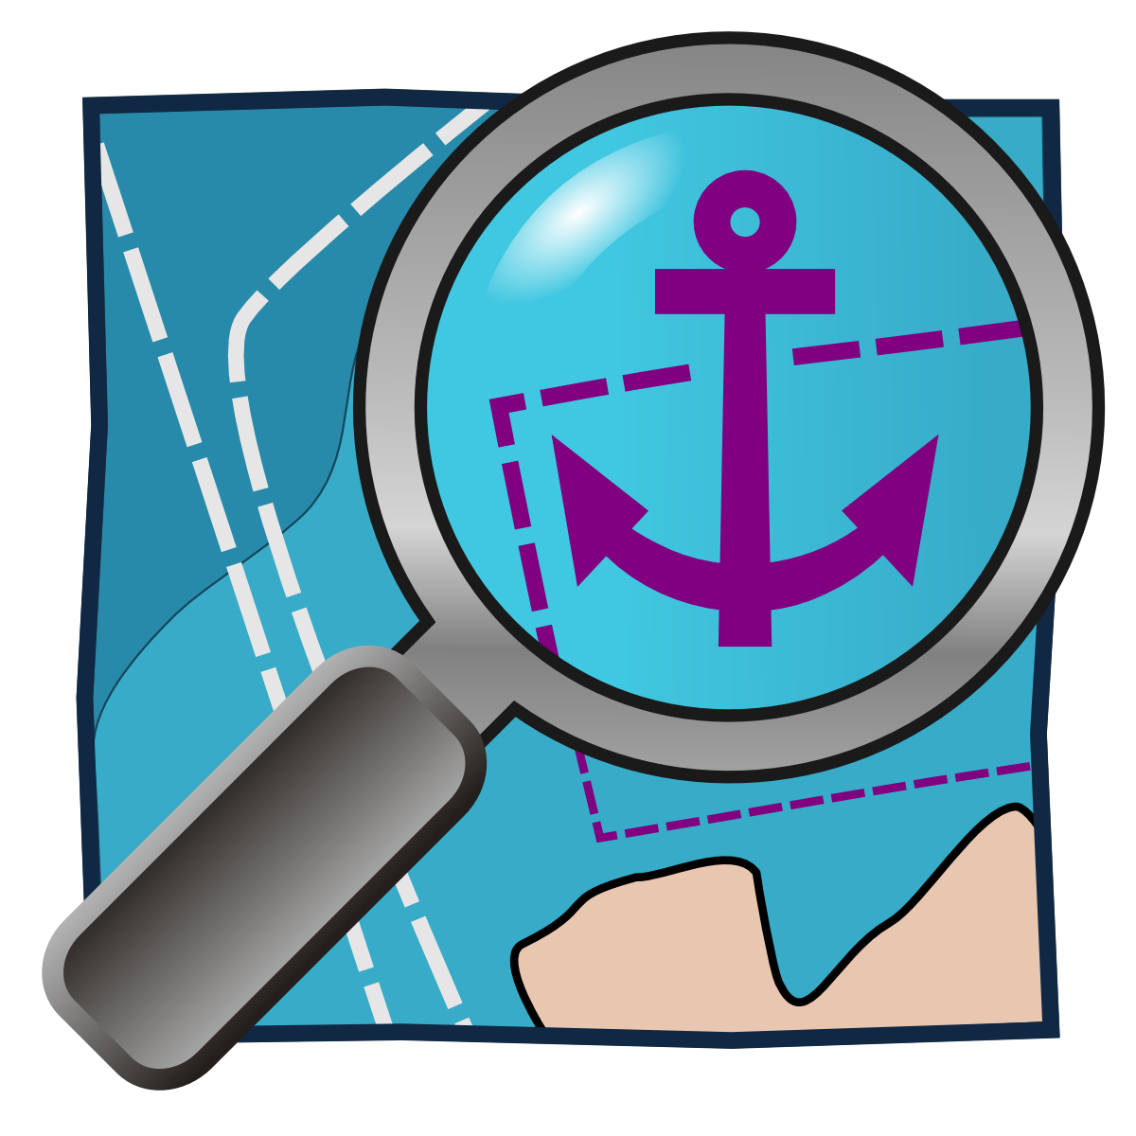
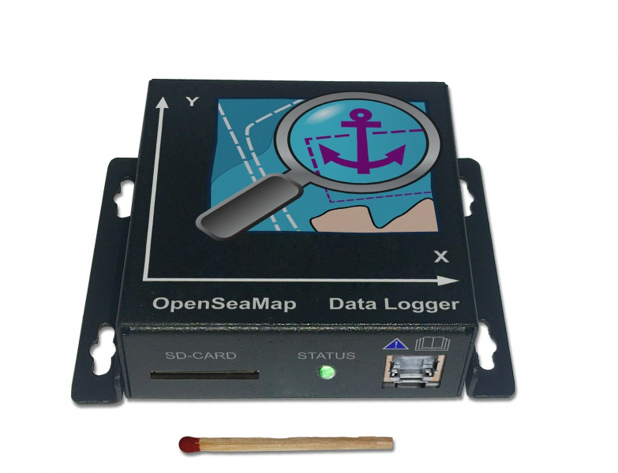

OpenSeaMap Data Logger

Content
Preface 3
Installation 3
Mounting the logger 3
Connect Cable 3
Connecting GPS 5
Connecting Echolot 5
Connecting Seatalk 5
Connecting supply (12V) 5
Connecting Cable 5
Strain relief 5
Functions 6
Control panel 6
Errors 6
Preparing the SD card 7
Firmwareupdate with sd card 7
Operation 8
For the skipper 8
For charter 8
Upload data 9

Preface
The OpenSeaMap data logger is capable to logging data of two NMEA 0183 devices, for example depth-sounder and gps. For this there are two input channels. Both inputs will be written with a timestamp for a later chronological sorting. In addition acceleration and displacement for determining heeling, heaving and pitching, will be logged, too. All data will be written to a sd card. No filtering is done, data is recorded RAW for further processing..
Features:
- Data logger for NMEA-Data
- built-in 6-axis MotionTracking (Gyroscope and Accelerometer)
- writing data on standard sd card in NMEA 0183 format
- simplest handling
- LED for operation, input data and sd access
- 2 NMEA0183 inputs (4800 Baud)
- 1 SeaTalk-1 input alternative (selectable by internal jumper)
- 12V supply

Installation

Mounting the logger
Install the logger to a protected location where you have access to the SD card and you can see the LED's.

Mount it as perpendicular as possible to the front panel of the navigation area (outside or inside) or perpendicular to a vertical wall behind the top edge -ideally horizontally to the ship's transverse axis. The two arrows on the upper surface indicate the direction in respect to the ship's axis.

The logger should be mounted on a flat vertical surface. Thus, the data of the position detection are meaningful to the logger are in a defined direction. The ideal position is with the control panel towards the stern.

Connecting the Cable
The logger will turn on automatically with the operating voltage. After switching on it takes about 30 seconds the logger starts to write data. If the green power indicator LED is lighting, the logger is active and ready to receive. The connection is made via the RJ45 jack. This is where all signals and the supply are connected.

A suitable cable comes with the logger. In case that you need to buy a longer one, please use a simple normal patch cable (network cable) as it is available at any electronics store. Make sure that this is not a"crossover" cable or "cross cable" for directly connecting two computers.
Cutting the patch cable in half, you need only one side (connector and open end). The colors show you if that cable is European or American. Are the cables in the crystal plugs on one side green, you've got a cable according to the European standard (568A), these are orange it is a American standard (568B)

There are the following connections:
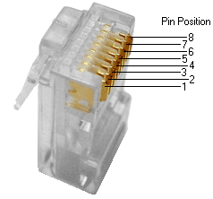
Pin | -568A pairno. | -568B pairno. | -568A Color | -568B (AT&T 258A) Color | Logger meaning
1 | 3 | 2 | 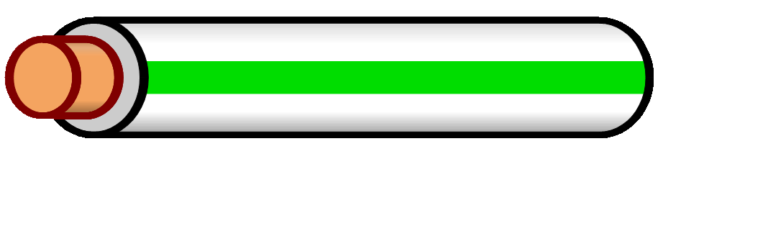  white/green line | 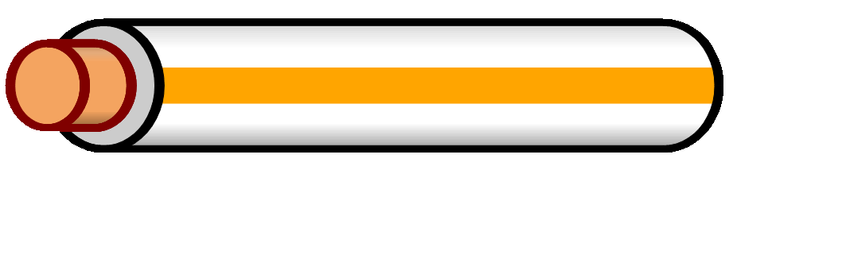  white/orange line | Seatalk -
2 | 3 | 2 | 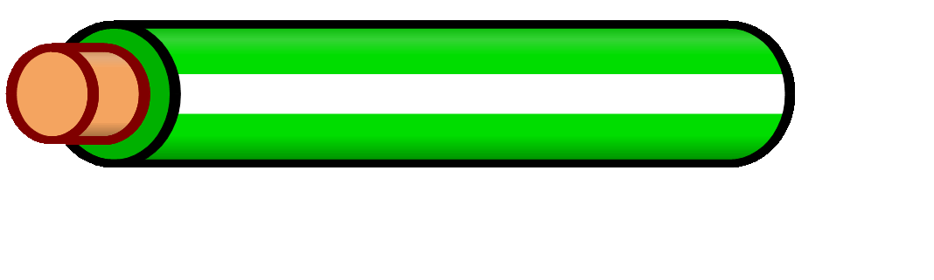  green/white line oder green (w.o. line) | 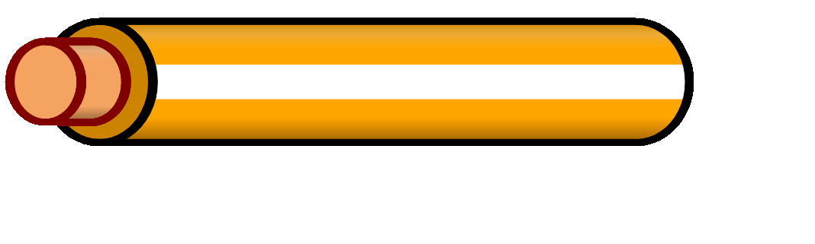  orange/white line or orange (w.o. line) | Seatalk +
3 | 2 | 3 | white/oranger line | white/ green line | NMEA A -
4 | 1 | 1 | 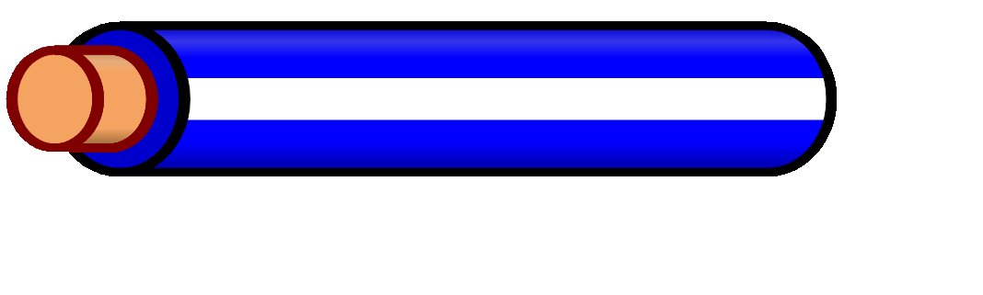  blue/white line or blue | blue/white line or blue | NMEA B +
5 | 1 | 1 | 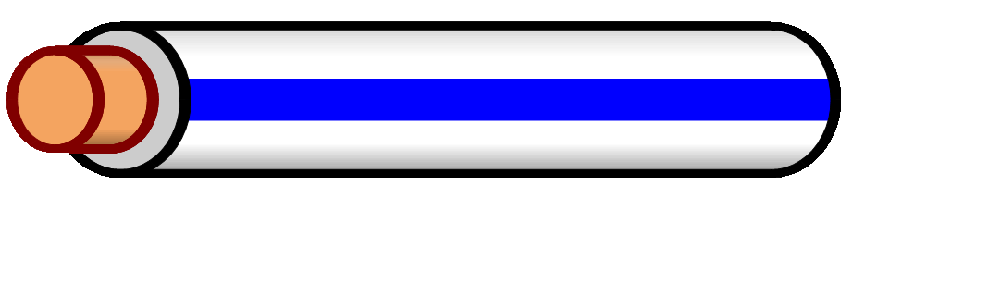  white/blue line | white/blue line | NMEA B -
6 | 2 | 3 | orange/white line or orange | green/white line or green | NMEA A +
7 | 4 | 4 | 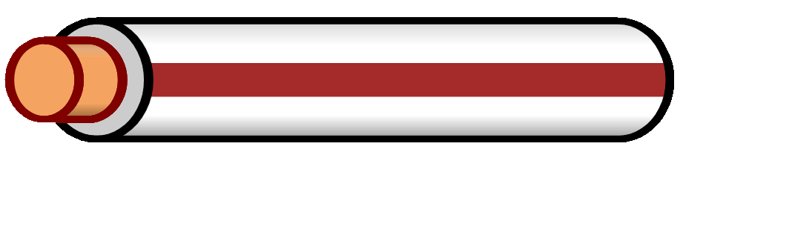  white/brown line | white/brown line | GND
8 | 4 | 4 | 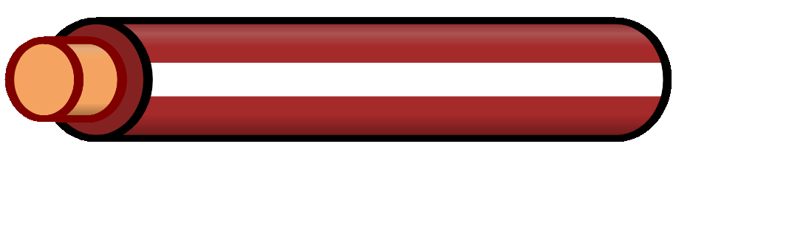  brown/white line or brown | brown/white line or brown | +12V

Connecting GPS
Connect the NMEA output of the GPS device to the NMEA input of the logger. Use the NMEA-B for the GPS if possible.
Signal GPS | NMEA-B
- | Pin 5
+ | Pin 4

Connecting the Sounder
Connect the NMEA output of the sounder/sonar to the NMEA input of the logger. Use the NMEA-A for the sounder/sonar if possible.
Signal Sonar | NMEA-A
- | Pin 3
+ | Pin 6

Connecting Seatalk
The channel A of the logger can be switched to the Seatalk-1 protocol. These two steps are necessary.
- Please open the logger. There is a red jumper in the middle of the board. On the board you will find the words Seatalk / NMEA. For NMEA protocol, the bridge put on the right and the middle pin, which are on the NMEA site. For Seatalk on the left and the middle pin.
- Start the configuration program and create a configuration file with the appropriate entries. Put this configuration file on an SD card and start the logger with this card.

Connecting supply (12V)
The logger is operating with 12V voltage (9V ..15V). To start the data recording automatically when the navigation devices are turned on, the logger must be connected to the same circuit as the navigation instruments.
Supply | Cable | Color
Gnd | Pin 7 | white/brown line
+12 V | Pin 8 | brown/white lien or brown

Connecting Cable
Ideal are terminal strips. If you connect the cable to a terminal block, you can bend the stripped end, it keeps better in the terminal block.

Strain relief
The loose end of the cable must be secured with a strain relief when connected to the onboard electronics (the wires are very thin).

Functions
After applying the operating voltage and a short initialization time (30 seconds), the data is written automatically to the sd card.
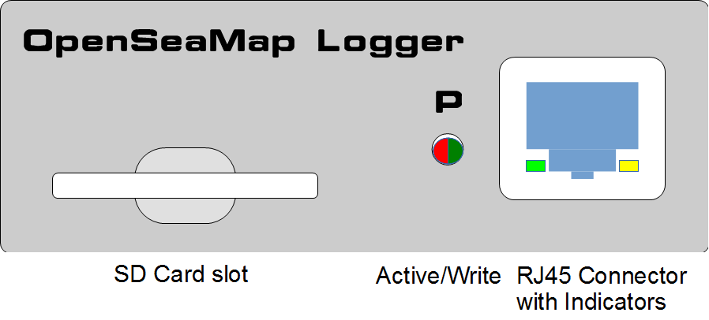Figure 1: Control and connecting panel

Control panel
The control panel is self-explaining:

SD Card | Insert sd card | We recommend a 4GB SD card. It can record up to 40 days. The SD card must be formatted FAT-32.
Active/write | Green  Red flashing | the logger is active and ready to receive  the logger writes to the SD card
RJ45 Connector | Connecting the power supply  connect sonar  connect the GPS  Yellow/Green flashing | on the NMEA channel is a valid signal is received.
Insert the sd card before turning.
Remove that card from the logger only when the unit is turned off.
On every start and every hour a new file on the card will be created automatically

Errors
When starting the logger or in operation when the data an error occurs, the red LED flashes regularly every second:
Where | What | Meaning | Action
Red LED | flashing | SD-card is full | Change SD-card with an empty one
Other possible causes:
- SD card has an unsupported file format (for data cards there is only FAT16 and FAT32 supported )
- SD card is not writable or is not recognized. Please test the card on your PC.

Wo | Wie | Bedeutung
LED next to plug  LED 1 in Plug  LED 2 in Plug | green  off  off | The logger is active and reciving
LED next to plug  LED 1 in Plug  LED 2 in Plug | flashing | Initialization of the logger (about 30 sec)
LED next to plug  LED 1 in Plug  LED 2 in Plug | red | The logger is currently turning off.
LED next to plug  LED 1 in Plug  LED 2 in Plug | flashing | The logger is writing data on the sd card
LED next to plug  LED 1 in Plug  LED 2 in Plug | flashing  flashing | in this NMEA channel is a valid signal is received  in this NMEA channel is a valid signal is received

Preparing the SD card
We recommend a 4GB SD card. It can record up to 40 days. (about 4MB per hour, 100MB per day).. The SD card must be formatted FAT-32.

Firmwareupdate with sd card
A card with FAT 16 file system must be used for the firmware update. The easiest way is to use a SD card with 2GB or smaller. This can be simply formatted with FAT 16 (on some operation systems are also just plain FAT) or creating a small partition. The latest firmware file can be downloaded, and put on the root of the sd card.

A software tool that simplifies the update process is in progress.

Operation

For the skipper
Start
If the logger is connected to the power supply of Navigation Devices,
it starts automatically when the navigation devices are turned on.
If the navigation devices be turned off (or if a power interruption), the log file is automatically closed. Once the power supply is switched on again, a new file is created automatically.
The logger has an built-in power-backup-circuit ensuring there is no data write fault during interruption of the supply voltage.
SD-Card

On an SD card with 2 GB can be recorded for about 18 days. Approximately 100MB of data recorded per day. (This can of course vary according to the GPS and sonar used.)
Thus, the SD card needs to be replaced in time.

For charter
For simple handling, use 2 SD card to each device.
After each charter trip the SD card needs to be replaced.
To do this, labeled for each vessel 2 SD cards with the ship's name.
A card is plugged into the logger, the other comes into the office to vessel/charter-documents.
The logger automatically starts with the navigation device.
The charter customers need to worry about anything.
The following checklists can be customized for their own base:

When crew changes
- remove the written card
- insert new empty card (from the vessel documents)
- bring removed card with the ship's documentation to the office

During crew briefing

It would be nice if the charterers employee in charge briefly tells that the charter company participates in the project "Detection of shallow water depths". And that the skipper can support the project particularly well by selectively moves a bit in bays and harbor entrances back and forth to capture the depth of the key points well.
This could also be advertised on your website.

In the office
- put removed card into a PC and upload data to the server.
- assign the uploaded data to the correct ship in the "..." (choose from the list of vessels)
- Erase data on the described card,
put empty card to the shipping documents.
- Note in the ship's documentation:
Data uploaded <trip/customer> <date>
Data deleted <trip/customer> <date>

Base data
For a reliable evaluation, we need accurate information about the ship and the measuring device used.
These data need be entered only once per vessel and are then valid for all log files for this ship. Changes to marine electronics, the original data can be easily changed or expanded.

Uploading data
- You need a computer with Internet connection and SD card reader
- Put the SD card into the SD card slot
- Please log in using your username: http://depth.openseamap.org
- Enter the metadata of your ship and to the measuring device.
If you use the same ship as the last time, and if nothing was changed in the measuring device, you can simply select your ship from the list of your ships.
- Upload the data to the server

The Logger fully complies to all relevant EU standards and it is marked with the CE Sign.
After usage the logger must be handed in as “electronic waste” to the local recycling site.
Informations how to dispose off the device can be obtained from your local government.

