

**Polytechnic University of the Philippines – Sta. Mesa Academic Year 2023 – 2024**

*Second Semester*

**GROUP 1: YOMIFY**

In Partial Fulfillment

Of the Academic Requirement in Integrative Programming From Bachelor of Science in Information Technology 2 – 4 Under Professor Aleta C. Fabregas

By:  
  
  
Igot, Honeylet I.

Bonavente, Willie M.

Dimacutac, Raymund Jr. B.

July 4, 2024

**Introduction**

In the digital age, music streaming platforms like Spotify have revolutionized how we consume music, offering vast libraries of songs at our fingertips. Among these, curated playlists have become particularly popular, often amassing millions of listens. One such playlist is "The Ultimate OPM," which has garnered significant attention on Spotify. Original Pilipino Music (OPM) is a significant cultural phenomenon in the Philippines, and understanding what makes certain OPM songs resonate more with audiences can provide valuable insights for musicians, composers, and producers.

This study aims to analyze the musical patterns and chord progressions that contribute to the popularity of songs in "The Ultimate OPM" playlist. By leveraging a dataset comprising these songs and their corresponding chords, we seek to uncover the underlying patterns that make these songs widely appealing. To achieve this, we employ the Apriori algorithm, a well-established method for mining frequent itemsets and discovering association rules in large datasets.

**Problem Definition and Objectives**

The goal of this study is to analyze the musical patterns and chord progressions that contribute to the popularity of songs in the "The Ultimate OPM" Spotify playlist. By leveraging a dataset comprising the songs and their corresponding chords, we aim to uncover the underlying patterns that make these songs resonate with a wide audience. This analysis will be conducted using the Apriori algorithm, a popular method for mining frequent itemsets and discovering association rules in large datasets. Our objectives, **Identify Frequent Chord Progressions**, Using the Apriori algorithm, the study aims to mine frequent chord progressions within the songs in the "The Ultimate OPM" playlist and **Discover Associations Between Chords**: The study seeks to uncover associations between different chords in the songs, which can help in understanding the common musical structures in popular OPM music.

**Historical Data**

The historical data was collected manually, focusing on the chord progressions from one of the most popular OPM playlists, "The Ultimate OPM," on Spotify. The dataset consists of the following columns: Composition, A, A#, Ab, B, Bb, C, C#, D, D#, Db, E, Eb, F, F#, G, G#, Gb, with a total of 18 columns.

Dataset collected by: BSIT 2-4, Group 1 from "The Ultimate OPM" playlist on Spotify.

(<https://drive.google.com/file/d/1BMCPl-QP1PSnnFeMnpINXgklzeBCA6hL/view?usp=drive_link>)

The historical data focuses on identifying which chords are the most used in OPM compositions. A chord is a group of (typically three or more) notes sounded together, as a basis of harmony, but in this analysis, we focus only on the root note of a chord for the analysis.

**Analysis**

*Computer Version, it includes the table format in text and the actual output in the program.*

|  |  |  |  |  |  |  |  |
| --- | --- | --- | --- | --- | --- | --- | --- |
| **antecedents** | **consequents** | **antecedent support** | **consequent support** | **support** | **confidence** | **lift** | **conviction** |
| A | B | 0.8356 | 0.6301 | 0.5479 | 0.6557 | 1.0406 | 1.0744 |
| B | A | 0.6301 | 0.8356 | 0.5479 | 0.8696 | 1.0406 | 1.2603 |
| C | A | 0.5479 | 0.8356 | 0.4795 | 0.8750 | 1.0471 | 1.3151 |
| A | C | 0.8356 | 0.5479 | 0.4795 | 0.5738 | 1.0471 | 1.0606 |
| A | D | 0.8356 | 0.8219 | 0.7123 | 0.8525 | 1.0372 | 1.2070 |
| D | A | 0.8219 | 0.8356 | 0.7123 | 0.8667 | 1.0372 | 1.2329 |
| E | A | 0.7397 | 0.8356 | 0.6575 | 0.8889 | 1.0638 | 1.4795 |
| A | E | 0.8356 | 0.7397 | 0.6575 | 0.7869 | 1.0638 | 1.2213 |
| G | A | 0.7671 | 0.8356 | 0.6712 | 0.8750 | 1.0471 | 1.3151 |
| A | G | 0.8356 | 0.7671 | 0.6712 | 0.8033 | 1.0471 | 1.1838 |
| B | D | 0.6301 | 0.8219 | 0.5068 | 0.8043 | 0.9786 | 0.9102 |
| D | B | 0.8219 | 0.6301 | 0.5068 | 0.6167 | 0.9786 | 0.9649 |
| E | B | 0.7397 | 0.6301 | 0.5479 | 0.7407 | 1.1755 | 1.4266 |
| B | E | 0.6301 | 0.7397 | 0.5479 | 0.8696 | 1.1755 | 1.9954 |
| C | D | 0.5479 | 0.8219 | 0.5068 | 0.9250 | 1.1254 | 2.3744 |
| D | C | 0.8219 | 0.5479 | 0.5068 | 0.6167 | 1.1254 | 1.1793 |
| G | C | 0.7671 | 0.5479 | 0.5068 | 0.6607 | 1.2058 | 1.3324 |
| C | G | 0.5479 | 0.7671 | 0.5068 | 0.9250 | 1.2058 | 3.1050 |
| E | D | 0.7397 | 0.8219 | 0.6575 | 0.8889 | 1.0815 | 1.6027 |
| D | E | 0.8219 | 0.7397 | 0.6575 | 0.8000 | 1.0815 | 1.3014 |
| F | D | 0.5068 | 0.8219 | 0.4658 | 0.9189 | 1.1180 | 2.1963 |
| D | F | 0.8219 | 0.5068 | 0.4658 | 0.5667 | 1.1180 | 1.1380 |
| G | D | 0.7671 | 0.8219 | 0.6712 | 0.8750 | 1.0646 | 1.4247 |
| D | G | 0.8219 | 0.7671 | 0.6712 | 0.8167 | 1.0646 | 1.2702 |
| G | E | 0.7671 | 0.7397 | 0.5479 | 0.7143 | 0.9656 | 0.9110 |
| E | G | 0.7397 | 0.7671 | 0.5479 | 0.7407 | 0.9656 | 0.8982 |
| G | F | 0.7671 | 0.5068 | 0.4658 | 0.6071 | 1.1979 | 1.2553 |
| F | G | 0.5068 | 0.7671 | 0.4658 | 0.9189 | 1.1979 | 2.8721 |
| A, B | D | 0.5479 | 0.8219 | 0.4521 | 0.8250 | 1.0038 | 1.0176 |
| A, D | B | 0.7123 | 0.6301 | 0.4521 | 0.6346 | 1.0071 | 1.0123 |
| B, D | A | 0.5068 | 0.8356 | 0.4521 | 0.8919 | 1.0673 | 1.5205 |
| A | B, D | 0.8356 | 0.5068 | 0.4521 | 0.5410 | 1.0673 | 1.0744 |
| B | A, D | 0.6301 | 0.7123 | 0.4521 | 0.7174 | 1.0071 | 1.0179 |
| D | A, B | 0.8219 | 0.5479 | 0.4521 | 0.5500 | 1.0038 | 1.0046 |
| E, A | B | 0.6575 | 0.6301 | 0.4658 | 0.7083 | 1.1241 | 1.2681 |
| E, B | A | 0.5479 | 0.8356 | 0.4658 | 0.8500 | 1.0172 | 1.0959 |
| A, B | E | 0.5479 | 0.7397 | 0.4658 | 0.8500 | 1.1491 | 1.7352 |
| E | A, B | 0.7397 | 0.5479 | 0.4658 | 0.6296 | 1.1491 | 1.2205 |
| A | E, B | 0.8356 | 0.5479 | 0.4658 | 0.5574 | 1.0172 | 1.0213 |
| B | E, A | 0.6301 | 0.6575 | 0.4658 | 0.7391 | 1.1241 | 1.3128 |
| E, A | D | 0.6575 | 0.8219 | 0.6027 | 0.9167 | 1.1153 | 2.1370 |
| E, D | A | 0.6575 | 0.8356 | 0.6027 | 0.9167 | 1.0970 | 1.9726 |
| A, D | E | 0.7123 | 0.7397 | 0.6027 | 0.8462 | 1.1439 | 1.6918 |
| E | A, D | 0.7397 | 0.7123 | 0.6027 | 0.8148 | 1.1439 | 1.5534 |
| A | E, D | 0.8356 | 0.6575 | 0.6027 | 0.7213 | 1.0970 | 1.2288 |
| D | E, A | 0.8219 | 0.6575 | 0.6027 | 0.7333 | 1.1153 | 1.2842 |
| G, A | D | 0.6712 | 0.8219 | 0.6027 | 0.8980 | 1.0925 | 1.7452 |
| G, D | A | 0.6712 | 0.8356 | 0.6027 | 0.8980 | 1.0746 | 1.6110 |
| A, D | G | 0.7123 | 0.7671 | 0.6027 | 0.8462 | 1.1030 | 1.5137 |
| G | A, D | 0.7671 | 0.7123 | 0.6027 | 0.7857 | 1.1030 | 1.3425 |
| A | G, D | 0.8356 | 0.6712 | 0.6027 | 0.7213 | 1.0746 | 1.1797 |
| D | G, A | 0.8219 | 0.6712 | 0.6027 | 0.7333 | 1.0925 | 1.2329 |
| G, E | A | 0.5479 | 0.8356 | 0.5342 | 0.9750 | 1.1668 | 6.5753 |
| G, A | E | 0.6712 | 0.7397 | 0.5342 | 0.7959 | 1.0760 | 1.2753 |
| E, A | G | 0.6575 | 0.7671 | 0.5342 | 0.8125 | 1.0592 | 1.2420 |
| G | E, A | 0.7671 | 0.6575 | 0.5342 | 0.6964 | 1.0592 | 1.1281 |
| E | G, A | 0.7397 | 0.6712 | 0.5342 | 0.7222 | 1.0760 | 1.1836 |
| A | G, E | 0.8356 | 0.5479 | 0.5342 | 0.6393 | 1.1668 | 1.2534 |
| E, B | D | 0.5479 | 0.8219 | 0.4795 | 0.8750 | 1.0646 | 1.4247 |
| E, D | B | 0.6575 | 0.6301 | 0.4795 | 0.7292 | 1.1572 | 1.3656 |
| B, D | E | 0.5068 | 0.7397 | 0.4795 | 0.9459 | 1.2788 | 4.8151 |
| E | B, D | 0.7397 | 0.5068 | 0.4795 | 0.6481 | 1.2788 | 1.4016 |
| B | E, D | 0.6301 | 0.6575 | 0.4795 | 0.7609 | 1.1572 | 1.4321 |
| D | E, B | 0.8219 | 0.5479 | 0.4795 | 0.5833 | 1.0646 | 1.0849 |
| G, C | D | 0.5068 | 0.8219 | 0.4658 | 0.9189 | 1.1180 | 2.1963 |
| G, D | C | 0.6712 | 0.5479 | 0.4658 | 0.6939 | 1.2663 | 1.4767 |
| C, D | G | 0.5068 | 0.7671 | 0.4658 | 0.9189 | 1.1979 | 2.8721 |
| G | C, D | 0.7671 | 0.5068 | 0.4658 | 0.6071 | 1.1979 | 1.2553 |
| C | G, D | 0.5479 | 0.6712 | 0.4658 | 0.8500 | 1.2663 | 2.1918 |
| D | G, C | 0.8219 | 0.5068 | 0.4658 | 0.5667 | 1.1180 | 1.1380 |
| G, E | D | 0.5479 | 0.8219 | 0.5342 | 0.9750 | 1.1863 | 7.1233 |
| G, D | E | 0.6712 | 0.7397 | 0.5342 | 0.7959 | 1.0760 | 1.2753 |
| E, D | G | 0.6575 | 0.7671 | 0.5342 | 0.8125 | 1.0592 | 1.2420 |
| G | E, D | 0.7671 | 0.6575 | 0.5342 | 0.6964 | 1.0592 | 1.1281 |
| E | G, D | 0.7397 | 0.6712 | 0.5342 | 0.7222 | 1.0760 | 1.1836 |
| D | G, E | 0.8219 | 0.5479 | 0.5342 | 0.6500 | 1.1863 | 1.2916 |
| G, E, A | D | 0.5342 | 0.8219 | 0.5205 | 0.9744 | 1.1855 | 6.9452 |
| G, E, D | A | 0.5342 | 0.8356 | 0.5205 | 0.9744 | 1.1660 | 6.4110 |
| G, A, D | E | 0.6027 | 0.7397 | 0.5205 | 0.8636 | 1.1675 | 1.9087 |
| E, A, D | G | 0.6027 | 0.7671 | 0.5205 | 0.8636 | 1.1258 | 1.7078 |
| G, E | A, D | 0.5479 | 0.7123 | 0.5205 | 0.9500 | 1.3337 | 5.7534 |
| G, A | E, D | 0.6712 | 0.6575 | 0.5205 | 0.7755 | 1.1794 | 1.5255 |
| G, D | E, A | 0.6712 | 0.6575 | 0.5205 | 0.7755 | 1.1794 | 1.5255 |
| E, A | G, D | 0.6575 | 0.6712 | 0.5205 | 0.7917 | 1.1794 | 1.5781 |
| E, D | G, A | 0.6575 | 0.6712 | 0.5205 | 0.7917 | 1.1794 | 1.5781 |
| A, D | G, E | 0.7123 | 0.5479 | 0.5205 | 0.7308 | 1.3337 | 1.6791 |
| G | E, A, D | 0.7671 | 0.6027 | 0.5205 | 0.6786 | 1.1258 | 1.2359 |
| E | G, A, D | 0.7397 | 0.6027 | 0.5205 | 0.7037 | 1.1675 | 1.3408 |
| A | G, E, D | 0.8356 | 0.5342 | 0.5205 | 0.6230 | 1.1660 | 1.2353 |
| D | G, E, A | 0.8219 | 0.5342 | 0.5205 | 0.6333 | 1.1855 | 1.2702 |

*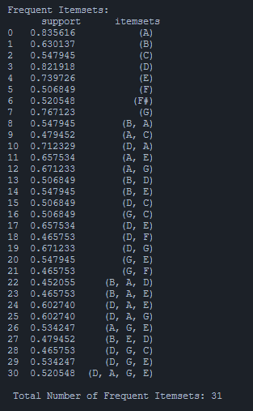Screenshot of the actual output of the code.*

*Figure 1: Frequent Itemsets*

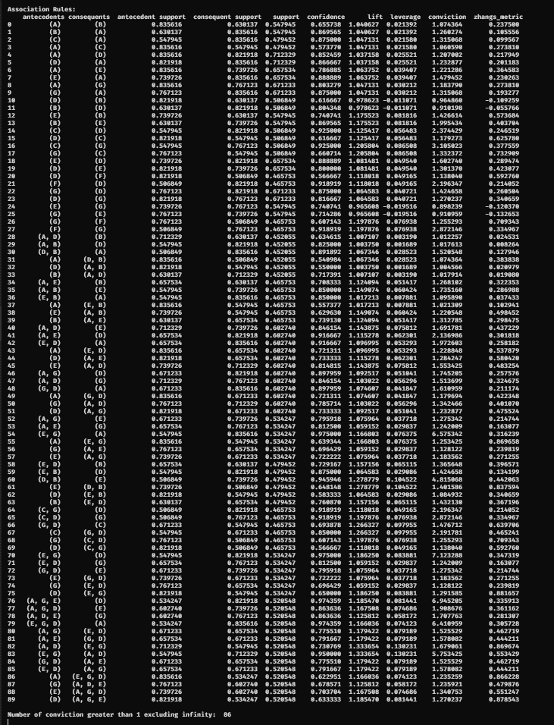

*Figure 2: Actual output of the generate associated rule*

*import pandas as pd*

*import numpy as np*

*import matplotlib.pyplot as plt*

*from mlxtend.frequent_patterns import apriori, association_rules*

*from mlxtend.preprocessing import TransactionEncoder*

*data_sets = pd.read_csv("output_root_notes.csv",header=None, dtype=str)*

*custom_transactions = data_sets.apply(lambda x: x.dropna().tolist(), axis=1).tolist()*

*te = TransactionEncoder()*

*te_ary = te.fit(custom_transactions).transform(custom_transactions)*

*df = pd.DataFrame(te_ary, columns=te.columns_)*

*# Apply the apriori algorithm to find frequent itemsets with a minimum support of 60%*

*frequent_itemsets = apriori(df, min_support=0.44, use_colnames=True)*

*print("\nFrequent Itemsets: \n", frequent_itemsets)*

*print("\n Total Number of Frequent Itemsets:" , len(frequent_itemsets))*

*# Generate association rules with a minimum confidence of 50%*

*rules = association_rules(frequent_itemsets, metric="confidence", min_threshold=0.5)*

*# Sort the rules based on the conviction in ascending order*

*# rules_sorted_by_conviction = rules.sort_values(by='conviction', ascending=True)*

*print("\nAssociation Rules:\n", rules.to_string())*

*The Program used to generate the association rule.*

***Manual Version*** *(Apriori Algorithm). Sorted in Ascending according to Support.*

|  |  |  |  |  |  |
| --- | --- | --- | --- | --- | --- |
| **LHS** | **RHS** | **support** | **confidence** | **lift** | **conviction** |
| A, B | D | 0.4521 | 0.8250 | 1.0038 | 1.0176 |
| A, D | B | 0.4521 | 0.6346 | 1.0071 | 1.0123 |
| B, D | A | 0.4521 | 0.8919 | 1.0673 | 1.5205 |
| A | B, D | 0.4521 | 0.5410 | 1.0673 | 1.0744 |
| B | A, D | 0.4521 | 0.7174 | 1.0071 | 1.0179 |
| D | A, B | 0.4521 | 0.5500 | 1.0038 | 1.0046 |
| F | D | 0.4658 | 0.9189 | 1.1180 | 2.1963 |
| D | F | 0.4658 | 0.5667 | 1.1180 | 1.1380 |
| G | F | 0.4658 | 0.6071 | 1.1979 | 1.2553 |
| F | G | 0.4658 | 0.9189 | 1.1979 | 2.8721 |
| E, A | B | 0.4658 | 0.7083 | 1.1241 | 1.2681 |
| E, B | A | 0.4658 | 0.8500 | 1.0172 | 1.0959 |
| A, B | E | 0.4658 | 0.8500 | 1.1491 | 1.7352 |
| E | A, B | 0.4658 | 0.6296 | 1.1491 | 1.2205 |
| A | E, B | 0.4658 | 0.5574 | 1.0172 | 1.0213 |
| B | E, A | 0.4658 | 0.7391 | 1.1241 | 1.3128 |
| G, C | D | 0.4658 | 0.9189 | 1.1180 | 2.1963 |
| G, D | C | 0.4658 | 0.6939 | 1.2663 | 1.4767 |
| C, D | G | 0.4658 | 0.9189 | 1.1979 | 2.8721 |
| G | C, D | 0.4658 | 0.6071 | 1.1979 | 1.2553 |
| C | G, D | 0.4658 | 0.8500 | 1.2663 | 2.1918 |
| D | G, C | 0.4658 | 0.5667 | 1.1180 | 1.1380 |
| C | A | 0.4795 | 0.8750 | 1.0471 | 1.3151 |
| A | C | 0.4795 | 0.5738 | 1.0471 | 1.0606 |
| E, B | D | 0.4795 | 0.8750 | 1.0646 | 1.4247 |
| E, D | B | 0.4795 | 0.7292 | 1.1572 | 1.3656 |
| B, D | E | 0.4795 | 0.9459 | 1.2788 | 4.8151 |
| E | B, D | 0.4795 | 0.6481 | 1.2788 | 1.4016 |
| B | E, D | 0.4795 | 0.7609 | 1.1572 | 1.4321 |
| D | E, B | 0.4795 | 0.5833 | 1.0646 | 1.0849 |
| B | D | 0.5068 | 0.8043 | 0.9786 | 0.9102 |
| D | B | 0.5068 | 0.6167 | 0.9786 | 0.9649 |
| C | D | 0.5068 | 0.9250 | 1.1254 | 2.3744 |
| D | C | 0.5068 | 0.6167 | 1.1254 | 1.1793 |
| G | C | 0.5068 | 0.6607 | 1.2058 | 1.3324 |
| C | G | 0.5068 | 0.9250 | 1.2058 | 3.1050 |
| G, E, A | D | 0.5205 | 0.9744 | 1.1855 | 6.9452 |
| G, E, D | A | 0.5205 | 0.9744 | 1.1660 | 6.4110 |
| G, A, D | E | 0.5205 | 0.8636 | 1.1675 | 1.9087 |
| E, A, D | G | 0.5205 | 0.8636 | 1.1258 | 1.7078 |
| G, E | A, D | 0.5205 | 0.9500 | 1.3337 | 5.7534 |
| G, A | E, D | 0.5205 | 0.7755 | 1.1794 | 1.5255 |
| G, D | E, A | 0.5205 | 0.7755 | 1.1794 | 1.5255 |
| E, A | G, D | 0.5205 | 0.7917 | 1.1794 | 1.5781 |
| E, D | G, A | 0.5205 | 0.7917 | 1.1794 | 1.5781 |
| A, D | G, E | 0.5205 | 0.7308 | 1.3337 | 1.6791 |
| G | E, A, D | 0.5205 | 0.6786 | 1.1258 | 1.2359 |
| E | G, A, D | 0.5205 | 0.7037 | 1.1675 | 1.3408 |
| A | G, E, D | 0.5205 | 0.6230 | 1.1660 | 1.2353 |
| D | G, E, A | 0.5205 | 0.6333 | 1.1855 | 1.2702 |
| G, E | A | 0.5342 | 0.9750 | 1.1668 | 6.5753 |
| G, A | E | 0.5342 | 0.7959 | 1.0760 | 1.2753 |
| E, A | G | 0.5342 | 0.8125 | 1.0592 | 1.2420 |
| G | E, A | 0.5342 | 0.6964 | 1.0592 | 1.1281 |
| E | G, A | 0.5342 | 0.7222 | 1.0760 | 1.1836 |
| A | G, E | 0.5342 | 0.6393 | 1.1668 | 1.2534 |
| G, E | D | 0.5342 | 0.9750 | 1.1863 | 7.1233 |
| G, D | E | 0.5342 | 0.7959 | 1.0760 | 1.2753 |
| E, D | G | 0.5342 | 0.8125 | 1.0592 | 1.2420 |
| G | E, D | 0.5342 | 0.6964 | 1.0592 | 1.1281 |
| E | G, D | 0.5342 | 0.7222 | 1.0760 | 1.1836 |
| D | G, E | 0.5342 | 0.6500 | 1.1863 | 1.2916 |
| A | B | 0.5479 | 0.6557 | 1.0406 | 1.0744 |
| B | A | 0.5479 | 0.8696 | 1.0406 | 1.2603 |
| E | B | 0.5479 | 0.7407 | 1.1755 | 1.4266 |
| B | E | 0.5479 | 0.8696 | 1.1755 | 1.9954 |
| G | E | 0.5479 | 0.7143 | 0.9656 | 0.9110 |
| E | G | 0.5479 | 0.7407 | 0.9656 | 0.8982 |
| E, A | D | 0.6027 | 0.9167 | 1.1153 | 2.1370 |
| E, D | A | 0.6027 | 0.9167 | 1.0970 | 1.9726 |
| A, D | E | 0.6027 | 0.8462 | 1.1439 | 1.6918 |
| E | A, D | 0.6027 | 0.8148 | 1.1439 | 1.5534 |
| A | E, D | 0.6027 | 0.7213 | 1.0970 | 1.2288 |
| D | E, A | 0.6027 | 0.7333 | 1.1153 | 1.2842 |
| G, A | D | 0.6027 | 0.8980 | 1.0925 | 1.7452 |
| G, D | A | 0.6027 | 0.8980 | 1.0746 | 1.6110 |
| A, D | G | 0.6027 | 0.8462 | 1.1030 | 1.5137 |
| G | A, D | 0.6027 | 0.7857 | 1.1030 | 1.3425 |
| A | G, D | 0.6027 | 0.7213 | 1.0746 | 1.1797 |
| D | G, A | 0.6027 | 0.7333 | 1.0925 | 1.2329 |
| E | A | 0.6575 | 0.8889 | 1.0638 | 1.4795 |
| A | E | 0.6575 | 0.7869 | 1.0638 | 1.2213 |
| E | D | 0.6575 | 0.8889 | 1.0815 | 1.6027 |
| D | E | 0.6575 | 0.8000 | 1.0815 | 1.3014 |
| G | A | 0.6712 | 0.8750 | 1.0471 | 1.3151 |
| A | G | 0.6712 | 0.8033 | 1.0471 | 1.1838 |
| G | D | 0.6712 | 0.8750 | 1.0646 | 1.4247 |
| D | G | 0.6712 | 0.8167 | 1.0646 | 1.2702 |
| A | D | 0.7123 | 0.8525 | 1.0372 | 1.2070 |
| D | A | 0.7123 | 0.8667 | 1.0372 | 1.2329 |

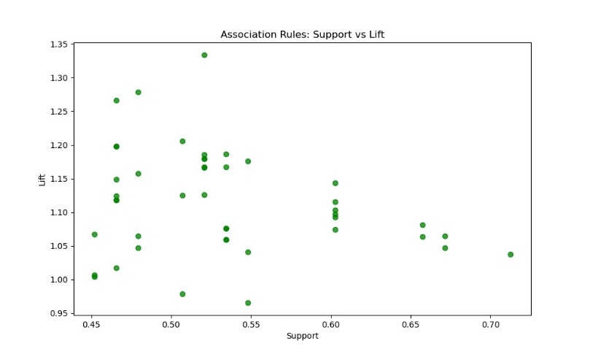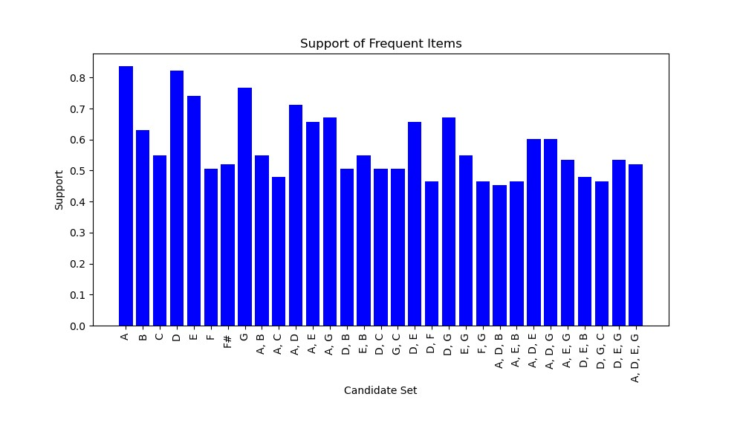**Visualization**

*Figure 1: Support of Frequent Items Figure 2: Support vs Lift*

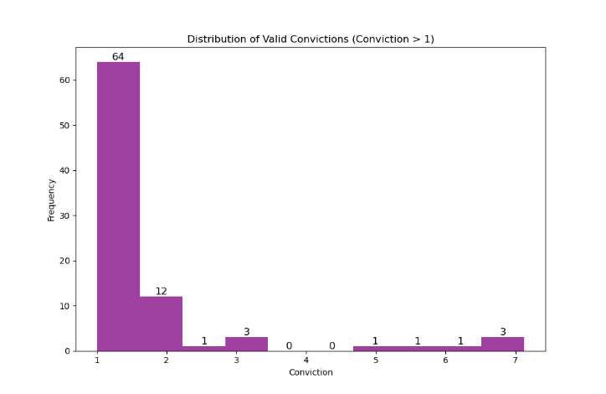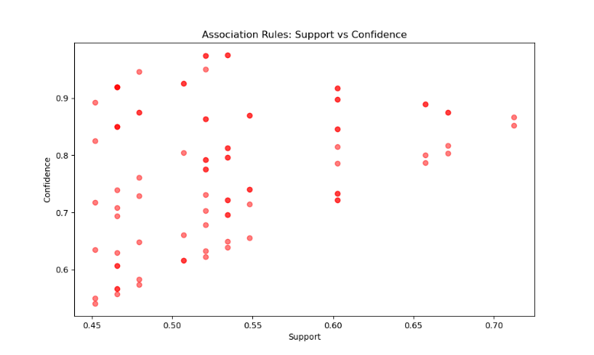

*Figure 3: Support vs Confidence Figure 4: Distribution of Valid Convictions*

**Market Basket Analysis Result Interpretation**

LHS RHS FREQUENCY SUPPORT CONFIDENCE LIFT

G, C D 34 0.4658 0.9189 1.1180

Regel Confidence

LHS → RHS fre(LHS, RHS) / frq(LHS)

G,C → D frq(G,C, D) / frq (G,C)

34/37 = 0.9189

Frequency Lift

Confidence(LHS, RHS) / Support(RHS)

frq(LHS, RHS) 0.9189 / 0.8219 = 1.1180

frq(G,C → D) = 34

Support

Frq(LHS, RHS) / N

34/73 = 0.4658

|  |  |  |  |  |  |  |  |  |
| --- | --- | --- | --- | --- | --- | --- | --- | --- |
| Compositions | A | B | C | D | E | F | F# | G |
| 1 | 1 | 1 | 0 | 1 | 1 | 0 | 1 | 0 |
| 2 | 0 | 1 | 0 | 1 | 1 | 0 | 1 | 0 |
| 3 | 1 | 1 | 1 | 1 | 1 | 1 | 1 | 1 |
| 4 | 1 | 0 | 0 | 1 | 1 | 1 | 0 | 1 |
| 5 | 1 | 0 | 0 | 1 | 0 | 1 | 0 | 1 |

**…**

|  |  |  |  |  |  |  |  |  |
| --- | --- | --- | --- | --- | --- | --- | --- | --- |
| 69 | 1 | 1 | 1 | 1 | 1 | 1 | 1 | 1 |
| 70 | 1 | 0 | 1 | 1 | 0 | 1 | 0 | 1 |
| 71 | 1 | 1 | 0 | 1 | 0 | 0 | 1 | 0 |
| 72 | 1 | 0 | 0 | 1 | 1 | 1 | 1 | 1 |
| 73 | 1 | 1 | 0 | 1 | 1 | 1 | 1 | 1 |