Willie M. Bonavente

BSIT 2-4

SEATWORK #3

***SOURCE CODE***

# Author: Willie M. Bonavente

# Seatwork #3

class Employee:

# 'Common base class for all employees'

empCount = 0

def __init__(self, name, salary,gender):

self.name = name

self.salary = salary

self.gender = gender

Employee.empCount += 1

def displayCount(self):

return ("Total Employee: %d" % Employee.empCount)

def displayEmployee(self):

return ("Name: ", self.name, "Salary: ", self.salary, "Gender: ", self.gender )

# "This would create first object of Employee class"

emp1 = Employee("Zara", 2000, "male")

# "This would create second object of Employee class"

emp2 = Employee('Manni', 5000, "female")

emp3 = Employee("Lee", 4000, "female")

# Storing Objects into sets and the category for dictionaries

data_base = {

"names": [

"Chopin",

"Liszt",

"Bach",

"Debussy",

"Mozart",

"Beethoven",

"Clara"

],

"salary": [

2000,

3000,

5000,

1000,

3400,

3003,

2500,

],

"gender": [

"male",

"male",

"male",

"male",

"male",

"male",

"female"

]

}

for i in range(len(data_base["names"])):

emp = Employee(data_base["names"][i], data_base["salary"][i], data_base["gender"][i])

recent_emp = i + 1

count = emp.displayCount()

print(emp.displayEmployee())

# Search for specific employee here

search_name = "Robert" # Example: searching for employee named "Mozart"

for i in range(len(data_base["names"])):

if data_base["names"][i] == search_name:

emp = Employee(data_base["names"][i], data_base["salary"][i], data_base["gender"][i])

recent_emp = i + 1

count = emp.displayCount()

print(emp.displayEmployee())

break

else:

print(search_name, "is not employee")

print("Recent Employee:",recent_emp)

print(count)

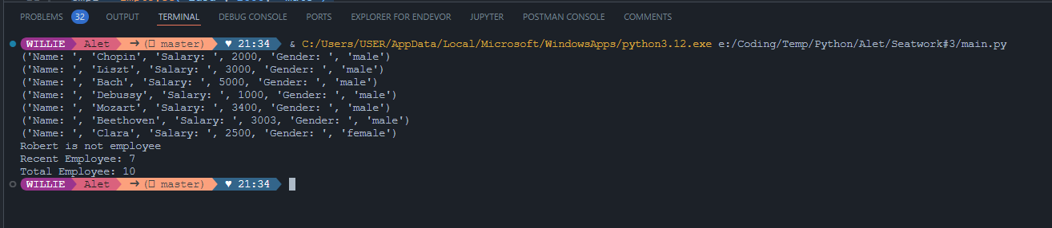**OUTPUT**