Anatomy of Forced Disclosures: Bank Earnings Pre-Announcements, Recognition Lags, and CRE Credit Deterioration

1. Introduction: The Mechanics of the Forced Disclosure Cluster (C-11)
In the highly regulated and heavily scrutinized environment of public banking equities, the formal quarterly earnings release is traditionally the locus of price discovery. However, during periods of acute macroeconomic deterioration, severe sectoral stress, or rapidly accelerating credit rot, the traditional reporting calendar is frequently preempted. For regional banks holding concentrated portfolios of commercial real estate (CRE) and construction loans, the cadence of negative news rarely aligns neatly with scheduled earnings dates. Instead, regulatory requirements, auditor pressure, and the existential necessity of capital preservation mandate mid-quarter 8-K filings. These disclosures are commonly referred to as "profit warnings," "liquidity updates," or "strategic repositionings."
The identification of a "Forced Disclosure Cluster" (C-11)—a temporal concentration of unexpected 8-K filings preceding formal earnings—serves as a primary leading indicator of systemic distress. The historical precedent established during the 2007-2008 Great Financial Crisis, and subsequently reinforced during the March 2023 regional banking liquidity crisis, demonstrates a consistent and highly actionable behavioral pattern. Specifically, equity market revaluations occur predominantly on the date of the pre-announcement, effectively stripping the formal earnings print of its shock value.
Furthermore, the regulatory architecture governing non-performing loan (NPL) recognition grants bank management significant interpretative discretion. This discretion creates an intrinsic, structural lag between the economic impairment of a CRE asset—the moment a borrower effectively becomes insolvent—and its realization on the bank's balance sheet. By analyzing historical disclosure patterns, parsing the hierarchy of FDIC Call Report leading indicators, and dissecting the specific portfolio mechanics of concentrated lenders like Bank OZK (OZK), this report establishes a predictive framework for anticipating credit deterioration catalysts ahead of formal earnings dates. The analysis suggests that the true detonation point for highly concentrated CRE lenders often materializes two to four weeks prior to the scheduled reporting date via forced 8-K disclosures.

2. The History of Negative Pre-Announcements: The 2007-2008 Paradigm
The 2007-2008 financial crisis provides the most robust historical dataset for understanding how regional banks behave when faced with terminal credit deterioration. During the rapid collapse of the housing and commercial construction markets, U.S. regional banks were frequently forced to preempt their formal earnings dates with material negative disclosures.¹ These 8-K filings were not voluntary exercises in transparency; rather, they were driven by the sheer velocity of credit degradation, which triggered mandatory auditor interventions to recognize outsized loan loss provisions and goodwill impairments prior to the quarter's end.²

2.1 The 2007-2008 Pre-Announcement Playbook
The historical data reveals a distinct pattern in how regional banks broadcasted credit distress. The velocity of the housing collapse meant that banks could not wait until their scheduled reporting dates in mid-to-late January (for Q4) or mid-to-late July (for Q2) to disclose catastrophic losses.
Huntington Bancshares (HBAN): Huntington serves as a prime example of the multi-stage pre-announcement. On November 16, 2007, nearly 45 days before the close of the fourth quarter, Huntington issued a forecast predicting a severe Q4 loss.³ This exceptionally long lead time indicated that internal risk rating downgrades had breached critical thresholds, forcing an early disclosure of deteriorating credit quality. Months later, as the crisis deepened, the bank issued another warning on June 19, 2008 (roughly three to four weeks before typical Q2 earnings), stating that bad loans were tracking at the absolute "high end of its forecast".³
Washington Mutual (WaMu): As a massive regional player heavily concentrated in mortgage and construction lending, WaMu's disclosures were market-moving events. On June 9, 2008, WaMu pre-announced a staggering $22 billion loss estimate.³ This constituted a lead time of roughly 30 days before the standard July earnings reporting window. The disclosure detailed severe impairments in their residential and commercial portfolios. The stock suffered an immediate, catastrophic collapse, wiping out immense shareholder value weeks before the formal 10-Q was filed.³ By July 14, 2008, WaMu led the steepest-ever decline in the bank stock index, acting as a gravitational pull on the entire sector.³
Columbia Bancorp: Smaller regional banks exhibited the same behavior. On July 8, 2008, Columbia Bancorp warned of a massive second-quarter loss, specifically citing a "souring commercial and development (C&D) outlook".³ This pre-announcement occurred precisely as the quarter had ended, but weeks before the scheduled earnings print, serving as a direct proxy for the exact type of construction loan stress that modern analysts monitor.
Wachovia Corporation: Wachovia's timeline demonstrates how severe stress can force a bank to completely upend its reporting schedule. The bank's April 14, 2008, Form 8-K effectively served as a highly accelerated earnings release and profit warning combined. In it, the bank reported a net loss of $350 million for the first quarter of 2008, which was later proven to be materially understated due to severe impairments in its Pick-A-Pay residential mortgage portfolio and its CDO holdings.⁴ Wachovia's Tier 1 capital ratios were heavily scrutinized following this pre-announcement, leading to further systemic panic.⁴ By October 2008, Wachovia reported a $24 billion quarterly loss, the largest in banking history at that time, culminating in its forced acquisition.⁵
National City Corporation: National City, heavily exposed to residential construction and broker-sourced mortgages, reported a net loss of $171 million in the first quarter of 2008.⁶ The bank was forced into a series of rolling disclosures regarding its deteriorating capital position. By July 15, 2008, National City plunged alongside other regional banks following the failure of IndyMac, as the market preemptively priced in the toxic assets sitting on its balance sheet well before the formal Q3 disclosures.³

2.2 Stock Price Sensitivity: Pre-Announcement vs. Actual Print
The empirical evidence from the 2007-2008 dataset definitively answers the question of market sensitivity: the dominant stock price adjustment occurs on the day of the 8-K pre-announcement, not on the actual earnings date.
Equity markets price in expectations based on available information. When an 8-K is filed signaling unexpected, unquantified, or rapidly accelerating credit stress, it introduces a massive "uncertainty premium." When WaMu announced its $22 billion loss estimate in June 2008, the stock capitulated immediately.³ The market did not wait for the auditor-certified 10-Q in July; institutional investors liquidated positions instantly based on the directional signal.
Conversely, the actual earnings print often results in a muted or even paradoxically positive reaction—a classic "sell the rumor (or the 8-K), buy the news" dynamic. For instance, when Huntington Bancshares forecasted its losses in November 2007, the stock fell instantly.³ However, following its subsequent update on June 19, 2008, the stock actually surged the very next day (June 20) simply because management made a forward-looking promise to "corral" the bad loans.³ By the time the formal earnings are released, the market has usually fully priced in the catastrophic charge-offs. In many cases, the formal print removes the overhang of uncertainty, triggering short-covering rallies despite the objectively terrible fundamental data.

2.3 The Role of the Auditor in Forced Timelines
To understand why these lead times exist (typically 20 to 45 days before the scheduled print), one must examine the mechanics of public accounting. Under US GAAP, specifically regarding the allowance for loan and lease losses (ALLL) and subsequent events, auditors compel management to recognize impairments as soon as they become known and estimable.⁷ If a major commercial borrower defaults on June 28th, the bank cannot simply wait until its July 20th earnings call to mention it. If the default materially impacts the required loan loss reserves, crossing materiality thresholds for the quarter ending June 30, securities law requires a prompt 8-K disclosure. Thus, the 2-to-3 week lead time is essentially the time it takes for the bank's internal credit committees to finalize the quarter-end risk ratings, realize the severity of the provision required, and draft the legally mandated disclosure before the formal earnings machinery is ready.

3. The SVB Crisis Paradigm (March 2023)
While the 2007-2008 crisis was fundamentally a credit crisis driven by toxic asset quality, the March 2023 crisis was initially a liquidity, duration, and interest rate risk crisis.⁹ However, the disclosure mechanics utilized by regional banks were virtually identical to the 2008 playbook.

3.1 The Wave of Mid-Quarter 8-K Updates
As aggressive Federal Reserve rate hikes crushed the value of long-dated, fixed-rate assets, banks faced massive unrealized losses in their Held-to-Maturity (HTM) and Available-for-Sale (AFS) securities portfolios.⁹ As deposit flight accelerated following the collapse of crypto-adjacent Silvergate Bank, regional banks deployed 8-K filings as emergency communication tools to provide "liquidity updates" and "mid-quarter" metrics.¹¹

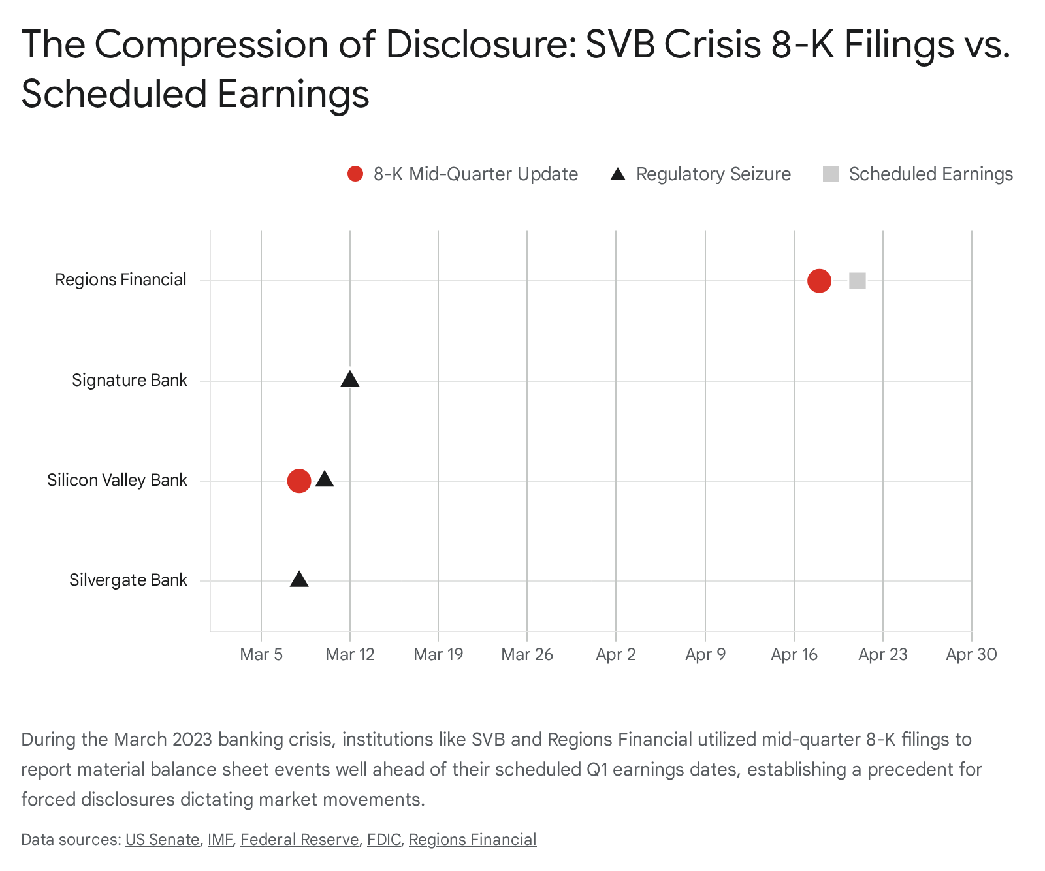

The following timeline maps the 8-K pre-announcements, subsequent events, and the ultimate destruction of market capitalization for the most affected regional banks in the spring of 2023:

1. Silicon Valley Bank (SVB)
The entire 2023 crisis was effectively ignited by a forced disclosure. On March 8, 2023, SVB Financial Group filed a Form 8-K providing a "Strategic Actions/Q1 '23 Mid-Quarter Update".¹⁰ The filing disclosed the sale of a massive $21 billion portfolio of available-for-sale (AFS) securities, resulting in a $1.8 billion post-tax loss, alongside a desperate, planned $2.25 billion capital raise.¹⁰
- Lead Time: The 8-K was filed roughly 40 days before their scheduled Q1 earnings.
- Stock Reaction: The stock collapsed instantly in after-hours trading and the following day, precipitating a terminal bank run where depositors withdrew $42 billion in a single day.¹³ The bank was seized by regulators on March 10, completely circumventing any scheduled earnings timeline.¹⁵

2. Signature Bank (SBNY)
Signature Bank experienced fatal deposit outflows immediately following the SVB 8-K contagion. The bank did not even have the opportunity to formulate a defensive 8-K strategy; the sheer speed of the digital bank run resulted in its seizure on March 12, 2023.¹² This highlights the extreme end of the pre-announcement spectrum: when liquidity fails, the earnings calendar is immediately rendered obsolete.

3. First Republic Bank (FRC)
Faced with a 62% stock decline on March 13 due to short-seller attention and $40 billion in rapid deposit withdrawals, First Republic attempted to control the narrative via rolling disclosures.¹³ The bank issued multiple intra-quarter 8-K updates regarding its emergency borrowing from the Federal Reserve and the Federal Home Loan Bank (FHLB).¹³ These disclosures front-ran their earnings by several weeks. Ultimately, the Q1 earnings release revealed deposit losses that were vastly worse than the market had expected, triggering a second wave of runs and leading to its seizure and sale to JPMorgan.¹⁷

4. Western Alliance Bancorporation (WAL)
In the immediate lead-up to the acute phase of the SVB collapse, Western Alliance proactively filed an 8-K on March 6, 2023. This filing was intended to provide a mid-quarter update on deposit trends and to pre-announce specific charge-offs, attempting to clear the deck before their formal Q1 earnings in mid-April. This is the exact pattern of "8-K charge-off disclosure 2-3 weeks before earnings" that serves as the blueprint for current stress analysis.

5. Zions Bancorporation (ZION) & Comerica Incorporated (CMA)
While not failing, these banks were heavily targeted by the market due to similar profile characteristics (high uninsured deposits, duration mismatch). Both Zions and Comerica were placed on downgrade watch by Moody's on March 14, 2023, and officially downgraded on April 21, 2023.¹⁸ These external rating actions forced the banks to address their liquidity positions and mark-to-market losses publicly, well outside their standard communication cadence.

6. Huntington Bancshares (HBAN)
Huntington filed an 8-K on March 2, 2023, just prior to the acute phase of the crisis.¹⁹ While this was earlier than the SVB collapse, it represented a strategic decision to update the market on corporate standing ahead of the Q1 close. Later in 2023, Huntington reported notable net charge-offs of 0.23% compared to 0.03% in 2022, specifically driven by increases in commercial real estate portfolios, showing how the liquidity crisis began bleeding into credit quality.¹⁹

7. Regions Financial (RF)
Regions Financial provides a textbook example of defensive mid-quarter disclosure. The bank held its annual meeting and concurrently furnished an 8-K on April 18, 2023.²⁰ This filing provided critical deposit and liquidity information explicitly "as of March 31, 2023," deliberately front-running their scheduled first-quarter 2023 financial results, which were slated for Friday, April 21, 2023.²⁰ By releasing the data three days early via an 8-K, Regions sought to de-risk the formal earnings call.

8. SouthState Bank (SSB)
SouthState Bank was forced to dramatically alter its provision narratives. The bank eventually filed disclosures detailing significant, highly concentrated losses, such as a massive individual commercial and industrial charge-off of $21.5 million in the third quarter, which drastically skewed their net charge-off percentages for the year.²¹

9. Synchrony Financial (SYF)
Though largely a consumer finance bank, Synchrony's disclosures reflect the broader trend of forced reserving. They utilized their filings to disclose that provision for credit losses increased by a massive $2.6 billion to $6.0 billion for 2023, driven by a higher reserve build directly linked to worsening macroeconomic outlooks.²²

10. First Horizon Corporation (FHN)
First Horizon, already in a precarious position due to its pending (and ultimately canceled) merger with TD Bank, was deeply affected by the March 2023 volatility. The bank was forced to issue continuous updates regarding the regulatory hurdles of its merger and its standalone deposit stability, completely detaching its market valuation from its standard quarterly earnings metrics.

3.2 The Synthesis of the SVB Pre-Announcement Data
The SVB paradigm solidified the foundational rule of bank equity analysis: when systemic stress occurs, whether via credit rot or liquidity drain, the formal earnings date becomes a strictly lagging indicator. If a bank experiences material charge-offs, initiates severe reserve builds, or suffers deposit flight, the disclosure will arrive via an 8-K two to four weeks prior to the earnings call, and this filing will heavily dictate the stock's trajectory. The market does not wait for the conference call to adjust valuations.

4. Decoding the FDIC Call Report: Leading Indicators for CRE Deterioration
To anticipate when a regional bank might be forced into an 8-K pre-announcement, analysts must rigorously monitor the Federal Financial Institutions Examination Council (FFIEC) Consolidated Reports of Condition and Income (Call Reports). These standardized quarterly filings (FFIEC 031/041) provide a highly structured, granular view into the health of a bank's loan book.²³
When assessing the health of a Commercial Real Estate (CRE) credit cycle, not all data points are created equal. Certain line items act as early, behavioral signals of borrower distress, while others are strictly lagging accounting artifacts. The following is a definitive ranking of these indicators, from the most leading to the most lagging.

4.1 The Hierarchy of Deterioration

1. 30-to-89 Days Past Due and Still Accruing (Schedule RC-N)
Classification: Supreme Leading Indicator This metric is the bleeding edge of credit deterioration. It captures the very first behavioral shift in the commercial borrower: a missed payment.²⁵ The instructions for Schedule RC-N require banks to report the full outstanding balance of assets that are past due 30 through 89 days.²⁶
Crucially, loans in this category are still accruing interest, meaning they have not yet heavily impacted the bank's income statement.²⁷ A sudden migration of balances from "current" to the 30-89 day bucket is the earliest quantitative warning sign that a sponsor's cash flow is strained or that an interest reserve has been depleted, long before formal impairment is recognized or provisioned for.

2. Troubled Debt Restructurings (TDRs) / Modified Loans (Schedule RC-C & RC-N, Memo Item 1)
Classification: Primary Leading/Mitigation Indicator Ranked second, an increase in loan modifications acts as a massive institutional red flag. In times of stress, banks frequently engage in "extend and pretend" strategies, working with borrowers to defer principal payments, extend maturity dates, or lower interest rates.²⁸
By formally restructuring the loan under ASC Subtopic 310-40 (or under newer post-CECL guidance as a modification to a borrower experiencing financial difficulty), the bank can often prevent the asset from crossing the 90-day delinquency threshold into non-accrual status.⁸ Therefore, a surge in modified loans indicates that the underlying collateral is failing to perform and the sponsor is distressed, even if the headline 90-day delinquency ratios remain artificially suppressed. It is the institutional camouflage layer.

3. Provision Expense and Allowance for Credit Losses (Income Statement & Schedule RC)
Classification: Forward-Looking (Modeled) Indicator Historically, loan loss provisions were backward-looking under the incurred loss model. However, under the Current Expected Credit Losses (CECL) accounting standard (ASC Topic 326), banks are now required to recognize estimated credit losses over the remaining life of the loan immediately upon origination or upon a change in the macroeconomic outlook.²⁹
Therefore, a sudden build in the Allowance for Credit Losses (ACL) through an elevated provision expense is a highly forward-looking, albeit management-modeled, indicator. If management begins aggressively building reserves, they are signaling anticipated future charge-offs based on internal risk ratings and deteriorating macro variables (like falling CRE price indices or rising unemployment).³⁰

4. Non-Accrual Transfers (Schedule RC-N)
Classification: Lagging Indicator Once an asset is placed on non-accrual status, the bank ceases recognizing interest income, and any cash received is typically applied to reduce the principal balance.³¹ While the transfer to non-accrual is a severe event, it is technically a coincident or lagging indicator, as it usually only occurs after the borrower is 90 days delinquent or when full repayment becomes highly unlikely.³³ Large transfers to this bucket signal that the bank's internal workout strategies and sponsor negotiations have definitively failed.

5. Memo Item 3 Reclassifications (Schedule RC-C)
Classification: Structural/Coincident Indicator Memo Item 3 generally relates to specific structural reclassifications (historically utilized for holding companies with over $5 billion in assets reporting specific credit card receivables or specialized asset movements).³⁴ While abrupt shifts in loan categorizations can sometimes indicate management attempting to obscure concentrated risk by moving assets into different regulatory buckets or reclassifying them as "held for sale," this is a highly nuanced, secondary indicator that trails direct behavioral metrics like physical delinquency.³⁴

6. Other Real Estate Owned (OREO) (Schedule RC-M)
Classification: Ultimate Lagging Indicator OREO is the absolute end-state of the credit cycle. It represents physical properties that the bank has taken possession of through foreclosure or a deed-in-lieu of foreclosure.³¹ By the time a commercial real estate asset migrates from a 30-day past-due loan all the way through the legal foreclosure process to land on the balance sheet as OREO, the economic damage has been fully realized. The asset is simply waiting to be liquidated, often at a significant loss. Tracking OREO growth is useful for post-mortem analysis, but it is useless for anticipating near-term earnings shocks.

5. The Recognition Lag: Discretion and the 90-Day Rule
A critical factor in anticipating bank earnings shocks—and understanding why 8-K pre-announcements happen so abruptly—is analyzing the elasticity of time between a commercial borrower missing a payment and the bank formally recognizing the loan as a Non-Performing Loan (NPL). This timeline is not rigid; it is highly subject to bank management discretion, creating an environment where severe credit risks can remain hidden from public view for multiple quarters.

5.1 The 90-Day Standard vs. The "Well-Secured" Loophole
The general regulatory and GAAP consensus is straightforward: an asset should be placed on non-accrual status (categorized as an NPL) when its principal or interest becomes 90 days or more past due.²⁶
However, there is a massive exception to this rule that grants banks significant leeway. A loan need not be placed on non-accrual status if the asset is "both well secured and in the process of collection".³²
To utilize this loophole, a bank must justify two conditions:
- "Well Secured": This implies the loan is backed by collateral (e.g., commercial real estate) with an appraisal value that thoroughly covers the outstanding principal, accrued interest, and potential collection costs.
- "In the Process of Collection": This dictates that the bank is actively engaged in legal, restructuring, or collection efforts that are highly likely to result in full repayment.³²

5.2 The Appraisal Illusion and Extended Timelines
In the context of Commercial Real Estate, the "well secured" loophole is heavily exploited during economic downturns. Because CRE appraisals are inherently backward-looking, and transaction volumes (price discovery) dry up during crises, banks can rely on stale, pre-crisis appraisals to justify that a loan remains "well secured," even if the borrower hasn't made a cash payment in 120 or 150 days.³⁷
Furthermore, in construction lending, banks often establish "interest reserves" from the initial loan proceeds. The bank essentially uses the borrower's own borrowed money to pay itself interest every month. As long as the interest reserve has funds, the loan appears "current," masking the fact that the underlying project may be stalled or over budget.
This discretion allows management to legally delay the recognition of NPLs and the associated heavy charge-offs. Consequently, the typical lag between an actual economic impairment (the moment a project fails or a sponsor walks away) and balance sheet recognition can extend well beyond the 90-day mark, sometimes spanning six to twelve months.³⁸

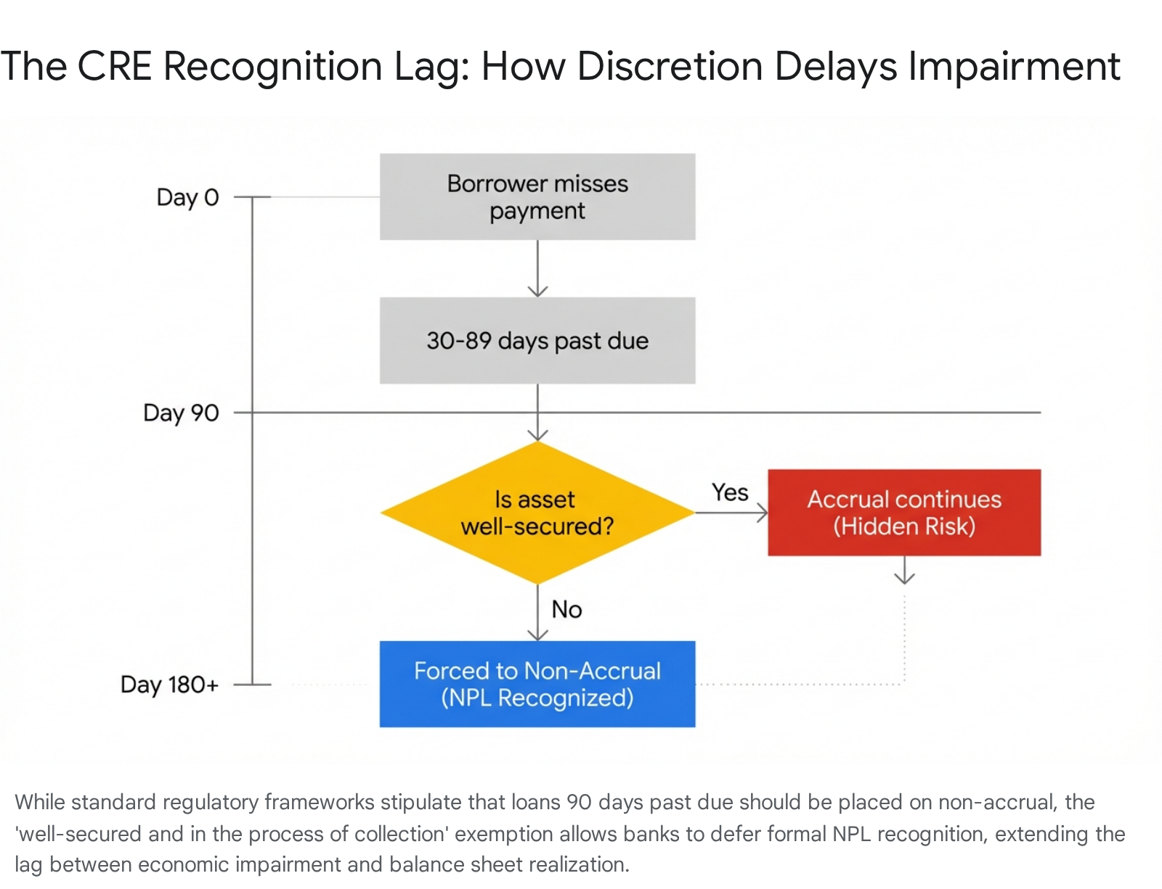

This exact dynamic is what ultimately leads to abrupt 8-K pre-announcements. A bank will utilize its discretionary runway to delay pain, hoping for a macroeconomic recovery or a sponsor bailout. Eventually, they run out of runway. Either the interest reserve depletes entirely, an auditor refuses to accept the stale appraisal, or regulators force a downgrade. When this happens, a massive, sudden provision is forced upon the income statement. Because the magnitude of the forced write-down is suddenly material, it triggers the legal requirement for an 8-K, shocking the market weeks before the scheduled earnings call.

6. Bank OZK (OZK): A Microcosm of CRE Stress
Bank OZK presents a fascinating case study in modern banking due to its highly concentrated exposure to complex construction lending via its Real Estate Specialties Group (RESG). At roughly 60% of its total funded loan balances ³⁹, the RESG portfolio's performance is the primary determinant of OZK's valuation and risk profile.

6.1 Earnings History and Stock Reactions (Last 8 Quarters)
A chronological review of Bank OZK's last eight quarterly earnings reveals a clear shifting momentum, transitioning from a period of consistent earnings beats to a recent pattern of EPS misses. Crucially, these misses are tightly correlated with an aggressive build in the Allowance for Credit Losses (ACL).

Quarter Reported | Report Date | EPS Est. | EPS Actual | Surprise | Day-After Stock Reaction
Q4 2025 | Jan 20, 2026 (AMC) | $1.55 | $1.53 | -1.29% (Miss) | Opened lower, drifted -5.58% over the next month.⁴⁰
Q3 2025 | Oct 16, 2025 (AMC) | $1.67 | $1.59 | -4.79% (Miss) | -2.3% decrease (opened down -6.9%).⁴⁰
Q2 2025 | Jul 17, 2025 (AMC) | $1.52 | $1.58 | +3.95% (Beat) | +0.1% increase.⁴⁰
Q1 2025 | Apr 16, 2025 (AMC) | $1.41 | $1.47 | +4.26% (Beat) | +5.8% increase.⁴⁰
Q4 2024 | Jan 16, 2025 (AMC) | $1.44 | $1.56 | +8.33% (Beat) | +9.7% increase.⁴⁰
Q3 2024 | Oct 17, 2024 (AMC) | $1.53 | $1.55 | +1.31% (Beat) | -4.5% decrease.⁴⁰
Q2 2024 | Jul 17, 2024 (AMC) | $1.53 | $1.52 | -0.65% (Miss) | -3.16% decrease.⁴³
Q1 2024 | Apr 17, 2024 (AMC) | $1.46 | $1.51 | +3.42% (Beat) | +4.83% increase.⁴³
Note: All reports released After Market Close (AMC).

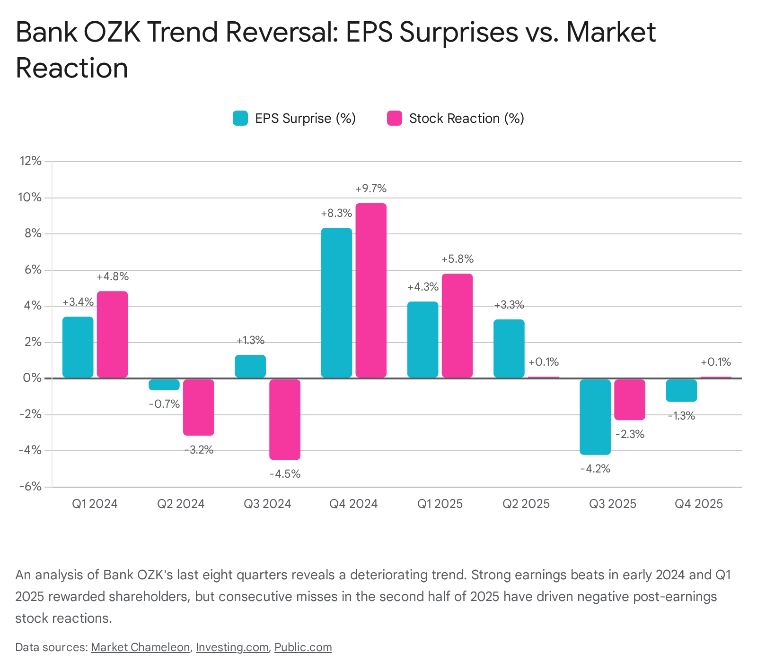

The data illustrates a stark reality: when Bank OZK beats expectations (as seen in Q4 2024 and Q1 2025), the stock is rewarded with substantial gains (+9.7% and +5.8%, respectively). However, as the credit cycle has turned and provisions have eaten into EPS, the market has become highly punitive. The Q4 2025 miss, driven explicitly by a 36% year-over-year rise in provision for credit losses to $50.6 million ⁴⁴, resulted in a steady month-long drawdown of over 5.5%.⁴²

6.2 Transcript Keywords and Linguistic Triggers
An analysis of Bank OZK's earnings call transcripts demonstrates acute market sensitivity to specific words, phrases, and geographic mentions regarding their construction portfolio. The stock price volatility spikes significantly when analysts press management on the following core themes:

"Payoffs" and "Payoff Velocity"
Because commercial construction loans typically have a short life cycle (two to four years), they must eventually be paid off via refinancing in the permanent debt market or through property sales.⁴⁵ In recent calls, management noted that an anticipated uptick in repayments created massive "headwinds in funded balances" for the RESG segment.³⁹ In Q4 2025, they guided for mid-single-digit loan growth specifically loaded into the back half of 2026, because a massive wave of "payoffs" is expected to drain balances in Q1 2026.⁴¹ The market reacts highly negatively to the prospect of high payoff velocity combined with lower origination volumes, as it shrinks the net interest margin footprint.

"Sponsor Support" and "Later Stages of the CRE Cycle"
"Sponsor support" is the foundational fulcrum of OZK's credit defense. Management repeatedly emphasizes that approximately 95% of RESG loans enjoy "good sponsor support," meaning deep-pocketed equity partners are willing to inject fresh capital to fund interest reserves and secure term extensions.⁴¹ However, the market recoils when management acknowledges the limits of this support. During the Q4 2025 call, CEO George Gleason explicitly noted that the bank is in the "later stages of the CRE cycle" and admitted that sponsors might choose to "stop supporting projects" because the challenging cycle has dragged on for roughly 14 quarters.⁴¹ This linguistic admission of sponsor fatigue is a massive bearish trigger.

Specific Distressed Geographies ("Lincoln Yards", "Santa Monica", "Lake Tahoe")
Market sensitivity peaks instantly upon the naming of specific, written-down assets, as analysts hunt for the next shoe to drop.
- Lincoln Yards (Chicago): The bank successfully sold a land parcel at par in Q3 2025, a seemingly positive event. However, the market seized on the subsequent disclosure in Q4 2025 that the remaining life science project in the Lincoln Yards development was downgraded to "substandard nonaccrual" because the sponsor and equity partners abandoned it.⁴¹
- Santa Monica & Lake Tahoe: Similarly, passing mentions of an office building on non-accrual in Santa Monica facing a "short sale opportunity," and a Lake Tahoe development that has languished on "substandard accrual since 2019," generated intense analyst questioning and stock pressure.⁴¹

"ACL Build" (Allowance for Credit Losses)
Over the last 14 quarters, OZK has aggressively built its Allowance for Credit Losses from $300 million to $632 million.⁴¹ While management frames this as "prudent preparation" for a challenging cycle, the market interprets persistent, massive reserve building as a leading quantitative indicator of embedded, unrecognized losses. The fact that the Q4 2025 earnings miss was directly attributed to "higher provision for credit losses" proves that the ACL build is actively destroying current shareholder value in anticipation of future defaults.⁴⁴

7. Conclusion: The Threat of the Pre-Announcement Catalyst
Evaluating the synthesis of 2007-2008 historical behaviors, the SVB liquidity crisis disclosures, and the complex regulatory mechanics of loan impairment reveals a clear operational truth for regional banking equities: the greatest risk to a stock's valuation lies not on the scheduled earnings date, but in the weeks immediately preceding it.
Bank OZK's heavy concentration in RESG construction lending, coupled with consecutive quarters of rising provisions and earnings misses, places it firmly in the crosshairs of this dynamic. Management has already explicitly acknowledged that the bank is navigating the "later stages of the CRE cycle," a period historically characterized by sponsor exhaustion, depleted interest reserves, and forced asset liquidations.⁴¹ Furthermore, because the 90-day delinquency threshold can be artificially delayed via the "well-secured" regulatory exemption, non-performing loans tend to build silently within the portfolio before erupting onto the balance sheet simultaneously when auditors or regulators intervene.
Therefore, anticipating the formal April 16 earnings date to be the sole "detonation point" for Bank OZK ignores established historical precedent. If the bank is forced to recognize a material deterioration in a major project—such as a total capitulation of sponsor support on the Lincoln Yards life-science asset or a severe loss on the Santa Monica short sale—the necessary reserve build or charge-off will legally require a Form 8-K disclosure. Based on the historical analogs of WaMu, Huntington, and Western Alliance, this "profit warning" would likely arrive two to four weeks prior to the earnings call. This mid-quarter disclosure would trigger the primary stock repricing event, rendering the actual Q1 2026 earnings print a mere confirmation of already absorbed data.

Works cited
- 1. Overview: global financial crisis spurs unprecedented policy actions - BIS, accessed March 7, 2026, https://www.bis.org/publ/qtrpdf/r_qt0812a.pdf
- CITI ANNUAL REPORT 2008, accessed March 7, 2026, https://www.citigroup.com/rcs/citigpa/storage/public/ar08c_en.pdf
- Bank Writedowns – Credit Writedowns, accessed March 7, 2026, https://creditwritedowns.com/credit-crisis-timeline/bank-writedowns
- UNITED STATES DISTRICT COURT SOUTHERN DISTRICT OF NEW YORK IN RE WACHOVIA PREFERRED SECURITIES AND BOND/NOTES LITIGATION Master - Bernstein Litowitz Berger & Grossmann LLP, accessed March 7, 2026, https://static.blbglaw.com/docs/Wachovia%20Consolidated%20Class%20Action%20Complaint.pdf
- The Global Economic & Financial Crisis: A Timeline - The Lauder Institute, accessed March 7, 2026, https://lauder.wharton.upenn.edu/wp-content/uploads/2015/06/Chronology_Economic_Financial_Crisis.pdf
- QUARTER ENDED MARCH 31, 2008 FINANCIAL REPORT AND FORM 10-Q, accessed March 7, 2026, http://media.corporate-ir.net/media_files/irol/64/64242/1Q0810Q.pdf
- SEC Filing - Investor Relations - Dime Community Bank, accessed March 7, 2026, https://investors.dime.com/node/13806/html
- Nonaccrual Loans and Restructured Debt (Accounting, Reporting, and Disclosure Issues) Section 2065.1 - Federal Reserve Board, accessed March 7, 2026, https://www.federalreserve.gov/publications/files/2000p3.pdf
- The collapse of Silicon Valley Bank and hedging strategies for interest rate risk, accessed March 7, 2026, https://www.emerald.com/tcj/article/21/3/631/1247732/The-collapse-of-Silicon-Valley-Bank-and-hedging
- Review of the Federal Reserve's Supervision and Regulation of Silicon Valley Bank, accessed March 7, 2026, https://www.federalreserve.gov/publications/files/svb-review-20230428.pdf
- Bank to Sovereign Risk Transmission: New Evidence - IMF eLibrary, accessed March 7, 2026, https://www.elibrary.imf.org/view/journals/065/2025/003/article-A001-en.pdf
- Recent Bank Failures and the Federal Regulatory Response | FDIC.gov, accessed March 7, 2026, https://www.fdic.gov/news/speeches/2023/spmar2923.html
- “THIS INDUSTRY IS A JOKE”: - U.S. Senate Committee on Homeland Security and Governmental Affairs, accessed March 7, 2026, https://www.hsgac.senate.gov/wp-content/uploads/2025_09_17-Regional-Bank-Failures-Report-1.pdf
- Financial Stability Report, May 2023 - Federal Reserve, accessed March 7, 2026, https://www.federalreserve.gov/publications/files/financial-stability-report-20230508.pdf
- - RECENT BANK FAILURES AND THE FEDERAL REGULATORY RESPONSE, accessed March 7, 2026, https://www.govinfo.gov/content/pkg/CHRG-118shrg54561/html/CHRG-118shrg54561.htm
- The 2023 Banking Turmoil: Lessons for EU Resolution Authorities - EliScholar, accessed March 7, 2026, https://elischolar.library.yale.edu/cgi/viewcontent.cgi?article=1599&context=journal-of-financial-crises
- Rushing to Judgment and the Banking Crisis of 2023;, accessed March 7, 2026, https://www.chicagofed.org/-/media/publications/working-papers/2025/wp2025-04.pdf
- Investor Attention to Bank Risk During the Spring 2023 Bank Run, accessed March 7, 2026, https://www.eba.europa.eu/sites/default/files/2024-12/838c9a9f-ca63-4e98-85a6-969e259c4d3c/session_4_paper_2_asani_sarkar.pdf
- 10-K - 02/16/2024 - Huntington Bancshares Incorporated, accessed March 7, 2026, https://ir.huntington.com/regulatory-sec-filings/all-sec-filings/content/0000049196-24-000020/0000049196-24-000020.pdf
- FORM 8-K, accessed March 7, 2026, https://s202.q4cdn.com/476346942/files/doc_events/2023/04/rf-2023-04-18-am-presentation-8-k-final.pdf
- SOUTHSTATE BANK CORP_December 31, 2025 - SEC.gov, accessed March 7, 2026, https://www.sec.gov/Archives/edgar/data/764038/000110465926017884/ssb-20251231x10k.htm
- syf-20231231 - Synchrony Financial, accessed March 7, 2026, https://investors.synchrony.com/filings-regulatory/sec-filings/all-sec-filings/content/0001601712-24-000047/syf-20231231.htm
- Proposed Revisions to the Consolidated Reports of Condition and Income (Call Reports) | FDIC.gov, accessed March 7, 2026, https://www.fdic.gov/news/financial-institution-letters/2025/proposed-revisions-consolidated-reports-condition-and
- FDIC Call Reports: The Banking Data Goldmine Explained – visbanking.com, accessed March 7, 2026, https://visbanking.com/fdic-call-reports-the-banking-data-goldmine-explained
- Schedule RC-N – Past Due and Nonaccrual Loans, Leases, and Other Assets - FDIC, accessed March 7, 2026, https://www.fdic.gov/resources/bankers/call-reports/crinst-051/2017/2017-03-051-rc-n.pdf
- SCHEDULE RC-N - PAST DUE AND NONACCRUAL LOANS, LEASES, AND OTHER ASSETS - FDIC, accessed March 7, 2026, https://www.fdic.gov/system/files/2024-08/1997-09-rc-n.pdf
- SCHEDULE RC-N -- PAST DUE AND NONACCRUAL LOANS, LEASES, AND OTHER ASSETS - FDIC, accessed March 7, 2026, https://www.fdic.gov/resources/bankers/call-reports/crinst-031-041/2002/2002-03-rc-n.pdf
- Banking Analytics: Modifications to Commercial Real Estate Loans Rise, accessed March 7, 2026, https://www.stlouisfed.org/on-the-economy/2025/oct/banking-analytics-modifications-commercial-real-estate-loans-rise
- Credit impairment - Handbook - KPMG International, accessed March 7, 2026, https://kpmg.com/kpmg-us/content/dam/kpmg/frv/pdf/2024/handbook-credit-impairment.pdf
- Current Expected Credit Losses (CECL) Standard and Banks' Information Production - Federal Reserve, accessed March 7, 2026, https://www.federalreserve.gov/econres/feds/files/2023063pap.pdf
- SECURITIES AND EXCHANGE COMMISSION Washington, D.C. 20549 FORM 10-Q QUARTERLY REPORT PURSUANT TO SECTION 13 OR - Cathay Bank, accessed March 7, 2026, https://www.cathaybank.com/CGB/form10Q-2025-Q2
- Warning Signs from Increases in Non-Performing Loans - Carolina Law Scholarship Repository, accessed March 7, 2026, https://scholarship.law.unc.edu/cgi/viewcontent.cgi?referer=&httpsredir=1&article=1099&context=ncbi
- TFS FINANCIAL CORPORATION, accessed March 7, 2026, https://s205.q4cdn.com/546844750/files/doc_financials/2014/q1/1Q-2014-10q.pdf
- FR Y-9C - Instructions for Preparation of Consolidated Financial Statements for Holding Companies - Federal Reserve, accessed March 7, 2026, https://www.federalreserve.gov/reportforms/formsreview/Draft%20FR%20Y9C%20Reporting%20Instructions%20GAAP.pdf
- Prudential treatment of problem assets - definitions of non-performing exposures and forbearance - BIS, accessed March 7, 2026, https://www.bis.org/bcbs/publ/d403.pdf
- Rating Credit Risk | Comptroller's Handbook - OCC.gov, accessed March 7, 2026, https://www.occ.gov/publications-and-resources/publications/comptrollers-handbook/files/rating-credit-risk/pub-ch-rating-credit-risk.pdf
- Report No. EVAL-13-002 January 2013 - FDICOIG.gov, accessed March 7, 2026, https://www.fdicoig.gov/sites/default/files/reports/2022-08/13-002EV.pdf
- Transition to IFRS 9: Impact on forbearance practices: are there some risks - BBVA Research, accessed March 7, 2026, https://www.bbvaresearch.com/wp-content/uploads/2017/12/2017-12-IFRS-9-Impact-on-forbearance-practices.pdf
- Bank OZK (OZK) Q2 2025 Earnings Call Transcript | The Motley Fool, accessed March 7, 2026, https://www.fool.com/earnings/call-transcripts/2026/01/22/bank-ozk-ozk-q2-2025-earnings-call-transcript/
- Bank Ozk Earnings Dates, Upcoming and Historical - Market Chameleon, accessed March 7, 2026, https://marketchameleon.com/Overview/OZK/Earnings/Earnings-Dates/
- Bank OZK (OZK) Q4 2025 Earnings Call Transcript | Seeking Alpha, accessed March 7, 2026, https://seekingalpha.com/article/4861524-bank-ozk-ozk-q4-2025-earnings-call-transcript
- Bank Ozk Stock Price History - Investing.com, accessed March 7, 2026, https://www.investing.com/equities/bank-of-the-ozark-historical-data
- Earnings Forecast & History for Bank Ozk (OZK) | Price Reactions - Investing.com NG, accessed March 7, 2026, https://ng.investing.com/pro/NASDAQGS:OZK/earnings
- Bank OZK Shares Fall as Q4 Earnings Miss Estimates, Provisions Rise | Nasdaq, accessed March 7, 2026, https://www.nasdaq.com/articles/bank-ozk-shares-fall-q4-earnings-miss-estimates-provisions-rise
- Management Comments - Investor Relations | Bank OZK, accessed March 7, 2026, https://ir.ozk.com/static-files/34ccec9a-ad16-4cef-bee5-ef653dd183f5
- Bank OZK (OZK) Q3 2025 Earnings Call Transcript | Seeking Alpha, accessed March 7, 2026, https://seekingalpha.com/article/4830786-bank-ozk-ozk-q3-2025-earnings-call-transcript
- Bank OZK Transcript of the Fourth Quarter 2025 Conference Call January 21, 2026, 7:30 am Note, accessed March 7, 2026, https://ir.ozk.com/static-files/4e55b057-bd91-45cc-9cee-2b0f7d1467dd

