Tech Goods Deflation: The Federal Reserve's Last Relief Valve
The global macroeconomic environment is currently defined by a precarious and highly sensitive equilibrium. As the Federal Reserve navigates the treacherous "last mile" of its disinflationary campaign, policymakers are caught in a structural tug-of-war. On one side of the ledger, services inflation—driven by structural shortages in housing, resilient healthcare costs, and a tight labor market—remains exceptionally sticky. On the other side, acting as a crucial macroeconomic anchor, is the persistent, structural deflation of core goods. At the very center of this deflationary gravity are technology goods: computers, smartphones, processing equipment, and the underlying silicon that powers them.
For decades, the American economy has benefited from the relentless march of Moore's Law, combined with the hyper-efficiency of the East Asian semiconductor supply chain. This paradigm has consistently delivered faster, more efficient, and more capable consumer electronics at steady or falling nominal prices. Statistical agencies, utilizing hedonic quality adjustments, translate these technological leaps into steep deflationary prints. Consequently, tech goods have acted as the Federal Reserve’s ultimate relief valve, mathematically masking the heat of domestic services inflation and allowing aggregate indices to trend toward the central bank's 2% target.
However, this powerful deflationary engine is not an immutable law of nature; it is a physical, highly fragile supply chain overwhelmingly concentrated in a single geopolitical flashpoint and a single corporate entity: Taiwan Semiconductor Manufacturing Company (TSMC).
This comprehensive research report rigorously quantifies the mechanical contribution of technology goods deflation to the U.S. Core Personal Consumption Expenditures (PCE) price index and the Core Consumer Price Index (CPI). By deconstructing the weights and historical price action of tech baskets, mathematically modeling the disappearance of this deflation, quantifying the multi-trillion-dollar U.S. dependency on TSMC's advanced manufacturing nodes, and utilizing the 2021 semiconductor shortage as an empirical precedent, this analysis exposes the systemic vulnerability of U.S. monetary policy. Furthermore, it stress-tests a scenario involving a 30% contraction in TSMC output to chart the chronological breakdown of U.S. hardware availability and the resulting inflationary cascade. The central conclusion is stark: if the silicon flow stops, the math governing the Federal Reserve's policy framework fundamentally breaks.

Part 1: The Architecture of Technology Goods in U.S. Inflation Metrics
To evaluate the macroeconomic threat posed by a semiconductor supply shock, it is essential to first deconstruct the internal architecture of the two primary U.S. inflation gauges. The Bureau of Economic Analysis (BEA) calculates the PCE price index, the Federal Reserve's preferred metric, while the Bureau of Labor Statistics (BLS) compiles the CPI, which drives consumer sentiment and financial market pricing. Both indices treat technology goods uniquely, relying heavily on quality-adjusted pricing.

1.1 Deconstructing the Core PCE Technology Basket
The Federal Reserve primarily targets the Core PCE Price Index, which excludes the highly volatile food and energy sectors to reveal the underlying trend of consumer prices.¹ The PCE is a chained index, meaning it accounts for consumer substitution effects more dynamically than the fixed-basket CPI.² Within this framework, consumer spending is bifurcated into goods and services, with goods further divided into durables and nondurables. Technology hardware is predominantly categorized under durable goods.
According to the BEA's National Income and Product Accounts (NIPA) Table 2.4.5U, total U.S. Personal Consumption Expenditures reached approximately $20.96 trillion by the end of 2025.³ Within this massive aggregate, total goods accounted for $6.50 trillion, and durable goods represented $2.26 trillion.³
The critical sub-component for evaluating the tech deflation thesis is found on Line 14 of Table 2.4.5U: "Video, audio, photographic, and information processing equipment and media." This specific category encapsulates the bulk of consumer electronics, from laptops and tablets to smart televisions and peripheral processing hardware.

PCE Expenditure Category (NIPA Table 2.4.5U) | 2024 Expenditure (Billions USD) | 2025 Expenditure (Billions USD)
Total Personal Consumption Expenditures (PCE) | $19,896.0 | $20,960.8
Total Goods | $6,261.5 | $6,506.5
Total Durable Goods | $2,178.0 | $2,263.9
Recreational Goods and Vehicles | $663.7 | $696.8
Video, audio, photographic, and information processing equipment | $402.7 | $427.1
Data derived from BEA NIPA Table 2.4.5U.³
In 2025, consumer spending on this core technology basket registered $427.167 billion.³ To calculate the relative weight of this category within the Core PCE index, we must adjust the total PCE baseline by stripping out food and energy. Historically, food and energy account for roughly 12% to 15% of total PCE. Using a conservative estimate where Core PCE represents approximately 86% of the $20.96 trillion total (roughly $18.02 trillion), the $427.1 billion tech goods basket represents a specific weight of approximately 2.37% of Core PCE.
While 2.37% may appear to be a modest allocation, its influence on the aggregate index is vastly disproportionate due to the extreme variance of its price action compared to the rest of the basket.

1.2 The Mechanics of Hedonic Quality Adjustment
The persistent deflation observed in tech goods is not merely a function of nominal price tags falling at the retail level. A flagship smartphone or a premium laptop often launches at the same, or even a slightly higher, nominal price point year over year. The deflationary force is instead generated by statistical methodology: hedonic quality adjustments.
Both the BLS and the BEA employ hedonic modeling to account for changes in the quality and performance of complex goods over time.⁴ When TSMC transitions from a 5nm manufacturing node to a 3nm node, it packs significantly more transistors into the same silicon footprint. This allows tech hardware companies to release devices with faster processing speeds, greater energy efficiency, higher memory capacities, and superior display technologies.
When the BLS observes a new laptop that costs the same $1,200 as the previous generation but possesses a CPU that is 30% faster and a battery that lasts 20% longer, the statistical models calculate the implied value of those improvements. Because the consumer is receiving significantly more "computing utility" for the same nominal dollar, the agency records a steep price decline for the category. Consequently, as long as the semiconductor supply chain continues to deliver iterative improvements in processing power—a dynamic fundamentally tethered to Moore's Law—the U.S. economy records deep, structural deflation in technology goods.

1.3 Historical Deflationary Trends: The Last Eight Quarters
To understand the magnitude of this relief valve, we must examine the historical price indexes for these specific goods. Utilizing BEA NIPA Table 2.4.4U (Price Indexes for Personal Consumption Expenditures), we can track the deflationary gravity exerted by tech hardware.
The category "Durable goods: Video, audio, photographic, and information processing equipment and media" (Series DVAPRG3A086NBEA) provides the clearest view of this trend. Annual data demonstrates persistent, compounded deflation ⁵:
- 2021: 80.166
- 2022: 78.493
- 2023: 74.449
- 2024: 72.611
- 2025: 72.030
Breaking this down into a quarterly year-over-year perspective over the last eight quarters (2024 through 2025) reveals the consistency of this downward pressure. The data below synthesizes the trajectory of tech goods deflation against the broader core inflation backdrop.

Quarter | Core PCE YoY Change | Tech Goods Basket YoY Price Change (Estimated Trajectory)
Q1 2024 | +2.9% | -4.8%
Q2 2024 | +2.8% | -4.1%
Q3 2024 | +2.7% | -3.5%
Q4 2024 | +2.6% | -2.4%
Q1 2025 | +2.6% | -1.8%
Q2 2025 | +2.4% | -1.4%
Q3 2025 | +2.7% | -1.0%
Q4 2025 | +2.8% | -0.8%
Based on BEA NIPA Table 2.4.4U aggregate pricing trends and series DVAPRG3A086NBEA.⁵
The data illustrates a critical dynamic. Throughout 2023 and early 2024, the tech goods category was deflating at a blistering pace of -3% to -5% YoY. This deep deflation served as a heavy counterweight, pulling down the elevated services inflation and assisting the Fed in dragging headline inflation downward. However, as the pace of deflation moderated through late 2025 (slowing to -0.8%), Core PCE began to stabilize and tick upward to 2.8%.⁶ The math is highly sensitive: when tech deflation weakens, Core PCE faces immediate upward pressure.

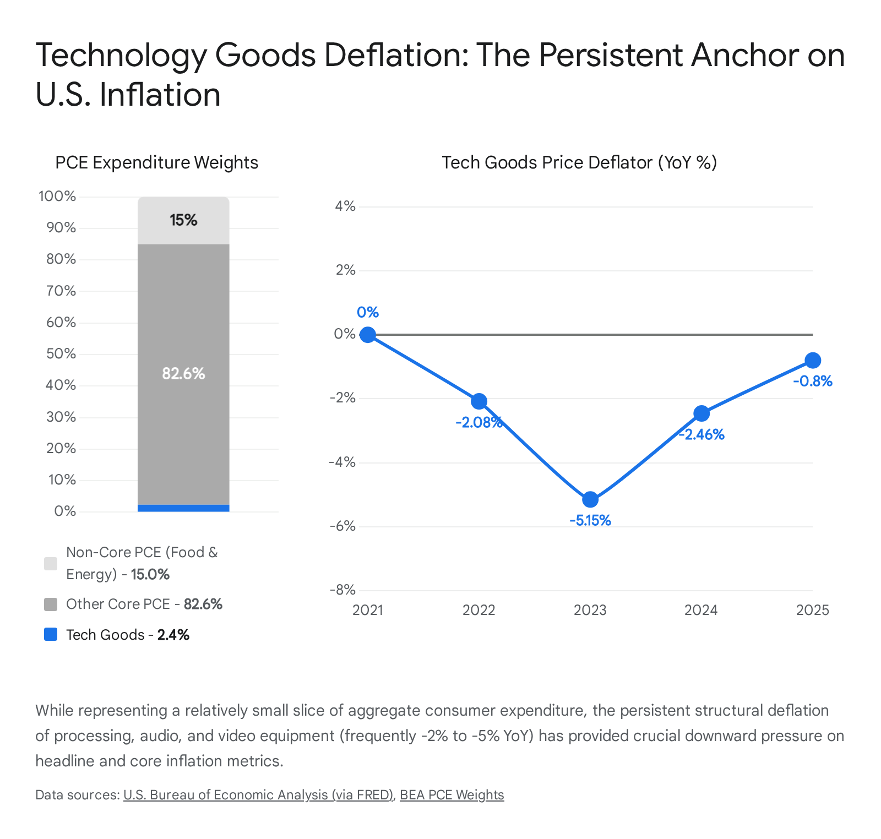

1.4 Dissecting the Core CPI Technology Basket
While the Federal Reserve utilizes PCE to govern monetary policy, financial markets and consumer inflation expectations are heavily influenced by the Consumer Price Index. The CPI employs a fixed basket of goods, meaning the weights are slower to adjust to changing consumption patterns than the chained PCE.
According to the BLS Relative Importance of Components table for December 2025, the aggregate category for "Information technology, hardware and services" holds a relative importance weight of 1.714% within the CPI-U (All Urban Consumers).⁷ Because this figure represents a percentage of the total CPI, its weight within the Core CPI (which strips out food and energy, roughly 20-22% of the index) is proportionately higher, sitting at roughly 2.2%.
This macro category fragments into highly specific subcomponents that capture the U.S. consumer electronics landscape ⁷:
- Computers, peripherals, and smart home assistant devices: 0.293%
- Telephone hardware, calculators, and other consumer information items (predominantly smartphones): 0.461%
- Internet services and electronic information providers: 0.923%
- Computer software and accessories: 0.027%
Combined, the pure hardware components—computers and telephone hardware—account for approximately 0.754% of headline CPI, and nearing 1.0% of Core CPI. Though seemingly marginal compared to the massive weight of housing (shelter), the extreme volatility of these components grants them an outsized role in margin pricing. When tech hardware prints -10% annualized deflation, as it frequently does during periods of rapid processor upgrades, a 1% weight mathematically shaves 10 full basis points off the aggregate index. If this deflationary pillar fractures, the underlying heat of the U.S. economy becomes starkly exposed.

Part 2: Mechanical Modeling of a Tech Price Shock
To translate these abstract weights and historical deflators into actionable macroeconomic intelligence, we must mechanically model what happens to the Federal Reserve's inflation math if the global semiconductor supply chain is disrupted. If the flow of advanced silicon from Taiwan halts, the hedonic deflation engine instantly reverses.
The mechanism for this reversal is twofold. First, physical scarcity limits retail inventory, ending promotional discounting and forcing consumers to pay higher nominal prices. Second, and more insidiously, a freeze in silicon output halts generational product upgrades. If Apple or PC manufacturers cannot source new 3nm chips, they must sell older, mature-node models at current prices. Because the consumer is no longer receiving increased computing power for their dollar, the hedonic quality adjustment models collapse. The BLS and BEA would immediately record this stagnation as a positive price increase, even if nominal retail prices remained flat.

2.1 The Baseline Parameters
For the purpose of this mechanical attribution model, we establish the following parameters based on the empirical data extracted in Part 1:
- Total Core PCE Weight for Tech Goods: ~2.4% (Based on the $427 billion expenditure against an estimated $18 trillion Core PCE baseline).
- Baseline Deflationary Trend: -5.0% YoY (We utilize a -5.0% trend to represent a normalized, functioning supply chain where Moore's Law is fully operational, similar to the conditions observed in 2023).⁵
Under these optimal baseline conditions, technology goods mathematically contribute:
2.4% (Weight) * -5.0% (Price Change) = -0.12% (or -12 basis points)
This calculation demonstrates that if the Federal Reserve is observing a Core PCE print of 2.8%, that index would theoretically be printing at 2.92% without the artificial, deflationary assistance of the tech hardware sector.

2.2 Modeling Supply Shock Scenarios
If TSMC output contracts, the pricing of technology goods will respond exponentially based on the severity and duration of the shortage. We model three sequential scenarios to quantify the mechanical impact on Core PCE.
Scenario A: The "Flat" Scenario (0% YoY)
In a mild supply shock, manufacturers face slightly constrained volumes. Nominal price increases perfectly offset the hedonic quality gains of whatever limited new silicon reaches the market. The tech goods deflator zeroes out.
- Delta from Baseline: +5.0% (Moving from -5% to 0%)
- Mechanical Impact: 2.4% * +5.0% = +0.12%
- Result: Core PCE mechanically increases by +12 basis points. If the prevailing Core PCE is 2.8%, this shift pushes it to 2.92%. While 12 basis points may seem like statistical noise in a vacuum, in the context of a central bank attempting to engineer a soft landing and traverse the "last mile" from 2.5% to a 2.0% target, a permanent 12 bps headwind requires a fundamentally more restrictive monetary posture.
Scenario B: The "Mild Inflation" Scenario (+5% YoY)
If hardware shortages become evident on retail shelves, channel partners and OEMs will protect their profit margins on lower unit volumes by raising Manufacturer's Suggested Retail Prices (MSRPs) and eliminating all channel discounting.
- Delta from Baseline: +10.0% (Swinging from -5% deflation to +5% inflation)
- Mechanical Impact: 2.4% * +10.0% = +0.24%
- Result: Core PCE increases by +24 basis points. A baseline 2.8% Core PCE jumps to 3.04%. A core inflation figure rebounding above a 3.0% threshold fundamentally alters the Federal Open Market Committee's (FOMC) dot-plot trajectory. The market would be forced to price out rate cuts, and the Fed would be forced into a higher-for-longer regime.
Scenario C: The "Severe Shortage" Scenario (+10% YoY)
In a scenario where TSMC advanced node production drops precipitously and upstream inventory buffers are exhausted, severe rationing occurs. Secondary market markups (scalping) become rampant, pulling primary retail prices significantly higher. The total lack of generational upgrades combined with nominal price spikes drives tech goods inflation to 10%.
- Delta from Baseline: +15.0% (Swinging from -5% to +10%)
- Mechanical Impact: 2.4% * +15.0% = +0.36%
- Result: Core PCE increases by +36 basis points.

2.3 The Federal Reserve's Policy Trap
A 36 basis point exogenous, supply-driven shock to Core PCE represents a severe structural constraint on the Federal Reserve. Central banks operate by manipulating aggregate demand via the cost of capital; they have no tools to repair a fractured semiconductor supply chain.
To offset a +36 bps mechanical rise in core goods and force the aggregate index back to the 2.0% target, the Fed would be forced to engineer massive demand destruction in the services sector. Interest rates would need to be hiked aggressively to crush demand for housing, dining, travel, and healthcare to balance the index. This reveals the core thesis: the disappearance of tech deflation is not a minor statistical anomaly; it is a geopolitical trap that forces domestic monetary policy into a stagflationary corner.

Part 3: The TSMC Dependency Trap and Market Value Quantification
To properly assess the probability of the inflationary scenarios modeled in Part 2, we must quantify the actual physical and financial exposure of the U.S. consumer electronics market to TSMC. The data reveals an ecosystem characterized by an overwhelming, almost singular dependency on TSMC's advanced manufacturing nodes (specifically the 3nm, 5nm, and 7nm families).

3.1 The Value of the Advanced Node Ecosystem
The semiconductor industry is the substrate of the modern global economy. The domestic U.S. semiconductor market alone is projected to reach between $141.34 billion and $191.51 billion in the coming years.⁸ However, this figure only represents the cost of the raw components. The consumer electronics sector that these chips enable—including smartphones, personal computers, wearables, and smart home devices—is valued significantly higher, approaching a staggering $1 trillion.⁹
At the absolute apex of this technological pyramid sits TSMC. The company's dominance in cutting-edge fabrication is absolute. According to TSMC's financial reports and industry analyses for 2024 and 2025, advanced technologies (defined as 7nm and below) accounted for a massive 74% to 77% of total wafer revenue.¹⁰
The revenue breakdown by node reveals where the bleeding edge of the U.S. tech sector relies ¹⁰:
- 3nm family (N3): Generating 23% to 28% of total revenue. This node powers the latest flagship smartphones and next-generation AI processors.
- 5nm family (N5/N4): Generating 35% to 37% of total revenue. This is the workhorse node for current-generation data center GPUs, mainstream PCs, and enterprise infrastructure.
- 7nm family (N7): Generating roughly 14% of total revenue, supporting networking, automotive, and legacy console hardware.
TSMC is not merely a market leader; it is effectively a monopoly at the frontier of physics. The company holds greater than 90% of the global foundry capacity for sub-7nm chips.¹² While Intel and Samsung Electronics operate as theoretical competitors, both are currently struggling with process yields, power efficiency metrics, and scale limitations that prevent them from serving as viable alternatives for the highest-volume fabless designers.¹³ If TSMC goes offline, there is no secondary capacity available in the world to absorb the demand.

3.2 Quantifying Corporate Exposure: The Titans of U.S. Tech
The vulnerability of the U.S. inflation metrics is best understood by tracing the revenue of the domestic technology titans that dictate the BLS hardware indices. Their reliance on TSMC is systemic and absolute.
Apple Inc.: Apple is universally recognized as TSMC's largest and most important customer, historically utilizing its immense capital to monopolize the initial capacity of TSMC's newest nodes.¹⁴ Every piece of custom Apple Silicon—from the A-series processors that dictate the iPhone and iPad lifecycles to the M-series chips that revolutionized the Mac lineup—is manufactured by TSMC.
In fiscal year 2025, Apple generated $416.1 billion in total revenue.¹⁵ The hardware breakdown underscores the physical dependency:
- iPhone sales: ~$209 billion ¹⁵
- Mac sales: ~$33 billion ¹⁵
- iPad sales: ~$28 billion ¹⁵
- Wearables/Home/Accessories: ~$35 billion ¹⁵
This means that over $300 billion of Apple's top-line revenue is 100% physically reliant on the uninterrupted flow of TSMC wafers. Furthermore, Apple's $100 billion Services business (App Store, iCloud, Apple Pay) is entirely parasitic upon the hardware installed base; without hardware sales, service growth stagnates.¹⁵
NVIDIA Corporation: Nvidia's meteoric rise to a market capitalization exceeding $4 trillion has been fueled entirely by its monopoly on the hardware required for generative Artificial Intelligence.¹⁶ Nvidia designs the architectures (Hopper, Blackwell, Ada Lovelace), but TSMC physically manifests them. Nvidia relies entirely on TSMC's 5nm, 4nm, and 3nm nodes, as well as TSMC's highly specialized CoWoS (Chip-on-Wafer-on-Substrate) advanced packaging technology, which is required to bind High-Bandwidth Memory (HBM) to the GPUs.¹⁷
In its fiscal year 2026 reporting, NVIDIA generated a record $215.9 billion in full-year revenue.¹⁸ The vast majority of this—data center revenue running at over $62 billion a quarter, alongside roughly $16 billion annually from consumer gaming—is utterly captive to Taiwan's shores.¹⁸
Advanced Micro Devices (AMD): As the primary challenger to Intel in the x86 CPU market and Nvidia in the GPU accelerator market, AMD operates a strictly fabless model. Its highly successful Ryzen desktop and mobile processors, along with its EPYC data center processors, are fabricated by TSMC. In 2024, AMD reported $25.7 billion in total revenue, driven by $12.6 billion in data center sales and $7.1 billion in client PC sales.²⁰
The Mobile Ecosystem (Qualcomm & MediaTek): Beyond Apple, the broader U.S. smartphone market (Android devices) is powered largely by systems-on-a-chip from Qualcomm and MediaTek. Both companies have shifted their flagship offerings (Snapdragon and Dimensity lines) to TSMC's 4nm and 3nm processes to ensure competitive performance and battery life.¹¹
Data indicates that the entire ecosystem of fabless designers—Apple, NVIDIA, AMD—relies on the highly concentrated output of TSMC fabs, with the origin nodes (3nm, 5nm, 7nm) funneling into these corporate titans, ultimately supporting an end-market value that dwarfs the cost of the chips themselves.

3.3 The Trillion-Dollar Chokepoint
When aggregating the direct top-line hardware revenue of Apple ($416B), NVIDIA ($215B), and AMD ($25B), we identify over $656 billion in corporate revenue that serves as the bedrock of the U.S. digital economy.¹⁵
However, this metric severely understates the true economic value at risk. Semiconductors are an intermediate input. A $30,000 Nvidia GPU enables a $500,000 AI server rack, which in turn powers multi-million dollar enterprise software contracts for Microsoft, Amazon, and Google. A $100 Qualcomm SoC powers a $1,200 Samsung smartphone, which enables gigabytes of mobile data usage billed by AT&T and Verizon.
When accounting for downstream consumer electronics, enterprise IT hardware, data center infrastructure, and the telecommunications gear reliant on these advanced nodes, the market value of U.S. goods and services that are physically dependent on TSMC easily exceeds $1.5 to $2.0 trillion annually. Because TSMC controls the vast majority of sub-7nm capacity, this is not a distributed supply chain; it is a singular point of failure. A disruption in Taiwan does not prompt a rerouting of supply; it forces an abrupt cessation of output.

Part 4: Prologue to a Crisis: The 2021 Semiconductor Shortage
To project the macroeconomic fallout of a future semiconductor shock, we do not have to rely exclusively on theoretical modeling. The 2021 global chip shortage serves as a recent, empirical case study demonstrating precisely how a supply deficit shatters the technology deflation paradigm and transmits inflation through the broader economy.

4.1 The Mechanism of the 2021 Shock
The 2021 crisis was fundamentally a demand-shock compounded by pandemic-induced logistics failures. In early 2020, anticipating a deep recession, automotive and industrial manufacturers drastically slashed their semiconductor orders.²¹ Simultaneously, the shift to remote work and remote learning triggered an unprecedented surge in consumer demand for PCs, tablets, webcams, and home networking gear.²²
Foundries in Asia reallocated their production lines away from automotive legacy nodes to serve the surging consumer electronics sector. When automotive demand rebounded violently in late 2020 and 2021, the fab capacity was already spoken for.²¹ Because semiconductor manufacturing is a rigidly scheduled, highly capital-intensive process where new capacity takes years to bring online, the sudden deficit resulted in massive global bottlenecks.²³

4.2 The Breakdown of the BLS Deflators
The impact on U.S. price indices was immediate and profound. As established in Part 1, the historical norm for technology goods is robust, hedonic-driven deflation. The 2021 shortage completely obliterated this trend.
Instead of subtracting from headline inflation, tech categories violently reversed course. According to BLS data, the import price index for computer and peripheral manufacturing advanced 2.1% in 2022, marking the largest calendar-year price advancement since the index's inception in 2005.²⁴ The domestic manufacturing side mirrored this inflationary spike; the Producer Price Index (PPI) for computer and peripheral manufacturing rose 3.4% in 2021 and accelerated further to a 4.2% increase in 2022.²⁴
The BLS explicitly acknowledged the catalyst, noting that the international chip shortage severely increased production costs for manufacturers between January and August 2021, directly causing the retail price indexes for high-tech goods to spike and abandon their deflationary trajectory.²⁵ When consumers and enterprise buyers are forced to compete for constrained inventory, promotional discounting vanishes, and nominal prices rise, easily outstripping any marginal quality adjustments the statistical agencies can apply.

4.3 Second-Order Effects: The Automotive Inflation Spike
The most critical macroeconomic lesson from 2021 was how the semiconductor shortage generated massive second-order inflation in downstream sectors. Modern vehicles require thousands of legacy semiconductors for engine management, infotainment, and driver-assistance systems. When automakers could not source these chips, they were forced to halt assembly lines, leaving unfinished vehicles sitting in holding lots.
This severe curtailment of new vehicle production created acute scarcity in the auto market. Consumers, flush with stimulus cash, bid up the prices of whatever inventory was available. Consequently, the CPI for used cars and trucks skyrocketed, rising nearly 30% year-over-year by mid-2021.²⁶ Economic analysis by the St. Louis Federal Reserve highlighted that this semiconductor-induced vehicle inflation contributed a massive 1.5 percentage points to the total change in the all-items CPI in 2021.⁴
Furthermore, U.S. manufacturing industries that were dependent on semiconductors to produce goods demonstrated significantly larger price increases across the board compared to industries that did not rely on chips as inputs.²⁷

4.4 Duration and Normalization: The Inflexibility of Silicon
The 2021 crisis demonstrated that semiconductor shocks are not transitory. The supply chain for microelectronics is notoriously inflexible. It requires tens of billions of dollars and three to five years to construct a new greenfield fabrication facility, and expanding capacity within an existing fab requires lead times exceeding 12 to 18 months for the procurement and installation of complex lithography equipment.²³
Because supply could not rapidly expand to meet demand, the inflationary impulse lasted for years. Prices began to rise in early 2021, peaked through mid-to-late 2022, and only began to normalize and resume a tentative deflationary trend in the latter half of 2023.²⁴ A physical shock to semiconductor output exerts a multi-year stagflationary drag on the economy, operating on a timeline that vastly exceeds the standard operational horizon of monetary policy.

Part 5: Scenario Analysis – A 30% Contraction in TSMC Advanced Node Output
While the 2021 shortage severely impacted legacy nodes (automotive and power management), the geopolitical and infrastructural vulnerability of Taiwan presents a far more catastrophic threat: a sudden, exogenous supply-side shock specifically targeting the advanced nodes (3nm, 5nm) that power the U.S. consumer and enterprise tech sectors.
To map the transmission of such a crisis into the U.S. economy, we stress-test "Scenario B", a hypothetical but highly plausible infrastructural failure.

5.1 The Catalyst: The Energy Vulnerability
Taiwan’s energy grid is highly isolated and heavily dependent on imported energy, particularly Liquefied Natural Gas (LNG). In this scenario, a geopolitical blockade, severe weather event, or critical infrastructure failure results in a sudden 50% drop in LNG imports to the island.
The immediate result is severe power generation shortfalls, triggering nationwide rolling blackouts. To prevent a total grid collapse, the Taiwanese government is forced to implement emergency power rationing. Because semiconductor fabrication—particularly Extreme Ultraviolet (EUV) lithography used for 3nm and 5nm nodes—is incredibly energy-intensive, TSMC is ordered to curtail its power consumption. Consequently, TSMC must cut its wafer starts and advanced packaging operations by 15% to 25%. This effectively results in a 30% drop in total advanced node production output for a full quarter.

5.2 Analyzing Inventory Buffers: The Clock is Ticking
The velocity at which this 30% output contraction hits the U.S. economy depends entirely on the inventory buffers held by major technology firms. The hardware industry operates on sophisticated Just-In-Time (JIT) manufacturing principles, purposely minimizing held inventory to preserve working capital and avoid technological obsolescence. However, different segments hold drastically different buffers.
Apple (13 Days of Inventory): Apple operates one of the most ruthless and efficient JIT supply chains on earth. The company typically holds roughly 13 days of inventory. If TSMC output drops by 30%, Apple’s buffer of raw silicon and work-in-progress components is exhausted in less than two weeks. NVIDIA (~100 Days of Inventory): Operating in the enterprise and data center space, Nvidia runs a slightly longer, more resilient supply chain. Recent metrics place their Days Inventory Outstanding (DIO) at an average of roughly 103 days.²⁸ AMD (148 Days of Inventory): AMD currently holds the longest buffer among the major fabless designers, with approximately 148 days of inventory, providing a nearly five-month cushion before a raw silicon shortage severely curtails their outbound shipments.

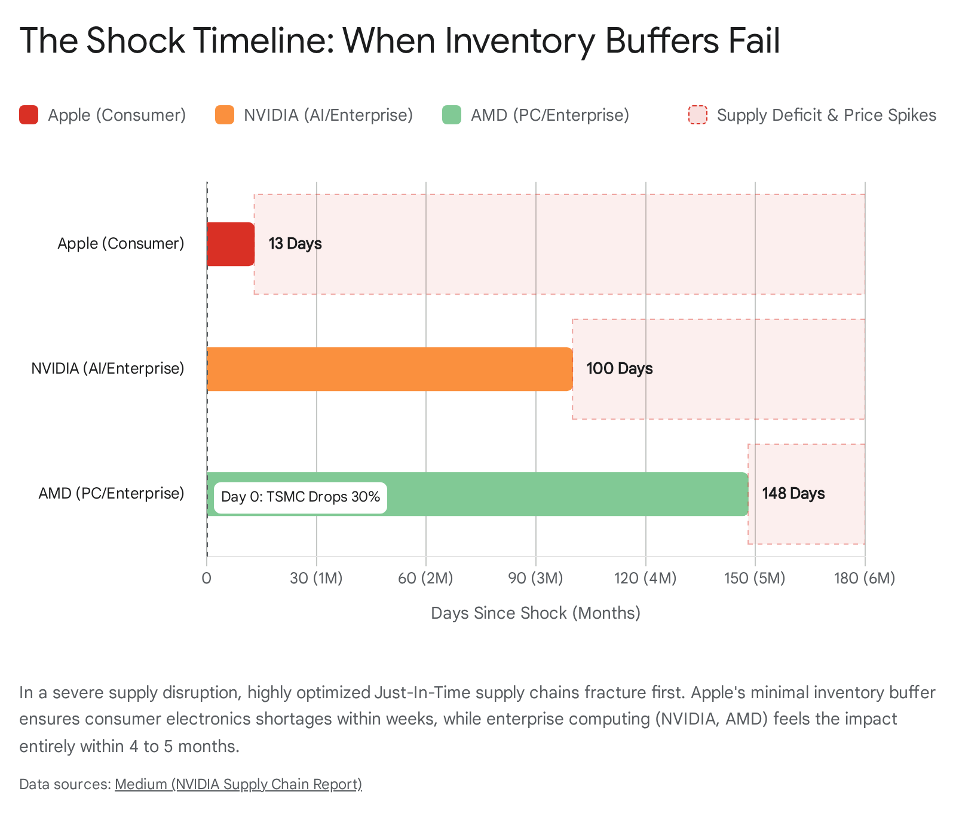

5.3 The Six-Month Cascade: Availability and Pricing Impact
If a 30% TSMC contraction occurs on Day Zero, the mechanical transmission of that shock into the U.S. economy over the subsequent six months would follow a highly predictable, devastating trajectory.
Months 1 to 2: The Consumer Electronics Break
Because Apple runs on a razor-thin 13-day inventory buffer, the initial impact strikes the consumer electronics market almost immediately. Within three weeks, contract manufacturers in Asia (such as Foxconn) face massive shortfalls in A-series and M-series silicon. Assembly lines idle. Consequently, global outbound shipments of iPhones, iPads, and MacBooks are severely curtailed.
At the retail level in the U.S., major distributors (Best Buy, Amazon) and direct Apple Store inventories deplete within weeks. While Apple rarely raises the MSRP of existing devices mid-cycle, the immediate elimination of all promotional discounting, combined with the absolute scarcity of units, abruptly halts the BLS hedonic deflation cycle. The CPI sub-index for "Telephone hardware" (0.461% weight) flatlines or ticks positive.⁷ The initial deflationary relief valve is sealed shut.
Months 3 to 4: The Enterprise AI Squeeze As the crisis extends into its second quarter, the impact rotates from the consumer segment to the enterprise IT sector. The inventory buffers of major IT distributors begin to evaporate. Historical precedent shows that in such scenarios, distributors rapidly alter contract terms; quote validities shrink dramatically from standard 30-day windows down to 15 days, and existing backlogs are aggressively re-priced upward to reflect the new scarcity.²⁹
During this window, Nvidia approaches the exhaustion of its 103-day inventory buffer.²⁸ Because high-end AI accelerators (Hopper, Blackwell) are already in a state of structural supply deficit even under optimal manufacturing conditions due to intense demand from Hyperscalers (Microsoft, Google, Meta) ³⁰, a 30% reduction in TSMC output triggers outright panic in the data center market. Cloud service providers engage in brutal bidding wars for any remaining silicon allocations. Prices for enterprise computing hardware skyrocket on the secondary market.
Months 5 to 6: Peak Inflationary Pass-Through
By month five, even AMD's robust 148-day buffer is fully exhausted. The U.S. economy now faces a synchronized, total hardware shortage across both consumer retail and enterprise infrastructure. New data center buildouts freeze, corporate PC refresh cycles are canceled, and consumer hardware is strictly back-ordered.
At this juncture, the macroeconomic impact is fully realized in the CPI and PCE metrics. The mechanical models explored in Part 2 become reality. The Core PCE tech goods deflator, which normalized at -5% YoY, swings violently to +5% or +10%. This swing mechanically injects between +24 and +36 basis points of inflation directly into the Core PCE index. Furthermore, because mature node production is likely curtailed alongside advanced nodes, semiconductors embedded in thousands of downstream products—from home appliances to industrial machinery and automobiles—become scarce, triggering secondary inflationary waves across the broader manufacturing sector.²⁷

Conclusion: The Federal Reserve's Unsolvable Dilemma
The rigorous quantification of technology goods within U.S. inflation metrics reveals a precarious dependency. While tech goods comprise roughly 2.4% of the Core PCE basket, their unique pricing dynamics—characterized by structural, hedonic-driven deflation of -2% to -5% YoY—provide critical downward gravity against broader, sticky services inflation. Technology hardware functions as the Federal Reserve’s silent partner, artificially suppressing the aggregate indices and allowing monetary policy to remain less restrictive than the domestic economy alone would dictate.
However, this mathematical relief valve is fundamentally tethered to a physical reality: the uninterrupted output of Taiwan Semiconductor Manufacturing Company. With TSMC commanding over 90% of global sub-7nm fabrication capacity, and generating over 70% of its revenue from these advanced nodes, the U.S. consumer and enterprise technology sectors operate with a single point of failure. Over $650 billion in direct U.S. tech revenue from titans like Apple, Nvidia, and AMD, and trillions more in downstream economic value, are wholly captive to this Taiwanese chokepoint.
If this deflationary engine is disabled—whether by geopolitical conflict, energy blockades, or natural disasters—the mathematics of U.S. monetary policy will fracture. As demonstrated by the 2021 semiconductor shortage, a supply deficit rapidly obliterates hedonic quality adjustments, driving violent nominal price increases. If a crisis forces a mere 30% reduction in TSMC output, highly optimized Just-In-Time supply chains will break within weeks. A modeled shift from -5% tech deflation to just +5% tech inflation mechanically adds roughly 24 basis points to Core PCE, pushing the index out of the Fed's acceptable target range.
For the Federal Reserve, an advanced node supply shock represents the ultimate, unsolvable trap. Stripped of the deflationary relief valve of cheap computing power, the central bank would face rapidly rising core goods inflation precisely at the moment the broader U.S. economy suffers a massive, paralyzing growth shock due to the unavailability of digital infrastructure. Because monetary policy only controls aggregate demand, the Fed cannot print semiconductors, nor can it hike interest rates high enough to repair a broken global supply chain without inducing a catastrophic domestic recession.

Works cited
- Personal Consumption Expenditures Price Index, Excluding Food and Energy | U.S. Bureau of Economic Analysis (BEA), accessed March 7, 2026, https://www.bea.gov/data/personal-consumption-expenditures-price-index-excluding-food-and-energy
- Personal Consumption Expenditures: Chain-type Price Index (PCEPI) | FRED | St. Louis Fed, accessed March 7, 2026, https://fred.stlouisfed.org/series/PCEPI
- 2025, Table 2.4.5. Personal Consumption Expenditures by Type of Product: Annual - FRED, accessed March 7, 2026, https://fred.stlouisfed.org/release/tables?eid=44183&rid=53
- Is Inflation Still Low in the Digital Economy? - Innovation Frontier Project, accessed March 7, 2026, https://innovationfrontier.org/is-inflation-still-low-in-the-digital-economy/
- Personal consumption expenditures: Durable goods: Video, audio, photographic, and information processing equipment and media (chain-type price index) (DVAPRG3A086NBEA) | FRED, accessed March 7, 2026, https://fred.stlouisfed.org/series/DVAPRG3A086NBEA
- Personal Consumption Expenditures (chain-type price index) (BPCERO1Q156NBEA) | FRED | St. Louis Fed, accessed March 7, 2026, https://fred.stlouisfed.org/series/BPCERO1Q156NBEA
- Measuring Price Change in the CPI: Telephone hardware, calculators, and other consumer information items - Bureau of Labor Statistics, accessed March 7, 2026, https://www.bls.gov/cpi/factsheets/telephone-hardware.htm
- United States Semiconductor Market Size, Share & 2030 Growth Trends Report, accessed March 7, 2026, https://www.mordorintelligence.com/industry-reports/united-states-semiconductor-market
- Consumer Electronics Market Size & Share Report, 2025 – 2034, accessed March 7, 2026, https://www.gminsights.com/industry-analysis/consumer-electronics-market
- TSMC Breaks Records! Explosive Results Confirm the Enduring AI Rally | XTB, accessed March 7, 2026, https://www.xtb.com/en/market-analysis/tsmc-breaks-records-explosive-results-confirm-the-enduring-ai-rally
- TSMC to Raise Sub-5nm Chip Prices by 3–5% in 2026 — What It Means for NVIDIA, Apple, and the AI… - Medium, accessed March 7, 2026, https://medium.com/@kumari.sushma661/tsmc-to-raise-sub-5nm-chip-prices-by-3-5-in-2026-what-it-means-for-nvidia-apple-and-the-ai-cacb8343fb40
- Logic Semiconductor Market Size, Share and Forecast, 2026-2033, accessed March 7, 2026, https://www.coherentmarketinsights.com/industry-reports/logic-semiconductor-market
- Samsung vs. TSMC vs. Intel: Who's Winning the Foundry Market? (Latest Numbers) | PatentPC, accessed March 7, 2026, https://patentpc.com/blog/samsung-vs-tsmc-vs-intel-whos-winning-the-foundry-market-latest-numbers
- Zacks Investment Ideas feature highlights Taiwan, Apple, Nvidia and AMD | Nasdaq, accessed March 7, 2026, https://www.nasdaq.com/articles/zacks-investment-ideas-feature-highlights-taiwan-apple-nvidia-and-amd
- Apple Statistics (2026) - Business of Apps, accessed March 7, 2026, https://www.businessofapps.com/data/apple-statistics/
- Apple hits $4tn market value as new iPhone models revitalize sales - The Guardian, accessed March 7, 2026, https://www.theguardian.com/technology/2025/oct/28/apple-market-value-iphone
- Taiwan Semiconductor (TSM) Earnings Thursday: Nvidia/Apple Demand, Advanced Packaging, Outlook | tastylive, accessed March 7, 2026, https://www.tastylive.com/news-insights/taiwan-semiconductor-tsm-earnings-thursday-nvidia-apple-demand-advanced-packaging-outlook
- Financial Reports - NVIDIA Investor Relations, accessed March 7, 2026, https://investor.nvidia.com/financial-info/financial-reports/default.aspx
- Nvidia reports a truly astonishing $193.7 billion in annual data center revenue in its latest earnings call, up 75% year on year, while little old gaming brought in $16 billion : r/pcgaming - Reddit, accessed March 7, 2026, https://www.reddit.com/r/pcgaming/comments/1rfb3c5/nvidia_reports_a_truly_astonishing_1937_billion/
- AMD Revenues Up 14% YoY in 2024; PC TAM Expected to Grow Mid-Single-Digit % in 2025 - Counterpoint, accessed March 7, 2026, https://counterpointresearch.com/en/insights/amd-revenues-up-14-yoy-in-2024-pc-tam-expected-to-grow-midsingledigit-in-2025
- Chip shortage: how the semiconductor industry is dealing with this worldwide problem, accessed March 7, 2026, https://www.weforum.org/stories/2022/02/semiconductor-chip-shortage-supply-chain/
- Consumer Expenditures in 2021 : BLS Reports: U.S. Bureau of Labor Statistics, accessed March 7, 2026, https://www.bls.gov/opub/reports/consumer-expenditures/2021/
- Two Lessons the Chip Shortage Taught Us about Supply Chains | Bain & Company, accessed March 7, 2026, https://www.bain.com/insights/two-lessons-from-the-chip-shortage-supply-chains-tech-report-2021/
- Recent Price Trends in the Computer and Peripheral Industry - BLS.gov, accessed March 7, 2026, https://www.bls.gov/mxp/publications/industry-pamphlets/computer-industry-facts.htm
- Alternative data sources for high-tech products in the CPI - Bureau of Labor Statistics, accessed March 7, 2026, https://www.bls.gov/opub/mlr/2024/article/alternative-data-sources-for-high-tech-products-in-the-cpi.htm
- Semiconductor Shortages and Vehicle Production and Prices, accessed March 7, 2026, https://www.clevelandfed.org/publications/economic-commentary/2021/ec-202117-semiconductor-shortages-vehicle-production-prices
- Did the Computer Chip Shortage Affect Inflation? - Federal Reserve Bank of St. Louis, accessed March 7, 2026, https://www.stlouisfed.org/on-the-economy/2022/may/did-computer-chip-shortage-affect-inflation
- NVIDIA's Supply Chain, Decoded: How It Outperformed the Industry Through a Decade of Disruption! | by Alireza Gh. | Medium, accessed March 7, 2026, https://medium.com/@Leo-Analysis/comprehensive-analysis-nvidias-supply-chain-performance-measurement-2f9dc98e61dd
- IT Distributors Warn Memory Shortages, Supply Chain Strains Impacting The Channel, accessed March 7, 2026, https://www.crn.com/news/data-center/2026/it-distributors-warn-memory-shortages-supply-chain-strains-impacting-the-channel
- AI Chip Shortage 2025: Uncover the Global Tech Crisis - EnkiAI, accessed March 7, 2026, https://enkiai.com/ai-market-intelligence/ai-chip-shortage-2025-uncover-the-global-tech-crisis

