Strategic Intelligence Report: Live Hormuz Transit Status and Escalation Scenarios

Executive Summary and Strategic Context
The initiation of the joint United States-Israeli military campaigns—designated Operation Epic Fury and Operation Roaring Lion—against the Islamic Republic of Iran on February 28, 2026, has fundamentally altered the global macroeconomic and geopolitical landscape. As of March 6–7, 2026, the Strait of Hormuz has entered a state of severe commercial deterrence and structural supply chain paralysis. The geopolitical risk premium has transitioned from a theoretical abstraction into a tangible, real-time supply disruption that threatens the foundational stability of global energy markets.¹ For energy market participants, the Day 30 threshold, which predicates a sustained $100 per barrel Brent crude scenario, is entirely contingent upon the duration and severity of this de facto closure.
The scope of the crisis extends far beyond the immediate disruption of crude oil flows. The blockade environment has severely impacted liquefied natural gas (LNG) distribution, dry bulk commodity transit, and regional food security architecture. In response to the collapse of maritime movement, the United States has announced unprecedented emergency measures, including a massive federal reinsurance backstop orchestrated by the U.S. International Development Finance Corporation (DFC) and the potential deployment of naval escorts.³ However, the physical and financial implementation of these protocols remains fraught with logistical, tactical, and capital-adequacy complexities.
Concurrently, the diplomatic landscape offers no immediate off-ramps. Established back-channels mediated through the Sultanate of Oman and the State of Qatar have comprehensively collapsed. Iranian leadership, now consolidating under the crisis management of Supreme National Security Council Secretary Ali Larijani, has explicitly rejected ceasefire negotiations and is rapidly preparing the state for a prolonged, asymmetric war of attrition.⁶ This report delivers an exhaustive, granular analysis of real-time transit data, marine insurance market dynamics, naval escort viability, diplomatic developments, Iranian military degradation, and the physical limits of regional bypass infrastructure to inform strategic holding decisions regarding USO and STNG positions.

1. Strait of Hormuz Transit Intelligence and Commercial Deterrence
The Strait of Hormuz represents the world's most critical energy transit chokepoint. Under normal operational conditions, the waterway accommodates approximately 20 million barrels per day (mb/d) of crude oil and refined petroleum products, representing roughly 20% of global petroleum liquids consumption and a quarter of the world's seaborne oil trade.⁹ As of the first week of March 2026, the operational status of the Strait is characterized not by a formal, impenetrable military naval blockade, but by a regime of absolute commercial deterrence.¹¹ This deterrence is enforced by a matrix of asymmetric physical threats, prohibitive insurance premiums, and localized kinetic strikes against commercial assets.

1.1 The Collapse of Mainstream Vessel Transits
Prior to the outbreak of hostilities on February 28, 2026, the seven-day moving average of vessel crossings through the Strait of Hormuz stood at approximately 77 transits per day across all major vessel classes, including a baseline of 50 to 60 crude and product tankers.¹¹ The deterioration of this traffic flow was precipitous and immediate. Overall maritime traffic declined by 80% within the first 24 hours of the conflict's escalation.¹³
By March 1, transits had fallen to just 10 vessels, and by March 3, only four vessels successfully crossed the Strait. On March 4, mainstream commercial transits had effectively reached absolute zero.¹¹ Recent Automatic Identification System (AIS) tracking and Kpler maritime data reveal that between March 2 and March 6, only nine mainstream oil tankers, cargo, and container ships were recorded successfully navigating the chokepoint.¹⁴
Transit Metric | Pre-War Baseline | Feb 28 (Day 1) | March 1 | March 3 | March 4 | March 6-7 Status
Total Daily Transits | ~77 vessels | 19 vessels | 10 vessels | 4 vessels | 0 vessels | Effectively Zero Mainstream
Crude/Product Tankers | 50-60 vessels | Rapid Decline | Rapid Decline | Near Zero | Zero | Highly Restricted / Dark Transits
The isolated vessels that are attempting the transit under current conditions are predominantly Iranian "shadow fleet" tankers or specific Greek-affiliated vessels.³ Many of these operators are executing "dark transits," intentionally disabling their AIS transponders to mitigate targeting risks. For example, maritime tracking platforms noted the Greek-affiliated Suezmax tanker making a northward voyage around midnight on March 2 without active AIS.³ Other vessels, such as the tanker Kavomaleas, the petroleum product vessel Pushpak, the cargo ship Hout, and the natural gas carrier Danuta I, have been tracked utilizing sporadic signal emissions to navigate the high-risk zone.¹⁴ While these dark transits and high-risk exploratory runs by Greek affiliates indicate that the waterway is not physically impassable, they do not represent a scalable resumption of normal commercial operations. If these vessels successfully load and exit without incident, it may marginally alter the risk calculus for highly risk-tolerant independent operators, but mainstream institutional shippers remain firmly sidelined.³

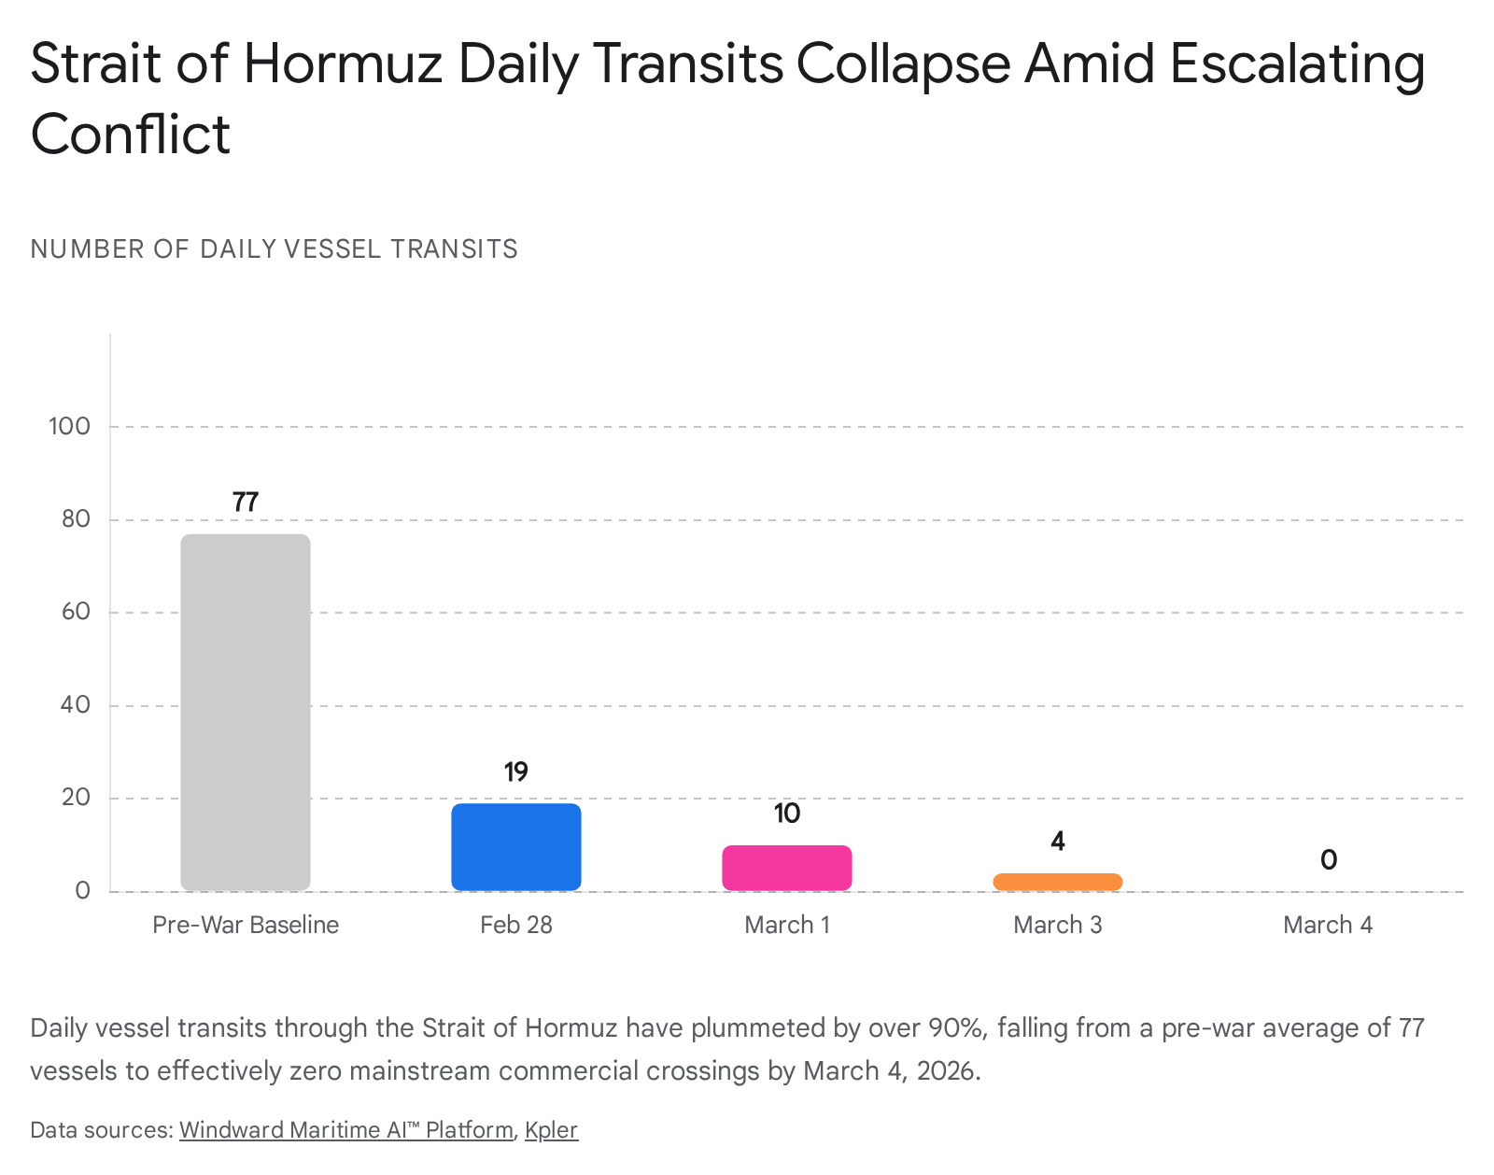

1.2 Sector-Wide Entrapment and Macroeconomic Cascades
The market narrative that the Hormuz crisis is solely an oil shock is demonstrably false and dangerously limits strategic foresight. The disruption to dry bulk commodities, liquefied natural gas, and regional container freight is equally profound, threatening diverse industrial and agricultural sectors globally.
Dry Bulk and Food Security Logistics: Transits for dry bulk carriers through the Strait have collapsed by an astonishing 91%.¹¹ Currently, approximately 280 bulkers of 10,000+ deadweight tonnage (dwt)—predominantly Panamaxes, Supramaxes, and Handysizes—are trapped at anchorages or within ports inside the Middle East Gulf.¹¹ This mass entrapment has fundamentally severed the flow of the 25 to 30 million tonnes of grains and oilseeds that the region typically imports annually by sea.¹¹
The Islamic Republic of Iran is particularly vulnerable to this specific disruption. The country relies heavily on the Strait for the vast majority of its animal feed and corn imports, typically importing around 14 million tonnes of corn annually.¹¹ With the vital port of Bandar Imam Khomeini essentially landlocked by the maritime threat environment, Iran is facing acute food inflation and irreversible damage to its agricultural supply chain. Intelligence indicates that over 20 grain-laden vessels are currently stranded outside the Gulf, unable to deliver vital sustenance.¹¹
Furthermore, the disruption has trapped roughly 16% to 18% of global seaborne fertilizer exports, primarily sulphur and urea.¹¹ The inability to export these critical agricultural inputs threatens global crop yields for the upcoming 2026 and 2027 harvests, presenting a secondary inflationary shock to global food markets. Industrial inputs are also paralyzed; major regional aluminum producers, including Qatar's Qatalum and Bahrain's Alba, are invoking force majeure or shutting down operations entirely due to the inability to import necessary alumina feedstock and export finished metal products.¹¹ Tracking data shows several specific vessels, including the Cape Shangrila, HT Huang Shan, and William Oldendorff, actively diverting away from the region, signaling a long-term rerouting of global dry bulk logistics.¹¹
Liquefied Natural Gas (LNG) Constraints: The LNG freight market has experienced total operational paralysis. There have been zero confirmed LNG carrier transits through the Strait since the onset of operations on February 28.¹¹ Approximately 20 LNG vessels, representing roughly 2% of the total global LNG fleet, are currently trapped inside the Gulf.¹¹ Compounding this logistical bottleneck is the physical degradation of export infrastructure; Qatar's massive Ras Laffan LNG export terminal has been reported offline following an attack.¹¹ This structural supply shock instantly transmitted through global energy pricing, causing the Spark 30 Atlantic Basin LNG freight benchmark to skyrocket by a record-breaking $100,000 per day in a single trading session.¹¹
Container Trade and Fleet Reallocation:
An operational snapshot of regional container services highlights severe systemic bottlenecks forming across the Gulf. Carriers have paused new bookings, vessels have halted near the strait, and global maritime services are being radically redrawn.
Container Vessel Status | Location | Vessel Count (Early March 2026)
Continuing regional port calls | Inside the Gulf | 87 vessels
Trying to exit but unable to transit | Inside the Gulf | 37 vessels
Waiting for clearance or instructions | Outside the Gulf | 16 vessels
Diverted to alternative ports | Outside the Gulf | 43 vessels
As the data demonstrates, while 87 container ships continue to service localized ports within the Gulf, 37 are effectively trapped, attempting to exit but unable to secure the necessary insurance or safety guarantees.¹⁷ Simultaneously, the 43 vessels that have diverted away from the Gulf represent thousands of TEUs (Twenty-Foot Equivalent Units) of cargo that will now require complex, highly expensive transshipment logistics to reach their final destinations.¹⁷

1.3 Electronic Warfare: GNSS Interference and Navigational Hazards
Adding a profound layer of physical danger to the operational environment is the dense electronic warfare landscape currently dominating the Middle East Gulf. Since February 27, 2026, there have been more than 10 confirmed, severe incidents of Global Navigation Satellite System (GNSS) interference.¹¹ This interference includes both broad-spectrum signal jamming and highly sophisticated positional spoofing, heavily concentrated near the coastlines of Mideast Gulf states, the Assaluyeh industrial complex, and the critical naval port of Bandar Abbas.¹¹
This military-grade electronic warfare severely distorts Automatic Identification System (AIS) reporting. The interference causes vessels to appear to cluster unnaturally on satellite tracking platforms, skewing the apparent distribution of maritime traffic and destroying accurate situational awareness for ship masters and fleet operators.¹⁸ It is highly critical for market analysts to understand that what frequently appears on Kpler or MarineTraffic platforms as deliberate, evasive "dark fleet" behavior is, in reality, the involuntary loss of positional data caused by this signal disruption.¹¹
The loss of reliable GNSS signals in a waterway that is only 21 nautical miles wide at its narrowest point exponentially increases the baseline risk of ship-to-ship collisions and groundings, independent of kinetic missile threats.¹¹ Given these factors, the region has been accurately described by shipping analysts as a "parking lot," where the vast majority of merchant vessels have voluntarily ceased all movement rather than navigate a highly kinetic chokepoint without basic navigational instruments.¹¹

2. The Marine Insurance Market Dislocation and Reinsurance Mechanics
The functional cessation of global shipping through the Strait of Hormuz is not solely dictated by the physical fear of missile strikes; it is heavily governed by the stringent mechanics and risk models of the global marine insurance and reinsurance markets. Without comprehensive third-party liability and physical hull damage coverage, major international shipping lines cannot legally, ethically, or financially justify ordering crews into the conflict zone, rendering the Strait de facto closed to institutional capital.

2.1 The Withdrawal of P&I Clubs and Lloyd's Syndicates
Within 72 hours of the conflict's dramatic escalation, the world's leading Protection and Indemnity (P&I) clubs—the mutual insurance associations that collectively cover third-party liabilities for approximately 90% of the global merchant fleet—took decisive action. Major mutual marine insurers, including Norway's Gard and Skuld, the UK's NorthStandard and the London P&I Club, and the New York-based American Club, issued formal notices canceling specific war-risk extensions for vessels trading in the Middle East.¹³
In accordance with standard maritime insurance covenants, these clubs provided a 72-hour notice period, making the cancellations effective between March 2 and March 5, 2026.¹³ This drastic action was directly catalyzed by the immediate withdrawal of reinsurance backing for those specific geopolitical risks by the world's largest reinsurers, who refused to underwrite the tail-risk of a multi-vessel catastrophic event in a hot war zone.¹³
However, the nuance of these cancellations is critical for assessing market capacity. P&I clubs have not issued a blanket cancellation of all insurance. Standard mutual P&I cover remains fundamentally intact, and existing policies for vessels that were already trapped inside the Gulf when the conflict began are generally being honored.²⁰ The suspension applies specifically to non-poolable war cover required for new voyages or specific chartered exposures entering the newly expanded high-risk zone.²⁰
Simultaneously, the London marine insurance market and Lloyd's syndicates drastically widened the geographic boundaries of the designated high-risk area to encompass the entirety of the Persian Gulf and adjacent waters.²⁰ For the isolated owners willing to risk passage, voyage-specific Additional Premiums (APs) for hull war-risk policies have skyrocketed. Prior to the conflict, APs hovered at a baseline of approximately 0.05% to 0.25% of a vessel's total hull value.¹¹ By March 6, these rates leaped to between 0.5% and 1.5%—and in some extreme, high-profile cases involving US or UK-linked tonnage, significantly higher.¹¹ To contextualize this financial barrier: for a modern Very Large Crude Carrier (VLCC) valued at $100 million, a 1.5% premium translates to a staggering $1.5 million per single transit solely for war-risk coverage, effectively destroying the economic viability of the voyage.²⁰

2.2 The United States DFC Reinsurance Facility Intervention
Recognizing that exorbitant free-market insurance costs were serving as a highly effective asymmetric weapon for Iran, the United States government initiated unprecedented federal intervention. On March 3, 2026, President Donald Trump directed the U.S. International Development Finance Corporation (DFC) to immediately provide political risk insurance and financial guarantees for maritime trade moving through the Gulf, with a specific focus on securing energy cargoes.⁴
By March 6–7, 2026, the operational details of this intervention crystallized into a massive $20 billion federal reinsurance facility, spearheaded by DFC Chief Executive Officer Benjamin Black and Treasury Secretary Scott Bessent.⁵ The facility is designed to operate on a rolling basis, initially focusing on backstopping hull and machinery as well as cargo insurance.⁴ The explicit policy goal is to offer coverage at a "very reasonable price" to artificially suppress the prohibitive rates quoted by the private London market, thereby restoring commercial confidence.³
Despite the aggressive magnitude of this federal intervention, broader financial market reception remains highly skeptical. Leading financial institutions and risk analysts highlight a glaring and dangerous capitalization mismatch. Currently, there are approximately 1,000 vessels trapped in the Persian Gulf and surrounding waters, possessing an aggregate hull value exceeding $25 billion—a figure that entirely excludes the immense underlying value of the oil, LNG, and cargo aboard these ships.⁵
Analysts at JPMorgan Chase estimate that approximately $352 billion in aggregate reinsurance coverage would be required to fully stabilize the market and confidently absorb the tail-risk of a mass-casualty or multi-vessel sinking event.⁵ Therefore, while the $20 billion DFC facility serves as a potent diplomatic and market-signaling mechanism, it is mathematically insufficient to underwrite the totality of the physical risk.⁵ The profound psychological deterrence of losing a $150 million asset and its crew to an anti-ship missile remains the primary obstacle to resuming trade, rendering the insurance backstop a necessary but insufficient condition for market normalization.⁵

3. U.S. Naval Escort Viability and Operational Posture
To complement the DFC financial backstop and address the fundamental physical security deficit, the U.S. administration has signaled a profound shift in naval force posture. However, the operational execution of these directives heavily lags behind the political declarations.

3.1 Policy Reversals and "Operation Prosperity Guardian II"
The U.S. stance on providing naval protection has been highly volatile over the course of the crisis week. On the evening of March 2, U.S. Navy officials conducted private briefings with major shipping industry representatives, explicitly stating that no naval assets were currently available for commercial escorts and that there was "no chance" of such operations commencing in the immediate future.³
However, in a dramatic geopolitical U-turn just 24 hours later, President Trump publicly announced via Truth Social that the United States Navy would begin escorting commercial tankers through the Strait of Hormuz "as soon as possible" to ensure the free flow of energy to the world.³
This proposed operation—informally dubbed by defense analysts as "Operation Prosperity Guardian II"—aims to replicate the maritime escort services utilized against Houthi forces in the Red Sea throughout 2024 and 2025.²⁹ However, executing this concept in the Persian Gulf presents a fundamentally more dangerous and complex theater of war. Escorting sluggish, highly explosive VLCCs through a chokepoint just 21 miles wide places U.S. Arleigh Burke-class destroyers and allied surface combatants directly inside an Iranian "super weapons engagement zone".¹⁹

3.2 Current Escort Status and Tactical Realities (March 6–7)
As of March 6–7, 2026, there are no documented, successful, mainstream U.S. naval escort missions of commercial vessels through the Strait of Hormuz.¹⁵ The presidential announcement remains entirely within the planning and strategic force-positioning phase.
The severe delay in implementation is rooted in uncompromising tactical realities. The U.S. Navy and its regional allies are actively engaged in a high-intensity, multi-domain kinetic conflict, having operated over 1,700 strike sorties in the opening 48 hours of the war alone.² Diverting critical Aegis-equipped air-defense destroyers from strike-group protection to escort commercial tankers risks severely diluting the offensive architecture and defensive screen of Operation Epic Fury.
Furthermore, the specific threat vector in Hormuz is significantly more advanced and dense than the Houthi presence in the Red Sea. It encompasses a highly integrated Anti-Access/Area Denial (A2/AD) network, including sophisticated anti-ship cruise missiles, swarm tactics by the Islamic Revolutionary Guard Corps Navy (IRGCN), advanced naval mines, and shore-based heavy artillery.³³ Global security consultancies, such as the EOS Risk Group, continue to implore shipowners to aggressively defer transit, noting at least ten confirmed attacks against shipping in a tight 72-hour window, resulting in hull damage, engine room fires, and fatalities.²⁷ The IRGCN has publicly declared "complete control" over the Strait, warning that any vessel attempting to pass will face lethal force.³⁵
Even bolstered by a federal insurance backstop, the lack of guaranteed physical security and the intense density of the threat environment means the U.S. Navy's escort program remains a theoretical deterrent rather than a functional logistical corridor at this stage of the conflict.²⁷

4. Geopolitical Diplomatic Tracks and Ceasefire Prospects
For institutional energy investors, the strategic calculus governing USO and STNG holding decisions relies heavily on the probability of a rapid diplomatic off-ramp. Based on exhaustive live intelligence gathered up to March 7, 2026, it is evident that all credible ceasefire negotiations have completely disintegrated.

4.1 The Failure of the April 2025 Framework and Collapse of Back-Channels
To understand the current diplomatic gridlock, it is necessary to contextualize the preceding months. The conflict was ignited following the failure of a highly fragile 60-day negotiation deadline established in April 2025 by the Trump administration.³⁸ These high-level indirect talks, initially led by U.S. Special Envoy Steve Witkoff and Iranian Foreign Minister Abbas Araghchi, took place in Muscat, Oman, and Rome, Italy, with the primary objective of reaching a comprehensive nuclear peace agreement.³⁸
When the deadline expired without a ratified agreement, the U.S. and Israel initiated their preemptive strike campaign, instantly shattering the diplomatic architecture.³⁸ Prior to the February 28 strikes, the Sultanate of Oman and the State of Qatar served as vital, trusted intermediaries.⁷ Omani Foreign Minister Badr al-Busaidi mediated intense backdoor diplomacy alongside Turkish Foreign Minister Hakan Fidan, pushing back forcefully on U.S. claims that Iran posed an "imminent threat" and asserting that peace had been within reach.⁷
Despite Oman's continued public calls for an immediate ceasefire and desperate warnings regarding the grave risks of a widening regional conflict, their diplomatic leverage over Tehran has effectively evaporated.⁷ The Iranian regime views the strikes—particularly those that targeted the Supreme Leader and core IRGC command structures—not as a coercive negotiating tactic, but as an existential decapitation attempt, rendering intermediate diplomacy obsolete.

4.2 Iranian Consolidation, Rejection of Diplomacy, and UN Gridlock
The definitive signal eliminating near-term ceasefire prospects has emanated directly from Tehran's highest surviving echelons. Following the targeted strikes on Supreme Leader Ali Khamenei, Ali Larijani—the veteran Secretary of Iran’s Supreme National Security Council—has been empowered to manage crisis governance, suppress internal unrest, and coordinate the state's war planning.⁸
Larijani has categorically refuted Western media reports suggesting he was utilizing Omani mediators to resume backdoor talks with Washington.⁶ In forceful statements on March 2 and March 6, Larijani publicly declared, "We will not negotiate with the United States," accusing the U.S. administration of sacrificing American soldiers for power-hungry ambitions and plunging the region into chaos.⁴²
This hardline, uncompromising posture is mirrored by Iranian Foreign Minister Abbas Araghchi, who confirmed explicitly on March 6 that Tehran is "not seeking a ceasefire or negotiations with Washington".⁶ Araghchi justified this stance by citing the history of the June 2025 "Twelve-Day War," arguing that the U.S. and Israel previously utilized the guise of active negotiations to launch surprise military strikes, eliminating any remaining baseline trust required for talks.⁶
Instead of seeking a face-saving off-ramp, Iranian leadership is actively preparing the nation for a protracted war of attrition. Araghchi emphasized that Iran is fully prepared to absorb a potential U.S. ground invasion, stating definitively, "We are waiting for them. That would be a big disaster for them".⁶
Consequently, any activity at the United Nations Security Council (UNSC) remains purely performative diplomatic gridlock. While emergency briefings were requested by France, Colombia, China, Russia, and Bahrain, and UN Secretary-General António Guterres has held urgent meetings with ambassadors from Iran, Oman, and Saudi Arabia, these engagements have yielded zero substantive progress.⁴⁴ There is absolutely no evidence of a credible, actionable ceasefire process underway as of March 7, 2026.

5. Kinetic Degradation of Iranian A2/AD Capabilities and Missile Inventories
The operational duration of the Strait's closure is inversely correlated with the pace at which the United States and Israel can systematically dismantle Iran's Anti-Access/Area Denial (A2/AD) networks. The current intelligence assessment of Iran's military degradation reveals a highly successful decapitation of high-end strategic ballistic systems, countered by a lingering, highly potent threat from asymmetric naval and drone assets.

5.1 The Success of Operations Epic Fury and Roaring Lion
The opening phases of the U.S.-Israeli campaign rigidly prioritized the suppression of enemy air defenses (SEAD) and the systematic destruction of ballistic missile production, storage, and launch infrastructure.³³ By March 3, 2026, Israel reported conducting over 1,600 precision strike sorties, while the U.S. executed over 1,700 sorties targeting more than 1,250 designated military sites.²
The degradation of Iran's strategic air defense and ballistic capabilities is mathematically quantifiable and severe. The Israel Defense Forces (IDF) reported the destruction of over 300 ballistic missile launchers across Iranian territory within the first week.⁴⁸ Iran's premier air defense systems have been heavily compromised; Russian-supplied S-300 and S-400 batteries positioned near Tehran and Isfahan have been rendered largely non-functional, while their flagship domestic Bavar-373 long-range systems are severely degraded.⁵⁰ High-value strikes successfully targeted the Yazd Missile Base, the Khorgu Missile Base north of Bandar Abbas, and facilities near Najafabad, systematically dismantling Khorramshahr ballistic missile storage capabilities.⁵¹ Notably, combined forces have thus far avoided striking core nuclear infrastructure, such as Natanz and Fordow, which were previously damaged in the 2025 conflict.⁵¹
This massive destruction of launch architecture has precipitated a catastrophic decline in Iran's ability to sustain high-volume, long-range ballistic barrages. On the opening day of the conflict (February 28), Iran launched a massive salvo of 504 ballistic missiles.⁵³ By Day 5 (March 4), that rate of fire had plummeted by 96% to just 20 missiles, before showing a minor operational rebound to 35 missiles on March 5.⁵³

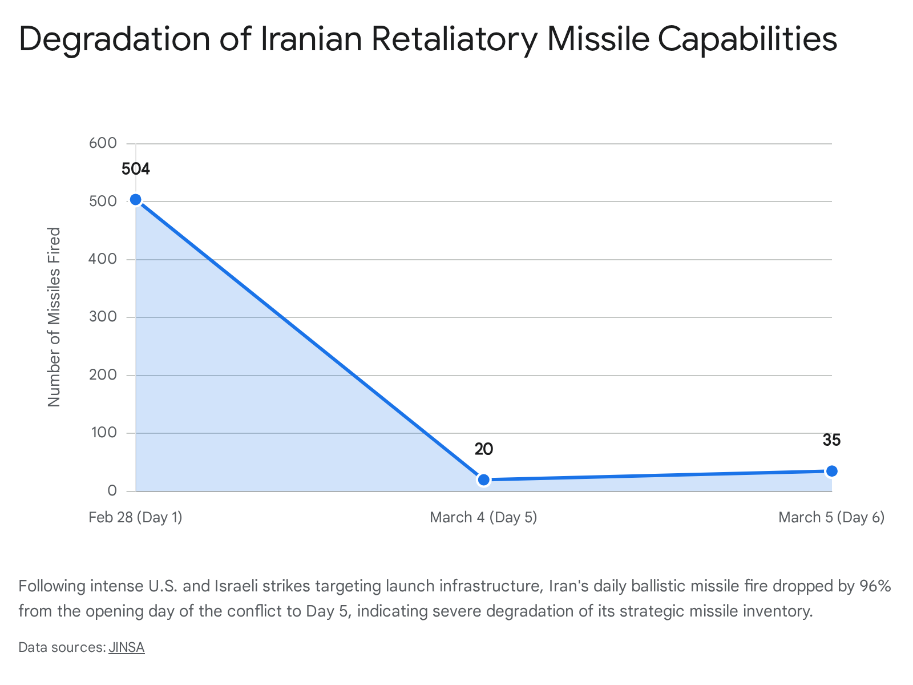

5.2 The Shift to Asymmetric Naval Threats and U.S. Munitions Constraints
While the strategic, long-range ballistic threat has been successfully suppressed, the specific, localized threat to commercial shipping in the Strait of Hormuz remains extraordinarily acute. Recognizing their inability to sustain a conventional blue-water naval confrontation against the U.S. Navy, Iranian forces have fully transitioned to asymmetric commercial deterrence.¹¹ The IRGCN is actively substituting their depleted ballistic inventories with an increased, aggressive deployment of cheap, reverse-engineered Shahed-136 one-way attack drones, highly mobile small-boat commando raids, and low-flying anti-ship cruise missiles.²⁷
This specific asymmetric strategy places immense, unsustainable pressure on U.S. and allied munitions inventories. U.S. forces are being forced to expend multi-million-dollar Patriot, THAAD, and Standard Missile interceptors to neutralize incoming Iranian drones that cost a fraction of the defense interceptors.⁵⁵ The Pentagon has already expressed severe concerns to the White House regarding the rapidly dwindling stockpiles of expensive offensive and defensive assets, such as Tomahawk cruise missiles (of which only 18 were funded in the base FY25 budget).⁵⁵
Discussions are currently underway regarding the potential invocation of the Defense Production Act to replenish these vital interceptor stockpiles.⁵³ Ultimately, Iranian strategists calculate that they do not need an infinite, highly sophisticated supply of missiles; as long as their localized, low-cost A2/AD bubble in the Gulf remains partially intact, the threat of sporadic, unpredictable strikes is entirely sufficient to keep global shipping paralyzed and insurance rates prohibitively high.¹²

6. Energy Flow Mitigation: Bypass Pipeline Capacities and Constraints
With the primary maritime artery severed by kinetic threats and insurance withdrawals, global energy markets have pivoted their focus entirely to the capacity of overland pipeline infrastructure capable of circumventing the Strait of Hormuz. While Saudi Arabia and the UAE possess dedicated bypass pipelines, empirical data proves that their maximum physical capacities fall drastically short of replacing the ~20 mb/d normally exported through the Mideast Gulf.⁹

6.1 Saudi Arabia: The East-West Pipeline (Petroline) and Yanbu Bottlenecks
Saudi Aramco operates the East-West Crude Pipeline, commonly referred to as Petroline. This critical 745-mile system is designed to transport crude from the massive Abqaiq oilfields in the Eastern Province directly across the Arabian Peninsula to the port of Yanbu on the Red Sea coast.⁹ The pipeline system possesses a design capacity of approximately 5.0 to 5.5 mb/d. While Aramco previously reported that it could surge this capacity to 7.0 mb/d via the emergency conversion of natural gas liquids (NGL) lines, sustainable flows at that extreme level have never been empirically tested under wartime stress conditions.⁹
In direct response to the Hormuz closure, Aramco has actively instructed multiple Asian buyers and international traders to alter their logistics and load Arab Light cargoes at Yanbu.⁵⁷ Real-time shipping data confirms this strategic pivot: in the first five days of March 2026, the Yanbu terminal successfully loaded 9.4 million barrels of crude, equating to an average flow rate of 1.9 mb/d.⁵⁹ This represents a significant 60% surge compared to February’s average flow of 1.1 mb/d and January's 1.3 mb/d.⁵⁹
However, this overland diversion faces three highly restrictive physical and operational friction points:
- Crude Grade Limitations: The East-West pipeline infrastructure is optimized primarily for the transport of Arab Light crude. This severely limits Aramco's ability to effectively export its heavier or specialized crude grades, which remain trapped in the eastern fields.⁵⁹
- Terminal and Maritime Bottlenecks: While the pipeline itself can theoretically move 5.0 mb/d, the Yanbu port infrastructure possesses severe maritime loading bottlenecks. Historically, the port has rarely sustained loading rates exceeding 2.5 mb/d, making the pipeline's theoretical maximum capacity functionally irrelevant.⁵⁹
- The Red Sea Threat Matrix: Bypassing Hormuz via Yanbu forces massive crude tankers directly into the Red Sea. In this corridor, they immediately face exorbitant freight rates and the persistent, severe security threat of anti-ship ballistic missiles and drone swarms launched by Iranian-aligned Houthi forces in Yemen.⁵⁹ The dark irony of this bypass strategy is that it successfully routes critical crude supplies out of one high-risk conflict zone only to deliver them directly into another. While Egypt has offered the use of the Sumed pipeline to facilitate the movement of this Red Sea crude further north to the Mediterranean, this adds significant transit time and complex logistical steps.⁵⁷

6.2 The United Arab Emirates: ADCOP and the Structural Deficit
The United Arab Emirates utilizes the Abu Dhabi Crude Oil Pipeline (ADCOP), which runs 400 kilometers from the onshore Habshan facilities directly to the port of Fujairah on the Gulf of Oman, successfully bypassing the Strait of Hormuz entirely.⁹ ADCOP possesses a reported practical capacity of roughly 1.5 to 1.8 mb/d.⁹ Under normal baseline conditions, the UAE utilizes approximately 1.1 mb/d of this capacity for domestic and export flows, leaving an estimated 700,000 barrels per day of spare operational capacity that can be surged to offset the Hormuz closure.⁹
Bypass Pipeline System | Operator | Practical/Design Capacity | Current Estimated Flow (March 2026) | Port Destination
East-West (Petroline) | Saudi Aramco | 5.0 - 5.5 mb/d | ~1.9 mb/d | Yanbu (Red Sea)
ADCOP | ADNOC (UAE) | 1.5 - 1.8 mb/d | ~1.1 mb/d (surging to max) | Fujairah (Gulf of Oman)
By combining the absolute maximum realistic output of the Yanbu terminal (~2.5 to 3.0 mb/d) and the ADCOP system (~1.8 mb/d), the absolute maximum regional bypass capacity is rigidly constrained to under 5.0 mb/d.⁹ With Saudi Arabia alone normally exporting over 6.0 mb/d through Hormuz, and total Gulf exports historically exceeding 14.3 mb/d (excluding Iran), a massive, mathematically insurmountable structural deficit of nearly 10 to 15 mb/d remains physically trapped inside the Persian Gulf.⁹

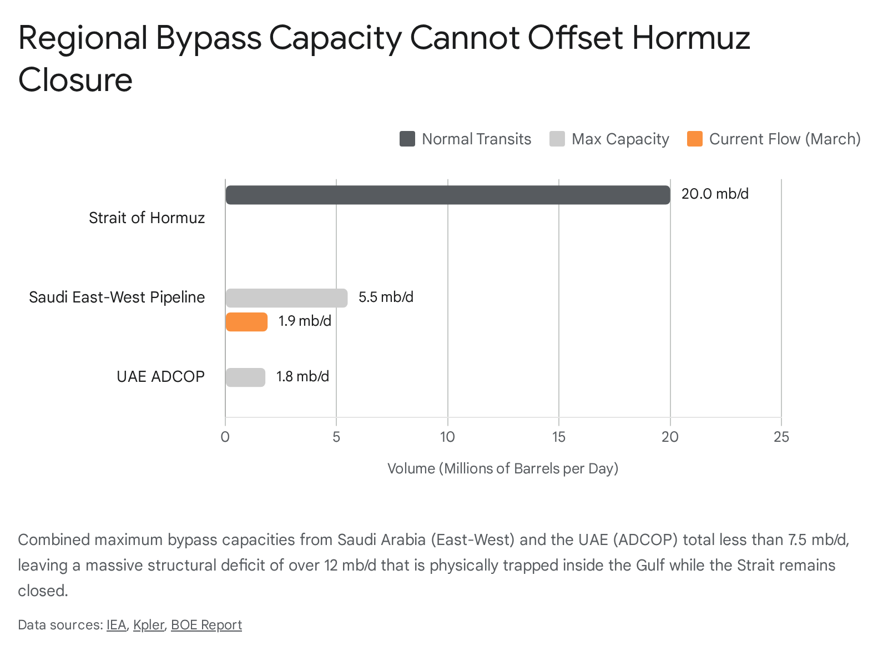

Conclusion and Strategic Market Implications
The empirical data synthesized as of March 6–7, 2026, unequivocally dictates a sustained escalation scenario, confirming the necessity to maintain strategic hold positions regarding USO and STNG assets. The maritime transit corridor through the Strait of Hormuz has functionally ceased to exist for mainstream commercial vessels, transitioning from a localized conflict zone into a black swan macroeconomic event that is starving the global market of crude, LNG, and critical dry bulk commodities.
The United States' deployment of a $20 billion DFC reinsurance backstop, while historically unprecedented, remains vastly undercapitalized to absorb the estimated $352 billion aggregate risk of the trapped fleet. Concurrently, promised U.S. Navy escort operations remain purely aspirational against an intact, highly motivated, and asymmetric Iranian naval threat environment that is rapidly depleting expensive U.S. interceptor stockpiles.
Most critically for duration modeling, diplomatic off-ramps have been intentionally and systematically dismantled by Tehran. The consolidation of Iranian crisis management under Ali Larijani, coupled with a stated willingness to absorb a protracted war of attrition, ensures that the conflict will not be resolved via near-term negotiations. With regional bypass pipelines physically incapable of offsetting the ~15 mb/d of Gulf crude exports trapped behind the Strait, severe physical shortages are mathematically guaranteed. These fundamental indicators—insurance gridlock, transit collapse, military entrenchment, and infrastructure limits—dictate that the Day 30 threshold and subsequent structural energy market shocks toward $100 Brent crude remain the highest probability trajectory.

Works cited
- US-Iran conflict: Strait of Hormuz crisis reshapes global oil markets | Kpler - Mar 01, 2026, accessed March 6, 2026, https://www.kpler.com/blog/us-iran-conflict-strait-of-hormuz-crisis-reshapes-global-oil-markets
- OPERATION EPIC FURY / ROARING LION, accessed March 6, 2026, https://defense-update.com/20260303_epic-fury.html
- US signals U-turn on naval convoys to restart Hormuz transits ..., accessed March 6, 2026, https://www.lloydslist.com/LL1156505/US-signals-U-turn-on-naval-convoys-to-restart-Hormuz-transits
- US to reinsure maritime losses in Gulf up to about $20 billion, agency says, accessed March 6, 2026, https://m.economictimes.com/industry/energy/oil-gas/us-to-reinsure-maritime-losses-in-gulf-up-to-about-20-billion-agency-says/amp_articleshow/129187875.cms
- "US to Create $20 Billion Reinsurance Facility for Strait of Hormuz ..., accessed March 6, 2026, https://en.fnnews.com/news/202603070438278333
- Iran says it is ready for ground invasion and rejects ceasefire with ..., accessed March 6, 2026, https://www.middleeastmonitor.com/20260306-iran-says-it-is-ready-for-ground-invasion-and-rejects-ceasefire-with-us/
- Oman renews push for diplomacy, says 'off-ramps available' in Iran war | News - Al Jazeera, accessed March 6, 2026, https://www.aljazeera.com/news/2026/3/3/oman-calls-for-immediate-ceasefire-says-off-ramps
- Why Khamenei Is Preparing Iran for War With the US to Protect Regime Survival | World News - The Times of India, accessed March 6, 2026, https://timesofindia.indiatimes.com/world/middle-east/ayatollah-ali-khamenei-donald-trump-us-attack-on-iran-protests-in-iran/articleshow/128747589.cms
- Strait of Hormuz – Oil security and emergency response - IEA, accessed March 6, 2026, https://www.iea.org/about/oil-security-and-emergency-response/strait-of-hormuz
- World Oil Transit Chokepoints - International - U.S. Energy Information Administration (EIA), accessed March 6, 2026, https://www.eia.gov/international/analysis/special-topics/World_Oil_Transit_Chokepoints
- How the Strait of Hormuz shutdown is disrupting dry bulk, LNG freight and trade compliance | Kpler - Mar 05, 2026, accessed March 6, 2026, https://www.kpler.com/blog/how-the-strait-of-hormuz-shutdown-is-disrupting-dry-bulk-lng-freight-and-trade-compliance
- Strait of Hormuz shock: Disruption is real but not indefinite | Kpler - Mar 02, 2026, accessed March 6, 2026, https://www.kpler.com/blog/strait-of-hormuz-shock-disruption-is-real-but-not-indefinite
- What Role Did Marine Insurers Play in Halting Hormuz Traffic? - Windward, accessed March 6, 2026, https://windward.ai/blog/role-of-marine-insurers-in-halting-hormuz-traffic/
- Only nine commercial ships detected crossing the Hormuz Strait since Monday, accessed March 6, 2026, https://www.bssnews.net/international/366516
- Iranian Shadow Fleet and Greek Affiliated Ships Lead Strait of ..., accessed March 6, 2026, https://gcaptain.com/iranian-shadow-fleet-and-greek-affiliated-ships-lead-strait-of-hormuz-transits/
- Middle East war disrupts dry bulk commodity trade as Hormuz shipping grinds to a halt, accessed March 6, 2026, https://www.kpler.com/blog/middle-east-war-disrupts-dry-bulk-commodity-trade-as-hormuz-shipping-grinds-to-a-halt
- Strait of Hormuz disruption: Which container vessels are trapped, waiting, or diverting?, accessed March 6, 2026, https://www.kpler.com/blog/strait-of-hormuz-disruption-which-container-vessels-are-trapped-waiting-or-diverting
- Strait Of Hormuz watch amid Iran conflict risk – tracking crude flows, interference and diversions in Kpler, accessed March 6, 2026, https://www.kpler.com/blog/strait-of-hormuz-watch-amid-iran-conflict-risk-tracking-crude-flows-interference-and-diversions-in-kpler
- Trump says US Navy will escort ships through Strait of Hormuz as Iran war spirals, accessed March 6, 2026, https://www.wsws.org/en/articles/2026/03/04/vnrv-m04.html
- Maritime insurers cancel war risk cover in Gulf as Iran conflict disrupts shipping, accessed March 6, 2026, https://www.theguardian.com/business/2026/mar/02/maritime-insurers-war-risk-cover-gulf-iran-shipping-strait-of-hormuz
- No, P&I clubs have not 'cancelled war risk cover' :: Lloyd's List, accessed March 6, 2026, https://www.lloydslist.com/LL1156515/No-PI-clubs-have-not-cancelled-war-risk-cover
- Strait of Hormuz & Persian Gulf Update | March 4, 2026 | US Sub Sinks Iranian Ship | Russian LNG Hit - YouTube, accessed March 6, 2026, https://www.youtube.com/watch?v=ruOkuy3Tqv0
- Lloyd's Market Engaging With US Government Over Gulf Maritime Plan, Officials Say, accessed March 6, 2026, https://www.insurancejournal.com/news/international/2026/03/05/860588.htm
- US to reinsure maritime losses in Gulf up to about $20 billion, agency says, accessed March 6, 2026, https://m.economictimes.com/industry/energy/oil-gas/us-to-reinsure-maritime-losses-in-gulf-up-to-about-20-billion-agency-says/articleshow/129187875.cms
- Trump directs US agency to insure Gulf shipping, says Navy may escort oil tankers through Strait of Hormuz, accessed March 6, 2026, https://m.economictimes.com/news/international/world-news/trump-directs-us-agency-to-insure-gulf-shipping-says-navy-may-escort-oil-tankers-through-strait-of-hormuz/articleshow/128989540.cms
- Political Appointee Tracker - Partnership for Public Service, accessed March 6, 2026, https://ourpublicservice.org/performance-measures/political-appointee-tracker/
- Insurance and Naval Escorts May Not be Enough to Reboot Gulf Shipping, accessed March 6, 2026, https://maritime-executive.com/article/insurance-and-naval-escorts-may-not-be-enough-to-reboot-gulf-shipping
- Trump says US Navy could escort ships through Strait of Hormuz - Navy Times, accessed March 6, 2026, https://www.navytimes.com/news/your-navy/2026/03/03/trump-says-us-navy-could-escort-ships-through-strait-of-hormuz/
- Trump says US Navy vessels could accompany tankers in Strait of Hormuz, accessed March 6, 2026, https://breakingdefense.com/2026/03/trump-says-us-navy-vessels-could-accompany-tankers-in-strait-of-hormuz/
- Strait of Hormuz Closure: Global Energy Markets Braced for Massive Shock After Iran Strikes US and UK Vessels, accessed March 6, 2026, http://markets.chroniclejournal.com/chroniclejournal/article/marketminute-2026-3-2-strait-of-hormuz-closure-global-energy-markets-braced-for-massive-shock-after-iran-strikes-us-and-uk-vessels
- Trump's Plan To Escort Ships Through Strait Of Hormuz Would Put U.S. Navy Warships In The Crosshairs - The War Zone, accessed March 6, 2026, https://www.twz.com/sea/trumps-plan-to-escort-ships-through-strait-of-hormuz-would-put-u-s-navy-warships-in-the-crosshairs
- US-Israel vs Iran war enters Day 6: Azerbaijan summons Iranian ambassador after drone strikes, Italy to send air-defence aid to Gulf countries - The Economic Times, accessed March 6, 2026, https://m.economictimes.com/news/defence/israel-iran-conflict-day-6-latest-us-iran-war-news-missiles-regional-spillover-and-global-powers-drawn-deeper-into-conflict/articleshow/129064186.cms
- The US-Israel campaign in Iran - The International Institute for Strategic Studies, accessed March 6, 2026, https://www.iiss.org/online-analysis/online-analysis/2026/02/the-us-israel-campaign-in-iran/
- Op-Ed: What's the Plan for the Strait of Hormuz?, accessed March 6, 2026, https://maritime-executive.com/editorials/op-ed-what-s-the-plan-for-the-strait-of-hormuz
- Strait of Hormuz | International Crisis Group, accessed March 6, 2026, https://www.crisisgroup.org/trigger-list/iran-usisrael-trigger-list/flashpoints/strait-hormuz
- Iran Guards say have ‘complete control’ of Hormuz Strait, accessed March 6, 2026, https://globalnation.inquirer.net/312275/iran-guards-say-have-complete-control-of-hormuz-strait
- Iran's IRGC Claims "Complete Control" Over Strait Of Hormuz As Trump Orders US Navy To Escort Tankers, accessed March 6, 2026, https://www.marineinsight.com/shipping-news/irans-irgc-claims-complete-control-over-strait-of-hormuz-as-trump-orders-us-navy-to-escort-tankers/
- 2025–2026 Iran–United States negotiations - Wikipedia, accessed March 6, 2026, https://en.wikipedia.org/wiki/2025%E2%80%932026_Iran%E2%80%93United_States_negotiations
- How is Turkey responding to the US-Israel-Iran war? - The National News, accessed March 6, 2026, https://www.thenationalnews.com/news/mena/2026/03/04/how-is-turkey-responding-to-the-us-israel-iran-war/
- Oman expresses regret over Israeli and US military operations against Iran | fm.gov.om, accessed March 6, 2026, https://www.fm.gov.om/en/38110/
- Oman's Flipflopping on Iran Will Leave It Isolated in the Gulf - FDD, accessed March 6, 2026, https://www.fdd.org/analysis/2026/03/04/omans-flipflopping-on-iran-will-leave-it-isolated-in-the-gulf/
- Iran's Larijani refutes claims Tehran pushed to resume US talks | News - Al Jazeera, accessed March 6, 2026, https://www.aljazeera.com/news/2026/3/2/irans-larijani-refutes-claims-tehran-pushed-to-resume-us-talks
- Iran War Reaches India's Shores - The Media Line, accessed March 6, 2026, https://themedialine.org/top-stories/iran-war-reaches-indias-shores/
- Noon briefing of 2 March 2026 | Secretary-General - the United Nations, accessed March 6, 2026, https://www.un.org/sg/en/content/highlight/2026-03-02.html
- Noon briefing of 4 March 2026, accessed March 6, 2026, https://www.un.org/sg/en/content/highlight/2026-03-04.html
- Emergency Meeting on the Military Escalation in the Middle East - Security Council Report, accessed March 6, 2026, https://www.securitycouncilreport.org/whatsinblue/2026/02/emergency-meeting-on-the-military-escalation-in-the-middle-east.php
- Daily Press Briefing by the Office of the Spokesperson for the Secretary-General, accessed March 6, 2026, https://press.un.org/en/2026/db260304.doc.htm
- Iran Update Evening Special Report, March 5, 2026 | ISW, accessed March 6, 2026, https://understandingwar.org/research/middle-east/iran-update-evening-special-report-march-5-2026/
- Iran Update Evening Special Report, March 3, 2026 | ISW, accessed March 6, 2026, https://understandingwar.org/research/middle-east/iran-update-evening-special-report-march-3-2026/
- Iran's missile capability is significantly degraded - Asia Times, accessed March 6, 2026, https://asiatimes.com/2026/03/irans-missile-capability-is-significantly-degraded/
- Iran Update Morning Special Report, March 2, 2026 | ISW, accessed March 6, 2026, https://understandingwar.org/research/middle-east/iran-update-morning-special-report-march-2-2026/
- Did Iran's Nuclear and Missile Programs Pose an Imminent Threat? No., accessed March 6, 2026, https://www.armscontrol.org/issue-briefs/2026-03/did-irans-nuclear-and-missile-programs-pose-imminent-threat-no
- Operations Epic Fury and Roaring Lion: 3/5/26 Update - JINSA, accessed March 6, 2026, https://jinsa.org/wp-content/uploads/2026/03/Operations-Epic-Fury-and-Roaring-Lion-03-05-26.pdf
- Iran Update Evening Special Report, March 4, 2026, accessed March 6, 2026, https://understandingwar.org/research/middle-east/iran-update-evening-special-report-march-4-2026/
- War with Iran Puts Pressure on Munitions Inventories and Signals Future Demand, accessed March 6, 2026, https://dsm.forecastinternational.com/2026/03/03/war-with-iran-puts-pressure-on-munitions-inventories-and-signals-future-demand/
- US Risks Running Out of Missiles In War With Iran, accessed March 6, 2026, https://www.investorideas.com/news/2026/defense/03061-us-missile-stockpiles-iran-war-rare-earth-magnet-china-dependency.asp
- Egypt Offers Sumed Pipeline for Saudi Crude as Strategic Bypass Amid Red Sea Oil Shift, accessed March 6, 2026, https://www.pipeline-journal.net/news/egypt-offers-sumed-pipeline-saudi-crude-strategic-bypass-amid-red-sea-oil-shift
- Saudi Aramco seeks to reroute crude away from Strait of Hormuz, Reuters’ sources say, accessed March 6, 2026, https://www.bnnbloomberg.ca/business/2026/03/03/saudi-aramco-seeks-to-reroute-crude-away-from-strait-of-hormuz-reuters-sources-say/
- Saudi Aramco boosts Red Sea oil shipments as Hormuz disruption ..., accessed March 6, 2026, https://boereport.com/2026/03/06/saudi-aramco-boosts-red-sea-oil-shipments-as-hormuz-disruption-curbs-exports/
- Middle East conflict - oil market implications: a continuing assessment | Kpler - Mar 05, 2026, accessed March 6, 2026, https://www.kpler.com/blog/middle-east-conflict---oil-market-implications-a-continuing-assessment

