Exercises 1

1. Create a file called message.txt in your home directory and move it into another directory.

Sudo –s -H

Cd home

Touch message.txt

Mv message.txt/*lib

1. Copy the message.txt you just moved into your home directory.

Cp /lib/message.txt /home/message.txt

1. Delete both copies of message.txt. Try to do this without using rm.

Sudo rm /

Exercises 2

1. Create a new directory called workbench in your home directory.

Sudo –s -H

Cd home

Mkdir workbench

1. Without changing directories create a file called readme.txt inside of workbench.

Touch /home/workbench/read.txt

1. Append the numbers 1, 2, and 3 to readme.txt so that each number appears on it’s own line.

Cd workbench

echo “1” > readme.txt

echo “2” >> readme.txt

echo “3” >> readme.txt

1. Print readme.txt to the command line.

Cat readme.txt

1. Use output redirection to create a new file in the workbench directory called list.txt which lists the files and folders in your home directory.

Ls -l > list.txt

1. Find out how many characters are in list.txt without opening the file or printing it to the command line.

Wc -m list.txt

### Exercises

1. Use man to look up the flag for human-readable output from ls.

-h, with –l and/or –s,print human readable sizes

1. Get help with man by typing man man into the console.

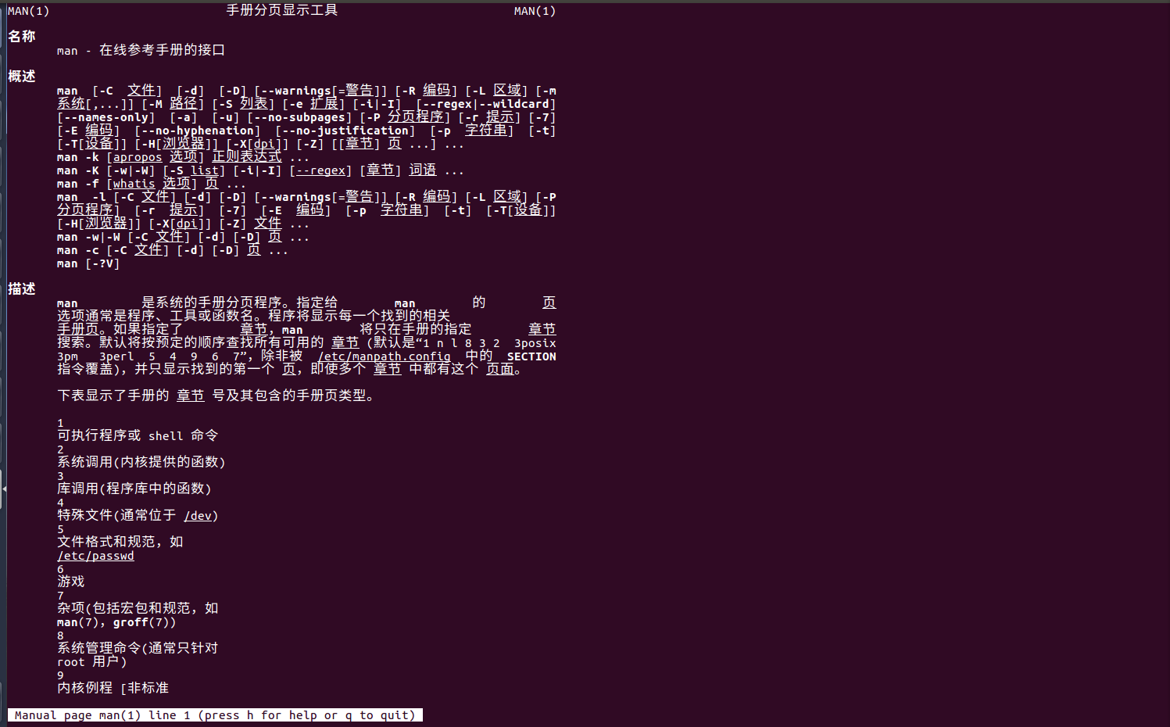

1. Wouldn’t it be nice if there was a calendar command? Use apropos to look for such a command, then use man to read about how that command works.

Synopsis:

Calendar [-ab][-A num] [-l num] [-w num] [-f calendarfile] [-t [[[cc]yy]mm]dd]

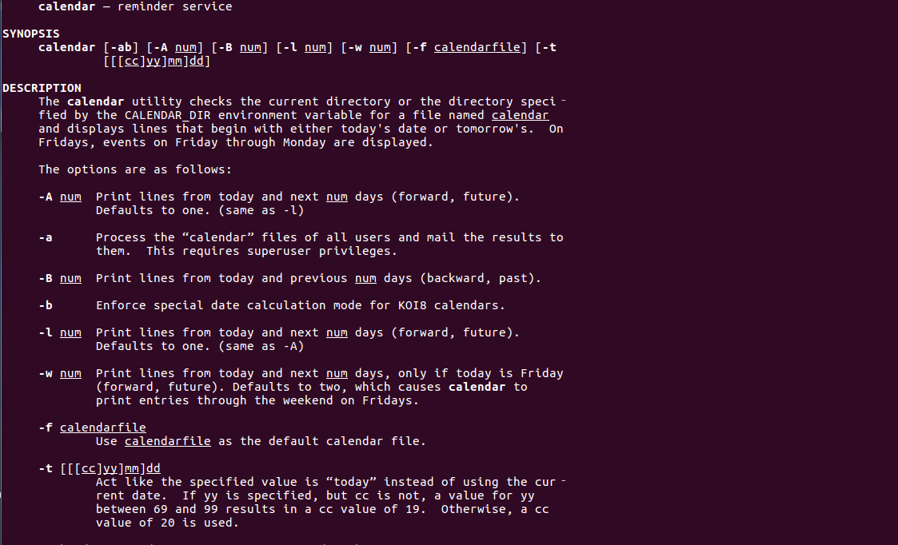

### Exercises

1. Before I organized the photos by year, what command would have listed all of the photos of type .png?

Find –name “*.png”

1. Before I organized the photos by year, what command would have deleted all of my hiking photos?

Rm –I “*.jpg”

1. What series of commands would you use in order to put my figures for a data science course and the pictures I took in the lab into their own folders?

Sudo –s –H 进入管理员模式；

Cd 至保存图片的文件夹

find . “指定文件类型”{-atime/-ctime/-mtime/-amin/-cmin/-mmin} [-/+]num mv{} /指定文件夹 ： 如果照片拍摄时间不同，可以根据时间找到对应照片集合并打包移动到指定文件夹。

或mv 文件名 /指定文件夹/；