William “Chris” Fenton

10/8/15

Digital Logic Lab 2

1.1)

╔═══╤═══╤═════╤══════╗  
║ A │ B │ Sum │ Cout ║  
╠═══╪═══╪═════╪══════╣  
║ 0 │ 0 │ 0 │ 0 ║  
╟───┼───┼─────┼──────╢  
║ 0 │ 1 │ 1 │ 0 ║  
╟───┼───┼─────┼──────╢  
║ 1 │ 0 │ 1 │ 0 ║  
╟───┼───┼─────┼──────╢  
║ 1 │ 1 │ 0 │ 1 ║  
╚═══╧═══╧═════╧══════╝

1.2)

Sum of the half adder: A XOR B

CarryOut: A AND B

1.3)

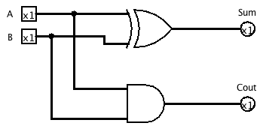

2.1)

╔═══╤═══╤══════╤═════╤═══════╗  
║ A │ B │ C-IN │ SUM │ C-OUT ║  
╠═══╪═══╪══════╪═════╪═══════╣  
║ 0 │ 0 │ 0 │ 0 │ 0 ║  
╟───┼───┼──────┼─────┼───────╢  
║ 0 │ 0 │ 1 │ 1 │ 0 ║  
╟───┼───┼──────┼─────┼───────╢  
║ 0 │ 1 │ 0 │ 1 │ 0 ║  
╟───┼───┼──────┼─────┼───────╢  
║ 0 │ 1 │ 1 │ 0 │ 1 ║  
╟───┼───┼──────┼─────┼───────╢  
║ 1 │ 0 │ 0 │ 1 │ 0 ║  
╟───┼───┼──────┼─────┼───────╢  
║ 1 │ 0 │ 1 │ 0 │ 1 ║  
╟───┼───┼──────┼─────┼───────╢  
║ 1 │ 1 │ 0 │ 0 │ 1 ║  
╟───┼───┼──────┼─────┼───────╢  
║ 1 │ 1 │ 1 │ 1 │ 1 ║  
╚═══╧═══╧══════╧═════╧═══════╝

2.2)

SUM = A XOR B XOR C-IN

C-OUT = (C-IN AND (A XOR B)) AND (A AND B)

2.3)

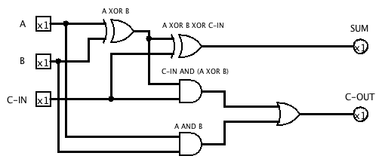

3.1)

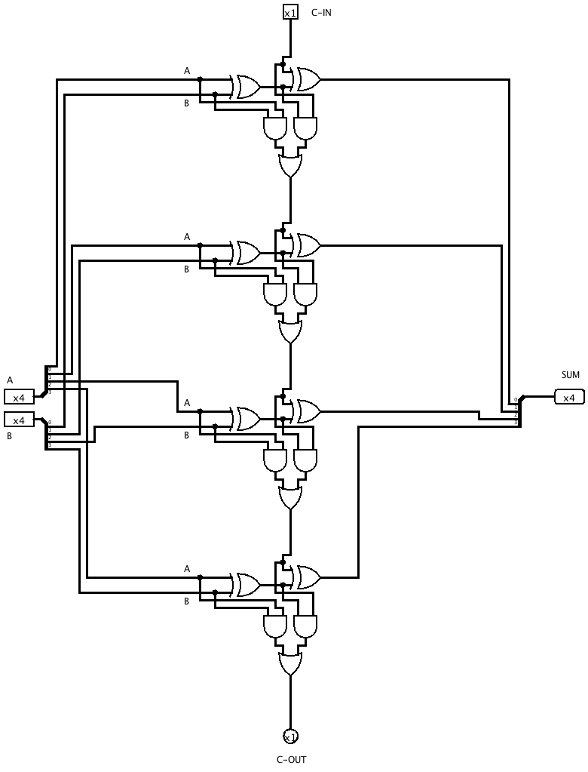

4.1)

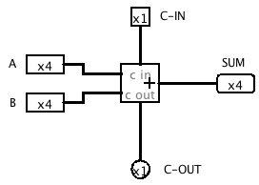

Questions about a 4-bit Adder

What is the range of unsigned numbers that you can represent in 4 bits?

0 - 15

Fill out the following table of sums, carry, and borrow that your 4-bit adder circuit will give. Assume unsigned representation of numbers in 4 bits.

|  |  |  |  |  |  |  |
| --- | --- | --- | --- | --- | --- | --- |
| **Binary A Input** | **Binary B Input** | **Binary Sum** | **Decimal A Input** | **Decimal B Input** | **Decimal Sum** | **Carry** |
| 0000 | 0111 | 0111 | 0 | 7 | 7 | 0 |
| 1100 | 0101 | 0001 | 12 | 5 | 17 | 1 |
| 0101 | 0101 | 1010 | 5 | 5 | 10 | 0 |
| 1111 | 1111 | 0000 | 15 | 15 | 30 | 1 |
| 0010 | 0110 | 1000 | 2 | 6 | 8 | 0 |

Assuming unsigned 4-bit representation of numbers, under what conditions does adding produce a result that is not meaningful with respect to normal addition and the constraint of only 4 bits to hold the sum?

When the any of the inputs or the sum are outside the range (0-15).

What does the carry out pin signify?

If the number is out of the range (greater than 15 for 4 bits)

Assuming unsigned 4-bit representation of numbers, what does your 4-bit adder actually produce if you try to add two numbers whose sum exceeds the 4-bit range of values? Give an arithmetic expression for the unsigned value of the sum bits in terms of x and y input values (use the modulus operation - mod; look for examples in your discrete math book).

It wraps around. SUM = x + y (mod 16)