#==============================#

| Yuan Wang, Yizhen Wang |

| ywang19, ywang22 |

| PA6 README |

#==============================#

#===================#

| Summary |

#===================#

**This is the Polymorphism program which is about PA6.**

1. The Standard Command Line input is : ./PA6 [#gridSize] [#doodlebugs] [#ants] [#time_steps] [#seed] [#pause]
2. Note: if you do not enter any argument in the command line, just press enter button, and it will show the default value: gridSize -> 20, doodlebugs-> 5, ants-> 100, time_steps-> 1000, seed-> 1,

**The whole program includes:**

1. grid.h (header class for grid.cpp):

Defined the class for grid which has organisms, size, organism_at, put_organism, get_size, get_occupied_surrounding, get_unoccupied_surrounding.

1. grid.cpp

Defined the above functions in details:

Organism* grid::organism_at(int x, int y)

void grid::put_organism(int x, int y, Organism* o)

int grid::get_size()

list<Organism*>* grid::get_occupied_surrounding(int x, int y)

list<Organism*>* grid::get_unoccupied_surrounding(int x, int y)

grid::grid(int size)

grid::grid()

1. organism.h (header class for organism.cpp)

Defined :

Classs of the Organism;

DoodleBug -> Organism;

Ant -> Organism;

GhostBug -> Organism;

And their individual functions.

Here is the Class of organism, and ant, doodlebug, ghostbug choose their individual methods from this class;

        virtual void move()           =  0;

virtual int  get_x()          =  0;

virtual int  get_y()          =  0;

virtual int  set_x(int a)     =  0;

virtual int  set_y(int a)     =  0;

virtual int  get_breed()      =  0;

virtual int  set_breed(int a) =  0;

virtual int  get_satiation()  =  0;

virtual void set_sat(int s)   =  0;

virtual char get_rep()        =  0;

virtual int  get_ID()         =  0;

1. organism.cpp: nothing special, just the method in details
2. simulation.cpp: main function:

int get_random(int min, int max) : random numbers

list<DoodleBug*>* iterate_doodles(list<DoodleBug*>* bugs, grid* g)//iterate the doodlebug

list<Ant*>* iterate_ants(list<Ant*>* ants, grid* g) //iterate the ant

void doodle(grid* g, int count, list<DoodleBug*>* db) // doodlebug

void ant(grid* g, int count, list<Ant*>* ants) // ant

ostream& operator << (ostream& os, Organism& o) // << organism

ostream& operator << (ostream& os, grid& g) // << grid

int main(int argc, char*argv[]) // main function

Outputs:

Here is how to run the default setting:

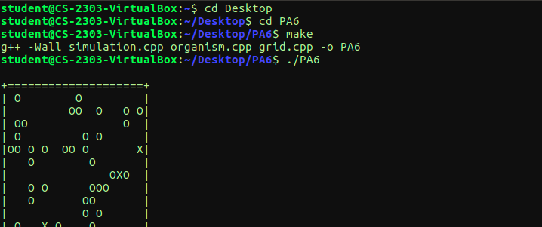

Here is the final output about the default setting:

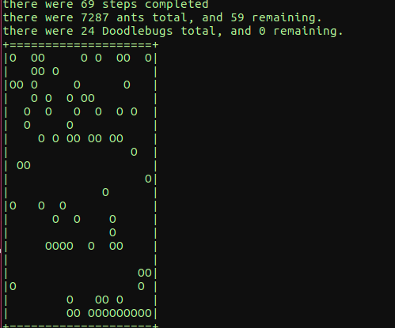

Here is the self_testing outpt:

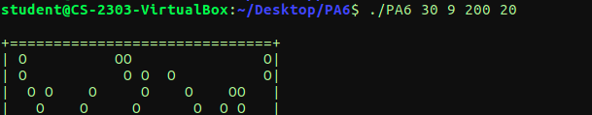

Here is the final output:

