Doll Head–Torso Detection & State Estimation – Handover Guide (EN)
Owner package: doll_head_torso
Core goal: Detect whether a doll is assembled (head+torso) or disassembled, and publish the decision plus 2D/3D coordinates for each part so a robot arm can pick them up.

1) High-level Overview
- Camera: Intel RealSense D456 (serial used during dev: 333422300494).
- Perception: YOLOv8 segmentation model trained on 3 classes: head, torso, ht (assembled head+torso).
- ROS node(s):
  - yolo_seg_node.py → runs segmentation and publishes an annotated image (for visual checks).
  - doll_state_node.py → runs segmentation with robust logic to decide assembled / disassembled / unknown, smooths the decision over time (hysteresis), and publishes coordinates (2D/3D) per detected part.
- Visualization: rqt_image_view for images; rostopic echo / rqt_plot for numeric data.

Data Flow (conceptual)
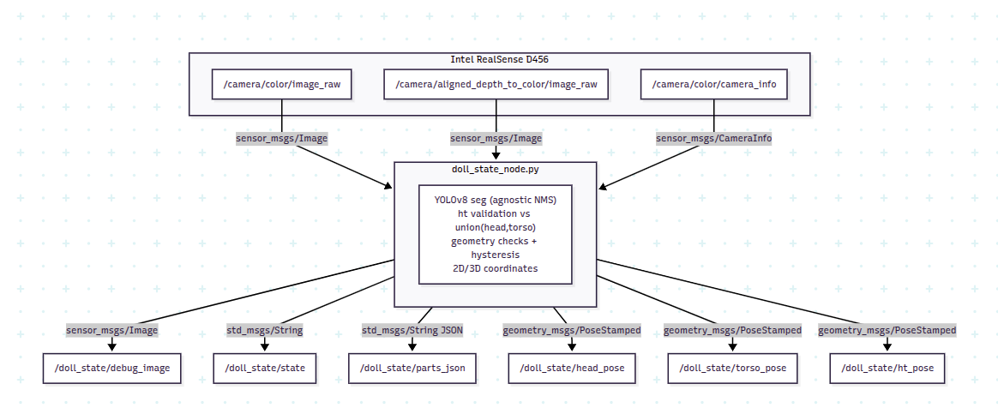

2) Environment & Dependencies
- ROS Noetic, Python 3, Ubuntu 20.04.
- Core ROS packages: realsense2_camera, cv_bridge, image_transport.
- Python libs: ultralytics, torch, opencv-python, numpy.
- RealSense: Depth aligned to color must be enabled for 3D points to match masks.
Install ultralytics/torch via pip in your ROS Python environment. Ensure CUDA is available if using GPU (set device=0 in params).

3) Package Layout
doll_head_torso/
├─ launch/
│ ├─ camera.launch # wraps realsense2_camera/rs_camera.launch
│ ├─ yolo_seg.launch # camera + yolo_seg_node.py (visual debug)
│ └─ doll_state.launch # camera + doll_state_node.py (state + coords)
├─ nodes/
│ ├─ yolo_seg_node.py # segmentation + annotated image
│ └─ doll_state_node.py # robust state + coords (2D/3D)
└─ ...
Model path used during dev: /doll/doll_2parts/runs/segment/train/weights/best.pt
Update this path via ROS param ~model_path if you relocate the weights.

4) Launch Files

launch/camera.launch
Wrapper around realsense2_camera/rs_camera.launch exposing only required args.
Key args (examples):
<arg name="enable_color" default="true"/>
<arg name="enable_depth" default="true"/>
<arg name="align_depth" default="true"/>
<arg name="serial_no" default="333422300494"/>
<arg name="color_width" default="640"/>
<arg name="color_height" default="480"/>
<arg name="color_fps" default="30"/>
<arg name="depth_width" default="640"/>
<arg name="depth_height" default="480"/>
<arg name="depth_fps" default="30"/>
<arg name="enable_pointcloud" default="false"/>
Publishes at least:
- /camera/color/image_raw (sensor_msgs/Image)
- /camera/aligned_depth_to_color/image_raw (sensor_msgs/Image)
- /camera/color/camera_info (sensor_msgs/CameraInfo)

launch/yolo_seg.launch
Starts camera + yolo_seg_node.py (for visual testing only).
- Publishes annotated image: /yolo_seg/annotated.

launch/doll_state.launch
Starts camera + doll_state_node.py (main runtime). Enables aligned depth.
- Publishes state/coords topics (see below).

5) Nodes & Topics

nodes/yolo_seg_node.py
- Subscribes: /camera/color/image_raw
- Publishes: ~annotated → /yolo_seg/annotated (sensor_msgs/Image)
- Params: model_path, conf, iou, imgsz, device, process_every_n

nodes/doll_state_node.py (main)
- Subscribes:
  - Color: /camera/color/image_raw
  - Depth (aligned): /camera/aligned_depth_to_color/image_raw (if use_depth=true)
  - Camera intrinsics: /camera/color/camera_info
- Publishes:
  - ~debug_image → /doll_state/debug_image (sensor_msgs/Image)
  - ~state → /doll_state/state (std_msgs/String: assembled|disassembled|unknown)
  - ~parts_json → /doll_state/parts_json (std_msgs/String, JSON per frame)
  - ~head_pose → /doll_state/head_pose (geometry_msgs/PoseStamped, XYZ in camera frame)
  - ~torso_pose → /doll_state/torso_pose (PoseStamped)
  - ~ht_pose → /doll_state/ht_pose (PoseStamped)
Message content in parts_json:
{
"frame_id": "camera_color_optical_frame",
"parts": [
{
"class": "head|torso|ht",
"conf": 0.0..1.0,
"bbox": [x1, y1, x2, y2],
"centroid_px": [u, v],
"area_px": N_pixels,
"point_camera": [X, Y, Z] // meters in camera frame, null if depth unavailable
}
]
}

6) Decision Logic (summary)
- Primary assembled evidence: class ht present with confidence ≥ min_conf_ht and its mask sufficiently overlaps the union of (head ∪ torso) (IoU ≥ ht_union_iou_min).
- Else, evaluate head + torso pairs using:
  - Mask overlap (≥ overlap_thresh) or normalized centroid distance (≤ center_dist_factor).
  - Geometry constraints: head must be above torso by at least min_vertical_margin of image height; head area must be < max_head_to_torso_area_ratio × torso area.
- If only one part is detected → disassembled.
- Temporal hysteresis: require min_frames_to_assembled to confirm assembled; fewer frames (min_frames_to_disassembled) to fall back to disassembled.
Additional inference settings:
- Agnostic NMS (agnostic_nms=True) to reduce cross-class duplicates.
- Tunable conf/iou thresholds for Ultralytics inference.

7) Parameters (with suggested defaults)
Set in doll_state.launch or via rosparam:
Model/Inference
- ~model_path (str): path to YOLOv8 segmentation weights.
- ~conf (float, default 0.33)
- ~iou (float, default 0.58)
- ~imgsz (int, default 640)
- ~device (str|int, default 0 → GPU #0; or 'cpu')
- ~process_every_n (int, default 1 → process every frame)
Topics
- ~image_topic (default /camera/color/image_raw)
- ~depth_topic (default /camera/aligned_depth_to_color/image_raw)
- ~camera_info_topic (default /camera/color/camera_info)
- ~use_depth (bool, default true)
Segmentation/Logic
- ~mask_threshold (float, default 0.5)
- ~min_conf_ht (float, default 0.5)
- ~ht_union_iou_min (float, default 0.5)
- ~overlap_thresh (float, default 0.22)
- ~center_dist_factor (float, default 0.55)
- ~min_vertical_margin (float, default 0.05 of image height)
- ~max_head_to_torso_area_ratio (float, default 0.8)
Hysteresis
- ~min_frames_to_assembled (int, default 5)
- ~min_frames_to_disassembled (int, default 3)
- ~unknown_decay (int, default 1)
Debug
- ~publish_debug (bool, default true)

8) How to Run

One-time setup
chmod +x ~/catkin_ws/src/doll_head_torso/nodes/doll_state_node.py
source ~/catkin_ws/devel/setup.bash

Start camera + state node (with aligned depth)
roslaunch doll_head_torso doll_state_node_cord.launch

Visual checks
# Annotated image with state overlay
rqt_image_view /doll_state/debug_image

# State text
rostopic echo /doll_state/state

Coordinates (no robot required)
# 3D position (meters, camera frame)
rostopic echo /doll_state/head_pose/pose/position
rostopic echo /doll_state/torso_pose/pose/position
rostopic echo /doll_state/ht_pose/pose/position

# 2D+3D details (JSON per frame)
rostopic echo /doll_state/parts_json
# Pretty-print one sample (requires jq)
rostopic echo -n1 /doll_state/parts_json | sed -n 's/^data: //p' | jq

9) Troubleshooting
Grey image in rqt_image_view
- Open directly on the topic: rqt_image_view /doll_state/debug_image.
- Ensure the node is publishing: rostopic hz /doll_state/debug_image.
No 3D coordinates (null point_camera / empty PoseStamped)
- Check that depth is enabled and aligned: enable_depth=true, align_depth=true in camera.launch.
- Verify topics: /camera/aligned_depth_to_color/image_raw and /camera/color/camera_info exist.
Flaky assembled/disassembled decision
- Increase conf to 0.35–0.40 and iou to 0.6.
- Tighten geometry: raise overlap_thresh (e.g., 0.25), lower center_dist_factor.
- Adjust hysteresis: increase min_frames_to_assembled.
Performance issues
- Lower imgsz (e.g., 512 or 480) or set process_every_n=2.
- Use GPU (device=0) and ensure correct CUDA drivers.
Topic naming collisions
- Use remapping or rename node with name="doll_state" per robot.

10) Re-training Notes (if needed)
- Ensure balanced samples across head, torso, ht.
- Include edge cases: head near torso but not assembled, partial occlusions, varied lighting/angles.
- Encourage precise masks around the neck interface.
- Apply moderate augmentations (±20° rotation, slight blur, brightness/contrast jitter).
Model drop-in: train with Ultralytics (seg), then update ~model_path.

11) Future Work
- Replace parts_json (String) with custom messages (e.g., DollPart.msg, DollDetections.msg).
- Publish visualization_msgs/MarkerArray for RViz markers at 3D points.
- Add tracking across frames (e.g., ByteTrack/DeepSORT) to improve temporal consistency.
- Add grasp pose estimation (orientation) per part to directly feed a manipulator.

12) Changelog (brief)
- v1 (initial): yolo_seg_node.py for annotation only.
- v2: doll_state_node.py with assembled/disassembled logic and debug overlay.
- v3: Robustness upgrades: agnostic NMS, ht validation vs union(head∪torso), geometry constraints, hysteresis.
- v4: Coordinate publishing: 2D/3D per part (parts_json, PoseStamped topics).

13) Quick Command Cheat-Sheet
# Launch
roslaunch doll_head_torso doll_state.launch

# Visual debug
rqt_image_view /doll_state/debug_image

# State
rostopic echo /doll_state/state

# 3D coords
rostopic echo /doll_state/head_pose/pose/position

# JSON details
rostopic echo -n1 /doll_state/parts_json | sed -n 's/^data: //p' | jq

# Topic scan
rostopic list | grep -E "doll_state|camera|image|depth|camera_info"

Contact / Handover:
- Model weights location: /doll/doll_2parts/.../best.pt (update param if moved)
- Camera used: RealSense D456 (serial 333422300494)
- Primary entrypoint for production: roslaunch doll_head_torso doll_state.launch

