Question 1 (20 marks)
This question is based on Unit 5.
Read the following description of a publishing company and then answer the questions that follow.
The Notlaw Press publishes a series of books on technical subjects.
The books are written by freelance authors, who are not on Notlaw Press’s payroll but instead are contracted to write individual books for an agreed fee. Notlaw Press maintains a register of authors who write for them, keeping the name, contact and banking details of each writer together with a list of subject areas that the author is competent to write about. New books are commissioned by commissioning editors who identify a suitable author and draw up a contract for the writing of a book. When a book is commissioned the subject area is identified, and the book given a title, an outline description, an International Standard Book Number (ISBN), and a planned publication date. The contract will then refer to the book concerned, the commissioning editor, the chosen writer, and the agreed fee.
A technical editor and a copy editor are also assigned to the book. Technical editors are responsible for checking technical accuracy, whereas copy editors are mainly concerned with matters such as style, grammar and formatting. Both kinds of editor can be involved with many books at a time, but technical editors are associated with a particular subject area, which must be the same as the books they work on. Copy editors can be assigned to any book, whatever its subject.

- Imagine you have joined the team that is going to develop a new software system to help Notlaw Press manage and track its book commissions. As part of that project you have been asked to model the problem domain.
Use noun identification, or another technique, to identify candidate classes from the description above.
Draw up a list of the candidate classes in a table with the headings given in Table 1 below. For each candidate class identify whether or not it should be included in the first class diagram, using the guidelines given in Unit 5, Subsection 2.1 and your own judgement.
Follow the table with a final list of the classes you have decided to keep.
(5 marks)
- Using your final list of classes from part (a), draw a class diagram that includes the attributes of each class and the associations between the classes. Your diagram should show the multiplicities for each association.
(8 marks)
- Choose two of the associations in your diagram for part (b) and explain the meaning of each association and the multiplicities chosen.
(3 marks)
- Class models on their own have a number of limitations. Briefly discuss these in your own words. Your answer should not exceed 150 words.
(4 marks)

Table 1 Candidate class list
Candidate class name | Keep? (Yes/No) | Reason for keeping or discarding candidate class
.. | .. | ..
.. | .. | ..
Question 2 (15 marks)
This question is based on Unit 5.
Figure 1 shows a class diagram modelling a system for administering the photography competitions run by a camera club. Study the diagram and answer the questions that follow.
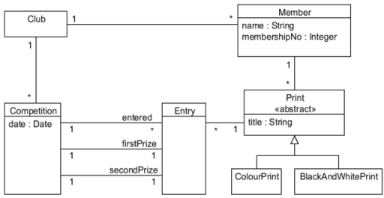
Figure 1 A class model for photography competitions
- According to Figure 1 is it possible for a given print to be entered for more than one competition? Explain your answer.
(3 marks)
- ColourPrint and BlackAndWhitePrint are specialisations of the abstract class Print.
What does it mean to say a class is abstract?
(2 marks)
- Discussions with the organisers of the photography competition led to the identification of some problems with this diagram, in particular in the multiplicities of the associations between Competition and Entry.
  - Suggest what those problems might be.
(2 marks)
  - Explain what modifications are needed to some of the multiplicities in the diagram, and why.
(4 marks)
- Use OCL to write down two invariants arising from the associations between Competition and Entry.
(4 marks)

Question 3 (15 marks)
This question is based on Units 6 and 8.
In this question you are asked to investigate an operation called enterPrint and its use in fulfilling the postcondition of a use case add entry, using the class model previously shown in Figure 1 of Question 2.
Club has been chosen to be the class representing the whole system (the system class), and we have allocated toMember the operation
enterPrint(aPrint : Print, aCompetition : Competition)
You should assume that a print can be entered for a competition only if the member currently has fewer than three prints entered for that competition.
Figure 2 below shows a pair of object diagrams which will help us explore the design of the enterPrint operation.
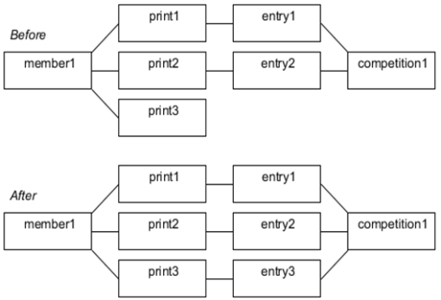
Figure 2 Before and after object diagrams
The enterPrint operation is needed to fulfil the postcondition of the use case add entry which is shown below. ClubAdministrator is the role of someone using the system being designed.
Identifier and name | UC5 add entry
Initiator | ClubAdministrator
Goal | To enter a print for a competition.
Precondition | TODO
Postcondition | The print will have been entered for the competition.

- Write down, in English, the missing precondition for the use case above.
(2 marks)
- Write a specification for the corresponding operation addEntry in the class Club.
(6 marks)
- Draw a sequence diagram for the collaboration necessary to fulfil the postcondition of the operation addEntry in the class Club. Use the objects shown in Figure 2 and assume Print, Entry and Competition have the operations shown in Figure 3.
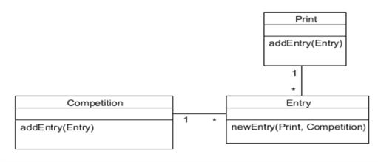
Figure 3 Operations in Print, Entry and Competition
(5 marks)
- Subsection 3.2 of Unit 7 discusses three strategies for implementing use cases. Explain which of the three strategies is being employed here to implement addEntry.
(2 marks)

Question 4 (20 marks)
This question is based on Units 6 and 7.
The Java code below shows a method run(int number) in a class ReservationCanceller and a fragment from the code of a user interface that invokes the method run(int number) on an object of class ReservationCanceller.
// ReservationCanceller class
public class ReservationCanceller {
Hotel hotel;

public ReservationCanceller (Hotel hotel) {
this.hotel = hotel;
}
public void run (int number) {
Reservation res =
hotel.getReservation(number); //1
Room room = res.getAllocatedRoom(); //2
room.removeRes(res);

hotel.removeRes(res);
}
}

// UI code fragment
ReservationCanceller rc =
new ReservationCanceller(hotel);
rc.run(num); //3

  - Draw a communication diagram for the interaction initiated by the method invocation at line //3. Note that at this point the ReservationCanceller object has already been created. Your diagram should include a user interface object that sends the message corresponding to line //3.
(10 marks)
  - State whether or not lines //1, //2 and //3 of the code above are consistent with the Law of Demeter, justifying your answer in each case.
(6 marks)
- Sequence diagrams and communication diagrams are both interaction diagrams and are used for similar purposes. Briefly outline the advantages and disadvantages of each.
(4 marks)

Question 5 (30 marks)
This question is based on Units 6, 7 and 8.
- The Notlaw Car Club (NCC) studied in TMA 01 maintains a fleet of cars for its members to use.
If a car is available, a member may book it. They then collect the reserved car from the location where it is parked and drive it for as long as they require. When they are finished they return the car to the same location.
If the member notes a fault while driving the car they report it and NCC sends the car for repair. The car is not available again for bookings until the repair is complete.
In addition, cars are cleaned regularly. If, when a car is returned, its mileage since it was last cleaned exceeds 1000 miles it is sent for cleaning and does not become available again until the cleaning is complete.
Otherwise when the car is returned it becomes available at once.
Draw a statechart diagram to represent the states of a car in the NCC fleet and the transitions between them. Assume that initially a car is available. You will find it useful to have studied Subsection 5.1 of Unit 7.
(6 marks)
- Classify each of events below as one of the types shown in Table 2 of Unit 7, explaining your reasoning in each case.
  - An electric kettle switches itself off when the water boils.
  - A programme sends a message to a server and waits for a response.
  - An egg timer runs out after three minutes.
  - A user clicks a button to send an email.
(6 marks)
  - The files stored on a hard disc are usually organised into folders. Does a folder act as a namespace? Explain your answer.
(2 marks)
  - Section 6 of Unit 7 explains that a UML package can be used to group any model element we wish, for example use cases can be organised into packages. Suggest two reasons why developers might want to group use cases into packages.
(4 marks)
  - Can packages interact with one another? Explain your answer briefly.
(2 marks)
  - Suppose you require a laundry service to wash and press clothing for you.
Your requirements are that you will pay no more than £0.75 per pound weight of laundry, you are willing to take the clothes to the laundry if necessary, and you want a two-day turnaround.
Say which of the following services A-D shown in Table 2 (below) will meet your requirements and which will not, justifying your answer in terms of both pre- and postconditions in each case.
(6 marks)
  - In your own words describe the difference between defensive programming and Design by Contract. Is it possible for the two approaches to be combined? Your answer should not exceed 100 words.
(4 marks)

Table 2 Laundry services
Service | Laundry price (per pound weight) | Arrangements | Turnaround time
A | £1.00 | Laundry will not collect | Two days
B | £0.65 | Laundry will collect clothes from customer’s home | Three days
C | £0.75 | Laundry will collect clothes from customer’s home | One day
D | £1.00 | Laundry will not collect | Three days

