SECONDARY 3 EXPRESS
END-OF-YEAR EXAMINATION 2026

ADDITIONAL MATHEMATICS
4049
Paper 1 2 hours

CANDIDATE NAME: ______________________________________________

CLASS: 3 ________________ INDEX NUMBER: ____________

READ THESE INSTRUCTIONS FIRST
Write your full name, class and index number in the spaces above.
Write in dark blue or black pen in the space provided for each question.
You may use an HB pencil for any diagrams or graphs.
Do not use staples, paper clips, highlighters, glue or correction fluid.

Answer all the questions.
Give non-exact numerical answers correct to 3 significant figures, or 1 decimal place in the case of angles in degrees, unless a different level of accuracy is specified in the question.
The use of an approved scientific calculator is expected, where appropriate.
You are reminded of the need for clear presentation in your answers.
The number of marks is given in brackets [ ] at the end of each question or part question.
The total number of marks for this paper is 80.

For Examiner's Use
Q1 | 4 |  | Q7 | 7
Q2 | 6 |  | Q8 | 12
Q3 | 7 |  | Q9 | 6
Q4 | 8 |  | Q10 | 6
Q5 | 7 |  | Q11 | 10
Q6 | 7 |  | Total | 80
 |  |  | Total | 80

This document consists of 16 printed pages including the cover page.

Mathematical Formulae

1. ALGEBRA

Quadratic Equation
For the equation $ax^{2} + bx + c = 0$,
$x = \frac{-b ± \sqrt{b^{2} - 4ac}}{2a}$

Binomial Expansion
$(a + b)^{n} = a^{n} + \left({n \atop 1}\right)a^{n-1}b + \left({n \atop 2}\right)a^{n-2}b^{2} + … + \left({n \atop r}\right)a^{n-r}b^{r} + … + b^{n}$
where n is a positive integer and
$\left({n \atop r}\right) = \frac{n!}{r!(n - r)!} = \frac{n(n-1)…(n-r+1)}{r!}$

2. TRIGONOMETRY

Identities
${\text{sin}}^{2} A + {\text{cos}}^{2} A = 1$
${\text{sec}}^{2} A = 1 + {\text{tan}}^{2} A$
${\text{cosec}}^{2} A = 1 + {\text{cot}}^{2} A$
$\text{sin}(A ± B) = \text{sin} A\text{cos} B ± \text{cos} A\text{sin} B$
$\text{cos}(A ± B) = \text{cos} A\text{cos} B ∓ \text{sin} A\text{sin} B$
$\text{tan}(A ± B) = \frac{\text{tan} A ± \text{tan} B}{1 ∓ \text{tan} A\text{tan} B}$
$\text{sin} 2A = 2\text{sin} A\text{cos} A$
$\text{cos} 2A = {\text{cos}}^{2} A - {\text{sin}}^{2} A = 2{\text{cos}}^{2} A - 1 = 1 - 2{\text{sin}}^{2} A$
$\text{tan} 2A = \frac{2\text{tan} A}{1 - {\text{tan}}^{2} A}$

Formulae for ΔABC
$\frac{a}{\text{sin} A} = \frac{b}{\text{sin} B} = \frac{c}{\text{sin} C}$
$a^{2} = b^{2} + c^{2} - 2bc\text{cos} A$
$Δ = \frac{1}{2}ab\text{sin} C$

Answer all the questions.

1 Find the range of values of $k$ for which the curve $y = x^{2} + (k-2)x + 4$ lies entirely above the line $y = 2x - k$. [4]

2
(a) Express $\frac{5 - 2\sqrt{3}}{2\sqrt{3} - 3}$ in the form $a + b\sqrt{3}$, where $a$ and $b$ are rational numbers. [3]

(b) Solve the equation $\sqrt{3x + 7} - \sqrt{x + 1} = 2$. [3]

3 It is given that $f(x) = 2x^{3} + ax^{2} + bx - 6$, where $a$ and $b$ are constants. $(x - 2)$ is a factor of $f(x)$, and $f(x)$ leaves a remainder of $-12$ when divided by $(x + 1)$.

(a) Find the value of $a$ and of $b$. [4]

(b) Solve the equation $f(x) = 0$, explaining why it has only one real root. [3]

4
(i) Explain why $\frac{2x^{4} + 2x^{3} + 6x^{2} + 4x + 4}{x^{2}(x^{2} + 4)}$ cannot be expressed in the form [2]
$\frac{A}{x} + \frac{B}{x^{2}} + \frac{Cx + D}{x^{2} + 4} \text{, where }A, B, C\text{ and }D\text{ are constants.}$

(ii) Express $\frac{2x^{4} + 2x^{3} + 6x^{2} + 4x + 4}{x^{2}(x^{2} + 4)}$ in partial fractions. [6]

5
(a) Solve the equation $3^{ 2x+1} - 10(3^{ x}) + 3 = 0$. [3]

(b) Solve the simultaneous equations [4]
${\text{log}}_{2} x + {\text{log}}_{2} y = 5, {\text{log}}_{4} x - {\text{log}}_{4} y = \frac{1}{2}$

6 The mass, $M$ grams, of a culture of bacteria after $t$ hours is modelled by $M = M_{0} e^{ kt}$, where $M_{0}$ and $k$ are constants. The mass is $8$ g when $t = 1$ and $27$ g when $t = 4$.

(a) Show that $k = \text{ln}\frac{3}{2}$ and find the exact value of $M_{0}$. [4]

(b) Find the least number of complete hours after which the mass first exceeds $200$ g. [3]

7
(a) In the expansion of $(1 + 2x)^{n}$, the coefficient of $x^{2}$ is $96$ more than the coefficient of $x$. Find the value of $n$. [3]

(b) Using this value of $n$, find the coefficient of $x^{5}$ in the expansion of $(2 - x)(1 + 2x)^{n}$. [4]

8 The points $A(-1, 2)$ and $B(5, 4)$ lie on a circle $C_{1}$, and $AB$ is a diameter of $C_{1}$.

(a) Find the equation of $C_{1}$. [3]

(b) The tangent to $C_{1}$ at $A$ meets the $y$-axis at $P$. Find the coordinates of $P$. [3]

(c) Show that $P$ lies outside $C_{1}$, and find the exact length of the tangent from $P$ to $C_{1}$. [3]

(d) Find the area of triangle $PAB$. [3]

9 Two variables $x$ and $y$ are related by the equation $y = \frac{x}{ax + b}$, where $a$ and $b$ are constants. The table below shows corresponding values of $x$ and $y$.

x | 1 | 2 | 4 | 5 | 10
y | 0.200 | 0.286 | 0.364 | 0.385 | 0.435

(a) Explain how a straight line graph may be drawn to represent this equation, and draw it for the given data on the grid below. [3]



(b) Use your graph to estimate the value of $a$ and of $b$. [3]

10 Given that $A$ is obtuse and $\text{cos} A = -p$, where $0 < p < 1$, express each of the following in terms of $p$.

(i) $\text{sin} A$ [2]

(ii) $\text{tan}(180^{°} - A)$ [2]

(iii) $\text{cosec}(90^{°} + A)$ [2]

11 The function $f$ is defined by $f(x) = a - b\text{cos}\frac{x}{2}$ for $0 ≤ x ≤ 4π$, where $a$ and $b$ are positive constants. The maximum value of $f$ is $7$ and the minimum value of $f$ is $-1$.

(a) Find the value of $a$ and of $b$. [3]

(b) State the period of $f$ and sketch the graph of $y = f(x)$ for $0 ≤ x ≤ 4π$ on the axes below. [3]

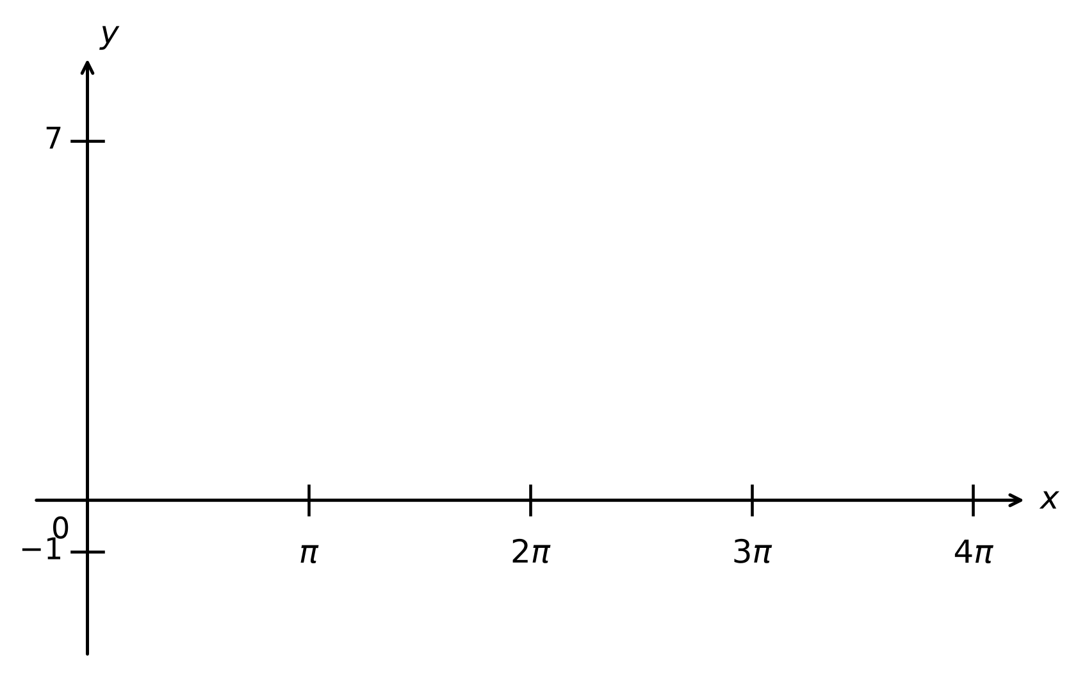

(c) Find the values of $x$, in terms of $π$, for which $f(x) = 5$. [4]

----- End of Paper -----

