SECONDARY 3 EXPRESS
END-OF-YEAR EXAMINATION

ADDITIONAL MATHEMATICS
4049
Paper 1 2 hours 15 minutes

CANDIDATE NAME: ______________________________________________

CLASS: 3 ________________ INDEX NUMBER: ____________

READ THESE INSTRUCTIONS FIRST
Write your full name, class and index number in the spaces above.
Write in dark blue or black pen in the space provided for each question.
You may use a HB pencil for any diagrams or graphs.
Do not use staples, paper clips, highlighters, glue or correction fluid.

Answer all the questions.
The number of marks is given in brackets [ ] at the end of each question or part question.
If working is needed for any question, it must be shown in the space below the question.
Omission of essential working will result in loss of marks.
The total of the marks for this paper is 90.

The use of an approved scientific calculator is expected, where appropriate.
If the degree of accuracy is not specified in the question and if the answer is not exact, give the answer to three significant figures. Give answers in degrees to one decimal place.
For π, use either your calculator value or 3.142.

For Examiner's Use
Q1 | 3 |  | Q8 | 7
Q2 | 4 |  | Q9 | 7
Q3 | 4 |  | Q10 | 7
Q4 | 4 |  | Q11 | 8
Q5 | 4 |  | Q12 | 10
Q6 | 5 |  | Q13 | 10
Q7 | 5 |  | Q14 | 12
 |  |  | Total | 90

This document consists of 18 printed pages including the cover page.

Mathematical Formulae

1. ALGEBRA

Quadratic Equation
For the equation ax² + bx + c = 0,
x = [ −b ± √(b² − 4ac) ] / 2a

Binomial Expansion
(a + b)ⁿ = aⁿ + C(n,1)aⁿ⁻¹b + C(n,2)aⁿ⁻²b² + … + C(n,r)aⁿ⁻ʳbʳ + … + bⁿ
where n is a positive integer and C(n,r) = n! / [ r!(n − r)! ] = n(n−1)…(n−r+1) / r!

2. TRIGONOMETRY

Identities
sin²A + cos²A = 1
sec²A = 1 + tan²A
cosec²A = 1 + cot²A
sin(A ± B) = sin A cos B ± cos A sin B
cos(A ± B) = cos A cos B ∓ sin A sin B
tan(A ± B) = (tan A ± tan B) / (1 ∓ tan A tan B)
sin 2A = 2 sin A cos A
cos 2A = cos²A − sin²A = 2cos²A − 1 = 1 − 2sin²A
tan 2A = 2 tan A / (1 − tan²A)

Formulae for ΔABC
a / sin A = b / sin B = c / sin C
a² = b² + c² − 2bc cos A
Δ = ½ ab sin C

Answer all the questions.

1 The triangle DEF has an area of ¼(7√3 + 9) cm². The length of DE is (√3 + 2) cm and angle EDF is 60°. Find, without using a calculator, the length of DF, in cm, in the form (a + b√3) where a and b are integers. [3]

2 Do not use a calculator in this question.
(a) Simplify 7 / (3 − √2), giving your answer in the form a + b√2, where a and b are integers. [2]

(b) Given that (2 + √3)x = 5 + 4√3, find the value of x in the form a + b√3, where a and b are integers. [2]

3 It is given that sin A = − 1/√5 and tan B = 3/4, where A and B are in the same quadrant. Find the value of p if cos(A − B) = p√5. [4]

4
(i) Express y = −2x² − 12x + 5 in the form y = −a(x + b)² + c, where a, b and c are constants. [2]

(ii) Hence find the range of values of the constant k for which the equation −2x² − 12x + 5 = k does not have two distinct roots. [2]

5 The diagram below shows a plaque designed in the shape of an equilateral triangle sitting on top of a rectangle. The rectangle has height p m and width q m, and the equilateral triangle has side q m.

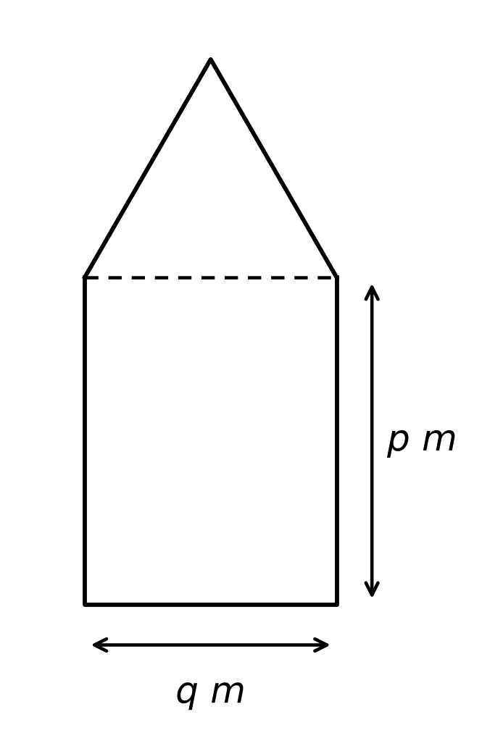

(i) Given that the perimeter of the plaque is 10 m, express p in terms of q. [2]

(ii) Show that the area of the plaque, A m², is given by A = 5q − (3/2)q² + (√3/4)q². [2]

6 Show that the line y = x − 1 intersects the curve y = nx² + 3x − n at two distinct points for all real values of n. [5]

7 Solve the equation log₂(x − 2) + 2 log₄(x − 3) = ½ log₃ 9 . [5]

8 The coordinates of the points A, B and C are (2, 3), (−1, −1) and (3, 1) respectively.

(i) Show that AC is perpendicular to BC. [3]

(ii) Given that ABCD is a parallelogram, find the coordinates of the point D. [2]

(iii) Find the area of the parallelogram ABCD. [2]

9 The curve y = a cos 2x + b, where a > 0, has a maximum value of 4 and a minimum value of −10, for 0 ≤ x ≤ 2π.

(i) Find the value of a and of b. [3]

(ii) State the period and the amplitude of the curve y = a cos 2x + b. [2]

(iii) Sketch the curve of y = a cos 2x + b for 0 ≤ x ≤ 2π on the axes provided below. [2]

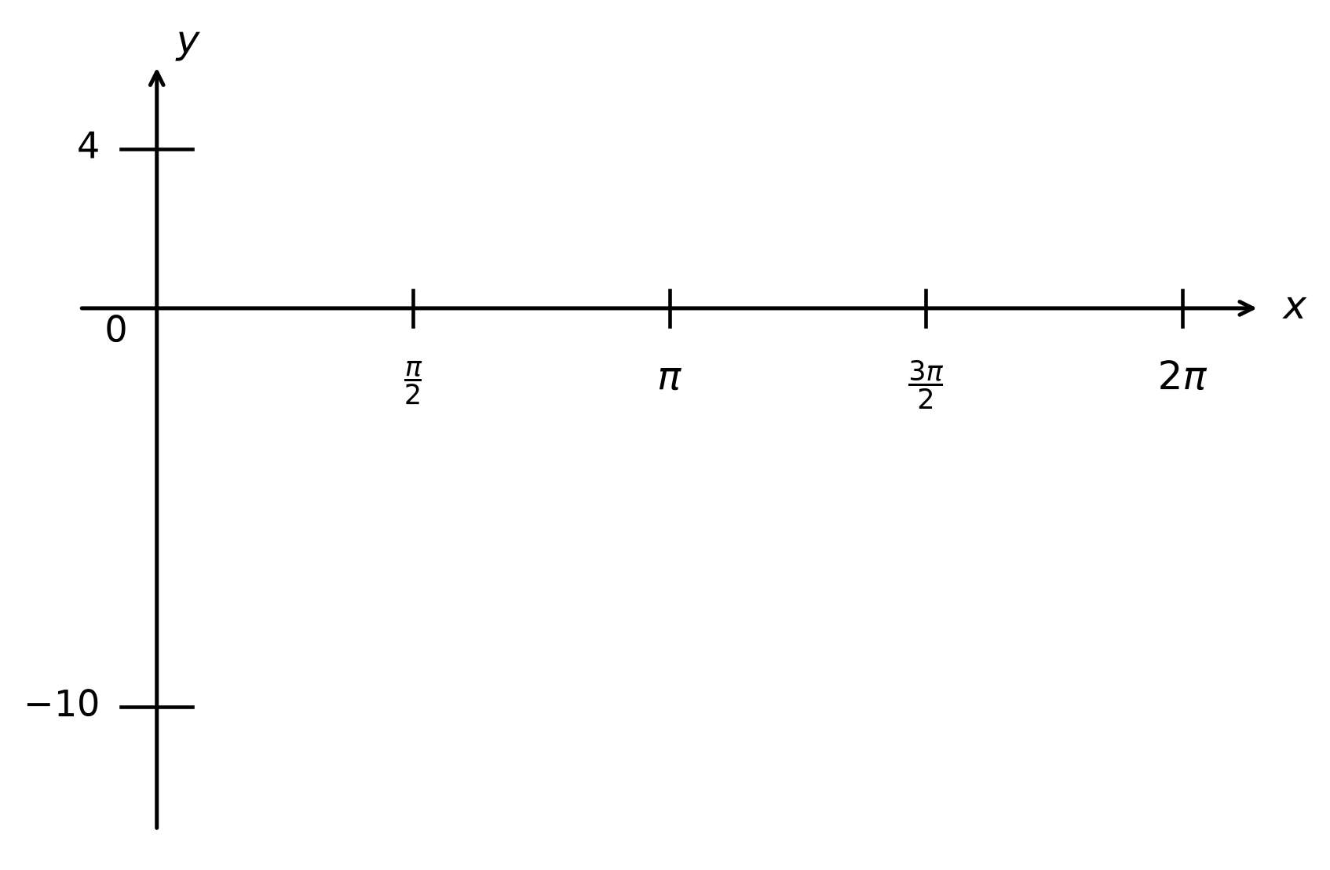

10 Mr Goh bought an antique vase at the beginning of 2015 as an investment. According to the seller, the vase's value, $P, increases over time, t years, after purchase. The value of the vase is given by P = 45 000eᵏᵗ, where k is a constant. An evaluation at the beginning of 2016 valued the vase at $50 000.

(a) Show that k = 0.10536, correct to 5 significant figures. [3]

(b) Assuming that the value of the vase continues to increase at the same rate, calculate the year in which Mr Goh's investment becomes tripled. [4]

11
(a) Find the term independent of x in the expansion of 3x³(2x − 1/(4x²))¹². [3]

(b) In the expansion of (2 + mx)¹⁵, where m is a constant, the ratio of the coefficient of x⁷ to the coefficient of x⁹ is 4/7. Find the possible values of m. [5]

12
(a) It is given that f(x) = x³ + x² + ax + 2b and g(x) = x³ − 4x² − ax − b, where a and b are constants.
(x + 3) is a factor of f(x).
g(x) leaves a remainder of 42 when divided by (x − 5).
Find the values of a and of b. [5]

(b) Solve the equation x³ − x² − 7x + 7 = 0, expressing the roots in an exact form. [5]

13 A marine monitoring buoy transmits data via Wi-Fi to a receiving station on shore. As the signal travels over the sea, it experiences a loss in strength. The signal loss, L (in dB), depends on the distance, d m, from the buoy and can be modelled by the formula L = Adᵏ, where A and k are constants.

The table below shows corresponding values of d and L.

d | 9 | 50 | 200 | 400 | 900
L | 8 | 15 | 25 | 32 | 43

(a) Explain how a straight line graph can be drawn to represent the formula, and draw it for the given data on the grid below. [4]



(b) Use your graph to estimate the value of A and of k. [4]

(c) Use your graph to estimate the distance from the buoy when the signal loss is 30 dB. Leave your answer to the nearest metre. [2]

14
(a) Prove the identity cos θ / (1 − sin θ) − (1 − sin θ) / cos θ = 2 tan θ . [5]

(b) Hence, solve the equation cos θ / (1 − sin θ) − (1 − sin θ) / cos θ = cot θ for 0 ≤ θ ≤ 2π. [4]

(c) Use the result in part (a) to find the set of values of the constant k for which there are no solutions to the equation cos θ / (1 − sin θ) − (1 − sin θ) / cos θ = k(1 + tan²θ). [3]

----- End of Paper -----

