Week 1 – Foundations & Planning
Will (Infra + Full-Stack)
● Provision GPU cloud environment (A100/H100) for model hosting.
● Set up backend project structure (FastAPI + API endpoints scaffold).
● Create React/Tailwind frontend skeleton (routing, base components).
● Implement basic document upload & parsing pipeline (no AI yet).

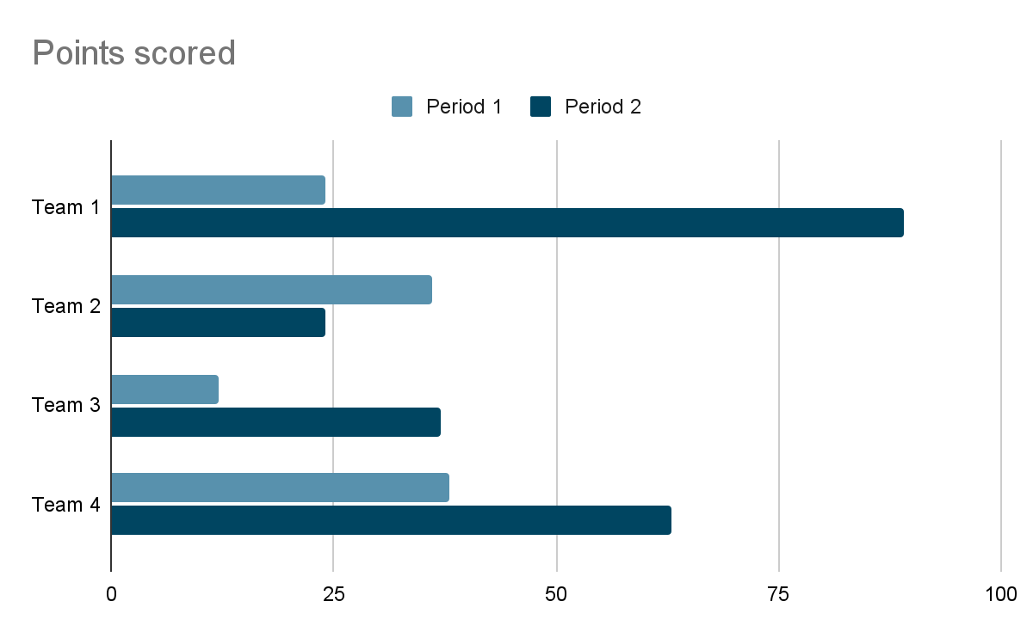

Javad
● Research dataset sources and define JSON slide schema.
● Draft data generation plan (GPT-4 + manual curation).
● Create small sample dataset for format validation.
Jenny
● Design wireframes for main flows (upload, outline, preview, export).
● Create branding kit (colors, typography, logo).

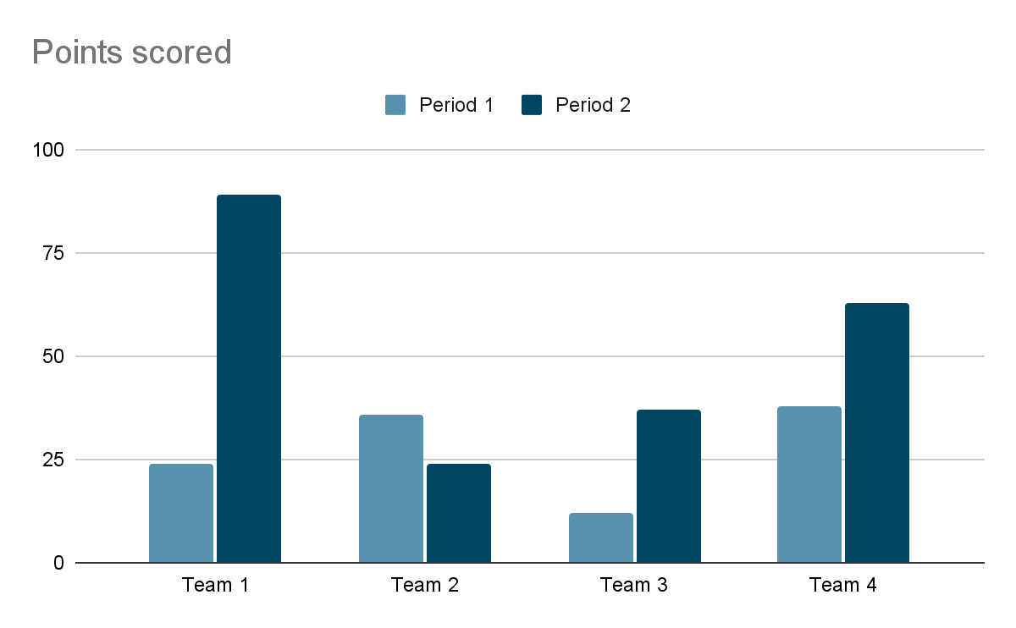

Week 2 – Data & Core Model
Will
● Integrate document→outline API endpoint (placeholder model).
● Implement frontend outline preview with editing UI.
● Set up image API integration for placeholder visuals.
Javad
● Generate bulk dataset (document→slide pairs).
● Clean & format dataset to match JSON schema.
● Start LoRA fine-tuning experiments on gpt-oss-20b.
Jenny
● Finalize 3–5 slide templates.
● Prepare icons, backgrounds, and sample theme assets.
Week 3 – Multi-Agent & Model Integration
Will
● Implement multi-agent orchestration (Outline → Content → Beautify → Visual).
● Deploy first fine-tuned model to cloud and integrate into backend API.
● Add PPTX/PDF export functionality in frontend.
Javad
● Evaluate fine-tuned model vs. base model (metrics: JSON validity, edit reduction).
● Iterate on fine-tuning with feedback from integration tests.
● Package model for production inference.
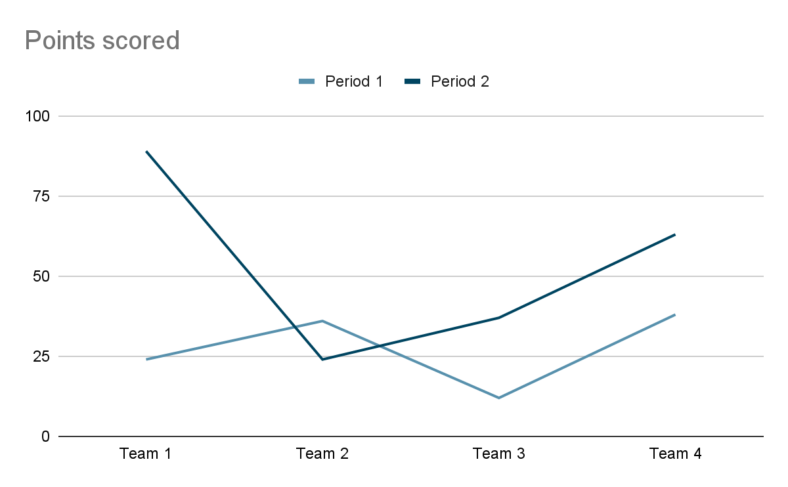
Jenny
● Deliver final UI assets and template mapping specs.
● Prepare animations and UI polish details.
Week 4 – Optimization & Demo Prep
Will
● Optimize backend for latency (batching, caching).
● Finalize frontend styles with UI/UX designer’s assets.
● Set up staging URL for judge testing.
● Record fallback demo flow in case of live issues.
Javad
● Finalize evaluation report with quantitative improvements over base model.
● Assist in creating demo scenarios that highlight model advantages.
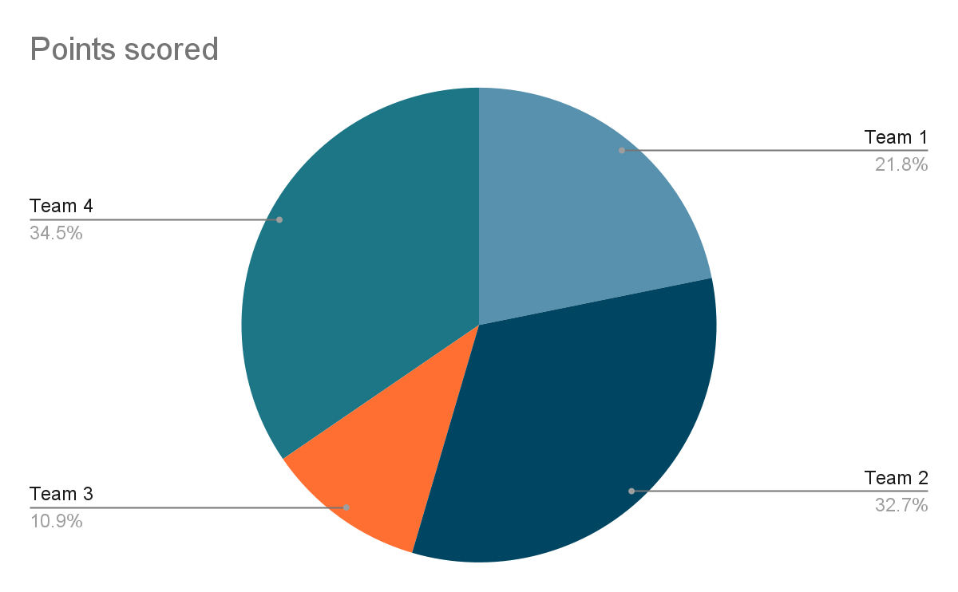
Jenny
● Review final build and adjust design details.
● Help prepare marketing visuals for hackathon submission page.
Integration Points
● End of Week 2: First frontend→backend pipeline working with placeholder outputs.
● Mid Week 3: Fine-tuned model plugged into pipeline.
● End of Week 3: Multi-agent + export fully functional.
● Week 4: Purely polish, optimize, and rehearse demo






