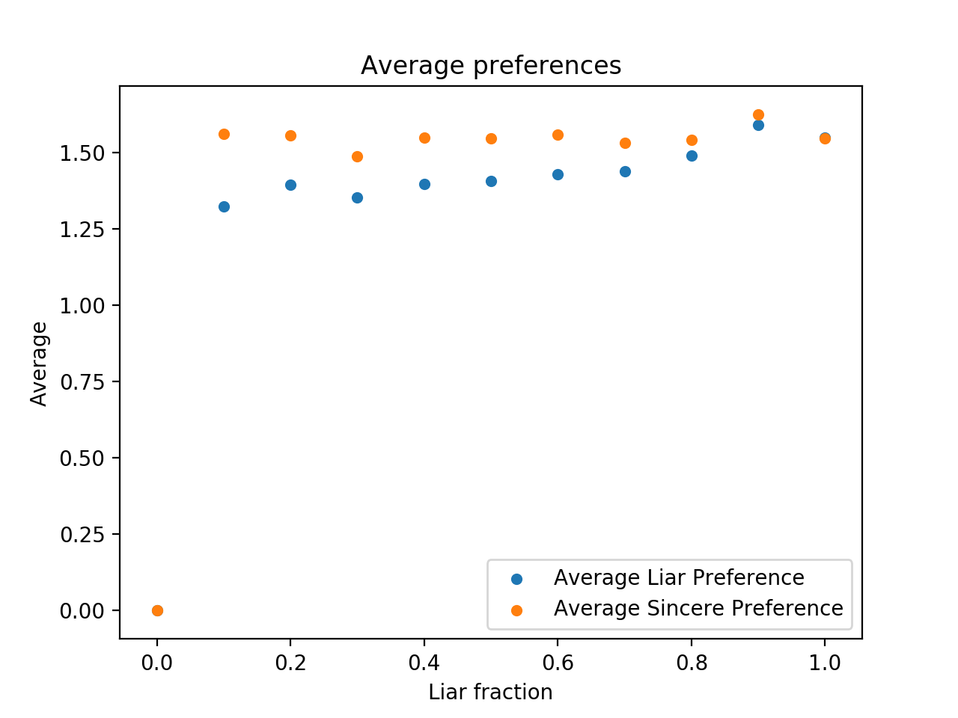

Boston Mechanism

Average true preference achieved by liars and sincere students. Sincere students do worse than students who lie

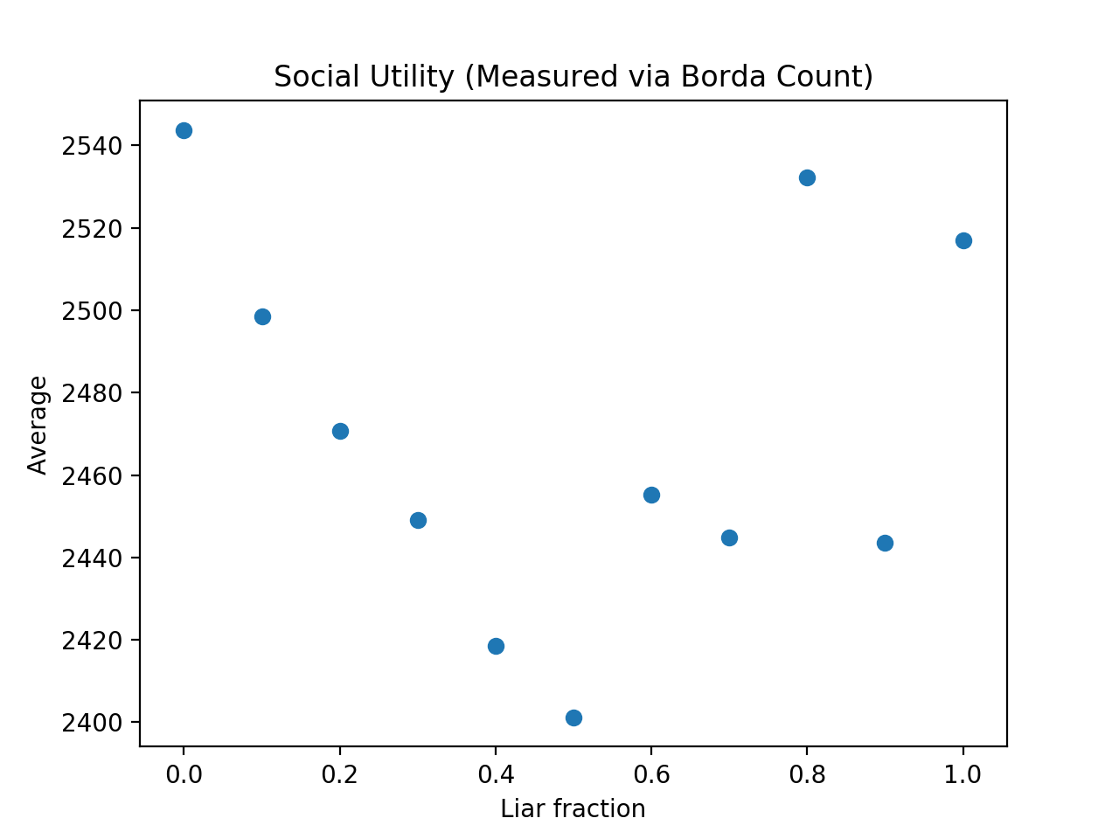

Boston Mechanism

Total Social Utility plotted vs the percentage of liars

Assumption was that we assumed everybody else was sincere. Once over half of students are sophisticated, this assumption fails and we see random results after. Compounding lies

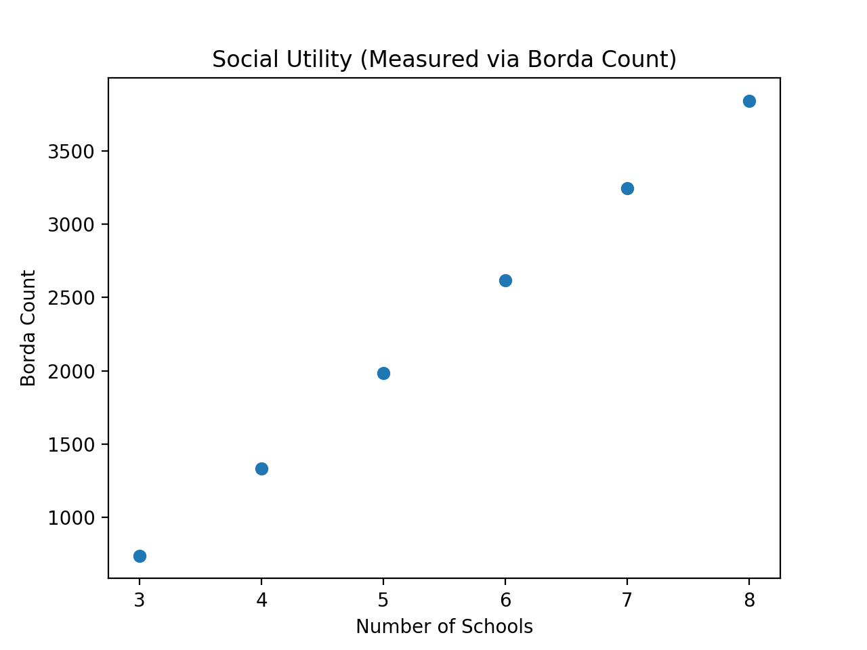

Boston Mechanism

Total Borda Count plotted vs number of schools

Students = 1000

Spots = 200 per school

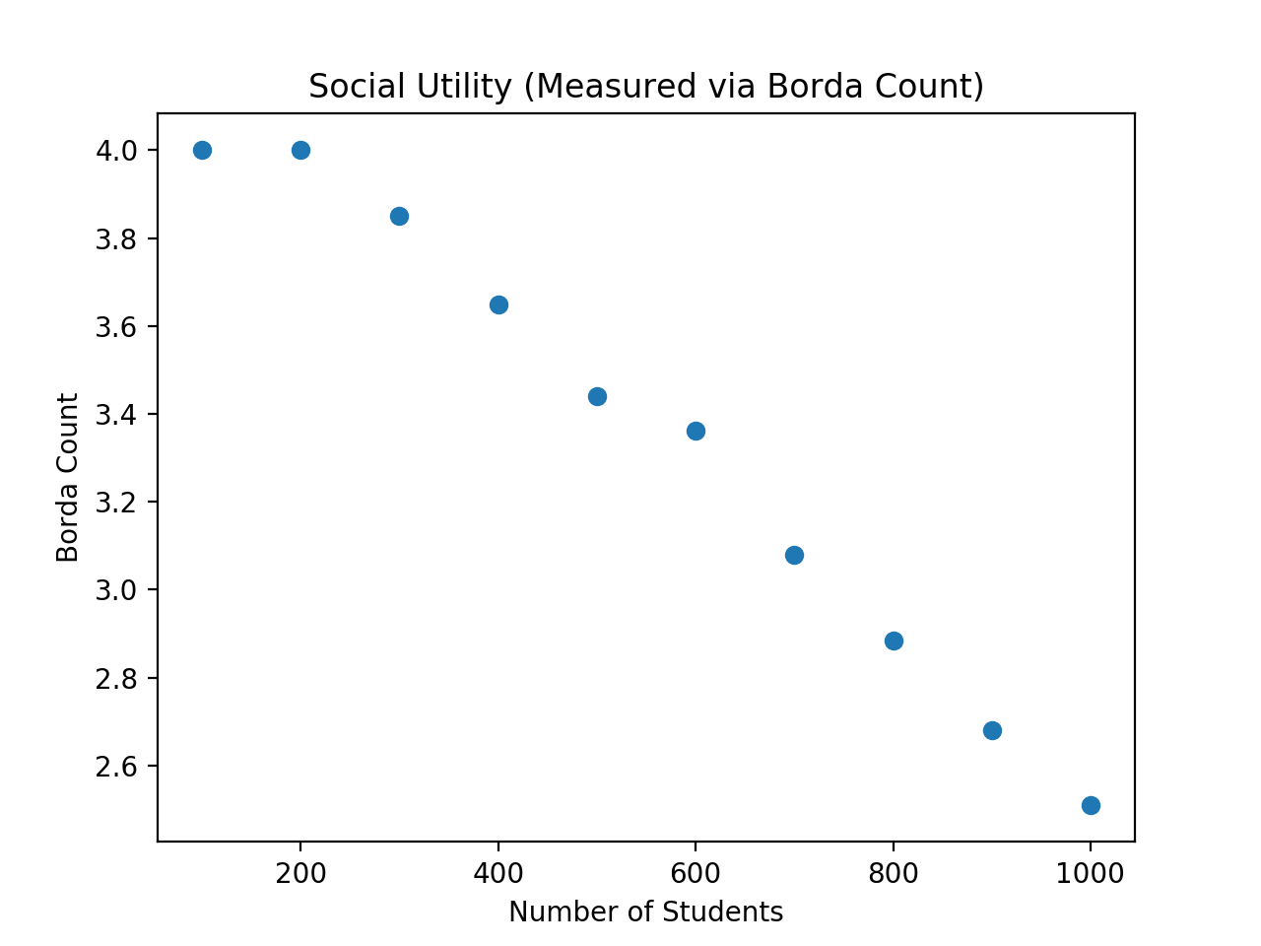

Average true Preference achieved by students

Schools = 5

Spots = 200