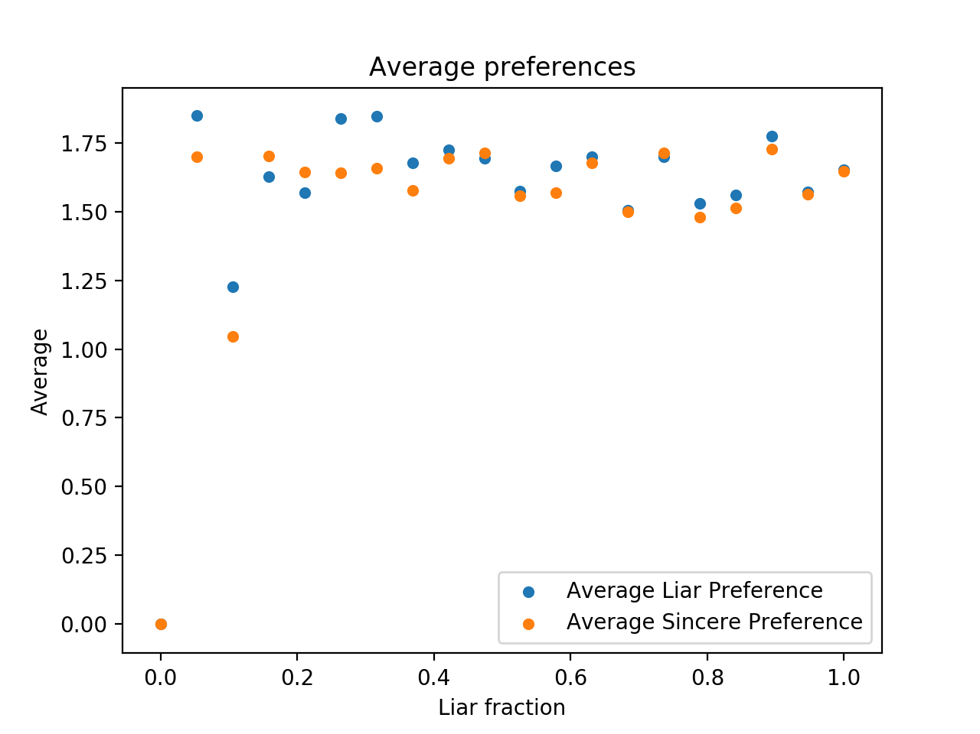

Gale Shapley

Average true preference achieved by liars and sincere students. Sincere students do worse than students who lie

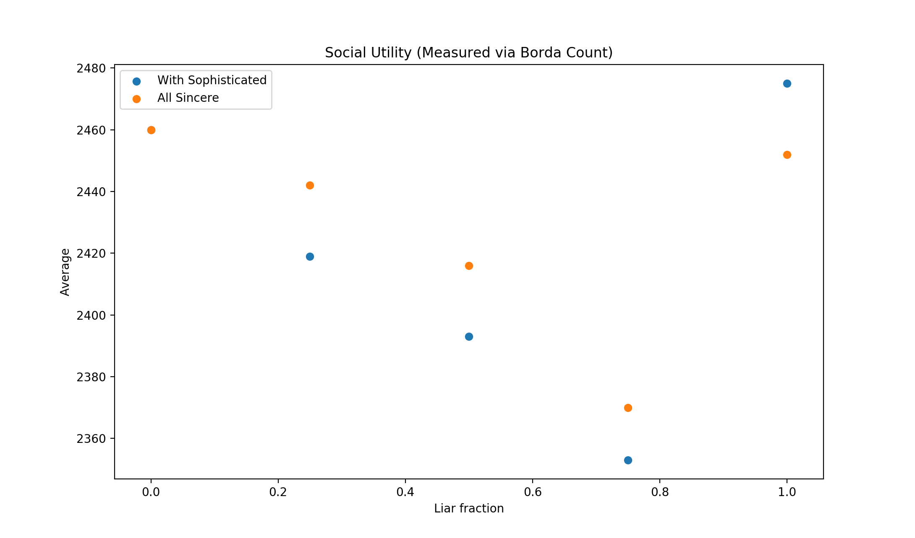

Gale Shapley

Total social utility as function of fraction of sophisticated students.

Social utility is worse in gale shapley if there are sophisticated students

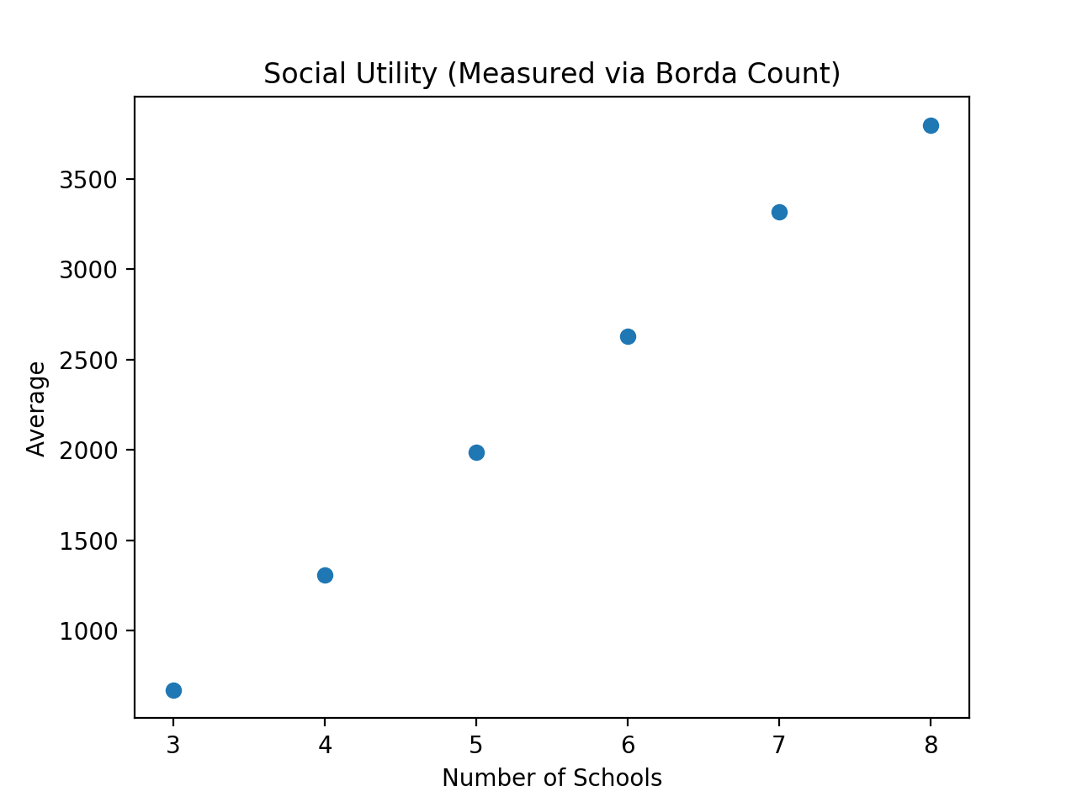

Gale Shapley

Total social utility as schools increases

Less competition, more likely to get a better option. Therefore higher borda

Students = 600

Spots = 200

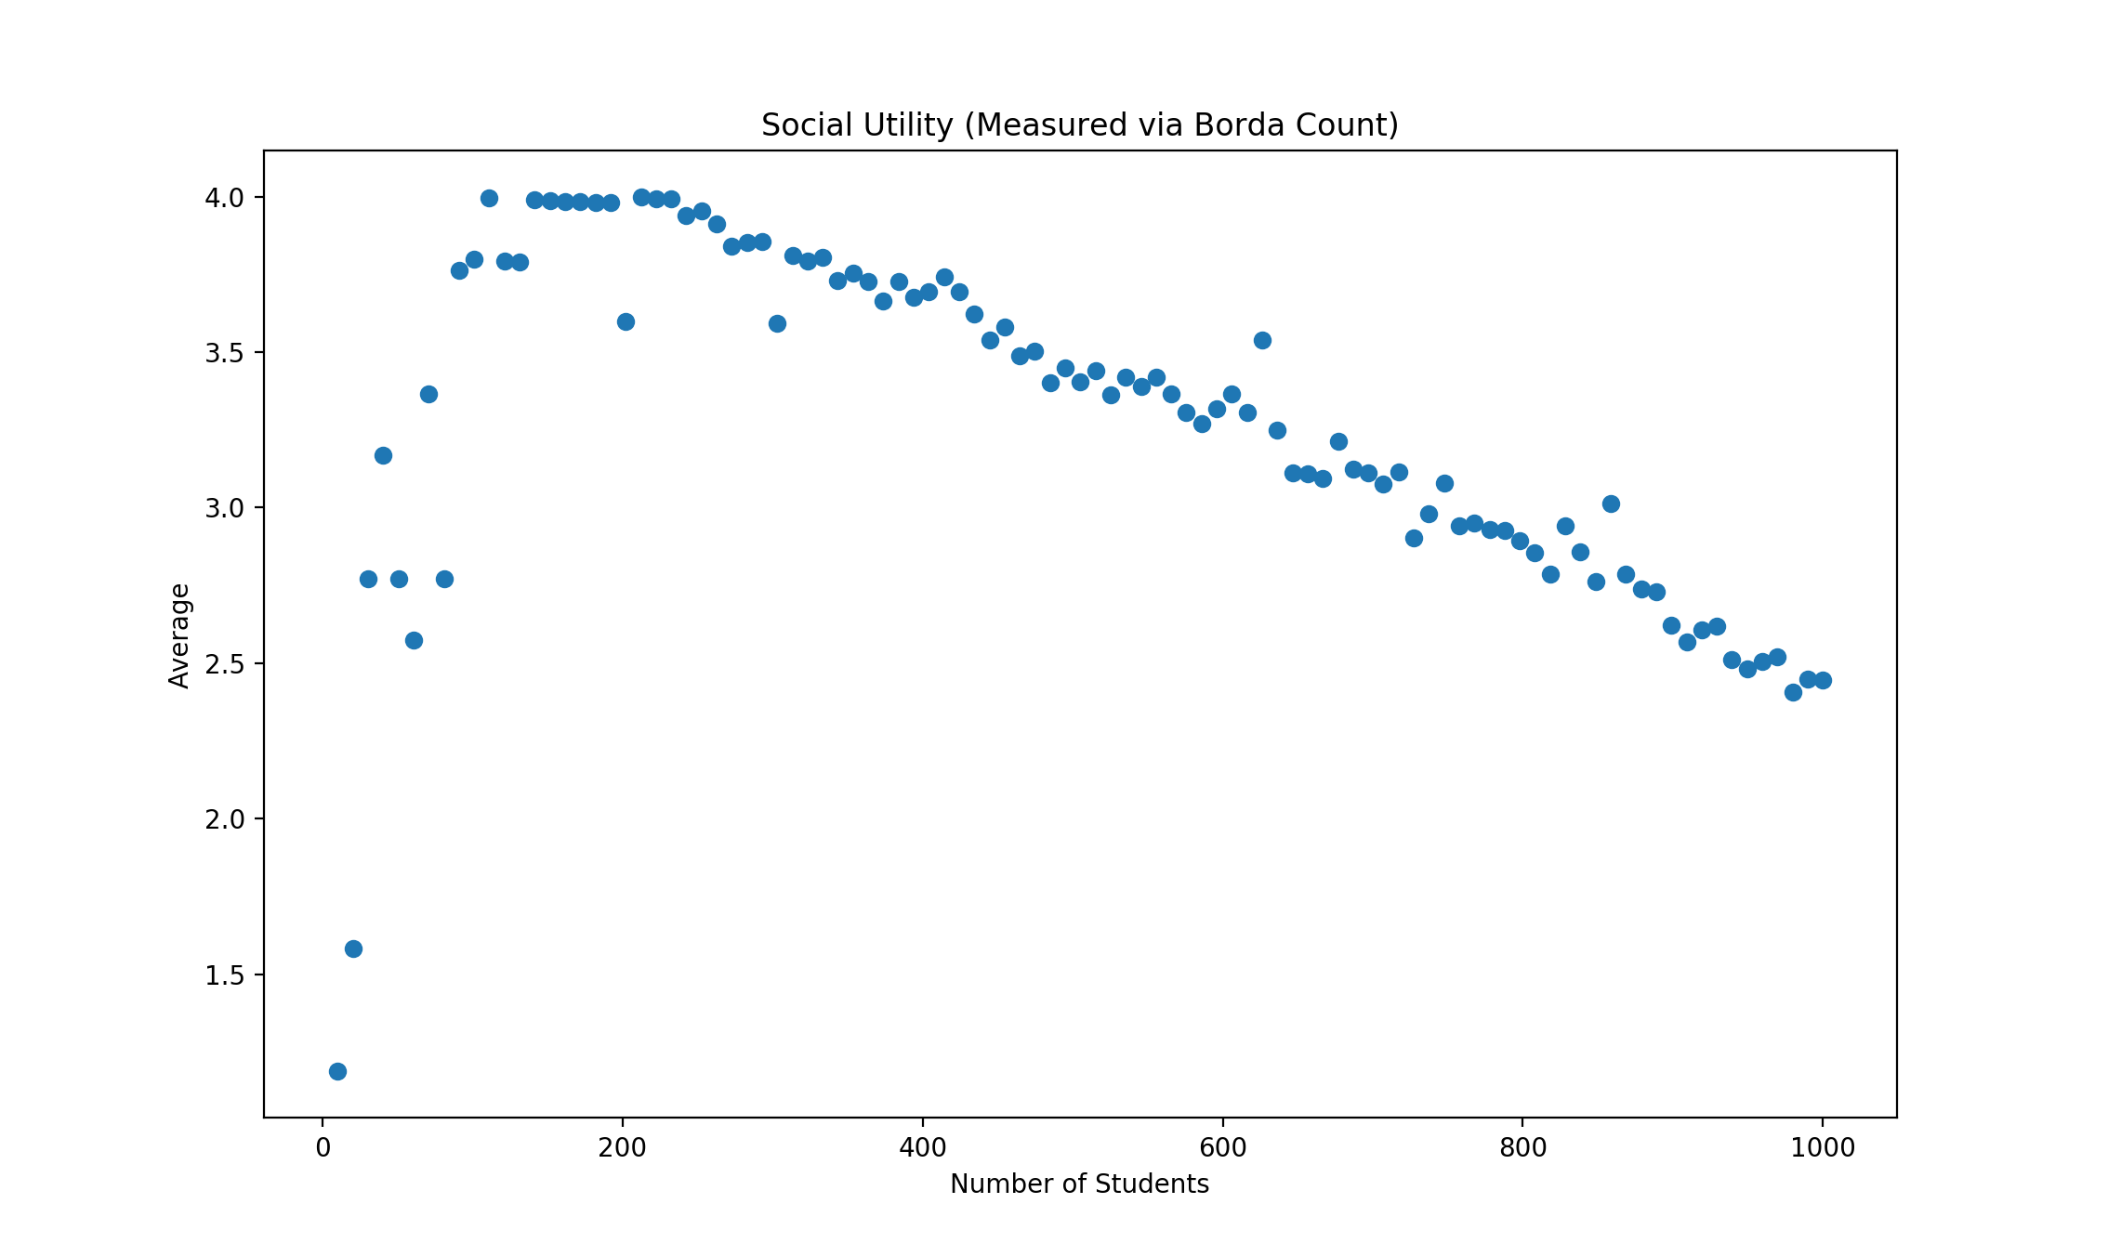

Gale Shapley

Schools = 5

Spots = 200