Project 1 Report

Introduction
The goal of this project is to provide and in depth analysis of air quality across Nebraska using AirPurple monitor data. The Client has requested four main tasks: (1) The top five locations in Nebraska with the highest pollutant levels, (2) an analysis on what caused the most sever pollutant days, (3) an analysis of humidity and temperature’s affects on air quality, and (4) find days posed health risks based off the AQI scale and find potential causes.

Methods
For the data analysis python was used with Jupyter Notebook. The pandas and matplotlib libraries were used to aid in the analysis. The raw data file was loaded into python and turned into a dataframe for easy manipulation.

For the first task the data was grouped by the sensor name and then aggregated to calculate the mean and median of the VOC, PM 2.5, and PM 10.0. These were then sorted into descending order and the top five values were kept.

For task two the data set was grouped by date, sensor name, and a pollutant. It was then aggregated to get the max value of the pollutant and put in descending order. The first value (date, name, and pollutant value) was kept. This was done for each pollutant type. The PurpleAir website was used to get the town where the sensor was located. Google Maps was used to look at the surrounding area. We searched for airports and other industrial buildings. Historic weather data and flight logs were also used to find potential causes.

In task three, two functions were made. One to assign temperature levels and another to assign humidity. These functions would take in a float argument and use if statements to assign its level as a string. These functions were then called to add the humidity and temperature levels to the data set. Next, humidity was plotted against VOC, PM 2.5, and PM 10.0 using matplotlib. Then the data was grouped by the assigned humidity level and the mean pollutant value was found for each category. This process was repeated with temperature and it’s assigned categories.

For the last task another function was created. This one was to assigned AQI values based of the EPA’s Air Quality Tables. It works similarly to the previous functions except it takes in two float arguments, PM 2.5 and PM 10.0. The function was used to assign AQI levels to each reading in the data set. Next the data was filtered to only include AQI levels of “Unhealthy for Sensitive Groups”. Similar research methods to task two were used for this task.

Results
High Pollutant Locations:
The following locations had the highest mean and median VOC levels:
Swnphd-ogallala,
FCHD-YPS,
Three Rivers Public Health Department,
ELVPHD Norfolk HD 4,
Swnphd-mccook.
The following locations had the highest mean and median PM 2.5 levels:
Broken Bow,
#16 - Richardson County Courthouse,
#18 - Southeast District Health Department- Tecumseh,
NCDHD O'Neill #11,
Swnphd-mccook,
ELVPHD Norfolk HD 4,
ELVPHD Wisner HD 5.
The following locations had the highest mean and median PM 10.0 levels:
Broken Bow,
#16 - Richardson County Courthouse,
#18 - Southeast District Health Department- Tecumseh,
NCDHD O'Neill #11,
Swnphd-mccook,
ELVPHD Norfolk HD 4,
ELVPHD Wisner HD 5.

Monitors such as Swnphd-mccook and ELVPHD Norfolk HD 4 showed up in every pollutant type. There were other monitors like Broken Bow that were consistently at the top of both PM values.

Pollutant Heavy Days:
The highest VOC reading happened on 6/24/24 at Swnphd-ogallala, the highest PM 2.5 reading happened on 2/18/25 at Richardson County Courthouse, and the highest PM 10.0 reading happened on 2/18/25 at Richardson County Courthouse.
Both of these sensor reside in rural towns, Ogallala and Falls City in Nebraska surrounded by farm lands. Both locations have regional airports near by. Ogallala has train tracks that run through the town and Falls City seems to have a small station(Google Maps). Both planes and diesel powered trains produced can produce considerable emissions which could spike the pollutant values. Ogallala had 6 flights on 6/24/24 however, there were days with even more flights that didn’t have the same pollutant levels(Flight Aware). Falls City had 0 flights on 2/18/25(Flight Aware). Looking at the weather on those dates nothing significant seems to have happened on those day except for some slight haze the day before in Ogallala(Weather Spark).

Humidity and Temperature on Air Quality:
Below are the graphs and tables comparing humidity and each pollutant.
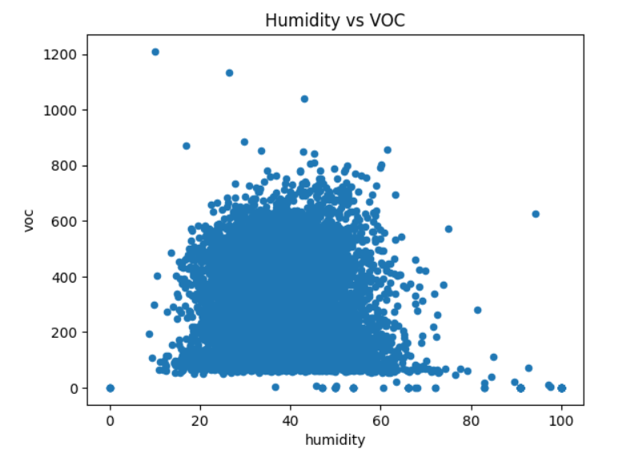
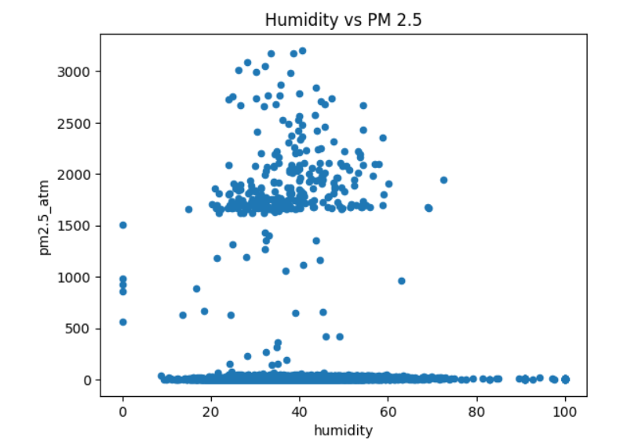
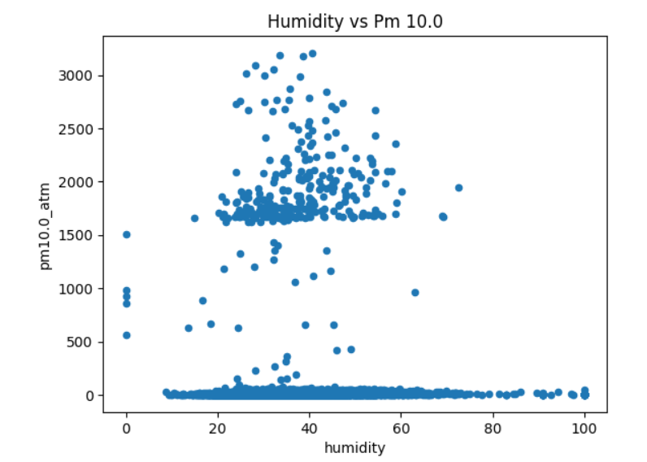

 | Mean VOC
humidity_level
Below Freezing | 266.977291
Cool | 285.182233
Hot | 48.469975
Warm | 257.049587

 | Mean PM 2.5
humidity_level
Below Freezing | 74.812324
Cool | 77.285427
Hot | 511.447530
Warm | 80.895660

 | Mean PM 10.0
humidity_level
Below Freezing | 76.109522
Cool | 78.685822
Hot | 514.102750
Warm | 82.600195

Based off of these figures there seems to be no correlation between the humidity level and the pollutant levels. Next is temperature and pollutant levels.

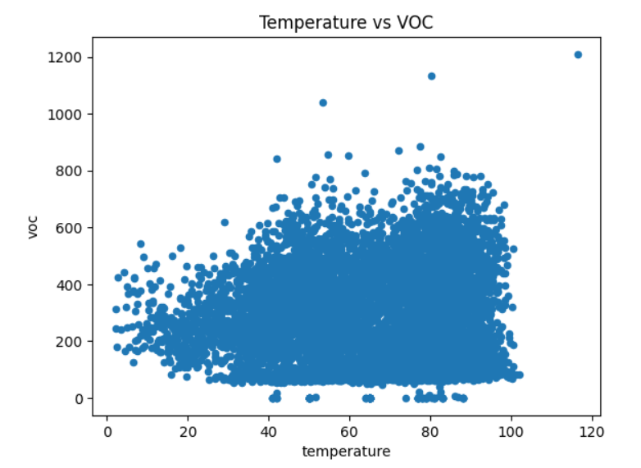
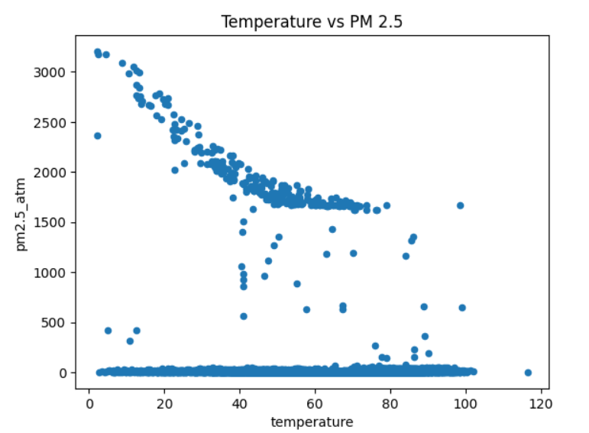
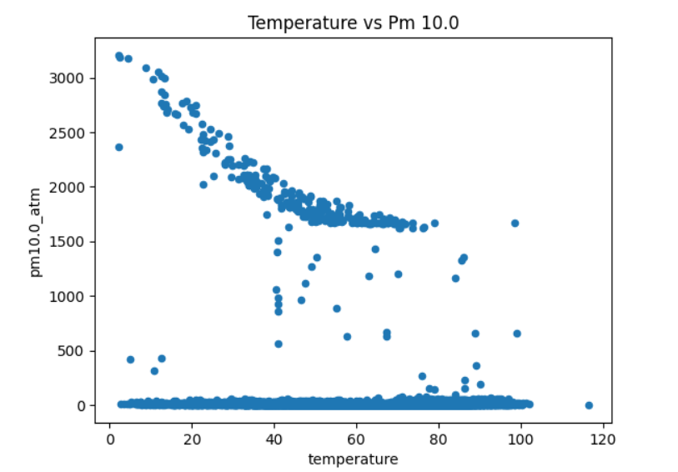

 | Mean VOC
temperature_level
Below Freezing | 257.628626
Cool | 285.435146
Hot | 282.145818
Warm | 257.015827

 | Mean PM 2.5
temperature_level
Below Freezing | 273.698560
Cool | 141.658843
Hot | 70.145543
Warm | 86.506629

 | Mean PM 10.0
temperature_level
Below Freezing | 276.080794
Cool | 143.074475
Hot | 71.821037
Warm | 87.428866

From these figures it can be said that temperature affects the pollutant level. For VOC there isn’t much of a relationship. With PM 2.5 and 10.0 there is a subtle decreasing curve as temperature increase. However, there are still low pollutant levels at all temperatures. So temperature can affect the levels of PM 2.5 and PM 10.0 but not always.

AQI Health Risks Across Nebraska:
Based of the AirPurple data set there were 118 entries where the air quality was at “Unhealthy for Sensitive Groups”. Most of these instances happened at ELVPHD Wisner HD 5 and Broken Bow, both with nine days on record. Broken Bow had the following dates:
05/14/24
07/23/24
07/24/24
07/25/24
07/26/24
08/20/24
08/21/24
09/05/24
09/30/24
ELVPHD Wisner HD 5 had the following dates:
03/29/24
05/14/24
05/15/24
07/09/24
07/10/24
08/20/24
12/24/24
12/25/24
02/15/25

A potential cause for Broken Bow’s multiple days of an unhealthy AQI rating is that it seems to be a cattle town. There are at least 100 pins next to a rail line right in the middle of town(Google Maps). Just west of the town are 10 extremely large pins that can hold 1000s of cattle. The beef industry is know to produced tons of emissions which could impact Broken Bow’s air quality. The spikes on the dates above could be from days when cattle are loaded on to trains for transportation. The town of Wisner is also a cattle town. There are several cattle farms with in just a couple miles of town(Google Maps).

References
map.purpleair.com
airnow.gov/aqi/
flightaware.com
weatherspark.com

