Introduction
Group 152-01
Project #2
The Nebraska Department of Transportation relies on standardized concrete mix design procedures to ensure consistent strength, durability, and performance across highway and structural applications. These procedures are formally defined in the NDOT Standard Specifications for Highway Construction [1] and are traditionally implemented through a structured Excel-based workflow. While spreadsheets are practical and widely used, they are susceptible to hidden formula dependencies, accidental cell modification, and version control inconsistencies. As outlined in the project Scope of Work [2], the objective of this project was to migrate the NDOT concrete mix design logic from Excel into a structured and modular Python system.
The purpose of this migration was not to alter the underlying engineering methodology, but to preserve it within a more transparent and stable computational framework. By translating spreadsheet formulas into clearly defined Python functions, the process becomes reproducible, easier to audit, and more suitable for future integration into digital engineering tools. This modernization aligns with broader NDOT efforts to improve workflow reliability and computational consistency [3].

Methods

The migration process began by mapping each Excel formula to its mathematical equivalent. The NDOT mix design procedure is based on the absolute volume method, in which the combined volume of cementitious materials, water, and aggregates must equal 27 cubic feet for one cubic yard of concrete [1]. Each component contributes volume according to its weight and specific gravity, and these relationships form the foundation of the calculation process.
In the original spreadsheet, calculations are distributed across multiple linked cells. In the Python implementation, each calculation was isolated into a dedicated function. This modular structure improved clarity and allowed each step to be independently reviewed and verified. Functions were developed to compute material volumes, determine the total cementitious contribution, calculate remaining aggregate volume, and distribute that volume among fine, coarse, and other aggregates based on specified proportions.
The Python model required user inputs consistent with the NDOT mix design worksheet, including material weights for cementitious components and water, specific gravities for each material, and aggregate distribution percentages. These inputs were collected sequentially to mirror the structure of the Excel workflow so that the transition would remain intuitive for future users.
From these inputs, the program calculated individual material volumes, total cementitious volume, available aggregate volume, and final aggregate weights for one cubic yard of concrete. This structure ensured that the absolute volume requirement of 27 cubic feet per cubic yard was satisfied in each scenario [1].
During validation testing, unusually large aggregate weight outputs were observed. Further review determined that the discrepancy did not originate from the NDOT formulas themselves, but from the interpretation of aggregate distribution inputs. Aggregate proportions had been entered as weight values rather than percentages, while the Python functions interpreted them as percent-based fractions. This resulted in inflated aggregate weights. Once identified, this issue reinforced the importance of strict unit consistency and input validation when translating spreadsheet-based engineering workflows into code. The engineering logic remained correct; the inconsistency was procedural rather than mathematical.

Results and Discussion

Four concrete mix designs were evaluated using the Python model: Class 47B, Class 47BR, Class 40, and Class D. These classifications correspond to different performance categories within NDOT construction standards [1]
.Class 47BR represents a bridge-related variation of the 47-series concrete. Bridge applications demand enhanced durability due to cyclic loading and exposure to deicing chemicals. Compared to 47B, the BR designation reflects adjustments in material proportions to improve resistance to these service conditions while maintaining required strength characteristics.
Class 47B is commonly used in structural applications requiring moderate to high strength and durability. This mix incorporates a relatively high cement content along with supplementary cementitious materials such as fly ash. The inclusion of fly ash enhances long-term durability and reduces permeability, contributing to improved performance under environmental exposure.
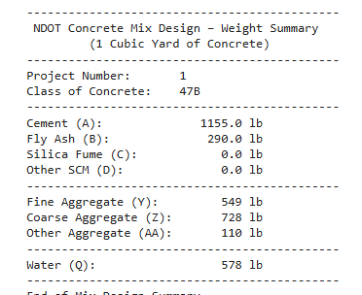
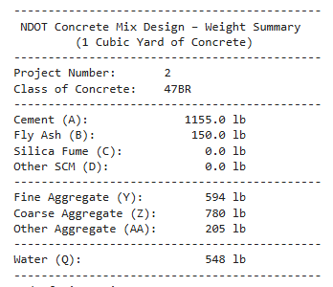
(Mix Results for 47BR and 47B)

Class 40 concrete is generally associated with pavement or general structural applications where slightly lower cement content is acceptable. This mix demonstrated a reduced binder quantity relative to the 47-series mixes and a greater reliance on aggregate volume. The design balances performance requirements with material efficiency.
Class D concrete is typically used for non-critical structural elements such as curb and gutter. Among the four mixes analyzed, this classification contained the lowest cement content and proportionally higher aggregate volume. This configuration reduces material cost while remaining appropriate for applications with lower structural demand.

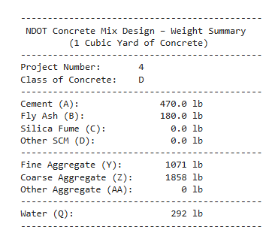
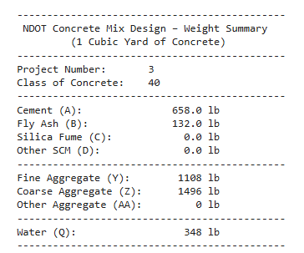
(Mix design D and 40)

When comparing the four designs, a clear pattern emerges. As the required strength and durability increase, the proportion of cementitious material rises and water content must be carefully controlled to maintain performance. Lower-strength mixes shift the volumetric balance toward aggregates, reducing binder content while still satisfying volumetric requirements. The presence and quantity of supplementary cementitious materials further influence long-term durability and workability characteristics across all classifications.
Despite the temporary scaling issue observed during early validation, the Python implementation successfully reproduced the volumetric relationships embedded in the original Excel worksheet. Once input interpretation was clarified, the computed results aligned with expected engineering behavior. The modular code structure improved transparency and reduced the risk of hidden computational errors, demonstrating the effectiveness of migrating the workflow into a structured programming environment.

Conclusion

The migration of NDOT concrete mix design logic from Excel to Python preserved the integrity of the absolute volume methodology while improving transparency and reliability. By converting spreadsheet formulas into modular functions, the new system reduces vulnerability to accidental formula modification and enhances reproducibility. Testing across four NDOT concrete classifications confirmed that the computational framework accurately reflects established specifications. With appropriate input validation controls in place, the Python model provides a stable foundation for future digital integration and workflow modernization within NDOT operations.

References

[1] Nebraska Department of Transportation. Standard Specifications for Highway Construction, 2017 Edition.
[2] Nebraska Department of Transportation. Project Scope of Work: Migration of NDOT Excel Logic to Python, 2026.
[3] Nebraska Department of Transportation. Final Report P336. https://dot.nebraska.gov/media/3isfdv45/final-report-p336.pdf

