The Chance that a Condorcet Winner exists in an Election and the Frequency that an Instant Runoff Election will elect the Condorcet Winner

William Meng

Harvey Mudd College

December 4, 2016

**Abstract**

The experiment aims to find how changing the number of candidates and changing the number of voters affected the chance that a Condorcet Winner would exist in an election and the chance the a Instant Runoff Method would elect the Condorcet Winner. It was found that the chance that a Condorcet Winner exists is inversely proportional to the amount of candidates and directly proportional to the number of voters. A Condorcet winner is also more likely to exist if there are an odd number of voters. The chance that an Instant Runoff Voting System would elect the Condorcet Winner is inversely proportional to the number of candidates and varies in relation to the number of voters.

**Introduction/Theory**

In voting theory, there are many different ways for holding elections and each different way of holding an election could generate different outcomes for the winner of the election. The Instant Runoff Voting System is one way of holding an election and is commonly considered as one of the fairest methods to run the election. In an Instant Runoff system, each voter submits his or her own preference table that ranks all of the candidates. To calculate the winner of the election, all the preference tables are then taken and the candidate with the least amount of first place vote is eliminated. The candidate is then taken off from every single preference table and this process is repeated until only one candidate is left.

On the other hand, the Condorcet Winner Criterion is one of the most basic criterions for holding what is considered a fair election. The Condorcet Winner is a candidate that will win against any other candidate in a head to head contest. However, the Condorcet Winner does not always exist and even when it does, it is not always elected by the Instant Runoff Voting System.

This paper aims to explore the frequency that the Condorcet Winner exists under the circumstance of different number of voters and candidates and find how frequently the Instant Runoff Voting System will elect the Condorcet Winner.

**Experiment**

The experiment was conducted using Java and the results were recorded and calculated using excel.

Three Java classes were made: Voter, Election, and Calculator. The Voter takes in the number of candidates and will return a random preference schedule generated in the form of an integer array.

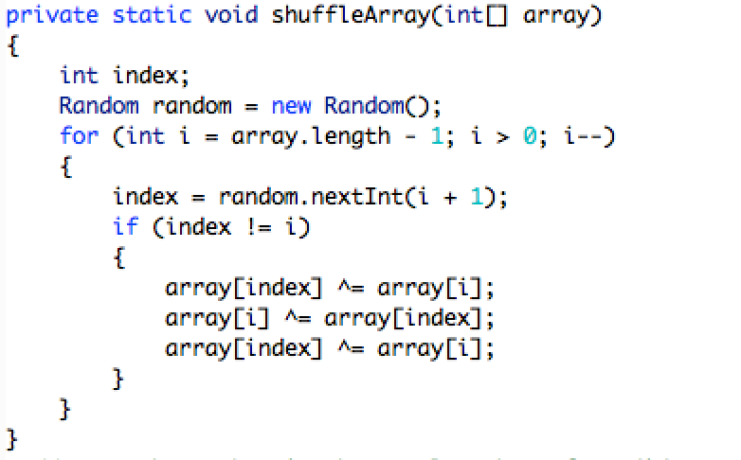

Figure 1: The algorithm used for creating the random preference schedule. It uses a random array shuffler found online at <http://stackoverflow.com/questions/1519736/random-shuffling-of-an-array>

The Election class takes in 2 numbers: number of candidates and number of Voters. It will then create a list of voters, each with a random preference schedule with the given number of candidates.

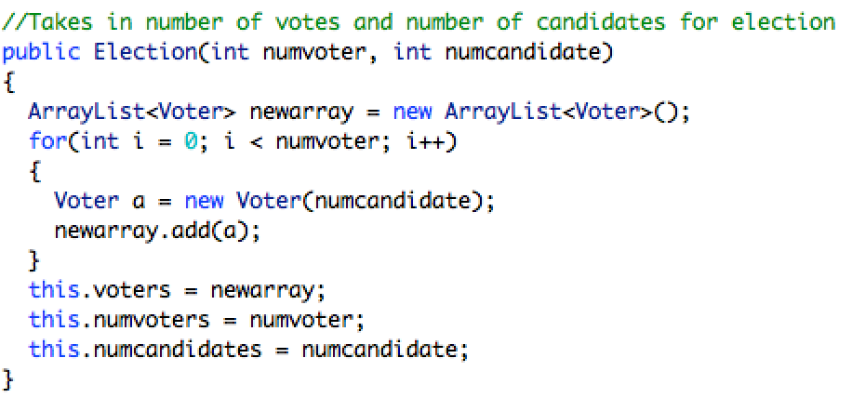

Figure 2: Constructor method for the Election Class. As seen, the number of voters, number of candidates are stored while the ArrayList stores all the voters, which will each generate a preference table.

Finally the Calculator class uses the Voter and Election classes to find the Condorcet Winner and the Winner of the Instant Runoff election. To find the Condorcet Winner, a helper method was used to find the winner between to candidates in an election with more than 2 candidates.

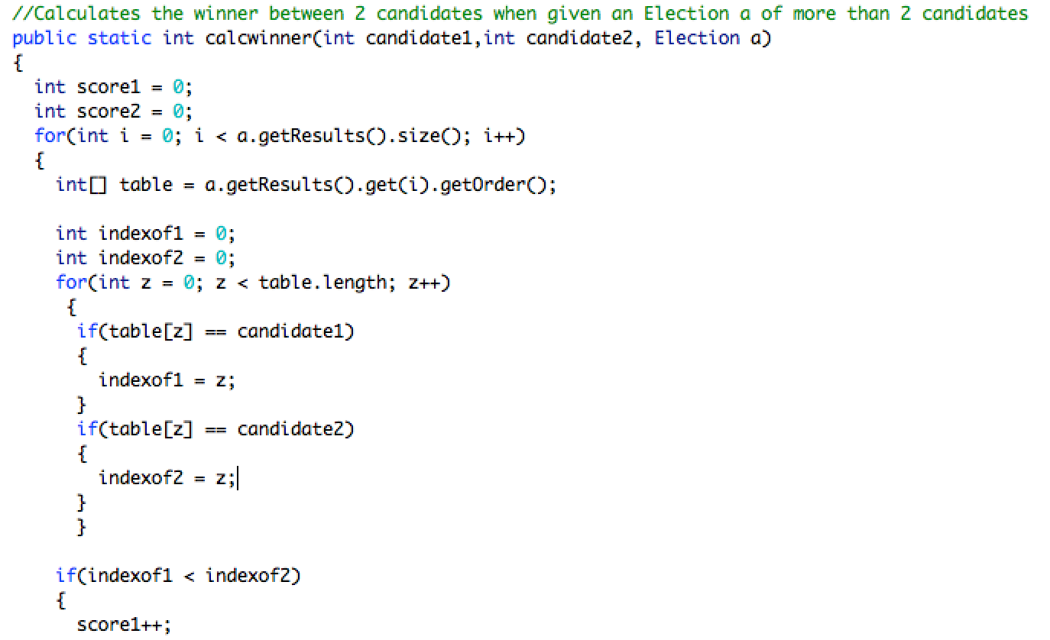

Figure 3: Part of the code of the helper method calcwinner() that calculates the winner between two candidates in a given election by comparing the position of the two candidates on every voter’s preference table. The method returns the candidate that wins between the two.

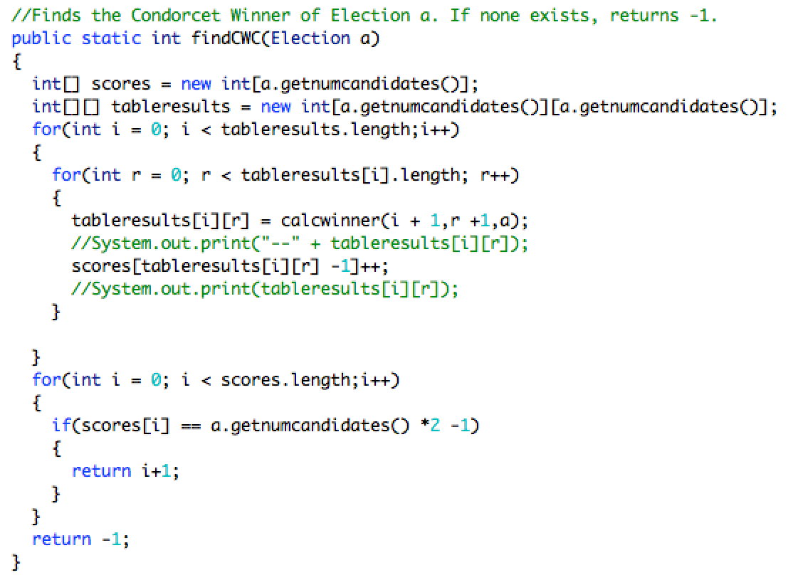

Figure 4: The Condorcet winner method that uses this helper method to find the overall Condorcet winner of the election. It will call the helper function for every single pair of candidates in the election to try to determine the Condorcet Winner. The method will return the Condorcet Winner and if the Condorcet Winner does not exist, the number -1 will be returned.

Next, in order to find the Instant Runoff winner of a given election, another helper method was also used to help remove the losing candidate from the voters’ preference tables.

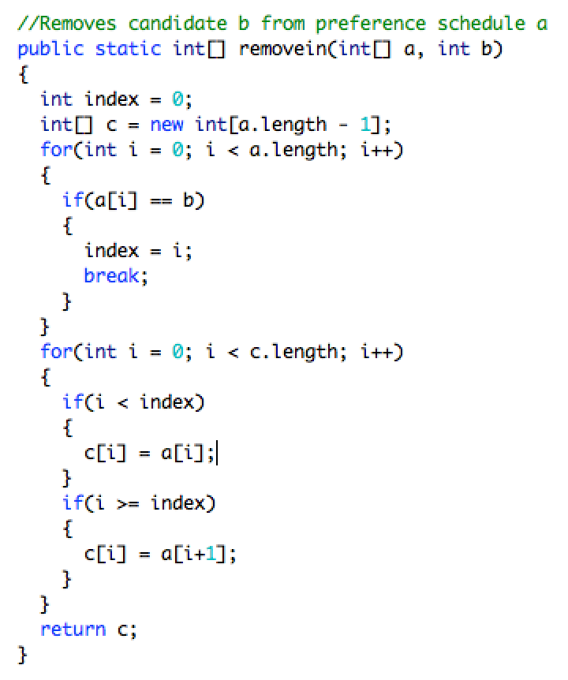

Figure 5: The helper method removein() used to later find the winner of the Instant Runoff Voting method. It removes a candidate from a preference list that is in the form of an integer array. It then returns an integer array that is 1 length shorter and does not include the candidate that was taken out.

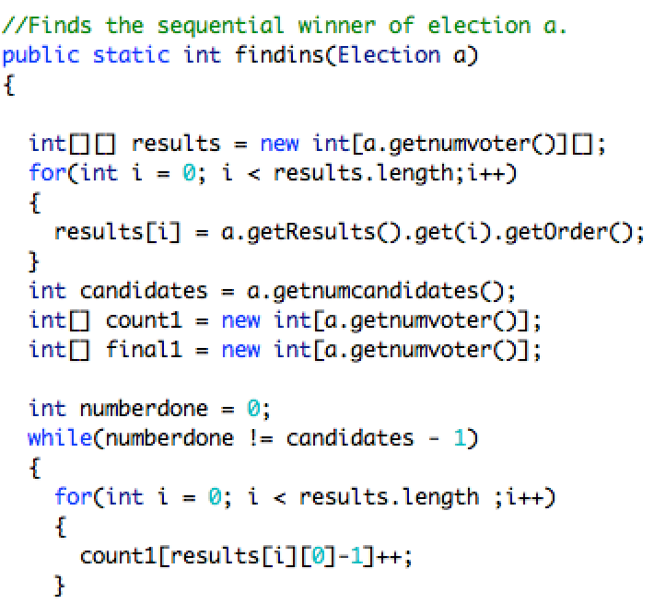

Figure 6: Part of the code used to find the instant runoff winner of the election. The method takes in the election and uses an array to keep track of the number of first place votes each candidate gets by looking at every preference table of the voters in the election. It will then remove, with the helper method, the eliminated candidate from all the preference tables and continue to recalculate until only one candidate is left.

To run both of the methods on numerous elections, a for loop was used and variables were used to keep track Condorcet Winner and Instant Runoff Winner.

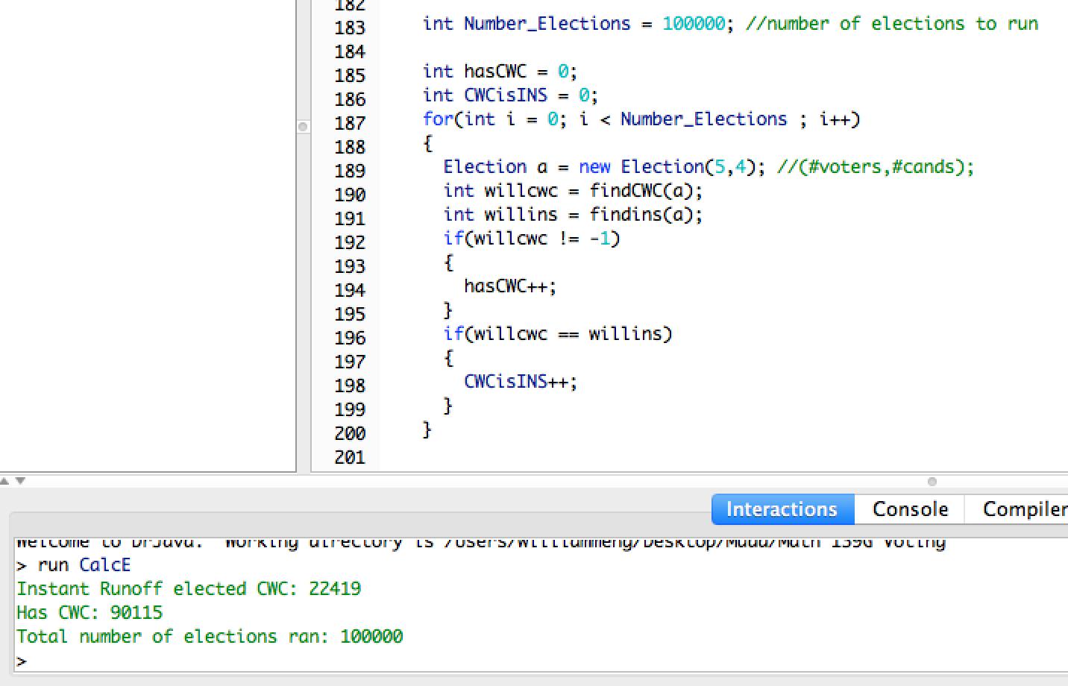

Figure 7: A sample run of the program. In this case, the 100,000 elections were run with 4 candidates and 5 voters in each election. If, in each election, the CWC exists, the variable hasCWC increments by 1 and if, in each election, the CWC winner is the same as the winner of the instant runoff outcome, the variable CWCisSEQ is incremented by 1. The results are then printed. In this case, 90115 of the elections produced a CWC and in 22419 of them, the CWC was the same as the winner of the Instant Runoff Election.

**Results/Analysis**

The program was ran for different amount of candidates and different amount of voters to determine if there is a relationship between these changing variables and the frequency of an existing CWC and if the CWC will also win in a Instant Runoff Election. This following table records the results of the trials:

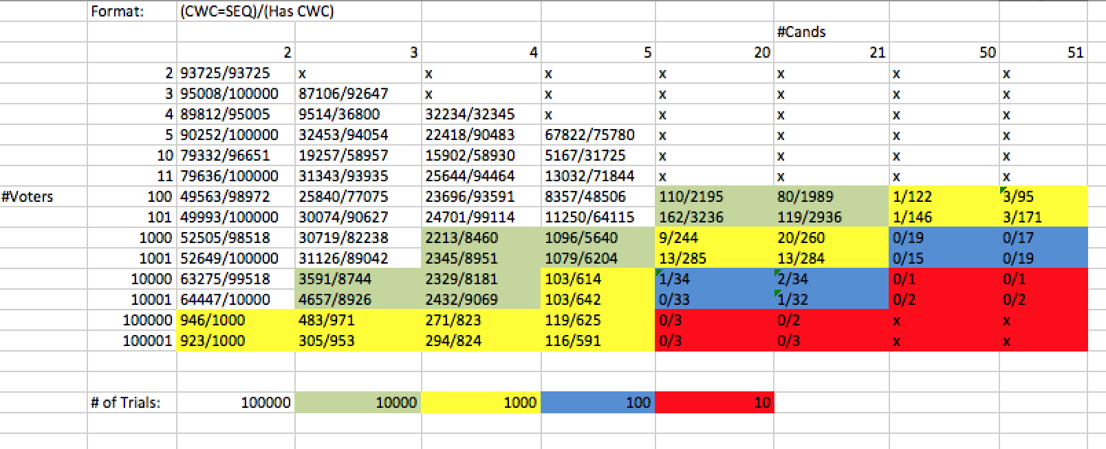

Figure 8: The result of the trials as produced in Microsoft Excel. Elections where the number of candidates was greater than the number of voters were ignored because many candidates would result with no first place votes and different ways of eliminating the candidate with zero first place votes could significantly change the overall results. On top of that, the likelihood in the real world where the candidates outnumber the voters is very unlikely. As the number of candidates and the number of voters increased, less trials were ran due to the lack of memory to handle the large amount of data.

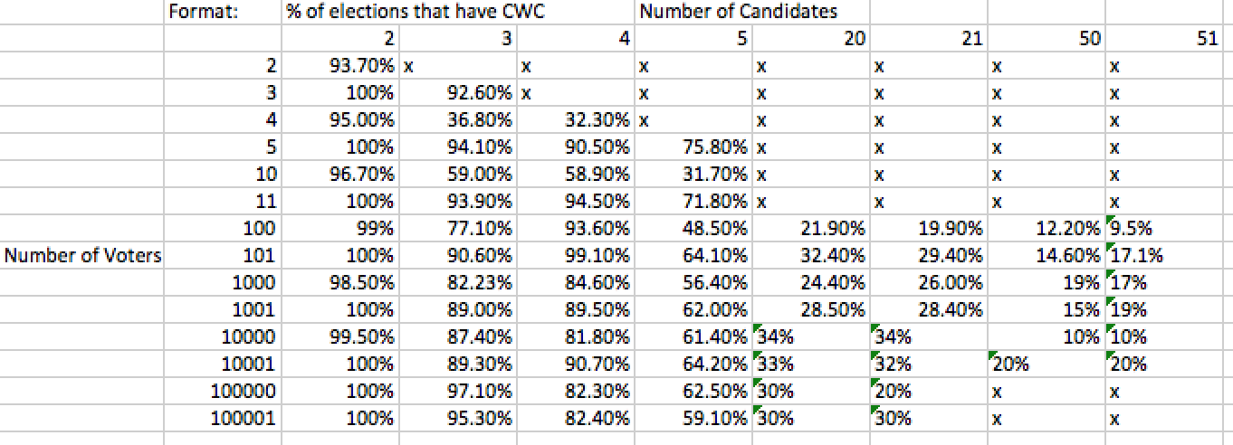

Figure 9: Results for the percent of elections where a Condorcet Winner exists. It is very clear from the table that as the amount of candidates increased, it is less likely that a Condorcet Winner exists. However, as the amount of voters increased, it is more likely that a Condorcet Winner exists. It is also evident that a Condorcet Winner is more likely to exist if there are an odd number of voters.

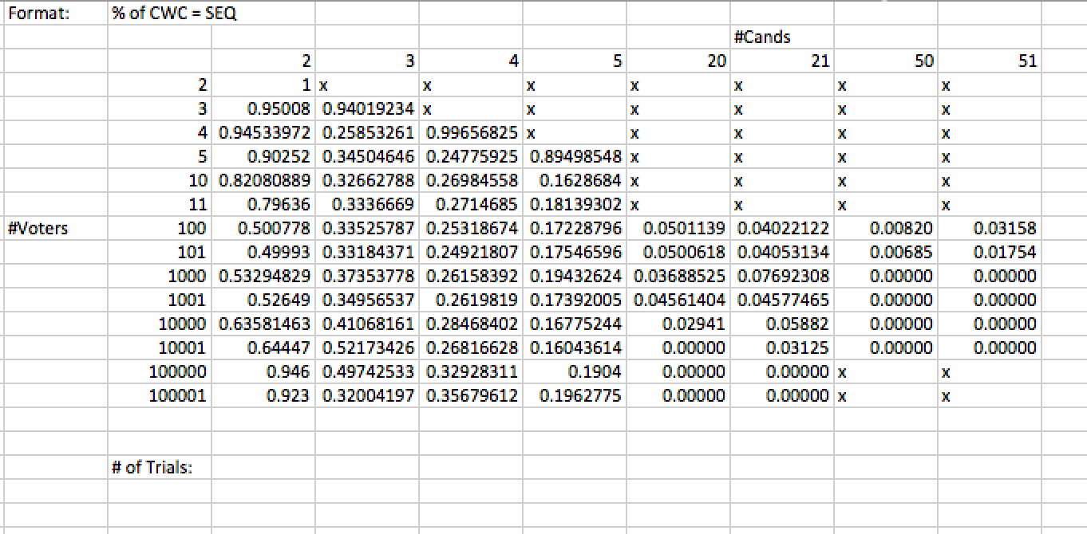

Figure 10: Results for the change that the Condorcet Winner elected would also be the winner from the Instant Runoff Voting Method. It is very evident that as the amount of candidates increased, the Condorcet Winner was less likely to be the winner from a Instant Runoff election. However, it is not very clear how increasing the number of voters related to the chance that the Condorcet Winner would be elected from the Instant Runoff Election. The probability seemed to drop to a minimum as the number of voters increased and then increase again.

**Conclusion**

The results are in line with the voting theory such that the Condorcet Winner did not always exist and that the Instant Runoff Voting Method did not always elect the Condorcet Winner.

The results showed that the chance that a Condorcet Winner exists is inversely proportional to the amount of candidates and directly proportional to the number of voters. This is because as the number of candidates was increased, it is less likely that a Condorcet Winner exists and as the amount of voters increased, it is more likely that a Condorcet Winner exists. Also, a Condorcet winner is more likely to exist if there are an odd number of voters. This makes sense because an odd number of voters will decrease the chance that the preference orders would create a cyclic result.

The results also showed that the chance that the Condorcet Winner will be elected by an Instant Runoff Voting method is inversely proportional to the number of candidates. However, it is unclear how the number of voters relate to the chance the Condorcet Winner would be elected. The probability usually dropped to a minimum as the number of voters increased and then began to increase again as the number of voters increased again.