Michael Lee

Alex Nguyen

CS 434: Assignment 4

1. Non-hierarchical clustering – K-means algorithm
   1. We implemented the K-means algorithm for k=2 as you can see from our code in part_2_1() in main.py. We can see from the below graph that we’ve plotted, that the algorithm indeed converges and it converges fairly quickly as it bottoms out at around 5-6 iterations.

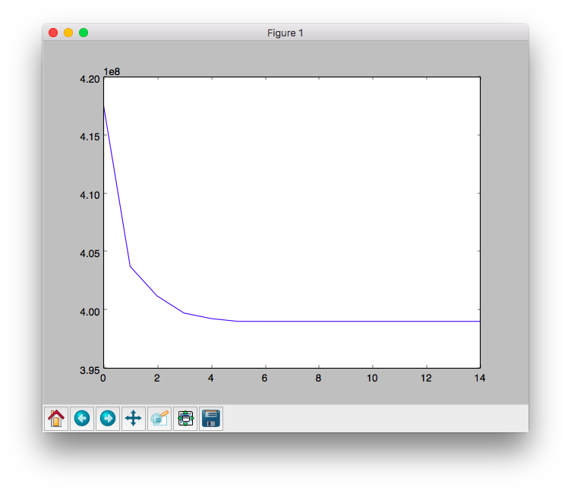

* 1. On the next page, you can see the results of multiple different K=n. To choose the best k=n we would want the k that converges the fastest which would be k = 6. This would mean that our data fits most neatly into our k distinct groups.

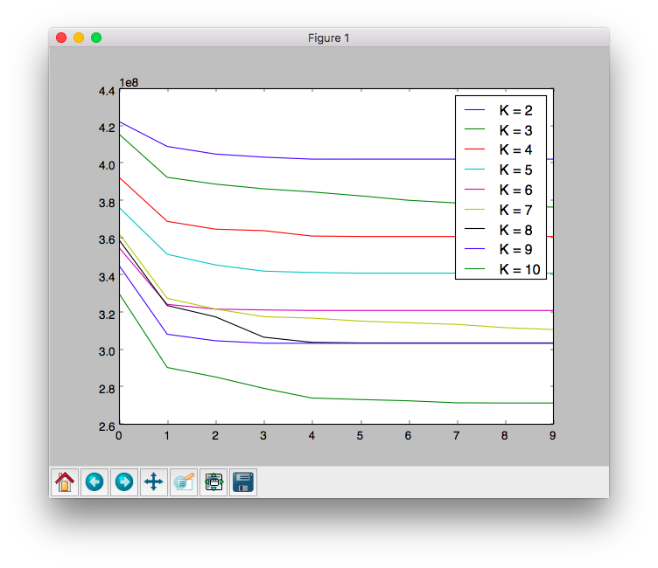

1. Hierarchical agglomerative clustering (HAC)

