William Morgan
002737412
- Setup Reasoning
FlutterFire configuration was the correct first step because every other part of the activity depended on it. Flutterfire configure created the google-services.json and firebase_options.dart allowing Firebase to initialize on my first run. Attempting to build the FCM service first would not allow for proper testing and debugging.
- Lifecycle Analysis
In the foreground, FirebaseMessaging.onMessage fires and the FCMService class passes the payload to setState(), updating _statusText and _BodyText on screen while flutter_local_notifications manually displays a system notification. In the background, FCM delivers the notification to the system automatically, and tapping it triggers onMessageOpenedApp, which routes the payload back into the UI. In the terminated state, getInitialMessage() catches the message that launched the app ensuring it is not lost when the app is closed.
- Debug Evidence
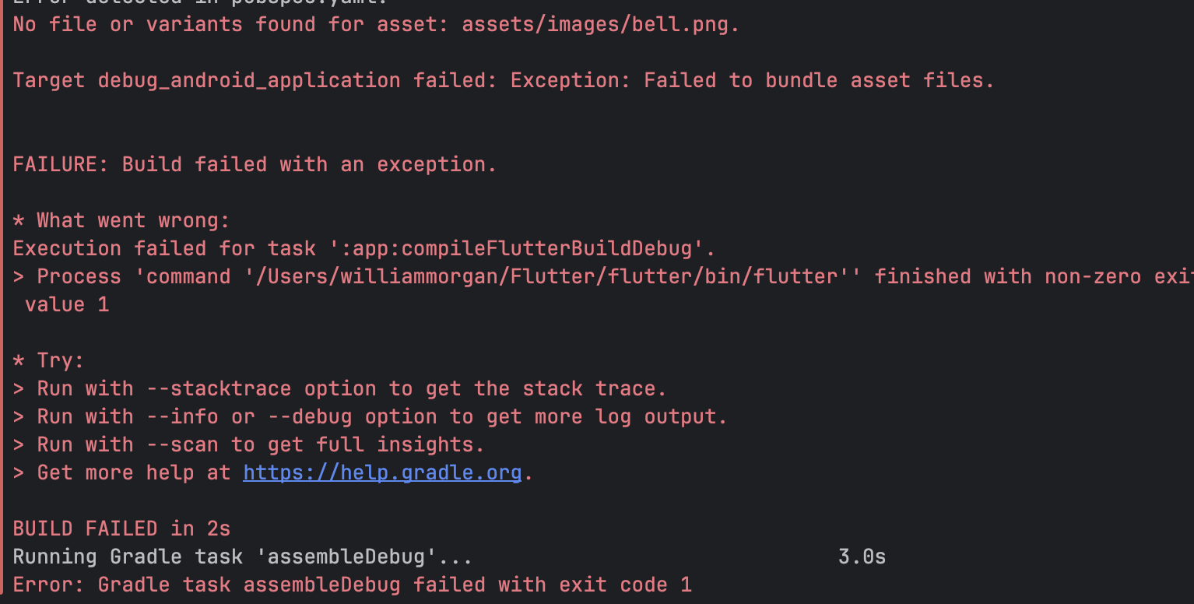
One bug I ran into was Flutter not recognizing my assets at build time. The pubspec.yaml declared the path correctly (at least I thought), but my assets folder was actually located in my lib directory rather than the project root. The fix was simple, I just moved the entire folder. After this the app successfully launched.
- Payload Design
The primary payload key was the notification title, mapped to _statusText in the UI. This key was the most appropriate as it is the standard FCM field that the Firebase Console always requires. This means that it is reliable for every test message without custom data keys. The body field was mapped to _bodyText for the same exact reason. I also had a custom asset key wired to _imagePath for data payload handling.
- Improvement Plan
With another hour, I would improve the message display UI to make notifications prettier and visually distinct. I would reposition the bell icon to sit to the right of the text using a Row widget. Additionally, I would bold the notification title and reduce the body text size to make the message title and body intuitively clear. Finally, I would wrap the message block in a Container with a background color and rounded border using BoxDecoration to allow it to stand out from the background.

