CEN 4010 Principles of Software Engineering

Summer Term 2023

Group 17

Health-Buddy

Milestone 3

7/18/2023

Team Members:

William Reed (wreed2020@fau.edu)

Nicolas Kraft (nkraft2018@fau.edu)

Jenny Jacob (jjacob2022@fau.edu)

Joao Ribeiro (jsilvaribeir2022@fau.edu)

<https://github.com/willmreed14/project-17-CEN4010>

**Executive Summary:**

Our final project is a user-friendly and accessible health tracking web app designed to help individuals monitor their daily food intake and exercise activities. With a simplified interface and basic features, our web app provides a convenient way for users to track their health and fitness goals.

Our project stands out by providing a basic yet accessible health tracking solution for individuals seeking to improve their overall well-being. By focusing on simplicity and ease of use, we ensure that even users with limited technical skills can engage with the app and achieve their health goals. We value user privacy and data security, ensuring that personal information is protected throughout the app.

Our target market encompasses a wide range of individuals who are interested in maintaining a healthy lifestyle. This includes health-conscious individuals, fitness enthusiasts, and those seeking to manage their weight or improve their overall well-being.

Our health tracking web app offers an accessible and simplified solution for individuals to track their food intake and exercise activities. By focusing on ease of use and providing essential tracking features, we aim to help users achieve their health and fitness goals. With effective marketing strategies, we plan to reach our target market and empower individuals to lead healthier lives.

Key features:

Easy-to-Use: Our web app offers a straightforward and intuitive user interface, making it simple for users to log their meals and exercise routines without any technical expertise.

Customizable Profiles: Users can personalize their profiles by setting their height, weight, and fitness goals, allowing them to track their progress more effectively.

Daily Calorie Monitoring: The app calculates and displays the total calorie intake for each day, helping users stay aware of their dietary habits and make healthier choices.

Exercise Tracking: Users can log their exercise activities and view a record of their workouts, enabling them to track their physical activities over time.

**Competitive Analysis:**

|  |  |  |
| --- | --- | --- |
| **Competitor** | **Competitors Features** | **Our Features** |
| MyFitnessPal | - User registration and  authentication: Allows users  to create accounts and  securely log in.  - Food diary: Users can log  meals by entering basic  information such as meal  name, description, and calorie  count.  - Calorie tracking: Calculates  and displays total daily  calorie intake based on  logged food items.  - Exercise tracking: Users can  log exercise activities and  keep a record.  - Basic reports: Generates  basic reports on daily calorie  intake and exercise activities.  - User profile: Users can view  and edit their profile  information, including height,  weight, and fitness goals.  -Community support:  Provides a community  platform for users to connect  and share experiences. | - Emphasis on user-friendly  interface and ease of use: Our  app will prioritize a  straightforward and intuitive  user interface, ensuring even  users with limited technical  skills can easily log meals  and exercise activities.  - Enhanced privacy and data  security measures: We will  implement security protocols  to protect user information  throughout the app, instilling  trust and confidence in our  users.  - Personalized  recommendations based on  the user's profile: By utilizing  user profiles, our app will  offer tailored  recommendations and  insights, helping users make  informed decisions in line  with their specific goals.  - Streamlined features: We  will focus on essential  tracking features, avoiding  unnecessary complexity and  providing a streamlined  experience for users.  - Accessibility: Our app will  be designed to be accessible  and inclusive, catering to a  wide range of individuals  seeking to improve their  health and fitness.  - Effective marketing  strategies: Through  well-planned marketing  efforts, we will establish a  strong presence in the market  and effectively reach our  target audience, highlighting  the simplicity and  user-friendly nature of our  solution. |
| Lose It! | - User registration and  authentication: Enables users  to create accounts and log in  securely.  - Food diary: Allows users to  log meals and track calorie  intake.  - Calorie tracking: Calculates  and displays daily calorie  intake based on logged food  items.  - Exercise tracking: Users can  log exercise activities and  track their workouts.  - Basic reports: Provides  basic reports on calorie intake  and exercise activities.  - User profile: Users can  personalize their profile with  height, weight, and fitness  goals.  - Challenges and rewards:  Offers challenges and rewards  to motivate users in achieving  their goals. | - Simplicity and ease of use:  Our app will focus on  providing a straightforward  and intuitive user interface,  ensuring a seamless  experience for users, even  those with limited technical  skills.  - Enhanced privacy and data  security measures: We will  prioritize the protection of  user data, implementing  security measures to  safeguard personal  information.  - Personalized  recommendations based on  the user's profile: By  leveraging user profiles, our  app will provide customized  recommendations and  insights tailored to individual  goals, helping users make  informed choices.  - Streamlined features: We  will avoid unnecessary  complexity and streamline  our app's features to prioritize  essential tracking capabilities,  making it easier for users to  track their health and fitness  progress.  - Accessibility: Our app will  be designed to cater to a wide  range of users, ensuring  inclusivity and accessibility  for individuals with different  levels of health consciousness  and fitness goals.  - Effective marketing  strategies: We will employ  well-planned marketing  strategies to effectively  communicate the benefits and  unique aspects of our app,  attracting users to our  user-friendly and simplified  health tracking solution. |
| FatSecret | - User registration and  authentication: Enables users  to create accounts and  securely log in.  - Food diary: Allows users to  log meals and track calorie  intake.  - Calorie tracking: Calculates  and displays daily calorie  intake based on logged food  items.  - Exercise tracking: Users can  log exercise activities and  track their workouts.  - Basic reports: Provides  basic reports on calorie intake  and exercise activities.  - User profile: Users can view  and edit their profile  information.  - Recipe ideas: Integration  with recipe ideas for meal  planning. | - User-friendly interface and  ease of use: Our app will  prioritize simplicity and ease  of use, ensuring a smooth and  intuitive experience for users.  - Enhanced privacy and data  security measures: We will  implement security protocols  to protect user information  throughout the app.  - Personalized  recommendations based on  the user's profile: By  leveraging user profiles, our  app will offer tailored  recommendations and  insights, aiding users in  making informed decisions.  - Integration with recipe ideas  for meal planning: We will  integrate recipe ideas within  our app to assist users in  planning their meals more  effectively, providing  additional value and  convenience.  - Streamlined features: Our  app will focus on essential  tracking features, eliminating  unnecessary complexity and  providing a streamlined  experience for users.  - Effective marketing  strategies: Through  well-executed marketing  efforts, we will effectively  reach our target market,  showcasing the user-friendly  and personalized nature of  our health tracking solution. |
| Lifesum | - User registration and  authentication: Allows users  to create accounts and log in  securely.  - Food diary: Users can log  meals and track calorie  intake.  - Calorie tracking: Calculates  and displays daily calorie  intake based on logged food  items.  - Exercise tracking: Users can  log exercise activities and  track their workouts.  - Basic reports: Provides  basic reports on calorie intake  and exercise activities.  - User profile: Users can  personalize their profile with  height, weight, and fitness  goals.  - Meal plans: Integration with  meal plans for guided  nutrition. | - Simplicity and ease of use:  Our app will focus on  providing a straightforward  and intuitive user interface,  ensuring ease of use for all  users.  - Enhanced privacy and data  security measures: We will  prioritize the protection of  user data, implementing  security measures to maintain  privacy throughout the app.  - Personalized  recommendations based on  the user's profile: By utilizing  user profiles, our app will  provide personalized  recommendations and  insights to support users in  achieving their health and  fitness goals.  - Integration with meal plans  for guided nutrition: We will  integrate meal plans within  our app, offering users  guidance and structure in  their nutritional choices.  - Streamlined features: Our  app will emphasize essential  tracking features, simplifying  the user experience and  avoiding unnecessary  complexities.  - Effective marketing  strategies: Through  well-planned marketing  initiatives, we will effectively  reach our target market,  highlighting the accessibility  and personalized nature of  our health tracking app. |
| SparkPeople | -User registration and  authentication: Enables users to create accounts and log in  securely.  - Food diary: Allows users to  log meals and track calorie  intake.  - Calorie tracking: Calculates  and displays daily calorie  intake based on logged food  items.  - Exercise tracking: Users can  log exercise activities and  track their workouts.  - Basic reports: Provides  basic reports on calorie intake  and exercise activities.  - User profile: Users can  personalize their profile with  height, weight, and fitness  goals.  - Articles and videos:  Integration with informative  articles and videos for health  education. | - Emphasis on user-friendly  interface and ease of use: Our app will prioritize a  user-friendly interface,  ensuring a seamless and  intuitive experience for users.  - Enhanced privacy and data  security measures: We will  implement security protocols  to protect user information  throughout the app.  - Personalized  recommendations based on  the user's profile: By  leveraging user profiles, our  app will provide tailored  recommendations and  insights, supporting users in  making informed decisions.  - Integration with informative  articles and videos for health  education: We will integrate  informative articles and  videos within our app to  provide users with valuable  health education resources.  - Streamlined features: Our  app will focus on essential  tracking features, avoiding  unnecessary complexity and  offering a streamlined  experience for users.  - Effective marketing  strategies: Through  well-planned marketing  efforts, we will effectively  reach our target audience,  highlighting the simplicity  and user-friendly nature of  our solution. |

**Competitive Advantage:**

1. **User-Friendly Interface:** Our app will prioritize simplicity and ease of use, ensuring a smooth and intuitive experience for users, even those with limited technical skills.
2. **Enhanced Privacy and Data Security:** We will implement security protocols to protect user information throughout the app, instilling trust and confidence in our users.
3. **Personalized Recommendations:** By leveraging user profiles, our app will offer tailored recommendations and insights, helping users make informed decisions in line with their specific goals.
4. **Streamlined Features:** We will focus on essential tracking features, eliminating unnecessary complexity and providing a streamlined experience for users.
5. **Accessibility:** Our app will be designed to be accessible to a wide range of individuals seeking to improve their health and fitness, ensuring inclusivity for all users.
6. **Effective Marketing:** Through well-planned marketing strategies, we will establish a strong presence in the market and effectively reach our target audience, highlighting the simplicity and user-friendly nature of our solution.

By combining these planned advantages, our web app aims to provide a competitive edge in the health tracking app market by offering a user-friendly, secure, and personalized experience for individuals striving to achieve their health and fitness goals.

**Data Definition:**

1. User Registration and Authentication:

- Name: User Registration and Authentication

- Meaning: The process by which users create accounts and securely log in to access their

personal tracking data.

- Usage: Users need to register with the app by providing their credentials such as username

and password. They can then authenticate themselves securely to access their account and

personal data.

2. User:

- Name: User

- Meaning: An individual who interacts with the health tracking web app.

- Usage: Users create accounts, log in securely, and utilize the various features of the app to

track their food intake, exercise activities, and monitor their progress.

3. Food Diary:

- Name: Food Diary

- Meaning: A feature that allows users to log their meals and related information.

- Usage: Users can enter details such as meal name, description, and calorie count to track their

daily food intake. The app may provide a predefined list of common food items for easy

selection.

4. Calorie Tracking:

- Name: Calorie Tracking

- Meaning: The process of calculating and displaying the total daily calorie intake based on

logged food items.

- Usage: The app calculates the sum of calories from the logged food items and presents it to

the user, enabling them to monitor their dietary habits and make healthier choices.

5. Exercise Tracking:

- Name: Exercise Tracking

- Meaning: A feature that allows users to log their exercise activities.

- Usage: Users can record the type of exercise and its duration to keep track of their physical

activities. The app maintains a record of the logged exercises for users to review and monitor

their progress over time.

6. Reports:

- Name: Reports

- Meaning: Summarized information presenting the user's daily calorie intake and exercise

activities.

- Usage: The app generates basic reports that display the user's consumed calories and exercise

routines in a simple format. These reports provide insights into the user's progress and help them

track their health and fitness goals.

7. User Profile:

- Name: User Profile

- Meaning: A section where users can view and edit their personal information.

- Usage: Users can access their profile to view and modify details such as height, weight, and

fitness goals. The app may provide basic recommendations based on the user's profile

information.

8. Health Tracking Web App:

- Name: Health Tracking Web App

- Meaning: The web-based application designed for tracking food intake and exercise

activities.

- Usage: The app offers an accessible and simplified solution for individuals to monitor their

health and fitness goals. It provides features such as food diary, calorie tracking, exercise

tracking, reports, and user profiles.

9. Target Market:

- Name: Target Market

- Meaning: The specific group of individuals for whom the app is intended.

- Usage: The app is targeted towards health-conscious individuals, fitness enthusiasts, and

those interested in managing their weight or improving their overall well-being.

10. Data Privacy:

- Name: Data Privacy

- Meaning: The protection and confidentiality of personal user information stored in the app.

- Usage: The app implements measures to ensure that user data remains secure and

inaccessible to unauthorized parties. It safeguards sensitive information from breaches or misuse.

11. User Interface:

- Name: User Interface

- Meaning: The visual and interactive components of the app that enable user interaction.

- Usage: The app's user interface encompasses the design, layout, and controls that users

interact with to log meals, track exercises, view reports, and manage their profile. It should be

intuitive, user-friendly, and visually appealing.

12. Fitness Goals:

- Name: Fitness Goals

- Meaning: The desired

objectives or targets that users set for their health and fitness.

- Usage: Users can establish specific goals within the app, such as weight loss, muscle gain,

overall wellness, or achieving specific athletic milestones. The app helps users track their

progress towards these goals.

13. Marketing Strategies:

- Name: Marketing Strategies

- Meaning: Planned activities and tactics to promote the app to the target market and acquire

users.

- Usage: The app employs various marketing techniques, including advertising, social media

campaigns, partnerships, and other promotional efforts, to increase visibility and attract users.

**Overview, Scenarios, and use cases:**

The following use cases and scenarios demonstrate the primary actions and interactions that end users can perform with our health tracking web app. The focus is on the user's experience and the tasks they can accomplish, rather than the underlying technical implementation. Each use case caters to different aspects of health tracking, allowing users to monitor their food intake, exercise routines, progress towards goals, and gain insights into their overall health and fitness journey.

Logging Meals:

* User opens the web app and logs into their account.
* User navigates to the "Food Diary" section.
* User selects the option to add a new meal.
* User enters the details of the meal, such as name, description, and portion size.
* User saves the meal, and it gets recorded in their food diary.

Tracking Calorie Intake:

* User accesses their food diary for the day.
* User reviews the logged meals and their respective calorie counts.
* User sees the total calorie intake for the day displayed prominently.
* User can compare the calorie intake against their set goals and make adjustments if needed.

Logging Exercise Activities:

* User goes to the "Exercise Tracking" section.
* User selects the exercise type from a predefined list or enters a custom activity.
* User enters the duration or other relevant details of the exercise.
* User saves the exercise entry, and it gets recorded in their activity log.

Monitoring Progress:

* User visits their profile or dashboard.
* User sees a summary of their logged meals, exercise activities, and progress.
* User can view tables, graphs or charts illustrating their calorie intake over time.
* User can track their progress towards their set goals and make adjustments as necessary.

Personalizing Profile and Goals:

* User accesses their profile settings.
* User updates personal information such as height, weight, and fitness goals.
* User sets specific targets for calorie intake or exercise routines.
* User saves the changes, and the app adjusts calculations and recommendations accordingly.

**High-level of Functional Requirements:**

1. User Registration and Authentication:

* 1.1 Allow users to create accounts with unique usernames and passwords.
* 1.2 Enable users to securely log into their accounts to access personalized data.
* 1.3 Provide password reset functionality in case users forget their credentials.

1. Food Diary:

* 2.1 Allow users to log their meals by entering meal details such as name, description, and portion size.
* 2.2 Provide a predefined list of common food items for easy selection.
* 2.3 Calculate and display the total calorie count for each logged meal.
* 2.4 Allow users to view and edit their logged meals.

1. Calorie Tracking:

* 3.1 Calculate and display the total daily calorie intake based on the logged food items.
* 3.2 Provide a summary of consumed calories for users to monitor their progress.
* 3.3 Allow users to set daily calorie intake goals and track their progress towards those goals.

1. Exercise Tracking:

* 4.1 Enable users to log their exercise activities by selecting the type of exercise and entering duration.
* 4.2 Maintain a record of the logged exercise activities for users to review.
* 4.3 Calculate and display the total calories burned based on the logged exercise activities.

1. User Profile:

* 5.1 Allow users to view and edit their profile information such as height, weight, and fitness goals.
* 5.2 Provide basic recommendations based on the user's profile and goals.
* 5.3 Display a summary of the user's progress towards their set goals.

1. Reports and Insights:

* 6.1 Generate basic reports to display the user's daily calorie intake and exercise activities.
* 6.2 Provide visual graphs or charts to illustrate trends and patterns in the user's data.

**Non-Functional Requirements:**

Performance:

* The web app shall load each page within 2 seconds to provide a responsive user experience.
* The system shall process user inputs and display results in real-time without significant delays.
* The web app shall handle concurrent user interactions smoothly to prevent performance degradation.

Usability or Ease of Use:

* The user interface shall be intuitive and user-friendly, allowing users to navigate and interact with ease.
* The web app shall provide clear instructions and prompts to guide users in using its features.
* The system shall support error prevention and provide informative error messages to assist users in resolving issues.

Accessibility (Web Browsers):

* The web app shall be compatible with the latest versions of popular web browsers such as Chrome, Firefox, and Safari.
* The system shall ensure proper rendering and functionality across different screen sizes and resolutions.

Expected Load:

* The web app shall handle a concurrent user load of at least 10 users without performance degradation.
* The system shall scale and optimize resources to accommodate increased user traffic during peak usage periods.

Security Requirements:

* User passwords shall be securely stored using industry-standard encryption algorithms.
* The system shall implement secure authentication mechanisms to prevent unauthorized access.
* The web app shall protect user data privacy by implementing appropriate security measures, including data encryption during transmission.

Storage:

* The system shall provide sufficient storage capacity to accommodate user data, including logged meals, exercise activities, and user profiles.
* The web app shall ensure efficient data storage and retrieval to maintain optimal performance.

Availability:

* The web app shall have a minimum uptime of 99% to ensure it is accessible to users at all times.
* The system shall implement backup and disaster recovery mechanisms to minimize downtime in case of system failures.

Fault Tolerance:

* The web app shall be designed to handle and recover gracefully from unexpected errors or system failures.
* The system shall employ error logging and monitoring mechanisms to identify and address issues promptly.

**High-level system architecture (UML):**

Main software products: VSCode, GitHub, Firebase, Postman, RapidAPI

Languages / Tools: HTML, CSS, JavaScript, Node.js

APIs: “Food Nutrition Information” from RapidAPI:

<https://rapidapi.com/hefesto-technologies-hefesto-technologies-default/api/food-nutrition-information>

Frameworks: Bootstrap (MIT License: <https://github.com/twbs/bootstrap/blob/v4.0.0/LICENSE> )

Supported Browsers: All popular browsers, including Chrome, Safari, Edge, Firefox, + mobile browser support.

1. Structure of it:

* User Interface (UI): Handles the presentation layer, allowing users to interact with the app and input data.
* Application Logic: Implements the core functionality of the web app, including user authentication, data processing, and generation of reports and recommendations.
* Data Storage: Stores and manages user data, including logged meals, exercise activities, and user profiles. It can utilize a database system such as MySQL or PostgreSQL.
* External APIs: Integrates with external APIs, such as the "Food Nutrition Information" API, to retrieve nutrition data for food items.
* Third-Party Services: Utilizes services like Firebase for authentication, hosting, and user management.
* Security Measures: Implements security measures like encryption of sensitive data, secure authentication, and access control.

1. DB Organization: The main database schema/organization for the web app will include the following tables:

* Users: Stores user information such as usernames, passwords, and profile details.
* Meals: Stores information about logged meals, including meal names, descriptions, calorie counts, and timestamps.
* Exercise: Stores details about logged exercise activities, such as exercise types, durations, and timestamps.

1. Media Storage: Images and media files can be stored either in the file system or in the database. If the files are small and the number of files is limited, then they will be in the database as binary blobs. However, if the files are larger or there are many files, then they will be in the file system stored in the file paths in the database.
2. Search/Filter Architecture: The search and filter functionality can be implemented by using relevant database fields and database query techniques. An example, searching for specific meal names or exercise types can be achieved by using SQL queries. Sorting can be completed by specifying the desired sorting order in the SQL queries.
3. Your Own APIs: We will create APIs for user registration, authentication, retrieving user data, logging meals, and exercise activities. These APIs would define the endpoints, request/response formats, and functionality that the client can utilize.

Details:

* User Registration API:

Endpoint: /api/register

Description: This API allows users to register a new account in the web app.

Request Format: The API expects a request with the user's registration information, such as username, password, and profile details.

Response Format: The API returns a response indicating the success or failure of the registration process.

* User Authentication API:

Endpoint: /api/login

Description: This API handles user authentication and generates an authentication token.

Request Format: The API expects a request with the user's login credentials, such as username and password.

Response Format: The API returns an authentication token if the provided credentials are valid, allowing the user to access protected routes.

* User Profile API:

Endpoint: /api/profile

Description: This API enables users to retrieve and update their profile information.

Request Format: The API expects requests with the user's authentication token to identify the user and retrieve or update their profile details.

Response Format: The API returns the user's profile information in the response or a success/failure status after profile updates.

* Meal Logging API:

Endpoint: /api/meals

Description: This API allows users to log their meals by providing meal details such as name, description, and calorie count.

Request Format: The API expects requests with the user's authentication token and the meal details.

Response Format: The API returns a success/failure status indicating whether the meal logging was successful.

* Exercise Logging API:

Endpoint: /api/exercises

Description: This API enables users to log their exercise activities by providing details such as exercise type, duration, and other relevant information.

Request Format: The API expects requests with the user's authentication token and the exercise details.

Response Format: The API returns a success/failure status indicating whether the exercise logging was successful.

1. Non-Trivial Algorithm/Process: Some examples that could be implemented are:
2. Personalized Recommendation Algorithm: we can develop an algorithm that analyzes a user's logged meals, exercise activities, and profile information to provide personalized recommendations. This could include recommending specific meal options based on dietary preferences or suggesting exercise routines tailored to the user's fitness goals.
3. Nutritional Analysis Algorithm: we could give users deeper insights into their dietary habits, by incorporating an algorithm that analyzes the nutrients in logged meals. The algorithm could calculate macronutrient distribution, identify potential deficiencies or excesses, and give recommendations for achieving a balanced diet.
4. Progress Tracking and Visualization: creating an algorithm to track user progress and give visualizations that can provide users with a clear understanding of their health and fitness journey. This could include charts, graphs, or progress reports that show changes in weight, calorie intake, exercise duration.

**High-Level UML diagrams:**

1) Class Diagram:

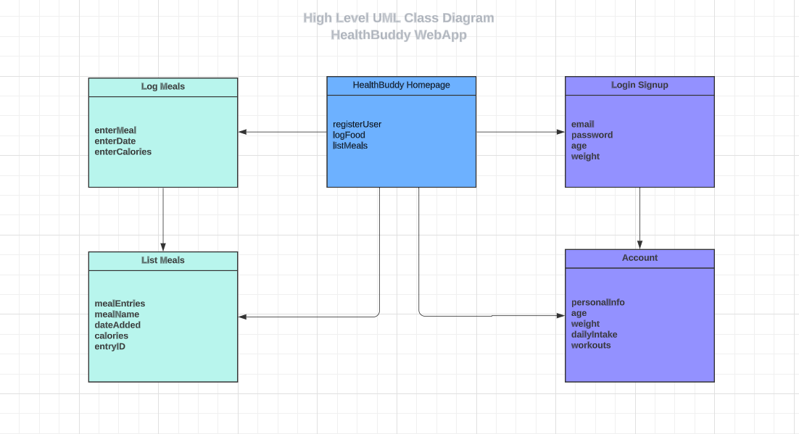

2) Component & Deployment Diagrams:

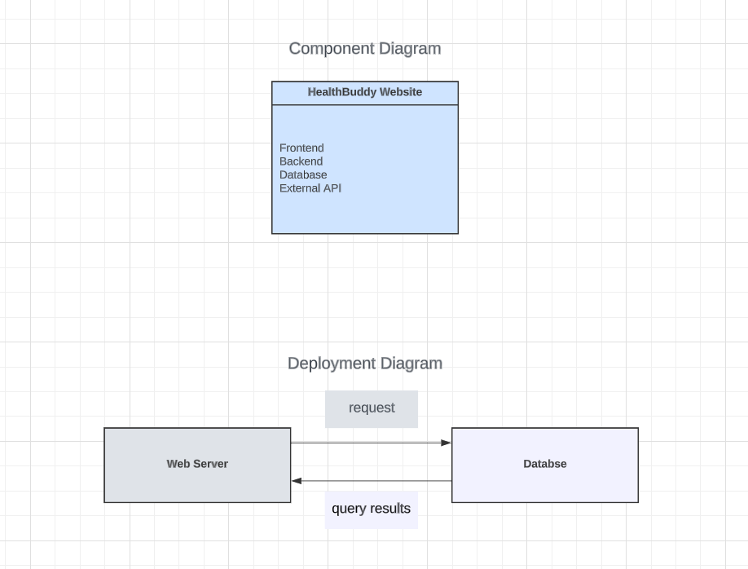

**Risks and actions:**

1. Skills Risk: We are all learning but have full confidence in our ability to perform and be able to learn what to do to create and finish the app on time.
2. Schedule Risk: We all do work on different schedules but have managed to be able to set times for communication to learn from each other and understand where our app currently is. Since we are learning while completing the project, it takes longer than needed sometimes to complete. However, we are confident that we will complete the project on time.
3. Technical Risks:

* Integration Risk: The integration of external APIs, such as the "Food Nutrition Information" API, could be challenging in terms of data compatibility, reliability, and API availability.

Action: Conduct thorough testing and validation of the external APIs during the development process. Implement error handling and fallback mechanisms to handle API failures gracefully. Regularly monitor the API provider's documentation for updates or changes that may affect the integration.

* Security Risk: Since the web app will deal with personal user data, the risk in security is there could be unauthorized access and data breaches. Bad security measures could lead to privacy concerns and potential legal issues.

Action: Implement robust security measures, including secure user authentication, encryption of sensitive data, and protection against common web application vulnerabilities. Regularly conduct security testing to identify and address any potential issues.

* Performance Risks: If the web app experiences high user traffic or data volume, performance issues like slow response times and resource constraints. Inefficient database queries could affect the app's performance.

Action: Perform load testing to identify potential performance issues and adjust the code and database queries accordingly. Implement caching mechanisms, database indexing, and utilize server resources effectively to ensure smooth performance under different loads.

* Usability and User Experience Risks: Important part of our health tracking web app is its easy usability and user experience. If the app is not intuitive it lacks being the easier option.

Action: Conduct user research and usability testing to identify user needs and preferences. We could also get user feedback during the design and development process to improve the app's usability and user experience.

1. Teamwork Risks:
2. Legal/content risks: we can obtain everything needed.

Resolving the risks: To resolve these risks our group can continue to communicate on our own ability, so we understand who is perfect for each role and learn from each other.

**GitHub Link:**

<https://github.com/willmreed14/project-17-CEN4010>

**Vertical demo:**

Link to Vertical Software Prototype Video:

<https://youtu.be/Rj9PO3apXas>

Link to our YouTube Channel:

<https://youtube.com/@HealthBuddy-mc4en>